312/1

GEOGRAPHY

PAPER 1

2021

TIME: 23/4 HOURS

***@West practice papers - 2021***

*Kenya Certificate of Secondary Education (K.C.S.E)*

Geography

Paper 1

Time: 23/4 hours

INSTRUCTIONS TO CANDIDATES

* *This paper consists of two sections; section A and section B.*
* *Answer all questions in section A. In section B answer question 6 and any other two questions.*
* *All answers must be written in the answer booklet provided.*
* *This paper consists of 6 printed pages.*
* *Candidates should check to ascertain that all pages are indicated and that no questions are missing.*

FOR EXAMINERS ONLY

|  |  |
| --- | --- |
| QUESTION | MARKS |
| SECTION A |  |
| 6 |  |
| 7 |  |
| 8 |  |
| 9 |  |
| 10 |  |

**SECTION A**

*Answer* ***ALL*** *the questions in this section*

1. The diagram below shows the internal structure of the earth. Use to answer question (a)

and (b).

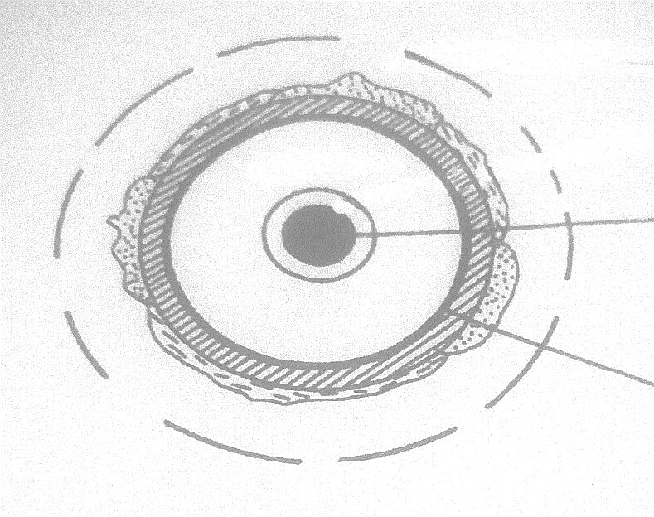

**Q**

**P**

**Inner core**

1. Identify:
2. the layer marked **P**. (1 mark)
3. the zone of discontinuity marked **Q**. (1 mark)
4. Give **four** characteristics of the core. (4 marks)
5. (a) What is a metamorphic rock? (2 marks)
6. Give the metamorphic rock that form when the following rocks are

metamorphosed:

(i) Granite (1 mark)

(ii) Limestone (1 mark)

1. (a) Name **two** main continental plates. (2 marks)
2. Describe how a subduction zone is formed. (3 marks)
3. Use the diagram below to answer question (a)

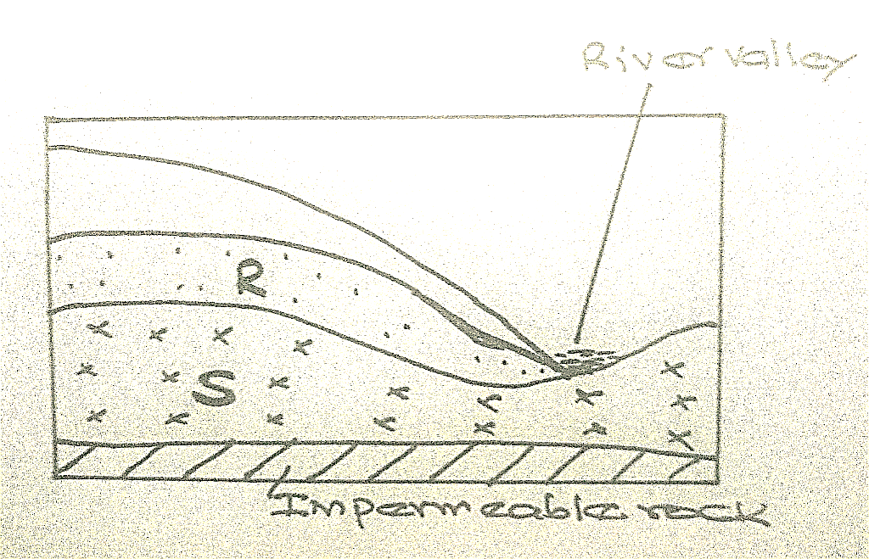

1. Name the zones of saturation marked **R** and **S**. (2 marks)
2. State **three** conditions necessary for the formation of an artesian well. (3 marks)
3. (a) What is a lake? (2 marks)
4. Give **three** ways through which a lake is formed. (3 marks)

**SECTION B: Answer *Question six* and any other *Two Questions* in this section. (75MKS)**

*6) Study the map of Kijabe (1:50000) sheet 134/3 provided and answer the questions that follow*

a) i) What type map of is Kijabe extract? (1mk)

ii) Convert the map scale into statement scale (2mks)

b) i) Measure the length of the railway line to the west of Easting 30 in kilometres. (2mks)

ii) Give six digit grid reference of the forest guard post. (2mks)

c) Draw a square measuring 10cm by 10cm to represent the area enclosed by easting 30 and 40 and northings 90 and 00. (2mks)

On it mark and label;

Thicket vegetation (1mk)

Railway line (1mk)

Bore hole (1mk)

* River upper Ewaso Kedong (1mk)

d) Describe the relief of the area shown by the map (5mks)

e) i) Explain two factors influencing dairy farming in the area covered by the map (4marks)

ii) Citing evidence from the map, state three functions of Kijabe town (3mks)

7 a) i) What is a weather station? (2mks)

ii) State four factors influencing the siting of a weather station. (4mks)

b) Explain how the following factors affect temperature

- Aspect (2mks)

- Ocean currents (2mks)

- Altitude (2mks)

c) Study the diagram below and use it to answer the questions that follow.



1. Label the parts marked X ,Y and Z (2mks)
2. Identify areas in Western Kenya where the phenomenon shown in the diagram above. Commonly occurs. (1mks)

c) With aid of a well labeled diagram, explain formation of relief rainfall. (6mks)

d) Give four reasons why weather forecasting is important. (4mks)

8.a (i) Explain two causes of faulting (4marks)

(ii) Identify two types of faults (2marks)

b) With the aid of well labelled diagrams, describe the formation of the rift valley by compressional forces (8marks)

c) Identify two examples of block mountains in East Africa (2marks)

d) Explain two effects of faulting on drainage (4marks)

e) Your class conducted a field study at the Great Rift Valley.

i) State three reasons why it was important to seek for permission (3marks)

ii) Give two methods you used to collect data (2marks)

9. (a) (i) Define the term glaciation. (2 marks)

(ii) Name **three** types of glaciers. (3 marks)

1. Give **two** reasons why there are no glaciers in Kenya. (2 marks)

(b) Explain how each of the following factors influence the movement

of a glacier:

(i) Gradient of the slope. (3 marks)

(ii) Temperature change (3 marks)

(c) Using a well labelled diagram, describe how a corrie lake is formed. (8 marks)

(d) (i) The diagram below shows the type of moraines:

**N**

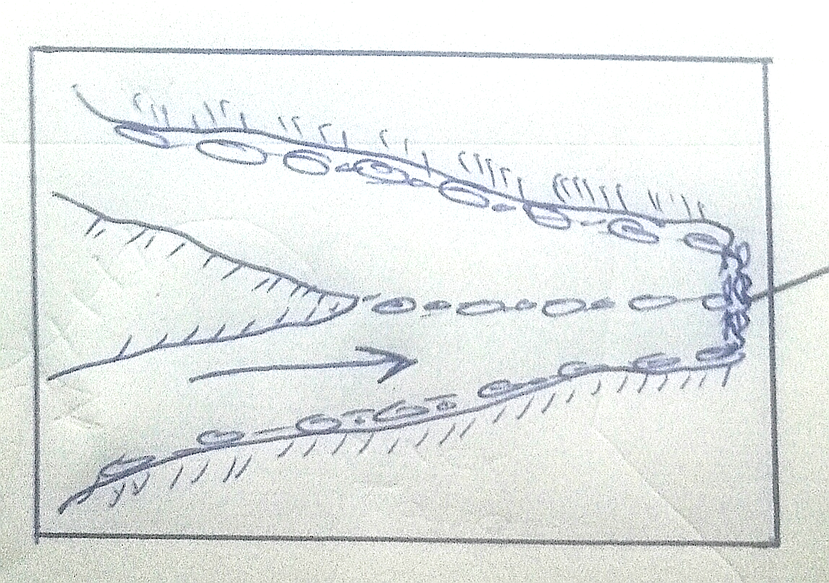

**K**

Name the type of moraine marked **K** and **N**. (2 marks)

(ii) State **two** negative effects of glaciation in lowland areas. (2 marks)

10. (a) Name any two cold deserts in the world. (2 marks)

(b) Describe three factors that influence wind transportation in desert areas. (6 marks)

(c) With the aid of well labelled diagrams, describe how a zeugen is formed. (8 marks)

(d) Give any three features formed by water erosion in desert landscapes. (3 marks)

(e) Explain three ways in which desert features are of significance to human

activities. (6 marks)