GEOGRAPHY
Name……………………………………………………………………
Class………………………………
Admission no……………………………………………
Date………………………………………………………
Sign……………………………………………………………
PAPER 2
DECEMBER 2021
TIME: 2³/₄ HOURS

MOKASA II EXAMINATION 2021
Kenya Certificate of Secondary Education (KCSE)
312/2
Paper 2
GEOGRAPHY
INSTRUCTIONS TO CANDIDATES
- This paper has two sections, A and B.
- Answer all questions in section A, question 6 and any other TWO questions.

FOR EXAMINERS USE ONLY
SECTION | QUESTION | MARKS | SCORE
A | 1-5 | 25
B | 6 | 25
 | 7 | 25
 | 8 | 25
 | 9 | 25
 | 10 | 25
TOTAL MARKS |  | 100
TOTAL SCORE

SECTION A:
Answer all questions in this section.
1. (a) What is human and Economic Geography (2marks)
(b) Name three sub-branches of geography that makes up social sciences. (3marks)
2. The diagram below shows the occurrence of petroleum on the earth crust.
Use it to answer questions (a) and (b)
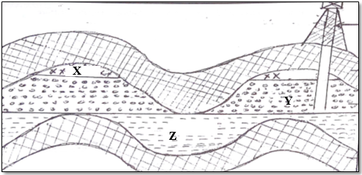
(a) Name the substance in the areas labeled X, Y and Z (3 marks)
(b) Give two by products obtained when crude oil is refined. (2 marks)
3.(a) Name two indigenous softwood trees grown in Kenya (2 marks)
(b) State three effects of deforestation in the environment. (3 marks)
4.(a) Diffenciate between fishing and fisheries (2 marks)
(b) Name three types of fishing (3 marks)
5.(a) List two man-made hazards. (3 marks)
(b. State three effects of diseases to the economy of Kenya (3marks)

SECTION B
Answer Question 6 And Any Other Two From The Remaining.
6. The table below represents agricultural crops exported from Kenya between 2009 - 2012
CROP /YEAR | 2009 | 2010 | 2011 | 2012
HORTICULTURE | 16,000 | 24,000 | 20,000 | 28,000
TEA | 36,000 | 40,000 | 32,000 | 34,000
COFFEE | 20,000 | 12,000 | 8,000 | 4,000

(a) Using a scale of 1cm to represent 4,000 tones, draw a comparative bar graph to represent the data. (8marks)
(b) (i) Describe the trend in coffee export earnings from 2009-2012. (2marks)
(ii) Give four possible reasons for the trend observed. (4marks)
(c) (i) Identify three countries in Kenya producing coffee. (3marks)
(ii) State four physical problems faced by coffee farmers in Kenya. (4marks)
(d) Outline four importance of coffee farming in Kenyan economy (4marks)
7.(a) (i) Define land reclamation (2marks)
(ii) A part from irrigation name three other methods of land reclamation. (3marks)
(b) (i) Identify two aims of setting up Perkerra irrigation scheme (2marks)
(ii) State three physical factors that influences the establishment of Perkerra irrigation scheme (3marks)
(iii) State three problems facing Perkerra irrigation scheme (3marks)
(iv) Name four crops grown under Perkerra irrigation scheme. (4marks)
(c) Explain four differences between land reclamation in Kenya and Netherlands (8marks)
8. (a) (i) Define the term industrialization (2marks)
(ii). Give four characteristics features of cottage industry in India (4marks)
(iii) State four problems facing Jua kali industry in Kenya (4marks)
(b)Study the map of the Ruhr region below and answer the following questions. 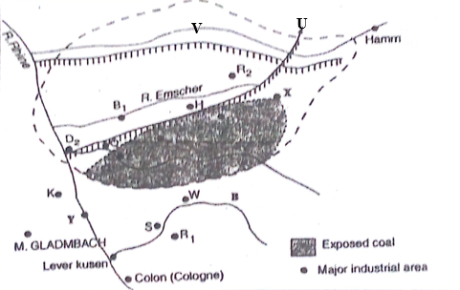
- Name four minerals found within the Ruhur region (4marks)
- Name (3marks)
- The canal mark U
- The river marked V
- The town marked Y
- Explain four factors that led to the growth of iron and steel industry in the Ruhr region (8marks)
9. (a) (i)Define Ecotourism (2marks)
(ii) Distinguish between a national park and a game reserve (4marks)
(iii) Identify three main inland attractions in Kenya (3marks)
(b. Explain how the following problems affect tourism in Kenya
(i) Poaching (2marks)
(ii) Terrorism (2marks)
(iii)Environmental pollution (2marks)
(c) Give three similarities between tourism in Korea and Switzerland (6marks)
(d) Your geography class intend to carry out a field study in a national park in Kenya.
(i) State two hypothesis of study (2marks)
(ii) Give two methods they would use to record data during the study (2marks)
10.(a) (i) What is settlement (2marks)
(ii) Give two types of settlements (2marks)
(b. (i) State five functions of Kisumu City (5marks)
(ii) Explain three factors that influence the growth Thika town (6marks)
(c) (i) State four negative effects of urbanization (4marks)
(ii) Differentiate the ports Mombasa and Rotterdam under the following sub-headings:
- Transport (2marks)
- Mechanization (2marks)
- Size of the port (2marks

