MARKING SCHEME- GEOGRAPHY P2
ARISE AND SHINE EXAMINATION
Kenya Certificate of Secondary Education (K.C.S.E)
TRIAL 1 –TERM 2 AUGUST - 2022
SECTION A
Answer All the Questions In This Section (25 Marks)

- (a). Define eco-tourism. (2 marks)
- It is a type of tourism with emphasis on conservation of the environment
(2x1=2mks)
(b). Name any three big five wild animals? (3 marks)
- Elephant
- Rhino
- Buffalo
- Lion
- Leopard
2. (a). What is agro-forestry? (2 marks)
- It is growing of trees alongside/ with crops on the same piece of land.
(b). Give three characteristics of planted forests.
  - Trees are arranged in rows
  - Trees are the same species
  - Trees are softwood
  - Trees are exotic
  - Trees are the same height

3. (a). Give two types of domestic trade. (2 marks)
- Wholesale trade
- Retail trade
(b). State three factors influencing internal trade in Kenya. (2 marks)
- Common National language/Kiswahili
- Difference goods produced from different parts of Kenya
- Efficient road transport
- Rigorous advertisement of goods to create awareness
4. (a). Differentiate between environmental management and environmental conservation.
(2 marks)
- Environmental management – It is careful use and control of resources in the environment
- Conservation – It is protection of resource I the environment with little wastage.
(b). Apart from diseases, give any three natural environmental hazards Diseases, (3 marks)
- Air pollution
- Water pollution
- Noise pollution
- Soil erosion
- Wind storms
- Lightening
- floods
5. (a). Study the sketch map below and answer the questions that follow.
(a).Identify two settlement patterns represent by the sketch map. (2 marks)
- Linear settlement
- Nucleated settlement
(b). State three causes of rural to rural migration. (3 marks)
- Wars
- Search for employment
- Job transfer
- Search for land
- Diseases outbreak

SECTION B
Answer question six (6) and any other two Questions from this section.
6. The table below shows three main crops produced in Kenya in the years 2008-2010
(amounts in metric tonnes). Use it to answer questions below.

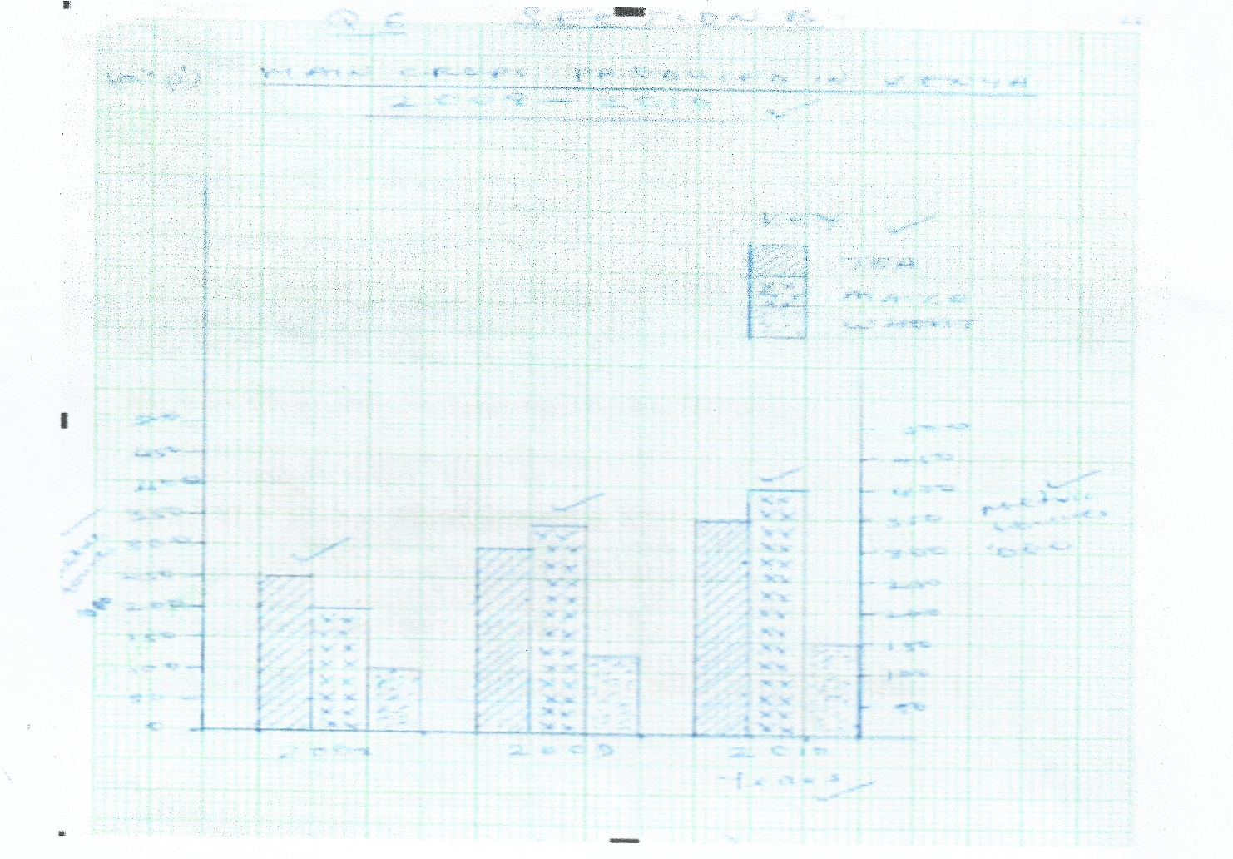

(a)(i) Using a scale of 1cm represent 50,000 metric tonnes, draw a comparative bar graph to represent the data above. (8 marks)
(ii). State two advantages of using comparative bar graph. (2 marks)
- It gives a clear visual impression
- Values in the same group can be compared easily
- The individual contribution made by the variables in each group can be easily identified
- It is easy to draw/construct
- It is easy to read/interpret
(b) i). Name two counties in Kenya where wheat is grown in large scale. (2 marks)
- Nakuru
- Narok
- UasinGishu
- Nyandarua
ii). State three conditions that favour wheat farming in Kenya. (3 marks)
- Gently sloping land for ease of mechanization
- High altitude (1500 – 2000m) above sea level
- Moderate rainfall (500mm – 1270mm)
- Moderate temperature/warm conditions (15ºc – 20ºc) for at least three months
- Deep fertile volcanic soils
- Warm dry sunny spell to enhance ripening and harvesting
(Any 3x1=3mks)
(c). State four benefits of whet growing in Kenya. (4 marks)
- Source of income for those involved in the activity
- Source of food to the Kenyan people
- Through wheat farming many are employed either directly or indirectly
- Saves foreign exchange if it was to be imported
- Promotes industrialization in Kenya
- Improvement of roads

(d). Explain three factors that make Canada produce more wheat than Kenya. (6 marks)
- Canada has extensive tracts of land which has enabled large scale mechanization of wheat
- Canada is a developed country therefore has more capital enabling farmers to sustain production unlike Kenya which has inadequate capital.
- Advanced scientific research in Canada enables the production of higher yielding seeds, better farming tools, seeds, pest control, disease control etc.
- Wheat farmers in Canada specialize in wheat unlike Kenya where farmers practice mixed farming
- There is higher demand for wheat in Canada while in Kenya low demand
- Farmers in Canada have had a long experience in wheat production spanning over centuries unlike Kenya where wheat farming is relatively new/introduced by white settlers
(Any 3x2=6 marks)

7. (a). Apart from Mwea name five large irrigation schemes in Kenya. (5 marks)
- Ahero
- West Kano
- Daua
- Galole/Hola/bura
- Mitunguu
- Katila
- Taveta
- Kibwezi
- Bunyala
- Perkerra
(b). Explain four conditions that made Mwea a suitable location for irrigation scheme.
(8 marks)
- The area was sparsely populated thus making it easy and cheap to resettle the people.
- Presence of river Thiba, Nyamindi which would provide water for irrigation.
- The black cotton soil in the area which was suitable for irrigation because they retain water.
- Extensive land for future expansion.
- The gentle land would allow water to reach the farm through gravity
- The unreliable/inadequate rainfall received in the area made it necessary for irrigation to be practiced
(Any 4x2=8mks)
(c). Explain three benefits to farmers in the Pekerra irrigation scheme. (6 marks)
- The people who live in the area were originally nomads but now they led settled lives.
- Initially the people in the area had no regular sources o income, but nowadays, this is earned from sale of maize and other crops.
- The establishment of the scheme led to provision of social amenities
- Infrastructure which have improved people standard of living
- Tenants are able to grow food crops. This has improved their sufficiency if food/has improved their diet.
- The establishment of the scheme has created employment opportunities for the people in the area.
(Any 3x2=6mks)
(d). Explain three problems experienced by farmers in the Perkera irrigation scheme. (6 marks)
- The stagnant water in the scheme encourages breeding of snails and mosquitoes which spread diseases.
- Silting of canals/weeds growing in the canals reduce the flow to water into the fields. The farmers spend extra time and money dredging the canal.
- Delayed low payment discourages the farmers.
- Fluctuation of papaw, onions prices in the market
- Competition discourages/demoralize the farmers.
- Diseases and pest that attack the crops leading to low yields.
- Weeds compete with crops for nutrients lowering crops yields.
- Salination lowers quality of soils hence lower yields.
- Shortage of labour leading to use of hired labour which is very expensive.
(Any 3x2=6 marks)

8. (a). Name two types of cattle breeds kept by nomadic pastoralist in Kenya. (2marks)
- Zebu
- Boran
- (indigenous breeds) (2x1=2mks)
(b). Describe the marketing of the animals by the nomadic pastoralists. (3 marks)
- Some cattle are sold to slaughter houses/to individual
- Some pastoralists sell their livestock through community groups/ranches
- Some livestock are sold o the livestock marketing department
- Some pastoralists sell their animals to the Kenya meat commission (3x1=3mks)

(c). Explain four measures taken by the government of Kenya to improve beef cattle farming.
- It encourages research the cross breeding of traditional cattle breeds with exotic ones in order to improve the quality of animals and in diseases resistance.
- Order to improve the quality of animals and its diseases resistance
- It strengthens community education to teach beef cattle farmers’ better livestock management.
- It sets up demonstration ranches for farmers to learn new trends in livestock management
- It constructs roads to make services accessible to farmers
- It encourages the replacement of the coarse grass with nutritious pasture to improve the quanlity of animals
- It has sunk boreholes and wells and dams to provide water for the animals
- It has revived KMC a government parastatal that takes animals from farmers for slaughter
- It encourages formation of group ranches for easier management
(Any 4x2=8mks)

(8 marks)
(d). Explain three factors that favour beef farming in Argentina. (6 marks)
- Replacement of coarse grasses with alfalfa and corn has improved the quality of pastures of the beef cattle
- Crossbreeding of the traditional wit higher quality breeds/Hereford, Aberdeen.
Angus shathorn has improved the quality of the yields
- The maritime climate of the area makes grazing of cattle possible throughout the year
- Availability of water supplied using wind pumps ensures constant supply of water for cattle.
- Availability of vast lands suitable for cattle grazing
- Availability of refrigeration facilities enables beef to reach far off markets in good condition.
(3x2=6mks)
(e). (i). State three problems facing nomadic pastoralism. (3 marks)
- Pests e.g. ticks
- Diseases e.g. foot and mouth
- Drought
- Inadequate pasture
- Inadequate water
(ii). Name three products obtained from beef farming in Kenya. (3 marks)
- Meat
- Hides/skin
- blood
9. Below is a sketch map showing Lake Victoria. Use it to answer question (a).

a). i). Name the ports marked P, Q, R, S (4 marks)
- P – Kisumu
- Q – Musoma
- R - Bukoba
- S - Entebbe
ii). Give four advantages of air transport over water transport. (4 marks)
- It is the best means fo transporting perishables and light cargo
- Planes help people in Africa land in remote areas war.
- Planes can perform other different functions such as spraying farms (4x1=4mks)
b). i). Name three types of communication. (3 marks)
- Verbal communication
- Written communication
- Audio-visual communication
ii). Explain four problems facing transport and communication in Africa. (8 marks)
- It is the fastest means of transport
- lack of an integrated traffic system – different countries have different traffic rules
- Landlocked countries –A number of African counters are located far inland and away from oceans, thus denying them direct link to the sea.
- Shortage of navigable rivers – fluctuations in river levels and presence of obstacles
- Uninhabited land –Vast areas are uneconomical
- Thick vegetation – it makes it different and expensive to construct transport system.
- Different railway gauges make difficult to have an integrated railway system.
- Political barriers _ political animosity between countries
- Inadequate capital –Heavy capital investment is required
- Poor technology and shortage of skilled labour
- High fuel costs –Africans are unable to cope with the ever icnreasin prices of petroleum
- Security – vandalism of communication facilities, road sign, Terrorisms, wars in several countries.
(Any four well explained
4x2=8marks)
c). Explain the role of the Great Lakes and St. Lawrence Seaway to the economies of Canada and the USA. (6 marks)
- Supply of hydro – electric power
- Creation of employment opportunities
- Promotion of tourism
- Development of town
- Improved navigation
- Development of Agriculture
- Development of industries
(6x1=6mks)
10. Use the word map below to answer question (a).
(a) (i). Name the ocean currents marked x and Y. (2 marks)
- X- Warm North pacific drift
- Y – Cold Peruvian ocean currents
(ii). Name the fishing ground marked Z. (1 mark)
- North East Atlantic fishing ground
(b). Explain three physical factors that favour fishing in the fishing ground marked Z.
(6 marks)
- Extensive continental shelf host a lot of planktons the basic food for fish
- Indented coastlines suitable site for fish breeding/port development
- Rugged landscape not ideal for Agriculture hence fishing is ideal alternative.
- Cool water s favours growth of varieties of fish species.
(c) (i). What is fish farming? (2 marks)
- It is artificial rearing o fish in fish ponds/rice field
(ii). Name two fish species reared in fish farms in Kenya. (2 marks)
- Tilapia
- Trout
- Nile Perch
(iii). Explain four problems which are experienced by fish farmers in Kenya. (8 marks)
- Poor feeder roads-delay transportation of fish to the market.
- Pour feeder roads-delay transportation of fish to the market
- Exploitation by middlemen reduces profit
- Inadequate market due to low purchasing power
- Some cultures despises eating fish hence low market.
- Inadequate capital to expand fish farming.
(d). Give four uses of fish. (4 marks)
- Food
- Sold to earn income
- Raw material for making feeds
- Alleviates chest problems e.g. cod liver oil

