Name: ______________________________________________Adm. No_____________

Index No: ___________________________ School:_________________________
Candidate’s Sign______________________ Date: ____________________________

312/2

GEOGRAPHY
Paper 2
AUGUST/SEPTEMBER2022
Time: 2 ¾ Hours

ARISE AND SHINE EXAMINATION
Kenya Certificate of Secondary Education (K.C.S.E)
TRIAL 1 EXAMINATION 2022

Instructions to Candidates:
- This paper consists of two sections: A and B.
- Answer ALL questions in section A. In section B answer question 6 and any other TWO questions.
- All answers to be written on the answer booklet provided.
- Candidates should check the question paper to ascertain that all the pages are printed as indicated and that no questions are missing.

FOR EXAMINERS USE ONLY
1 | 2 | 3 | 4 | 5 | Total
GRAND TOTAL

6 | 7 | 8 | 9 | 10 | Total

SECTION A

Answer All the Questions In This Section (25 Marks)

- (a). Define eco-tourism. (2 marks)
(b). Name any three big five wild animals? (3 marks)

2. (a). What is agro-forestry? (3 marks)
(b). Give three characteristics of planted forests.

3. (a). Give two types of domestic trade. (2 marks)
(b). State three factors influencing internal trade in Kenya. (3 marks)

4. (a). Differentiate between environmental management and environmental conservation.
(2 marks)
(b). Apart from diseases, give any three natural environmental hazards Diseases, (3 marks)

5. (a). Study the sketch map below and answer the questions that follow.

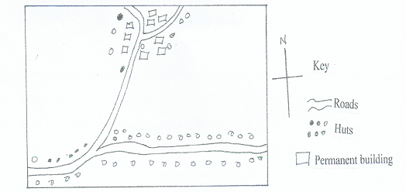

Identify two settlement patterns represent by the sketch map. (2 marks)
(b). State three causes of rural to rural migration. (3 marks)

SECTION B
Answer question six (6) and any other two Questions from this section.

6. The table below shows three main crops produced in Kenya in the years 2008-2010
(amounts in metric tonnes). Use it to answer questions below.
Crop | 2008 | 2009 | 2010
Maize | 200,000 | 380,000 | 400,000
Wheat | 100,000 | 130,000 | 150,000
Tea | 250,000 | 300,000 | 350,000

(a)(i) Using a scale of 1cm represent 50,000 metric tonnes, draw a comparative bar graph to represent the data above. (8 marks)
(ii). State two advantages of using comparative bar graph. (2 marks)
(b) i). Name two counties in Kenya where wheat is grown in large scale. (2 marks)
ii). State three conditions that favour wheat farming in Kenya. (3 marks)
(c). State four benefits of wheat growing in Kenya. (4 marks)
(d). Explain three factors that make Canada produce more wheat than Kenya. (6 marks)

7. (a). Apart from Mwea name five large irrigation schemes in Kenya. (5 marks)
(b). Explain four conditions that made Mwea a suitable location for irrigation scheme.
(8 marks)
(c). Explain three benefits to farmers in the Pekerra irrigation scheme. (6 marks)
(d). Explain three problems experienced by farmers in the Perkera irrigation scheme. (6 marks)

8. (a). Name two types of cattle breeds kept by nomadic pastoralist in Kenya. (2marks)
(b). Describe the marketing of the animals by the nomadic pastoralists. (3 marks)
(c). Explain four measures taken by the government of Kenya to improve beef cattle farming.
(8 marks)
(d). Explain three factors that favour beef farming in Argentina. (6 marks)
(e). (i). State three problems facing nomadic pastoralism. (3 marks)
(ii). Name three products obtained from beef farming in Kenya. (3 marks)

9. Below is a sketch map showing Lake Victoria. Use it to answer question (a).

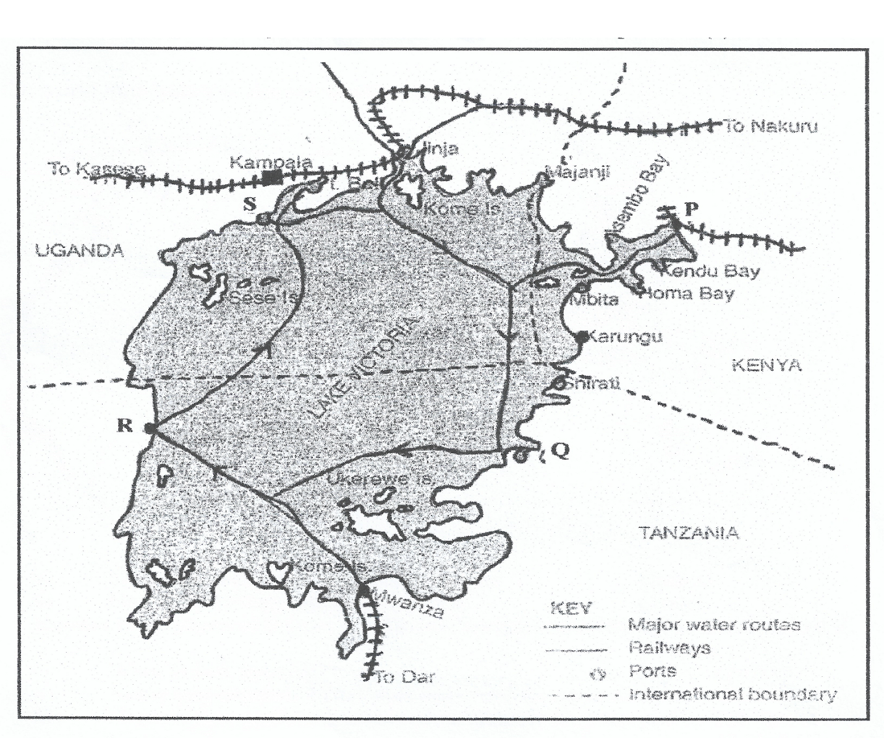
a). i). Name the ports marked P, Q, R, S (4 marks)
ii). Give four advantages of air transport over water transport. (4 marks)
b). i). Name three types of communication. (3 marks)
ii). Explain four problems facing transport and communication in Africa. (8 marks)
c). Explain the role of the Great Lakes and St. Lawrence Seaway to the economies of Canada and the USA. (6 marks)

10. Use the world map below to answer question (a).
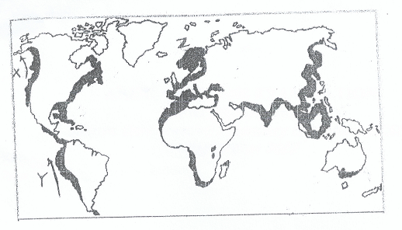
(a) (i). Name the ocean currents marked x and Y. (2 marks)
(ii). Name the fishing ground marked Z. (1 mark)
(b). Explain three physical factors that favour fishing in the fishing ground marked Z. (6 marks)
(c) (i). What is fish farming? (2 marks)
(ii). Name two fish species reared in fish farms in Kenya. (2 marks)
(iii). Explain four problems which are experienced by fish farmers in Kenya. (8 marks)
(d). Give four uses of fish. (4 marks)

