Name: ______________________________________Index No: ________________________

School:______________________________ Candidate’s Sign___________________

Date: ____________________________

312/1
GEOGRAPHY
Paper 1

AUGUST/SEPTEMBER, 2022
Time: 2 ¾ Hours

ARISE AND SHINE TRIAL EXAMS
Kenya Certificate of Secondary Education (K.C.S.E)

Instructions to Candidates:
- Write your name and admission number on the spaces provided above.
- This paper has two sections: A and B.
- Answer all questions in section A.
- In section B, answer question 6 and any other two questions.

FOR EXAMINERS USE ONLY

SECTION A
Question number | 1 | 2 | 3 | 4 | 5 | Sub Total
Marks
Grand total

SECTION B
Question number | 6 | 7 | 8 | 9 | 10 | Sub Total
Marks

SECTION A
Answer ALL Questions in this Section

- (a) What is a weather station? (2 marks)
(b) Give three factors that influence wind direction. (3 marks)

- (a) Name two types of tectonic plate boundaries. (2 marks)
(b) Give three effects of the movement of tectonic plates. (3 marks)

- (a) Give the difference between latitude and longitude. (2 marks)
(b) When the local time is 2:00pm at longitude 45E, what is the longitude of station A whose local time is 10:30am? (3 marks)

- The diagram below shows a section of a river. Use it to answer the questions that follow
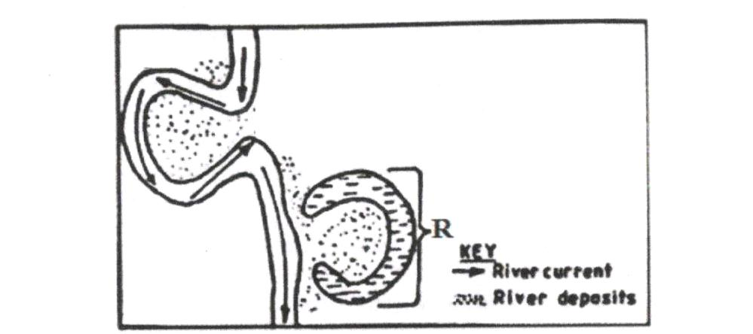
(a) Identify the stage of development of the section of the river. (1 mark)
(b) Apart from feature marked R, give two other features formed at this stage. (2 marks)
- (a) Draw a well labeled diagram of the hydrological cycle. (5 marks)
(b) State two ways in which underground water may reach the surface of the earth. (2 marks)

SECTION B
Answer Question 6 and Any Other Two Questions from this Section.

- Study the map of Nyeri 1:50,000 (sheet 120/4) provided and answer the following questions.
- (i) Give the longitudinal extent of the area covered by the map. (2 marks)
(ii) Give the six figure grid reference of the trigonometric station at Nyeri Hill Forest. (2 marks)
(iii) Calculate the area of Nyeri Forest. Give your answer in square kilometers. (2 marks)
- (i) What is the bearing of The Ark Lodge from trigonometric station 120 UT 16. (2 marks)
(ii) Identify three man-made features in grid square 7263. (3 marks)
(iii) Give three drainage features found in the area covered by the map. (3 marks)

- Describe the relief of the area covered by the map. (5 marks)
- Citing evidence from the map, identify three social services offered in Nyeri Township. (6 marks)

- (a) (i) State two causes of faulting. (2 marks)
(ii) Differentiate between a normal fault and a reverse fault. (4 marks)

(b) (i) Apart from Rift Valley, give three other relief features formed due to faulting. (3 marks)
(ii) With the aid of diagrams, describe how compressional forces can lead to formation of a rift valley. (8 marks)

(c) Explain four effects of faulting on drainage. (8 marks)

- (a) Give three examples of chemically formed sedimentary rocks. (3 marks)
(b) (i) State three conditions necessary for the growth of coral. (3 marks)
(ii) Describe how coral rocks are formed. (4 marks)

(c) Explain four ways in which rocks contribute to the economy of Kenya. (8 marks)
(d) Some students are planning to carry out a field study on rock weathering around their school.
- List three secondary sources of information they are likely to use as they prepare for the field study. (3 marks)
- Apart from using secondary sources, state four other ways in which the students would prepare themselves for the field study. (4 marks)

- (a) Describe plucking as a process in glacial erosion. (4 marks)
(b) Explain three conditions that lead to glacial deposition. (6 marks)

(c) The diagram below shows features resulting from glacial deposition in a lowland area.
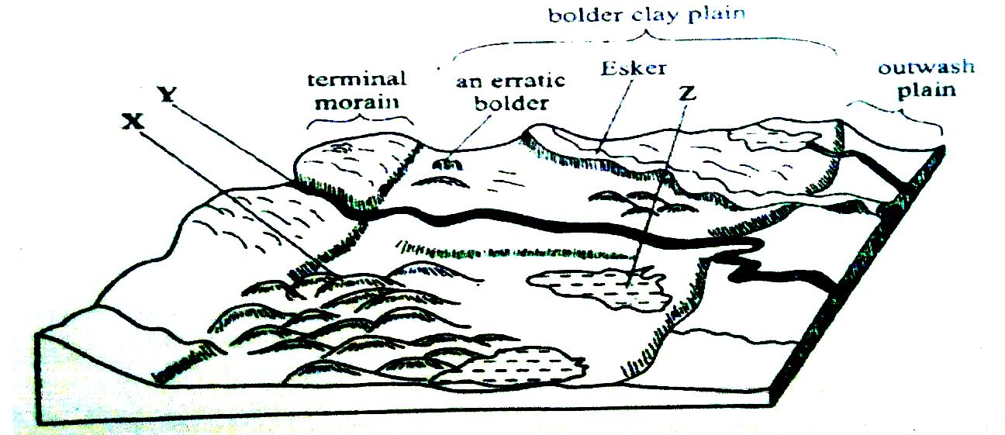
- Name the features marked X, Y and Z. (3 marks)
- Describe how terminal moraine is formed. (4 marks)

(d) Explain four positive effects of glaciation in lowland area. (8 marks)

- (a) (i) Define the term earthquake. (2 marks)
(ii) List three major earthquake zones of the world. (3 marks)

(b) Differentiate between seismic focus and epicenter. (2 marks)
(c) Explain four natural causes of earthquake. (8 marks)
(d) Explain five effects of earthquake in built up areas. (10 marks)

