MARKING SCHEME - GEOGRAPHY - Paper 1
AUGUST/SEPTEMBER, 2022
ARISE AND SHINE TRIAL 1 EXAMINATIONS
SECTION A
Answer ALL Questions in this Section

- (a) What is a weather station? (2 marks)
- A place that is set aside for the purpose of observing, measuring and recording weather elements. (1 X 2 = 2 marks)
(b) Give three factors that influence wind direction. (3 marks)
- The pressure gradient.
- Coriolis force /rotation of the earth.
- Centrifugal force.
- Friction with the earth's surface. (3 X 1 = 3 marks)

- (a) Name two types of tectonic plate boundaries. (2 marks)
- Divergence /extension /constructive.
- Convergence /compressional/destructive.
- Transform /conservative. (2 X 1 = 2 marks)

(b) Give three effects of the movement of tectonic plates. (3 marks)
- They cause earthquakes.
- Can lead to formation of Fold Mountains.
- Can lead to formation of new oceanic crust.
- Can lead to formation of submarine Islands /volcanic Islands.
(3 X 1 = 3 marks)
- (a) Give the difference between latitude and longitude. (2 marks)
- Latitude show how far a place is from the equator while longitude show how far a place is from prime meridian.
- Latitude are parallel to one another while longitudes meet at the poles.
- Distance between latitudes is even around the globe while distance between longitudes is longest at the equator and decrease polewards.

(b) When the local time is 2:00pm at longitude 45E, what is the longitude of station A whose local time is 10:30am? (3 marks)
Time difference = 14 - 10:30 = 3.5hours
3.5 X 15 = 52.5° 52.5 - 45 = 7.5°W

- The diagram below shows a section of a river. Use it to answer the questions that follow
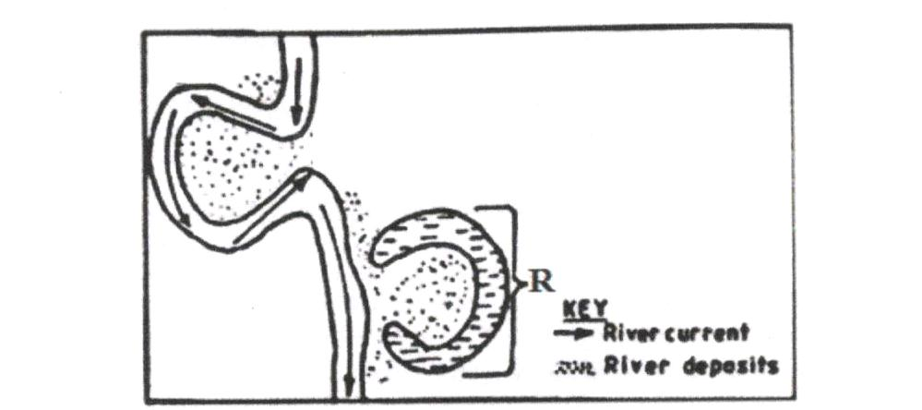
(a) Identify the stage of development of the section of the river. (1 mark)
- Old/ lower stage (1 X 1 = 1 mark)
(b) Apart from feature marked R, give two other features formed at this stage. (2 marks)
- Meanders
- Braided channel
- Flood plain
- Deltas
- Bluffs
- Deferred tributaries. (2X 1 = 2 marks)

- (a) Draw a well labeled diagram of the hydrological cycle. (5 marks)
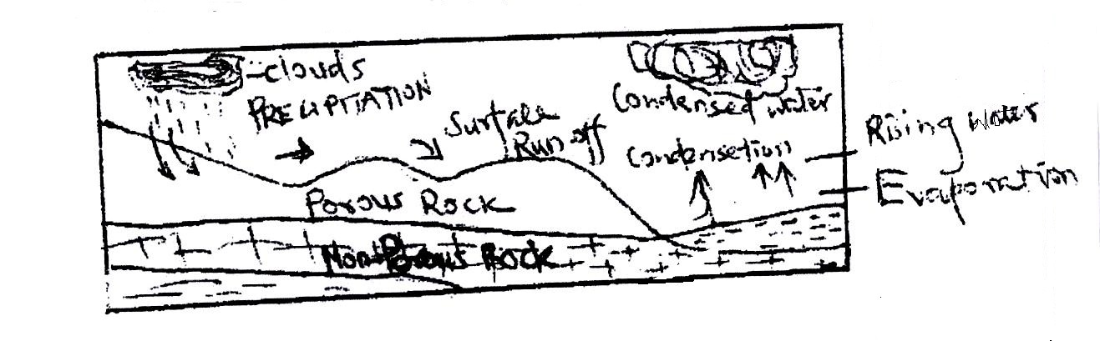
(b) State two ways in which underground water may reach the surface of the earth. (2 marks)
- Through springs /wells / see page
- Capillary action /transpiration. (3 X 1 = 3 marks)

SECTION B
Answer Question 6 and Any Other Two Questions from this Section.

- Study the map of Nyeri 1:50,000 (sheet 120/4) provided and answer the following questions.
- (i) Give the longitudinal extent of the area covered by the map. (2 marks)
36°45`E to 37°00`E (1 X 2 = 2 marks)
(ii) Give the six figure grid reference of the trigonometric station at Nyeri Hill Forest. (2 marks)
665548 (1 X 2 = 2 marks)
(iii) Calculate the area of Nyeri Forest. Give your answer in square kilometers. (2 marks)
2 + $\frac{19}{2}$ = 11.5km² (1 X 2 = 2 marks)
- (i) What is the bearing of The Ark Lodge from trigonometric station 120 UT 16. (2 marks)
317°± 1° or N43°W (1 X 2 = 2 marks)

(ii) Identify three man-made features in grid square 7263. (3 marks)
- Road D449
- Other track /footpath
- Settlement /houses
- Nderitu farm (3 X 1 = 3 marks)
(iii) Give three drainage features found in the area covered by the map. (3 marks)
- Rivers
- Dams/reservoirs
- Water holes
- Water tank
- Ditch (3 X 1 = 3 marks)
- Describe the relief of the area covered by the map. (5 marks)
- There are several river valleys
- There is a hill in grid square 6963
- North Eastern and Western area has gentle slopes
- There are steep slopes in the north western and Southern parts.
- There are ridges in the south western part.
- The highest point is 2820m and lowest point is 1680m
- The area generally slopes downwards from west to east. (5 X 1 = 5 marks)

- Citing evidence from the map, identify three social services offered in Nyeri Township. (6 marks)
- Administrative services - PC/DC/Admin offices
- Religion - church
- Recreation - golf course /club /showground/hotel
- Rehabilitation - prison
- Education - school
- Security - police station (3 X 2 = 6 marks)

- (a) (i) State two causes of faulting. (2 marks)
- earth movements causing tension within rocks
- earth movements causing compression within rocks
- faulting can occur when rocks shear
- vertical movement in the rocks cause rocks to fracture (3 X 1 = 3 marks)

(ii) Differentiate between a normal fault and a reverse fault. (4 marks)
- Anormal fault is caused by tensional forces while reverse fault is caused by compressional forces
- In a normal fault, the upthrow moves away from the downthrow while in a reverse fault, the upthrow rides over the downthrow. (2 X 2 = 4 marks)
(b) (i) Apart from Rift Valley, give three other relief features formed due to faulting. (3 marks)
- tilt block
- escarpment/scarp slope
- block mountain/horst
- fault steps (3 X 1 = 3 marks)
(ii) With the aid of diagrams, describe how compressional forces can lead to formation of a rift valley. (8 marks)
- When layers of crustal rocks are subjected to compressional forces, lines of weakness occur and forms adjacent reverse faults

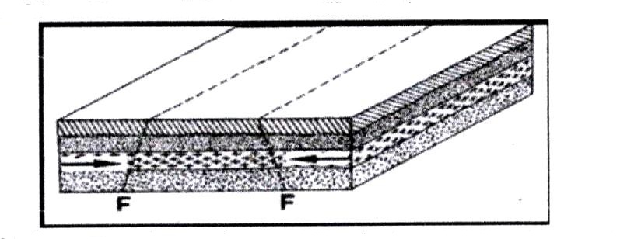
- Continued compression pushes out/thrusts the outer blocks over the central/middle block to form the floor of the rift valley.

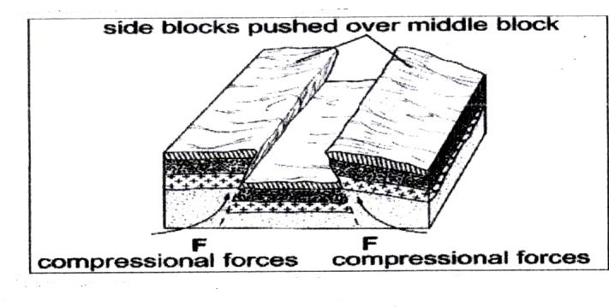

- The steep fault scarps on either sides of the outer blocks are further worn out by denudation (erosion, mass wasting and transportation) to form gentle slopes.
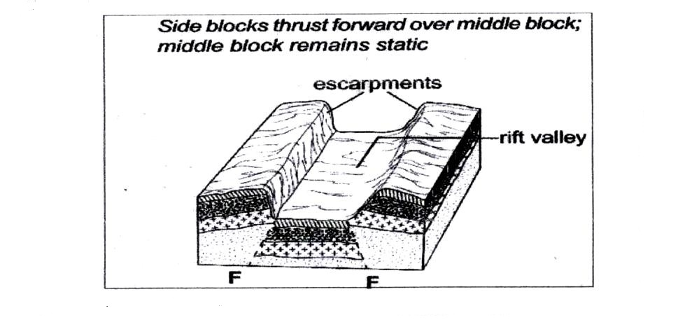
(Text – 5 marks) (diagrams – 3 marks)

(c) Explain four effects of faulting on drainage. (8 marks)
- Vertical faulting across river valleys cause water falls.
- Faulting occurring across a river valley causes disappearance of a river or change of direction.
- Faulting result in formation of deep basins which collect water to form lakes.
- Fault scarps may expose water table to form springs.
- Faulting forms lines of weakness from which hot magmatic water escape to the surface to form hot springs and geysers.
- Faulting create cracks on rocks which rivers flow forming fault guided drainage.
(8 marks)

- (a) Give three examples of chemically formed sedimentary rocks. (3 marks)
- Limonite
- Travertine /tufa
- Dolomite
- Rock salt
- Gypsum
- Trona
(b) (i) State three conditions necessary for the growth of coral. (3 marks)
- Temperature between 20 - 29°C.
- Warm water
- Salty water
- Shallow water
- Clean water /silt free /mud free
- Well oxygenated water

(ii) Describe how coral rocks are formed. (4 marks)
- Tiny marine organisms called coral polyps live in colonies in the sea.
- Polyps extract calcium from the sea water to make their shells.
- The spaces between the dead coral polyps are cemented by calcareous algae.

(c) Explain four ways in which rocks contribute to the economy of Kenya. (8 marks)
- Some rocks are exploited to provide building and construction material/this promotes the industry.
- Some rocks formation e.g. granite are tourist attractions. This earns the country some foreign exchange.
- Rocks have contributed to the development of cement industry through the provision of limestone as raw materials.
- Through weathering, rocks provide soils which are used for agricultural production.
- Some rocks have valuable mineral ores which are exploited and sold to generate revenue.
- Some rocks are curved for which are sold to generate revenue.
- Some rocks such as rock salts are sources of food.

(d) Some students are planning to carry out a field study on rock weathering around their school.
- List three secondary sources of information they are likely to use as they prepare for the field study. (3 marks)
- Text books /pamphlets
- Maps /geological maps
- Journals
- Periodicals /Magazines /Newspapers
- Handouts
- Teacher’s notes (1 mark each, max 3 = 3 marks)
- Apart from using secondary sources, state four other ways in which the students would prepare themselves for the field study. (4 marks)
- Setting up study objectives for the study
- Identifying methods of data collection
- Carrying out a reconnaissance survey
- Seeking permission from the relevant authority
- Identifying /sorting out relevant equipment/tools for the study
- Drawing a route map
- Identifying relevant stationery
- Dividing themselves into groups
- Discussion
- (a) Describe plucking as a process in glacial erosion. (4 marks)
- Pressure from the overlying mass of ice causes freeze thaw action.
- Melting water fills the cracks/joints in the bed rock.
- As water freezes it exerts pressure on the cracks enlarging them.
- The enlarged cracks lead to disintegration of the rock.
- The rock debris are scoured or pulled off the mother rock by the moving ice.
- The disintegrated rocks eventually get embedded within the mass of ice.
- As the ice moves, it pulls out or gorges out the embedded rock from the mother rock.
- This process is called plucking.

(b) Explain three conditions that lead to glacial deposition. (6 marks)
- Rising temperature lead to melting of ice thereby causing the ice to deposit its load.
- Change of gradient to relatively flat surface will reduce the velocity of the glacial movement which will subsequently lead to deposition of glacial materials.
- Alternating warm and cold periods lead to seasonal melting of ice which allows materials embedded in the ice to be released and deposited.
- Stagnation/accumulation of glaciers leads to pressure at the base of the glacier which in turn leads to melting of ice at the base. The melt water then carries and deposits materials underneath which loosens the heavy materials beneath the mass ice and is subsequently deposited.
- Friction at the base and sides of a glacier and a rough surface leads to melting of ice, causing the ice to deposit its load.

(c) The diagram below shows features resulting from glacial deposition in a lowland area.
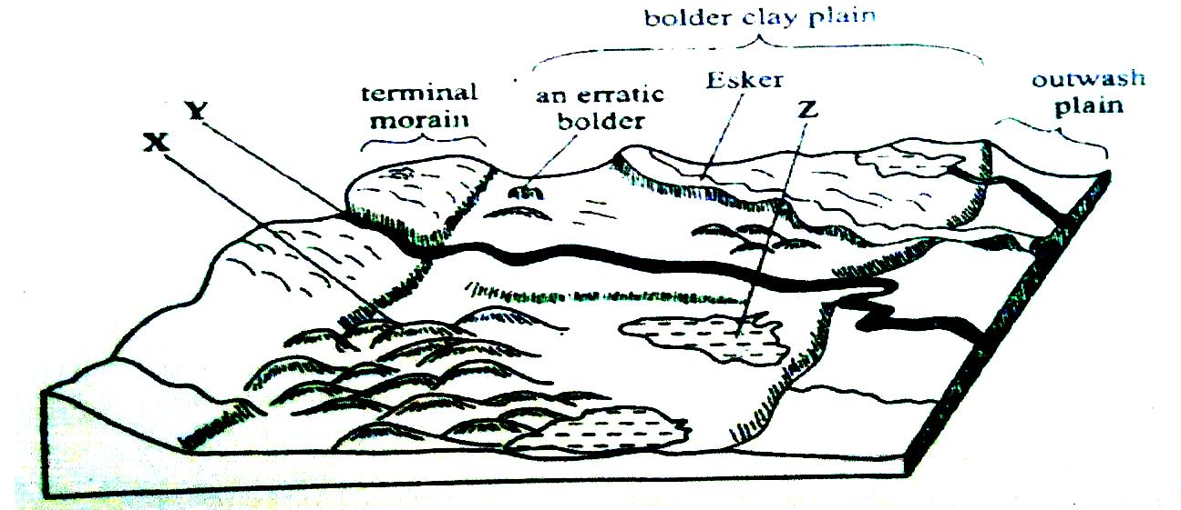
- Name the features marked X, Y and Z. (3 marks)
X – Drumlins
Y – A river/melt water
Z – kettle lake/lake.

- Describe how terminal moraine is formed. (4 marks)
- Moving ice carries solid materials
- Moving ice stagnates and ice at the snout melts
- Melting ice releases its load
- Gradually the load piles into a ridge
- Over time the ridge forms a horse shoe shape /block of solid materials called terminal moraine
(d) Explain four positive effects of glaciation in lowland area. (8 marks)
- Glacial till provides fertile soils which are suitable for arable farming.
- Ice sheets in their scouring effect may expose the minerals making them easy to extract.
- Out wash plains comprise of sand and gravel which are used as building/construction materials.
- Glacial lakes found in lowland areas can be exploited for various economic uses such as fishing and transportation.
- Glaciation forms features such as drumlins, eskers which are tourists attraction hence foreign exchange earnings.
- Glaciated lowlands are generally flat and ideal for establishment of settlements/development of transportation network.

- (a) (i) Define the term earthquake. (2 marks)
- A sudden and rapid movement tremor of the earth crust. (2 marks)

(ii) List three major earthquake zones of the world. (3 marks)
- Circum - pacific belt
- Mid Atlantic ridge
- Mediterranean Himalayan belt
- The great African Rift Valley

(b) Differentiate between seismic focus and epicenter. (2 marks)
- Seismic - the point inside the earth which is the origin of the earthquakes shocks.
- Epicenter - is the point on the surface of the earth which is vertically above the seismic focus.
(c) Explain four natural causes of earthquake. (8 marks)
- Tectonic movements
- Vulcanicity
- Gravitational pressure
- Isostatic adjustment
- Energy release in the mantle. (2 X 4 = 8 marks)
NB: mark factor and explanation
(d) Explain five effects of earthquake in built up areas. (10 marks)
- Collapsing of buildings
- Loss of life (human/animal and plant)
- Disruption of transport and communication lines
- Outbreak of fires
- Avalanches and landslides may cover the built up areas
- Tsunamis may drown coastal settlements (2 X 5 = 10 marks)
NB: Candidates should mentioned earthquakes of high intensity to score mark effect and explanation.

