NAME……………………………………………………….…… INDEX NO.:………………………...
STREAM: .…..…………………………………………………… ADM NO: …………………………
DATE: …………………….………

312/2
GEOGRAPHY
AUGUST-2022
TIME: 2 ³/₄ HOURS

MINCKS GROUP OF SCHOOLS
FORM FOUR
Kenya Certificate of Secondary Education(K.C.S.E)

312/2
GEOGRAPHY
AUGUST-2022
TIME: 2 ³/₄ HOURS

INSTRUCTIONS TO CANDIDATES
- Attempt all the questions in section A.
- Attempt question 6 and any other two questions in section B.
FOR EXAMINER’S USE ONLY

 | CANDIDATE’S SCORE | MAXIMUM SCORE
Section A
Question 6
Question 7
Question 8
Question 9
Question 10
TOTAL SCORE |  | 100
SECTION A
- (a) Define the term environment. (2marks)
(b) Name three aspects studied under population geography. (3marks)
- (a) Name two areas in Brazil where coffee is grown. (2marks)
(b) State three physical conditions that favour coffee growing in Kenya. (3marks)
- (a) Apart from land pollution, name two other types of environmental hazards. (2marks)
(b) State three ways through which land pollution can be controlled. (3marks)
- (a) What is reafforestation? (2marks)
(b) Name three exotic species of trees planted in Kenya. (3marks)
- (a) Apart from telephones, state two other forms of communication. (2marks)
(b) Give three reasons for the decline in the use of letters as a mode of communication in Kenya. (3marks)
SECTION B
Answer question 6 and any other two questions in this section
- The table below shows the number of zebu cattles in four different countries in Kenya in 2014.
Country | Number of zebu cattles
Isiolo  Wajir  Marsabit  Mandera | 42,500  22,600  20,300  15,400
- Draw a divided rectangle 15cm long to represent the data above. (7marks)
- Calculate the range of the above data. (2marks)
- State three advantages of using divided rectangles to represent data. (3marks)
- (i) Give three reasons why nomadic pastoralists keep large herds of animals. (3marks)
(ii) Name two nomadic communities involved in beef cattle rearing in Kenya. (2marks)
(iii) Explain four ways in which the government of Kenya assists nomadic pastoralists to improve the quality of their livestock. (8marks)
- (a) Name two types of human settlements. (2marks)
(b) Name the functional zones of an ideal urban centre labeled X, Y and Z. (3marks)

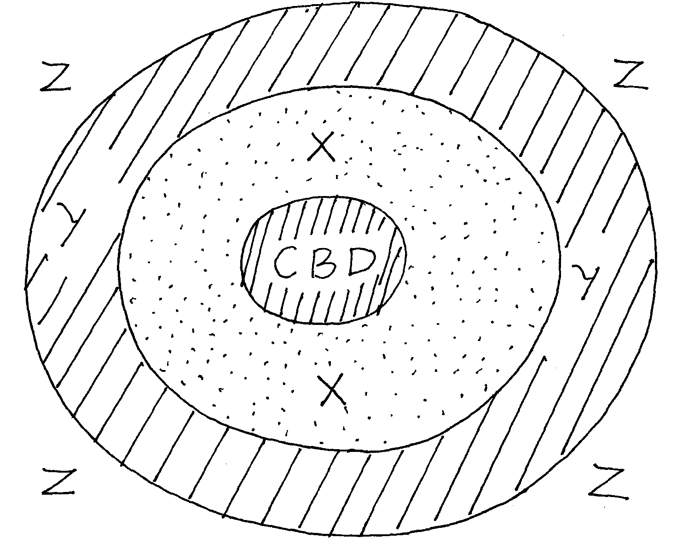
(c) Give three functions of Thika town. (3marks)
(d) Compare between the ports of Mombasa and Rotterdam under the following headings. (6marks)

(i) Transport links to the interior.
(ii) Mechanization of port.
(iii) The hinterland.
(e) (i) Name three types of settlement patterns. (3marks)
(ii) Explain how the following physical factors influence the location of human settlements. (8marks)
- Relief
- Climate
- Aspect
- Drainage and reliability of water supply.
- (a) (i) Differentiate between visible and invisible trade. (2marks)
(ii) Name two types of trade. (2marks)
(b) (i) State four economic benefits of COMESA to member countries. (4marks)
(ii) Name two major imports from Japan to Kenya. (2marks)
(iii) State four ways in which the government of Kenya may participate in trade. (4marks)
(iv) Explain four benefits that Kenya derives from international trade. (8marks)
(v) Name three member countries that make COMESA trading bloc. (3marks)
- (a) (i) Define fish farming. (2marks)
(ii) State three characteristics of fish farming in Kenya. (3marks)
(b) Study the diagram below and answer the questions that follow.
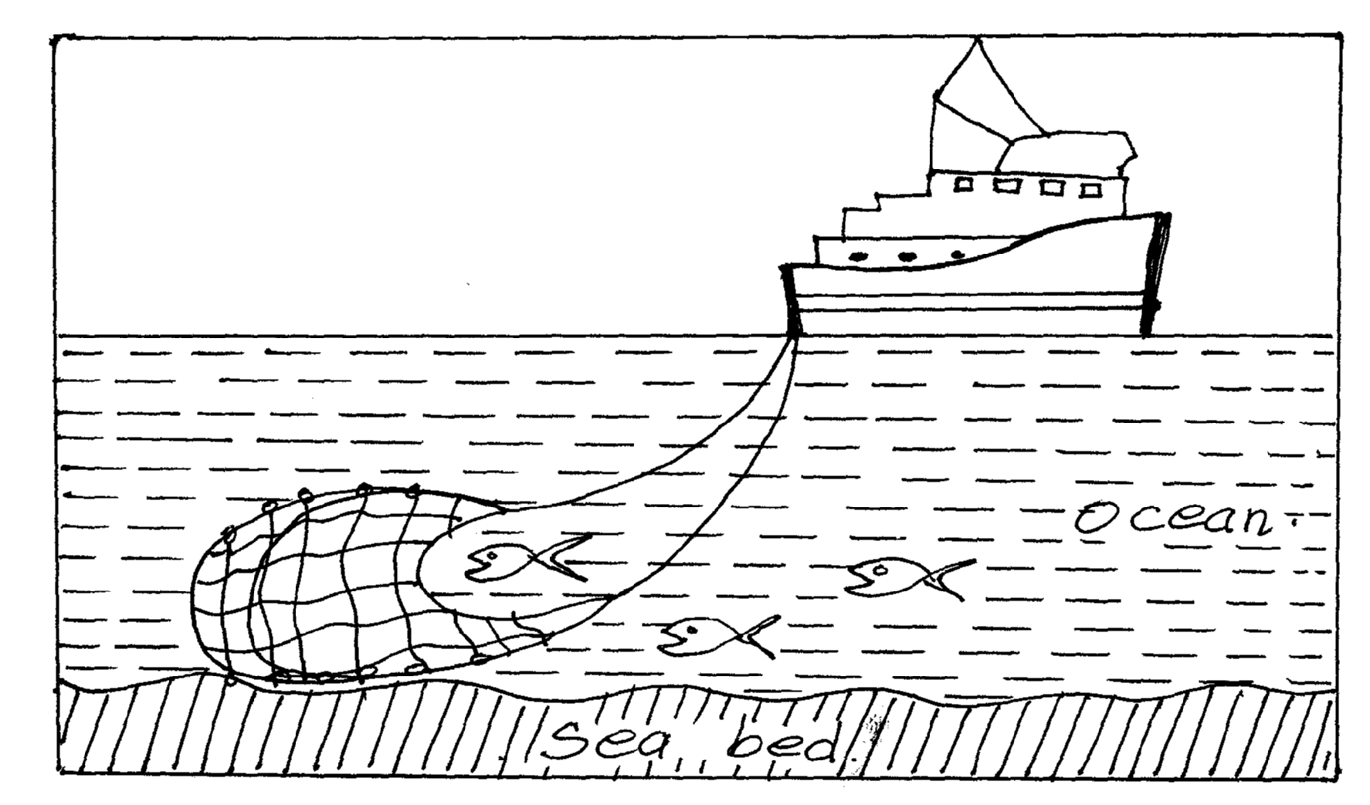
- Identify the above method of fishing. (2marks)
- Describe how the above fishing method is carried out in fishing. (5marks)
- Give three problems facing fishing in Japan. (3marks)
- Name two examples of crustaceans. (2marks)
(c) Explain four differences between fishing in Japan and in Kenya. (8marks)
- (a) (i) Give two appropriate examples of non-metallic minerals. (2marks)
(ii) Apart from soda ash, identify three other minerals mined in Kenya. (3marks)
(b) Describe diamond mining in Tanzania under the following headings. (6marks)
(i) Occurrence
(ii) Mining and processing
(iii) Marketing.
(c) Explain four factors to consider before exploitation of minerals is carried out. (8marks)
d) Students from your class decided to carry out a field work in a nearby mining centre and used photographing as a major method of data collection.
(i) Give three advantage of using photographs as a tool in collecting and recording data. (3marks)
(ii) State three importance of a working schedule in field work. (3marks)
….………………………………………………………………………………………………………………………………………………………………………………………………….………………………………………………………………………………………………………………………………………………………………………………………………….………………………………………………………………………………………………………………………………………………………………………………………………….………………………………………………………………………………………………………………………………………………………………………………………………….………………………………………………………………………………………………………………………………………………………………………………………………….………………………………………………………………………………………………………………………………………………………………………………………………….………………………………………………………………………………………………………………………………………………………………………………………………….………………………………………………………………………………………………………………………………………………………………………………………………….………………………………………………………………………………………………………………………………………………………………………………………………….………………………………………………………………………………………………………………………………………………………………………………………………….………………………………………………………………………………………………………………………………………………………………………………………………….………………………………………………………………………………………………………………………………………………………………………………………………….………………………………………………………………………………………………………………………………………………………………………………………………….………………………………………………………………………………………………………………………………………………………………………………………………….………………………………………………………………………………………………………………………………………………………………………………………………….………………………………………………………………………………………………………………………………………………………………………………………………….………………………………………………………………………………………………………………………………………………………………………………………………….………………………………………………………………………………………………………………………………………………………………………………………………….………………………………………………………………………………………………………………………………………………………………………………………………….………………………………………………………………………………………………………………………………………………………………………………………………….………………………………………………………………………………………………………………………………………………………………………………………………….………………………………………………………………………………………………………………………………………………………………………………………………….………………………………………………………………………………………………………………………………………………………………………………………………….………………………………………………………………………………………………………………………………………………………………………………………………….………………………………………………………………………………………………………………………………………………………………………………………………….………………………………………………………………………………………………………………………………………………………………………………………………….………………………………………………………………………………………………………………………………………………………………………………………………….………………………………………………………………………………………………………………………………………………………………………………………………….………………………………………………………………………………………………………………………………………………………………………………………………….………………………………………………………………………………………………………………………………………………………………………………………………….………………………………………………………………………………………………………………………………………………………………………………………………….………………………………………………………………………………………………………………………………………………………………………………………………….………………………………………………………………………………………………………………………………………………………………………………………………….………………………………………………………………………………………………………………………………………………………………………………………………….………………………………………………………………………………………………………………………………………………………………………………………………….………………………………………………………………………………………………………………………………………………………………………………………………….………………………………………………………………………………………………………………………………………………………………………………………………….………………………………………………………………………………………………………………………………………………………………………………………………….………………………………………………………………………………………………………………………………………………………………………………………………….………………………………………………………………………………………………………………………………………………………………………………………………….………………………………………………………………………………………………………………………………………………………………………………………………….………………………………………………………………………………………………………………………………………………………………………………………………….………………………………………………………………………………………………………………………………………………………………………………………………….………………………………………………………………………………………………………………………………………………………………………………………………….………………………………………………………………………………………………………………………………………………………………………………………………….………………………………………………………………………………………………………………………………………………………………………………………………….………………………………………………………………………………………………………………………………………………………………………………………………….………………………………………………………………………………………………………………………………………………………………………………………………….………………………………………………………………………………………………………………………………………………………………………………………………….………………………………………………………………………………………………………………………………………………………………………………………………….………………………………………………………………………………………………………………………………………………………………………………………………….………………………………………………………………………………………………………………………………………………………………………………………………….………………………………………………………………………………………………………………………………………………………………………………………………….………………………………………………………………………………………………………………………………………………………………………………………………….………………………………………………………………………………………………………………………………………………………………………………………………….………………………………………………………………………………………………………………………………………………………………………………………………….………………………………………………………………………………………………………………………………………………………………………………………………….………………………………………………………………………………………………………………………………………………………………………………………………….………………………………………………………………………………………………………………………………………………………………………………………………….………………………………………………………………………………………………………………………………………………………………………………………………….………………………………………………………………………………………………………………………………………………………………………………………………….………………………………………………………………………………………………………………………………………………………………………………………………….………………………………………………………………………………………………………………………………………………………………………………………………….………………………………………………………………………………………………………………………………………………………………………………………………….………………………………………………………………………………………………………………………………………………………………………………………………….………………………………………………………………………………………………………………………………………………………………………………………………….………………………………………………………………………………………………………………………………………………………………………………………………….………………………………………………………………………………………………………………………………………………………………………………………………….………………………………………………………………………………………………………………………………………………………………………………………………….………………………………………………………………………………………………………………………………………………………………………………………………….………………………………………………………………………………………………………………………………………………………………………………………………….………………………………………………………………………………………………………………………………………………………………………………………………….………………………………………………………………………………………………………………………………………………………………………………………………….………………………………………………………………………………………………………………………………………………………………………………………………….………………………………………………………………………………………………………………………………………………………………………………………………….………………………………………………………………………………………………………………………………………………………………………………………………….………………………………………………………………………………………………………………………………………………………………………………………………….………………………………………………………………………………………………………………………………………………………………………………………………….………………………………………………………………………………………………………………………………………………………………………………………………….………………………………………………………………………………………………………………………………………………………………………………………………….………………………………………………………………………………………………………………………………………………………………………………………………….………………………………………………………………………………………………………………………………………………………………………………………………….………………………………………………………………………………………………………………………………………………………………………………………………….………………………………………………………………………………………………………………………………………………………………………………………………….………………………………………………………………………………………………………………………………………………………………………………………………….………………………………………………………………………………………………………………………………………………………………………………………………….………………………………………………………………………………………………………………………………………………………………………………………………….………………………………………………………………………………………………………………………………………………………………………………………………….………………………………………………………………………………………………………………………………………………………………………………………………….………………………………………………………………………………………………………………………………………………………………………………………………….………………………………………………………………………………………………………………………………………………………………………………………………….………………………………………………………………………………………………………………………………………………………………………………………………….………………………………………………………………………………………………………………………………………………………………………………………………….………………………………………………………………………………………………………………………………………………………………………………………………….………………………………………………………………………………………………………………………………………………………………………………………………….………………………………………………………………………………………………………………………………………………………………………………………………….………………………………………………………………………………………………………………………………………………………………………………………………….………………………………………………………………………………………………………………………………………………………………………………………………….………………………………………………………………………………………………………………………………………………………………………………………………….………………………………………………………………………………………………………………………………………………………………………………………………….………………………………………………………………………………………………………………………………………………………………………………………………….………………………………………………………………………………………………………………………………………………………………………………………………….………………………………………………………………………………………………………………………………………………………………………………………………….………………………………………………………………………………………………………………………………………………………………………………………………….………………………………………………………………………………………………………………………………………………………………………………………………….………………………………………………………………………………………………………………………………………………………………………………………………….………………………………………………………………………………………………………………………………………………………………………………………………….………………………………………………………………………………………………………………………………………………………………………………………………….………………………………………………………………………………………………………………………………………………………………………………………………….………………………………………………………………………………………………………………………………………………………………………………………………….………………………………………………………………………………………………………………………………………………………………………………………………….………………………………………………………………………………………………………………………………………………………………………………………………….………………………………………………………………………………………………………………………………………………………………………………………………….………………………………………………………………………………………………………………………………………………………………………………………………….………………………………………………………………………………………………………………………………………………………………………………………………….………………………………………………………………………………………………………………………………………………………………………………………………….………………………………………………………………………………………………………………………………………………………………………………………………….………………………………………………………………………………………………………………………………………………………………………………………………….………………………………………………………………………………………………………………………………………………………………………………………………….………………………………………………………………………………………………………………………………………………………………………………………………….………………………………………………………………………………………………………………………………………………………………………………………………….………………………………………………………………………………………………………………………………………………………………………………………………….………………………………………………………………………………………………………………………………………………………………………………………………….………………………………………………………………………………………………………………………………………………………………………………………………….………………………………………………………………………………………………………………………………………………………………………………………………….………………………………………………………………………………………………………………………………………………………………………………………………….………………………………………………………………………………………………………………………………………………………………………………………………….………………………………………………………………………………………………………………………………………………………………………………………………….………………………………………………………………………………………………………………………………………………………………………………………………….………………………………………………………………………………………………………………………………………………………………………………………………….………………………………………………………………………………………………………………………………………………………………………………………………….………………………………………………………………………………………………………………………………………………………………………………………………….………………………………………………………………………………………………………………………………………………………………………………………………….………………………………………………………………………………………………………………………………………………………………………………………………….………………………………………………………………………………………………………………………………………………………………………………………………….………………………………………………………………………………………………………………………………………………………………………………………………….………………………………………………………………………………………………………………………………………………………………………………………………….………………………………………………………………………………………………………………………………………………………………………………………………….………………………………………………………………………………………………………………………………………………………………………………………………….………………………………………………………………………………………………………………………………………………………………………………………………….………………………………………………………………………………………………………………………………………………………………………………………………….………………………………………………………………………………………………………………………………………………………………………………………………….………………………………………………………………………………………………………………………………………………………………………………………………….………………………………………………………………………………………………………………………………………………………………………………………………….………………………………………………………………………………………………………………………………………………………………………………………………….………………………………………………………………………………………………………………………………………………………………………………………………….………………………………………………………………………………………………………………………………………………………………………………………………….………………………………………………………………………………………………………………………………………………………………………………………………….………………………………………………………………………………………………………………………………………………………………………………………………….………………………………………………………………………………………………………………………………………………………………………………………………….………………………………………………………………………………………………………………………………………………………………………………………………….………………………………………………………………………………………………………………………………………………………………………………………………….………………………………………………………………………………………………………………………………………………………………………………………………….…………………………………………………………………
THIS IS THE LAST PRINTED PAGE!

