NAME …………………………………………………..….. ADM NO…………….………..

SCHOOL …………………………………………………… DATE…………....…….……..

312/1
GEOGRAPHY
AUGUST/SEPTEMBER 2022
TIME: 2 ¾ HOURS

MINCKS GROUP OF SCHOOLS
FORM FOUR
KENYA CERTIFICATE OF SECONDARY EDUCATION (K.C.S.E)

INSTRUCTIONS TO CANDIDATES
- Write your name, class, school and admission number in the spaces provided.
- All your answers must be written in the spaces provided in your question paper.
- This paper consists of section A and B. Answer all the questions in section A, question 6 and any other two questions in section B.
- All answers must be written in English.

FOR EXAMINER’S USE ONLY

 | CANDIDATE’S SCORE | MAXIMUM SCORE
Section A
Question 6
Question 7
Question 8
Question 9
Question 10

TOTAL SCORE |  | 100
SECTION A
- (a) The diagram below shows the internal structure of the earth. Use it to answer question a (i).
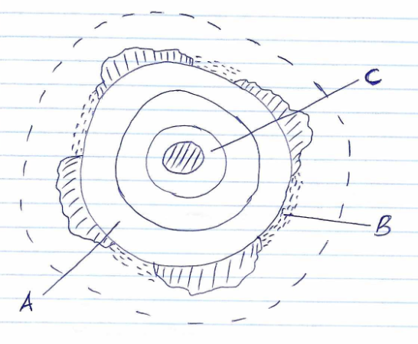
- Name the parts labeled A, B and C. (3marks)

- Mention two layers of disconuities found in the internal structure of the earth. (2marks)

- (a) Differentiate between soil catena and soil profile. (2marks)

(b) State three importances of soil water. (3marks)

- (a) Outline two types of river erosion. (2marks)

(b) State three factors influencing river transportation. (3marks)

- (a) Define an earthquake. (2marks)

(b) State three effects of earthquakes on built-up areas. (3marks)

- (a) What is a sea breeze. (2marks)

(b) State three effects of sea breeze on adjacent areas. (3marks)

SECTION B
- (a)(i) Give two types of scales used in map extract. (2marks)

(ii) Give the longitudinal extent of the map. (1mark)

(b) (i) Calculate the area of Nyeri Hill forest. (2marks)

(ii) Citing evidence, state the social function of Nyeri. (6marks)

(c) (i) Using a scale of 1cm to represent 40meters, draw a cross-section along Northing 57from grid reference 640570 to 700570 (4marks)

On it mark and label the following.
Boundary (1mark)

Dry weather road (1mark)

River Muringato (1mark)

- State two factors that have influenced trade in the area covered by the map. (2marks)

(d) Describe settlement in the area covered by the map. (5marks)

- (a) (i)What is vulcanicity. (2marks)

(ii) Apart from sill, name three other intrusive features. (3marks)

(b) The diagram below shows a composite volcano.

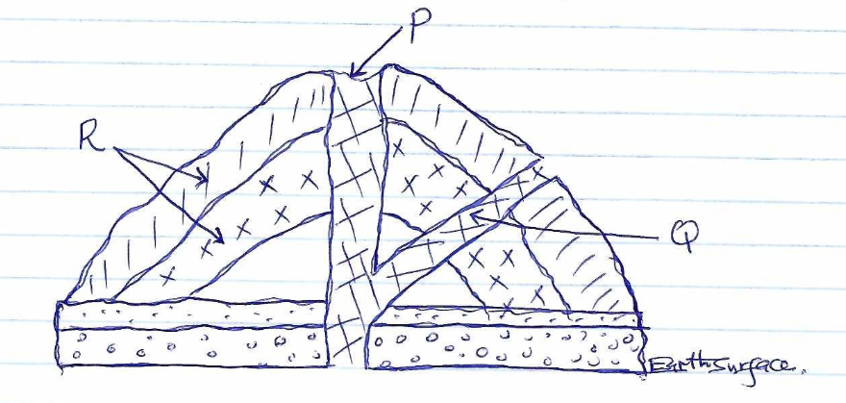
- Name the features marked P, Q, and R. (3marks)

- State three characteristics of the above volcano. (3marks)

(c) You are required to carry out a field study in a region affected by vulcanicity.
i) State three objectives you would formulate for the study. (3marks)

- Apart from preparing a route map, how would you prepare for the field study. (3marks)

(d) Explain four significances of vulcanicity to human activities. (8marks)

- (a) (i) Differentiate between a mineral and a mineral ore. (2marks)

ii) Describe the following characteristics of minerals;
Colour (2marks)

Lustre (2marks)

Density (2marks)

(b) (i) Name two examples of plutonic rocks. (2marks)

(ii) Explain how mechanically-formed sedimentary rocks are formed. (4marks)

- Name the type of rock which results from the metamorphism of:
Clay (1mark)

Coal (1mark)

Limestone (1mark)

(c) Explain four benefits of rock in the economy of Kenya. (8marks)

- (a) What is weathering? (2marks)

(b) (i) State three agents of weathering. (3marks)

(ii) Describe how block disintegration occurs. (5marks)

(c) Explain how the following factors influence weathering
(i) Time (2marks)

(ii) Nature of the rock (3marks)

(iii) Action of plants. (2marks)

(d) Your class decided to carry out a field study on the area affected by weathering around your school.
(i) State three reasons for seeking permission. (3marks)

(ii) Give three methods you would use to collect data. (3marks)

(iii) State two follow up activities you are likely to engage in after the study. (2marks)

- (a) Name three types of glaciers. (3marks)

(b) (i) Explain three processes in which glacier erodes. (6marks)

(ii) The diagram below shows features resulting from glaciation.
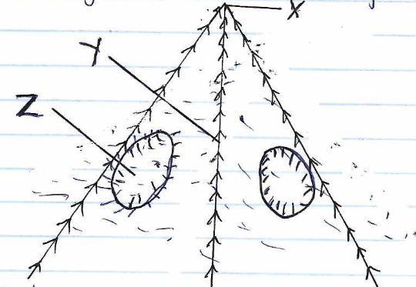
Name the features marked X, Y and Z.

(c) (i) Name three types of glacier moraines. (3marks)

(ii) List three depositional features on glaciated lowlands. (3marks)

(d) Explain four positive effects of glaciation. (8marks)

