OPENER EXAMS
GEOGRAPHY FORM FOUR
TERM ONE 2023
(MARKING SCHEME)

- a) Mathematics principles/formulae are used in Geography to calculate distances or area
or population density
- Geography information can be analyzed or presented accurately through the application of mathematical techniques
- Geographical concepts are applied in calculating certain concepts in mathematics
(1x2)
b) Geography focuses on physical study of the earth. We are therefore able to learn and
explain the origin of the earth and the solar system
- Geography creates awareness in the people on the significance of management and conservation of the environment, and the need to use resources sustainably
- Geography is a career subject. It provides a firm foundation for advanced studies in specialized fields like engineering, surveying, remote sensing and meteorology, urban planning, agriculture, forestry and fisheries.
- In learning Geography, one is able to acquire basic skills and knowledge, which contribute to local, regional and national development (1x3)

- a) The solar system is a system/an organization in the universe made up of the sun, the
the planets and other heavenly bodies

b) Difference in degrees: 60⁰ + 37⁰ = 97⁰
10 = 4’ 97x4 = 388 minutes 1 hr = 60’
Thus 388 ÷ 60 = 6 hrs 28 min
Time’ = 11.30 a.m + 6 hrs 28 min = 1758 hrs
5.58 pm
- a) – Horizontal/Lateral/Orogenic earth movement
- Vertical /epeirogenic movement

b) Jig-saw fit
Paleo climate
Sea floor spreading
Red sea trough
Tectonic evidence
Paleomagnetism
- a) It is the shaking/trembling of the crustal rocks caused by shock waves that originate
below the surface of the earth
b) i) Mercalli scale
ii) Ritcher scale
iii) Violent earthquakes motions damage structures from their foundations leading to loss of life and property
- Earthquakes form faults which damage infrastructure
- Earthquakes may cause landslides which destroy agricultural land, disrupting human activities
- a) It is the continuous interchange of water in a cycle between water bodies, land and the atmosphere

b) Alluvial fans
- Flood plains
- Meanders
- River braids
- Deltas

6 (a) The table below shows climatic figure for station Q. Use it to answer the questions that follow.

Months | J | F | M | A | M | J | J | A | S | O | N | D
Temp in ⁰C | 30 | 31 | 31 | 29 | 27 | 27 | 28 | 29 | 28 | 28 | 27 | 30
Rainfall in mm | 257 | 246 | 231 | 234 | 207 | 201 | 218 | 227 | 234 | 240 | 235 | 230

(i) Calculate the annual range of temperature for station Q. (2 marks)

$= {31}^{0}C-{27}^{0}C$
$= 4^{0}C$

(ii) Outline four characteristics of climate in station Q. (4 marks)
  - The station experiences high temperatures.
  - Highest temperature is 31⁰C/the lowest temperature is 27⁰C.
  - The annual range of temperature is 4⁰C/the station has a low range of temperature.
  - The station experiences high rainfall/2760mm.
  - The station experiences rainfall throughout the year/there is no dry month.
  - Lowest rainfall is experienced in May and July when temperature is also lowest.
  - The station has one rainfall maxima regime. (Any 4x1mk =4mks)

(d) With the aid of a well-labelled diagram, describe the formation of cyclonic rainfall. (6 marks)
- It occurs where two airmasses meet one warm and moist and the other cold and dry.
- It is the meeting point of cold, heavy dry polar easterlies and warm, light and moist north/south westerlies.
- The meeting of the air masses forms a front.
- When the two air masses meet along the front, the warm lighter westerly, winds
- rises over the cold polar air.
- Since it is moist, the air condenses forming clouds.
- The clouds become heavy enough, eventually falling as cyclonic rain through the cold air.
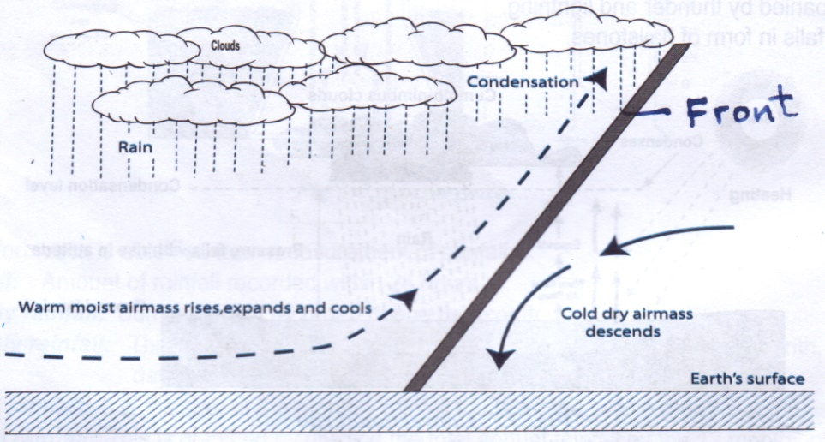
Text – 4 marks
Diagram – 2 marks
TOTAL- (6 marks)

(e) You intend to carry out a field study of a weather station in your school.
- Give two methods of recording data that you are likely to use. (2 marks)
- Filling in questionnaires
- Labelling of samples
- Note taking
- Taking photographs
- Sketching diagrams
- Tabulation (Any2x1mk = 2mks)

(ii) State three reasons why the recording of data at a school weather station may be inaccurate. (3 marks)
- Human error.
- Interference with the instruments by animals and people.
- Poor siting of a weather station.
- Extreme weather conditions.
- Natural calamities i.e. landslides.
- Use of defective instruments. (Any 3x1mk = 3mks)
8. (a) Three types of faults (3marks)
- Normal
- Reverse/ thrust/ low angle over thrust
- Tear / shear / transform
- Anticlinal fault (Any 3x1mk = 3mks)
Total = 7 mks
(ii) Two examples of Horst Mountains in east Africa (2 marks)
- Pare
- Usambara
- Ruwenzori (Any 2 x 1 = 2 marks)
ks)

