Term 2 - 2022
GEOGRAPHY
(MARKING SCHEME PAPER 2 ) FORM FOUR
TIME: 2 3/4 HOURS
Name: …………………………………………………………. Adm No: ………………. School: ……………………………………………………….. Class: …………………..
Signature: …………………………………………………….. Date:

1. Apart from fishing name two other economic activities that are practiced along the East African coastal waters (2mks)
- Tourism
- Transportation
- Farming/irrigation
First 2 x 1 = 2 marks
b) Identify three methods of fishing from are used for deep area fishing (3marks)
- Trawling
- Long line
- Purse seining
- Drifting
First 3 x 1 = 3 marks
2a) Give physical tourists attractions found in the western region of Kenya (3marks)

- Wildlife in Ruma National Park / Impala Sanctuary / bird sanctuary at orange / Kakamega forest
- Lake Victoria • Forests
- Granitic tours
- Museum/ mausoleums
- Hot sunny weather
- Sport / fishing activities/water sports
Any 3 x 1=(3marks)
- Islands
- Escarpment
- Historical monuments
- Beaches
- Water falls
- Hot springs
- Rivers
- Cultures of the local communities

b) State two reasons why domestic tourism is encouraged in Kenya (2 marks)
- For people to appreciate the need to preserve wildlife / culture
- To utilize tourist facilities during low tourist season • For the people to appreciate the tourist attraction features
- To earn revenue especially during the low tourist seasons.
- Create employment
- For education /research
- Enhance national unity
- Provide market for local products
- Earn incomes
- Enhance circulation of mercy in the country
3a) State two human problems facing HEP projects in Africa (2marks)
- The absence of the skilled personnel
- The high cost of purchase and maintain of the machines
- The high rate of corruption
- The drastic technological advancements
b) State three physical factors that have favoured high hydro-electric power production in Uganda (3marks)
- Large volume of water form River Nile / other rivers /Lake Victoria
- The owe n falls / natural waterfall for power generation
- High rainfall/1000 mm throughout the year to enable high volume of water
- Regular supply of water from permanent rivers / lakes
- Presence of non-porous rock that prevent leakage of water
- Hard basset rock
- Deep valley / gorges
First 3 x 1 = 3 marks
4a) Give two trading blocks in Africa (2marks)
- Common Market for Eastern and Southern Africa (COMESA)
- Southern African Development Community (SADC)
- Economic community of West African State (ECOWAA)
- East African community (EAC)
 | CEN –SAD  IGAD  ICCAS |  | SACU  WAEMU/ UEMUA  CEMAC
- UMA / UMU
Any 2 x 1= 2 marks
b) Identify three political problems facing regional trading blocs in Africa (3marks)
- Civil wars / insecurity in some countries
- Political differences among leaders • Negative publicity of goods among countries • Inadequate institutional / policy framework.
- Ideological differences among some countries
- Many African countries are still aligned to the form of colonial masters
First 3x1= 3marks
5. a) Name two towns in Kenya where motor vehicle assembling plants are located
(2marks)
- Nairobi
- Mombasa • Thika.
( first 2x1=2 marks )
b) List three risks associated with the use of motor vehicles (3marks)
- Air pollution / Toxic gas • Accidents
- Fires • Noise/sound pollution
- Oil spills / water pollution • Diseases
- Deaths
Any 3 x 1 = 3 marks

SECTION B
Answer Question 6 and any other TWO Questions in this Section.
6. The photograph below shows cattle rearing in an area in Kenya. Use it to answer the following questions;
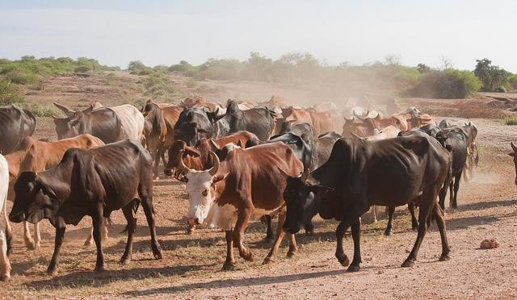
- (i) Name the type of photograph shown above (1 mk)
• Ground general view photograph
NB: Deny GROUND PHOTOGRAPH
  - What economic activity is carried out in the area shown by the photograph? (1mk) • Pastoralism/cattle rearing
  - Give three counties where the economic activity you identified in (ii) above takes
place in Kenya. (3marks)
    - Kajiado
    - Samburu
    - Isiolo
    - Marsabit
    - Turkana
( First 3x1= 3marks )
  - Draw a rectangle measuring 16cm by 9cm to represent the area of the photograph.
On it sketch and label the main features shown on the photograph (5 marks)
- (i) From the photograph, give two indicators showing that the area is experiencing
drought-like conditions.  - Bare ground  - Scattered vegetation  - Shrubs  - Cloudless sky | (2 marks)
(ii) Name two exotic breeds of dairy cattle reared in Kenya.  - Ayrshire  - Jersy  - Guernsey  - Friesian  - Alderney  - Brown Swiss  - Sahiwal | (2mark)
c) State three physical factors which favour dairy farming in Kenya.  - Low/Cool temperatures  - High rainfall  - Volcanic soils  - Pastures | (3 marks)
d) Explain four benefits of dairy farming to the economy of Kenya. | (8 marks)
  - Employment- the sector has provided opportunities in milk processing plants and related activities
  - Development of industries- industries that deal with milking cans, animal feeds, and pesticides are supported by the sector. The sector also provided s raw materials for the development of industries
  - Source of energy- biogas is generated from the cow dung which is in turn used for lighting and cooking
  - Provides manure- cow dung from dairy animals is used to make manure improve
  - Earns foreign exchange- the dairy products
  - Provision of proteins, fats and vitamins which s essential fo human health.
7a) State four factors that influence the occurrence of minerals (4marks)
  - Vulcanicity leads to the solidification of minerals in cracks and crevices
  - Metamorphism leads to change into new mineral/formation of minerals
  - Leaching into the concentration of minerals in the crust
  - Erosion loosens minerals and transports them eventually depicting them as alluvial deposits
  - Sedimentation deposits, accumulates and concentrates minerals in specific areas making them occur in layers, beds, and seams
  - Evaporation enhances crystallization leading to the formation of salts
  - Weathering exposes minerals near the earth’s surface.
Any 4 x 1 = 4 marks
- Describe the open cast method of mining? ( 5marks)
  - The mineral deposits lie within a few metres from the ground
  - The unwanted material on the top layer/overburden is removed
  - Soft mineral deposits are removed by drilling/scooping • Hard minerals are removed by blasting with explosives
  - The mineral is then scooped by an excavator
  - The mineral is loaded into lorries to be transported for processing
Any 5 x 1 = 5 marks
- Study the map below and answer the questions that follow
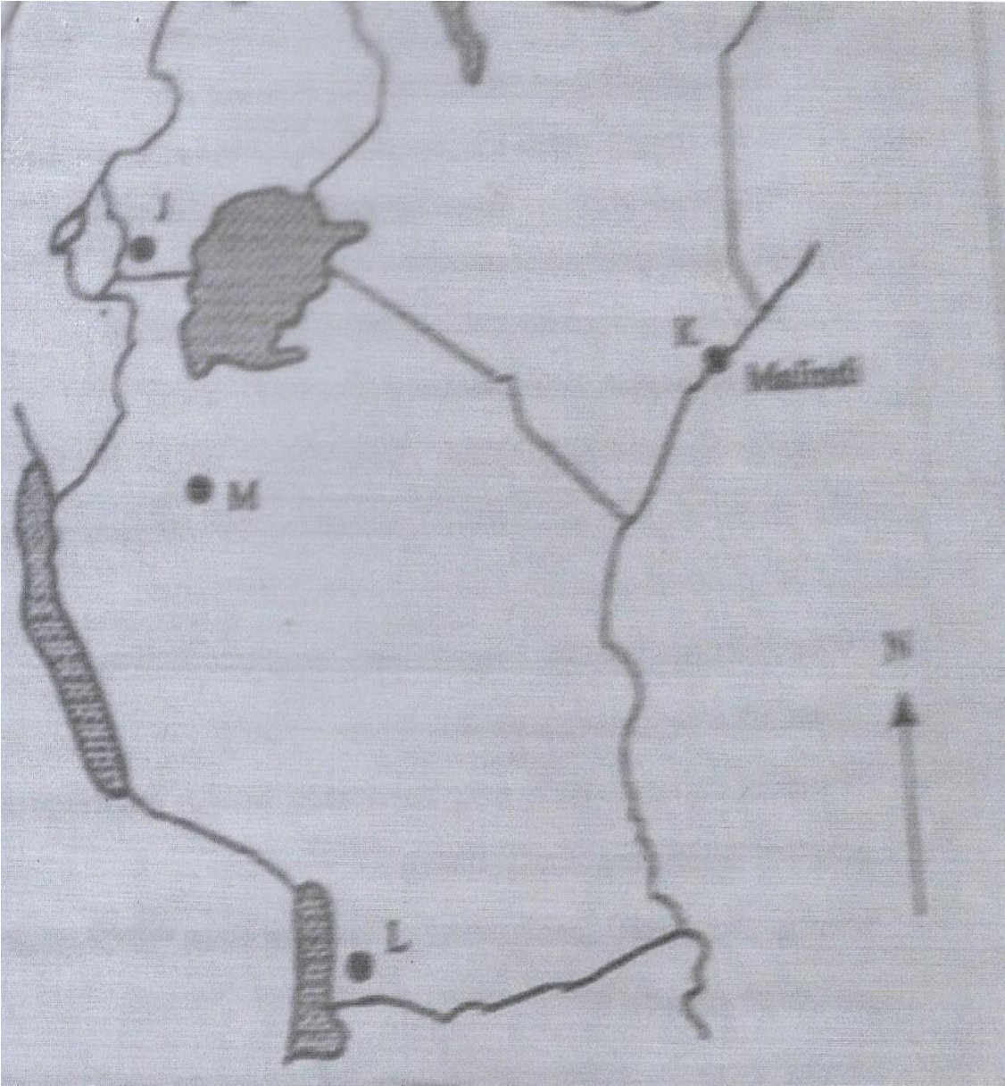
- Name the mineral found in areas marked I, K, L, and M (4marks)
J-Tin
K-Salt / limestone
L-Coal
M-Diamond

7d) Explain three ways in which mining promotes industrialization in Kenya (6marks)
  - Some minerals provide the essential raw material for some manufacturing industries
  - Minerals are exported to earn the country foreign exchange which is used for the development of industries
  - Mining stimulates the development of broads /railways which promotes industrial growth/ease movement of finished products
  - Mining attracts settlements of towns which attract industrial development
  - Mining creates employment raising the living standards of the people hence, creating a greater demand for industrial products thus promoting industrial growth
  - Stimulated growth of the related industries that supply inputs Any 3 x 2- 6 marks
7. ( e) Students carried out a felid study about rocks and minerals
i) State three problems they are likely to undergo during the field study (3marks)
  - Adverse weather condition
  - Inaccessibility of some areas
  - Students may fall off the rocks
  - May be attacked by wild animals such as snakes
First 3x1=3marks
- Give the follow-up activities they will undertake (3marks)
- Group discussions
- Photo display
- Displaying the samples
- Writing reports
- Presenting the data collected
Any 3x1= 3marks
8 (a) Define the term forestry (2marks)
Forestry is the science of developing and cultivating forests and utilizing them
(ii) Apart from tropical hardwood forest, name three other types of natural forests
(3marks)
- Temperature hardwood
- Coniferous forests / temperate softwood
- Montane forest
- Mangrove forest
Any 2 x 1= 2 marks
iii) State the problems experienced in the exploitation of tropical hardwood forest (4marks)
- Trees take a long time to mature
- Different trees species are clustered in one area making moments difficult
- Trees mature at different times making harvesting difficult and expensive
- The forest has mixed tree species making exploitation difficult and almost impossible
- Tree trunks are huge, supported by buttress roots hence difficult to exploit
- The trees are heavy/bulky making transportation difficult
- Impossible roads
- Hot / humid climate
- Attacks by wild animals
- Tree climbers
(Any 4x1= 4marks)
8b) List the characteristics of planted forests in Kenya (5marks)
- Trees appear in rows
- They have same species
- There are mainly softwoods
- They have little /no undergrowth
- They take time to mature
- They appear in blocks / same height
- Mainly located in high areas
- Scientifically managed • Are five monitored
Any 5 x 1 = 5 marks
- c) Explain three factors that favour forests in Canada (6marks)
  - The valley bottoms along the coast form suitable sites for the location of paper mill clay for smothering paper surface
  - There are many rivers with waterfalls suitable for the generation of hydro-electric power for use in the industries
  - The low temperature in the highlands discourage settlement leaving forestry as the only land use
  - The landscape is rugged with thin soils that discourage agriculture/activities therefore most of the mountain slopes are under forests
  - High precipitation throughout the year favours luxuriant growth of forests
  - Presence of rivers which provide cheap water transport to transport logs to factories / snow which facilitates movement of logs
  - There is ready market of forest products in Canada and USA
Max 3 x 2 = 6marks
d)Give five measures that the government has taken to conserve and manage forests in
Kenya (5marks)
  - it has enacted laws to prohibit the cutting of trees without a license / protecting indigenous trees
  - It has established forest research stations to conduct research on their species
  - The green belt movement / encourages protection of threatened forests • It encourages people to use energy-saving jikos.
  - It encourages people to use an an alternative source of energy
  - The tree planting programmes drawn during the rainy season and implemented
  - Forests are protected by establishing forest guards. the Development of Nyayo tea zones
(First 5x1=5marks)
- a Describe the following (i) Mulching (4marks)
  - This is the use of crop residues such as vegetable remains / plant litters /grass/polythene sheets to cover the soil/crop
  - It helps to retain soil moisture, reduce soil erosion, and reduce the splashing effect of rainwater on soil
  - It increases water infiltration into the soil by preventing it from surface runoff
  - When the vegetative materials decompose it produces organic matter which increases the fertility of the soil.
Any 2 x 2 = 4 marks
ii)Bunds and gabions (6marks)
  - Bunds are soil piles across a slope constructed to control soil erosion
  - Bunds are also built to check surface runoff which would cause soil erosion / influence water infiltration
  - Gabions are wire mesh that are filled with soil, stones and other materials
  - Gabions are constructed on slopes /across gullies to trap soils being carried by running water downslope
  - Gabions encourage vegetation growth ion the trapped soil.
  - They are effective for controlling soil erosion
Any 3 x 2= 6marks
b) Give three ways in which the government of Kenya is trying to rehabilitate overgrazed lands in Kenya (3marks)
- livestock extension officers move around advising farmers on the importance of keeping livestock according to the carrying capacity of the land
- introducing exotic breeds /cross breeds to emphasize quality and not quantity
- it has established / encouraged establishment of ranches in the livestock keeping regions to improve quality of animals
- it has encouraged farmers to grow fodder / introduced nourishing grass which is drought resistant any 3 x 1 = 3 marks
c (i) State examples of irrigation methods commonly used in Kenya  - Use of lifting devices  - drip irrigation  - overhead sprinkler irrigation  - furrow canal irrigation  - flood / basin irrigation • trickle irrigation any 4 x 1= 4 marks | (4marks)
ii)Explain two conditions that favour irrigation farming in Kenya | (4 marks)
- Gently sloping land which permits flow of water by gravity hence reducing pumping of water to the fields.
- Presence of clays soils / black cotton soils which retain water for longer use by crops
- Presence of rivers / reservoirs / lakes which provide regular water supply making it possible to irrigate land
- Government policy to develop irrigation scheme t
- Efficient transport that easen movements of goods
- High temperatures throughout the year which allows multiple cropping /continuous farming activities throughout the year
- Market that stimulates production
- Large tracks of land for expansion
- Low rainfall makes irrigation necessary
- Low population hence low costs of resettlement
( First 2x2=4 marks )
9d) Give the characteristics of land reclamation in Kenya (4marks)
- Simple methods of reclaiming land are used like digging canals / ditches to drain water
- Land is reclaimed mainly from swamps / marginal lands
- Irrigation is used where there is low rainfall / in arid areas
- Drought resistant crops are planted
- There is high evaporation of irrigation water due to high temperature
- Trees are planted
Any 4 x 1 = 4 marks
10a) Describe the characteristics of population of the two countries as represented by the
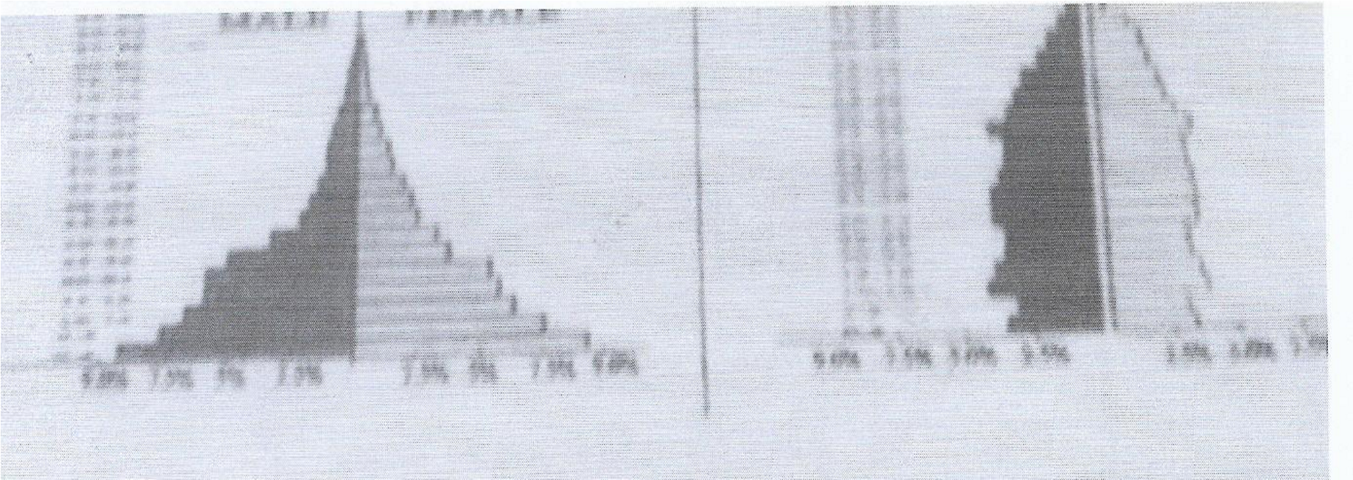
pyramids

(6
marks
)

•
In Kenya the fertility is high
•
In both Kenya and Sweden the number of male and female is almost equal at all ages
•
In Kenya the aging population is low that’s low life expectancy.
•
In Sweden the ageing population is higher due to high life expectancy.
•
In Kenya the dependency ratio is high.
•
In Sweden the dependency is low
•
In Kenya, the number of infants form age 0 to
4
years is high in Sweden the no of infants
from 0 to 4 years
•
In Kenya the working population is low, in Sweden its moderate
•
In Kenya, the number of youthful populations is high. in Sweden the number of useful
populations is
•
In Kenya birth rate is high
- In Sweden both rate is low
- In Kenya the death rate is high
- In Sweden death rate is low
10 b(i) What is the meaning of fertility rate? (2 marks)
- Fertility rate is the number of live births in a given population in a year
ii)Explain three factors that have contributed to the reduction in fertility rate in Kenya
(6marks) • The cost of bringing up children has gone up therefore parents limit the number of children they can have
- Increased use of birth control methods has lowered the number of children women get in their life time
- More girls are attending school / are pursuing higher education and training. this makes them stay longer before getting married
- Modern career opportunities have a limiting influence on a woman’s fertility rate. Some employers do not want to employ women who keep going on maternity leave
- There is an increase in the number of women opting to remain single, thus reducing the number filling
- Urbanization has influenced people to have small families
10 c) State three problems caused by slow population growth rate in developed countries
(3marks)
- The social amenities are underutilized/high cost of maintenance
- There is inadequate labour supply / manpower
- The dependency ratio is high in old age
- Here is reduction revenue collection
- There is under exploration of resources
- There is inadequate local market for the locally produced goods
- There is limited defense
- There is limited investment
- There is high cost of transport / service
10d) Explain four causes of rural – rural migration in Kenya (8marks)
- People move from one rural area to another in search of employment
- Insecurity in some rural areas make people move to safe places
- Pressure only and makes people buy / look for land elsewhere and settle
- Setting up of government development projects may cause displacement of people who are settled elsewhere / government projects may attract settlement in those areas
- Pastoral communities migrate from one rural area to another in search of pasture / water for their livestock
- Changes in land tenure system / inheritance e/land disputes cause people to move and settle elsewhere
- Natural calamities makes people to move to safer places
- Transfer of services form one rural area to another

