Term 2 - 2022
GEOGRAPHY
(MARKING SCHEME PAPER I ) FORM FOUR
TIME: 2 3/4 HOURS
Name: …………………………………………………………. Adm No: ………………. School: ……………………………………………………….. Class: …………………..
Signature: …………………………………………………….. Date

1. | (a) | Name the first two planets of the solar system.   Mercury
 |  | ▪ Venus | 1×2=2 marks
 | (b) | State three effects of the rotation of the earth on its axis.  - occurrence of day and night  - rising and falling of ocean tides  - deflection of winds and ocean currents
 |  | ▪ difference in time at different longitudes | 3×1=3 marks
2. | (a) | The diagram below shows the angles of the sun’s rays at different altitudes when the sun is overhead at the equator. Use it to answer question (a) and (b).  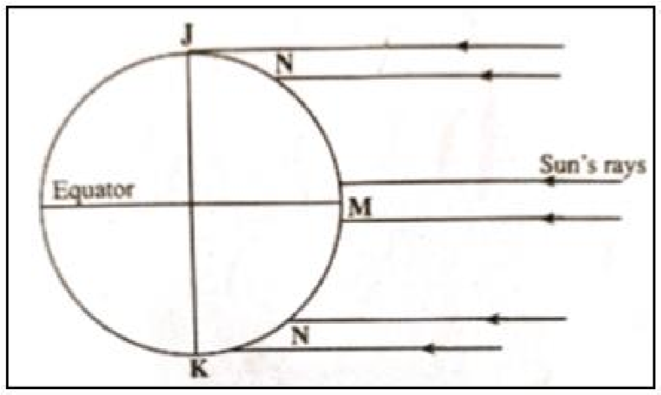  Name the parts of earth’s surface marked J and K.
 |  | - J – north pole  - K – south pole | 2×1=2 marks
 | (b) | Give two reasons why the intensity of insolation is higher at M than at N.   there is higher concentration of heating at M than N because the surface area is smaller at M than N
 |  | - the angle of inclination of the sun’s rays at M is higher than at N  - at N the rays travel over a longer distance compared to M | 3×1=3 marks
3. | (a) | Identify the temperate grasslands found in the following countries. (i) Canada – prairies  (ii) Russia – steppes
 |  | (iii) Australia – downs | 3×1=3 marks
 | (b) | Give two reasons why the Tundra region has scanty vegetation.  - the ground is frozen most of the year  - the area has thin soils  - the area has short summers/growing period
 |  | ▪ some parts are poorly drained | 2×1=2 marks
4. | (a) | Identify two sources of water found in a lake.  - rainwater  - rivers
 |  | - underground water  - glacial melt water | 2×1=2 marks
 | (b) | Give three ways through which lakes are formed.  - erosion  - earth movements  - vulcanicity  - human activities  - weathering
 |  | ▪ mass movement | 3×1=3 marks
5. | (a) | Give three factors that determine soil leaching.  - solubility of minerals  - amount of rainfall
 |  | - nature of the soil  - nature of slope | 3×1=3 marks
 | (b) | State three ways in which mulching helps in soil conservation.  - protects the soil from erosion  - increases the humus content of the soil
 |  | - increases the rate of infiltration of water into the soil  - reduces water loss/evaporation from the soil | 3×1=3 marks
6. | (a) | (i) Identify two map sheets to the eastern part of Nyeri.  - Karatina – 121/3  - Naro Moru – 121/1
 |  | ▪ Fort Hall (Muranga) – 135/1 | 2×1=2 marks
 |  | (ii) Name two administrative units found in Nyeri.  province
 |  | ▪ district | 2×1=2 marks
(iii) Calculate the magnetic declination of the area covered by the map as at 1978.
- as at 1975 – 1⁰31’
- 1978 – 1975 = 3 years
- annual change is 5’ East →(3×5’) = 15’
 |  | ▪ 1978 → 1⁰31’- 15’= 1⁰16’ | 3×1=3 marks
 | (b) | (i) Give three types of natural vegetation found in the area covered by the map.  - bamboo  - forest  - woodland
 |  | ▪ scrub | 3×1=3 marks
(ii) Measure the length of the road D 432 in the southern part from
Unjiru junction to Kangaita market. Give your answer in kilometers.
 |  | ▪ 4.1±0.1 km | 1×2=2 marks
 | (c) | Using a vertical scale of 1cm to represent 50 metres;  (i) Draw a cross section from grid reference 680630 to 730650.
(ii) On the cross section, mark and name the following;
- Hill
- River
- Road D 449
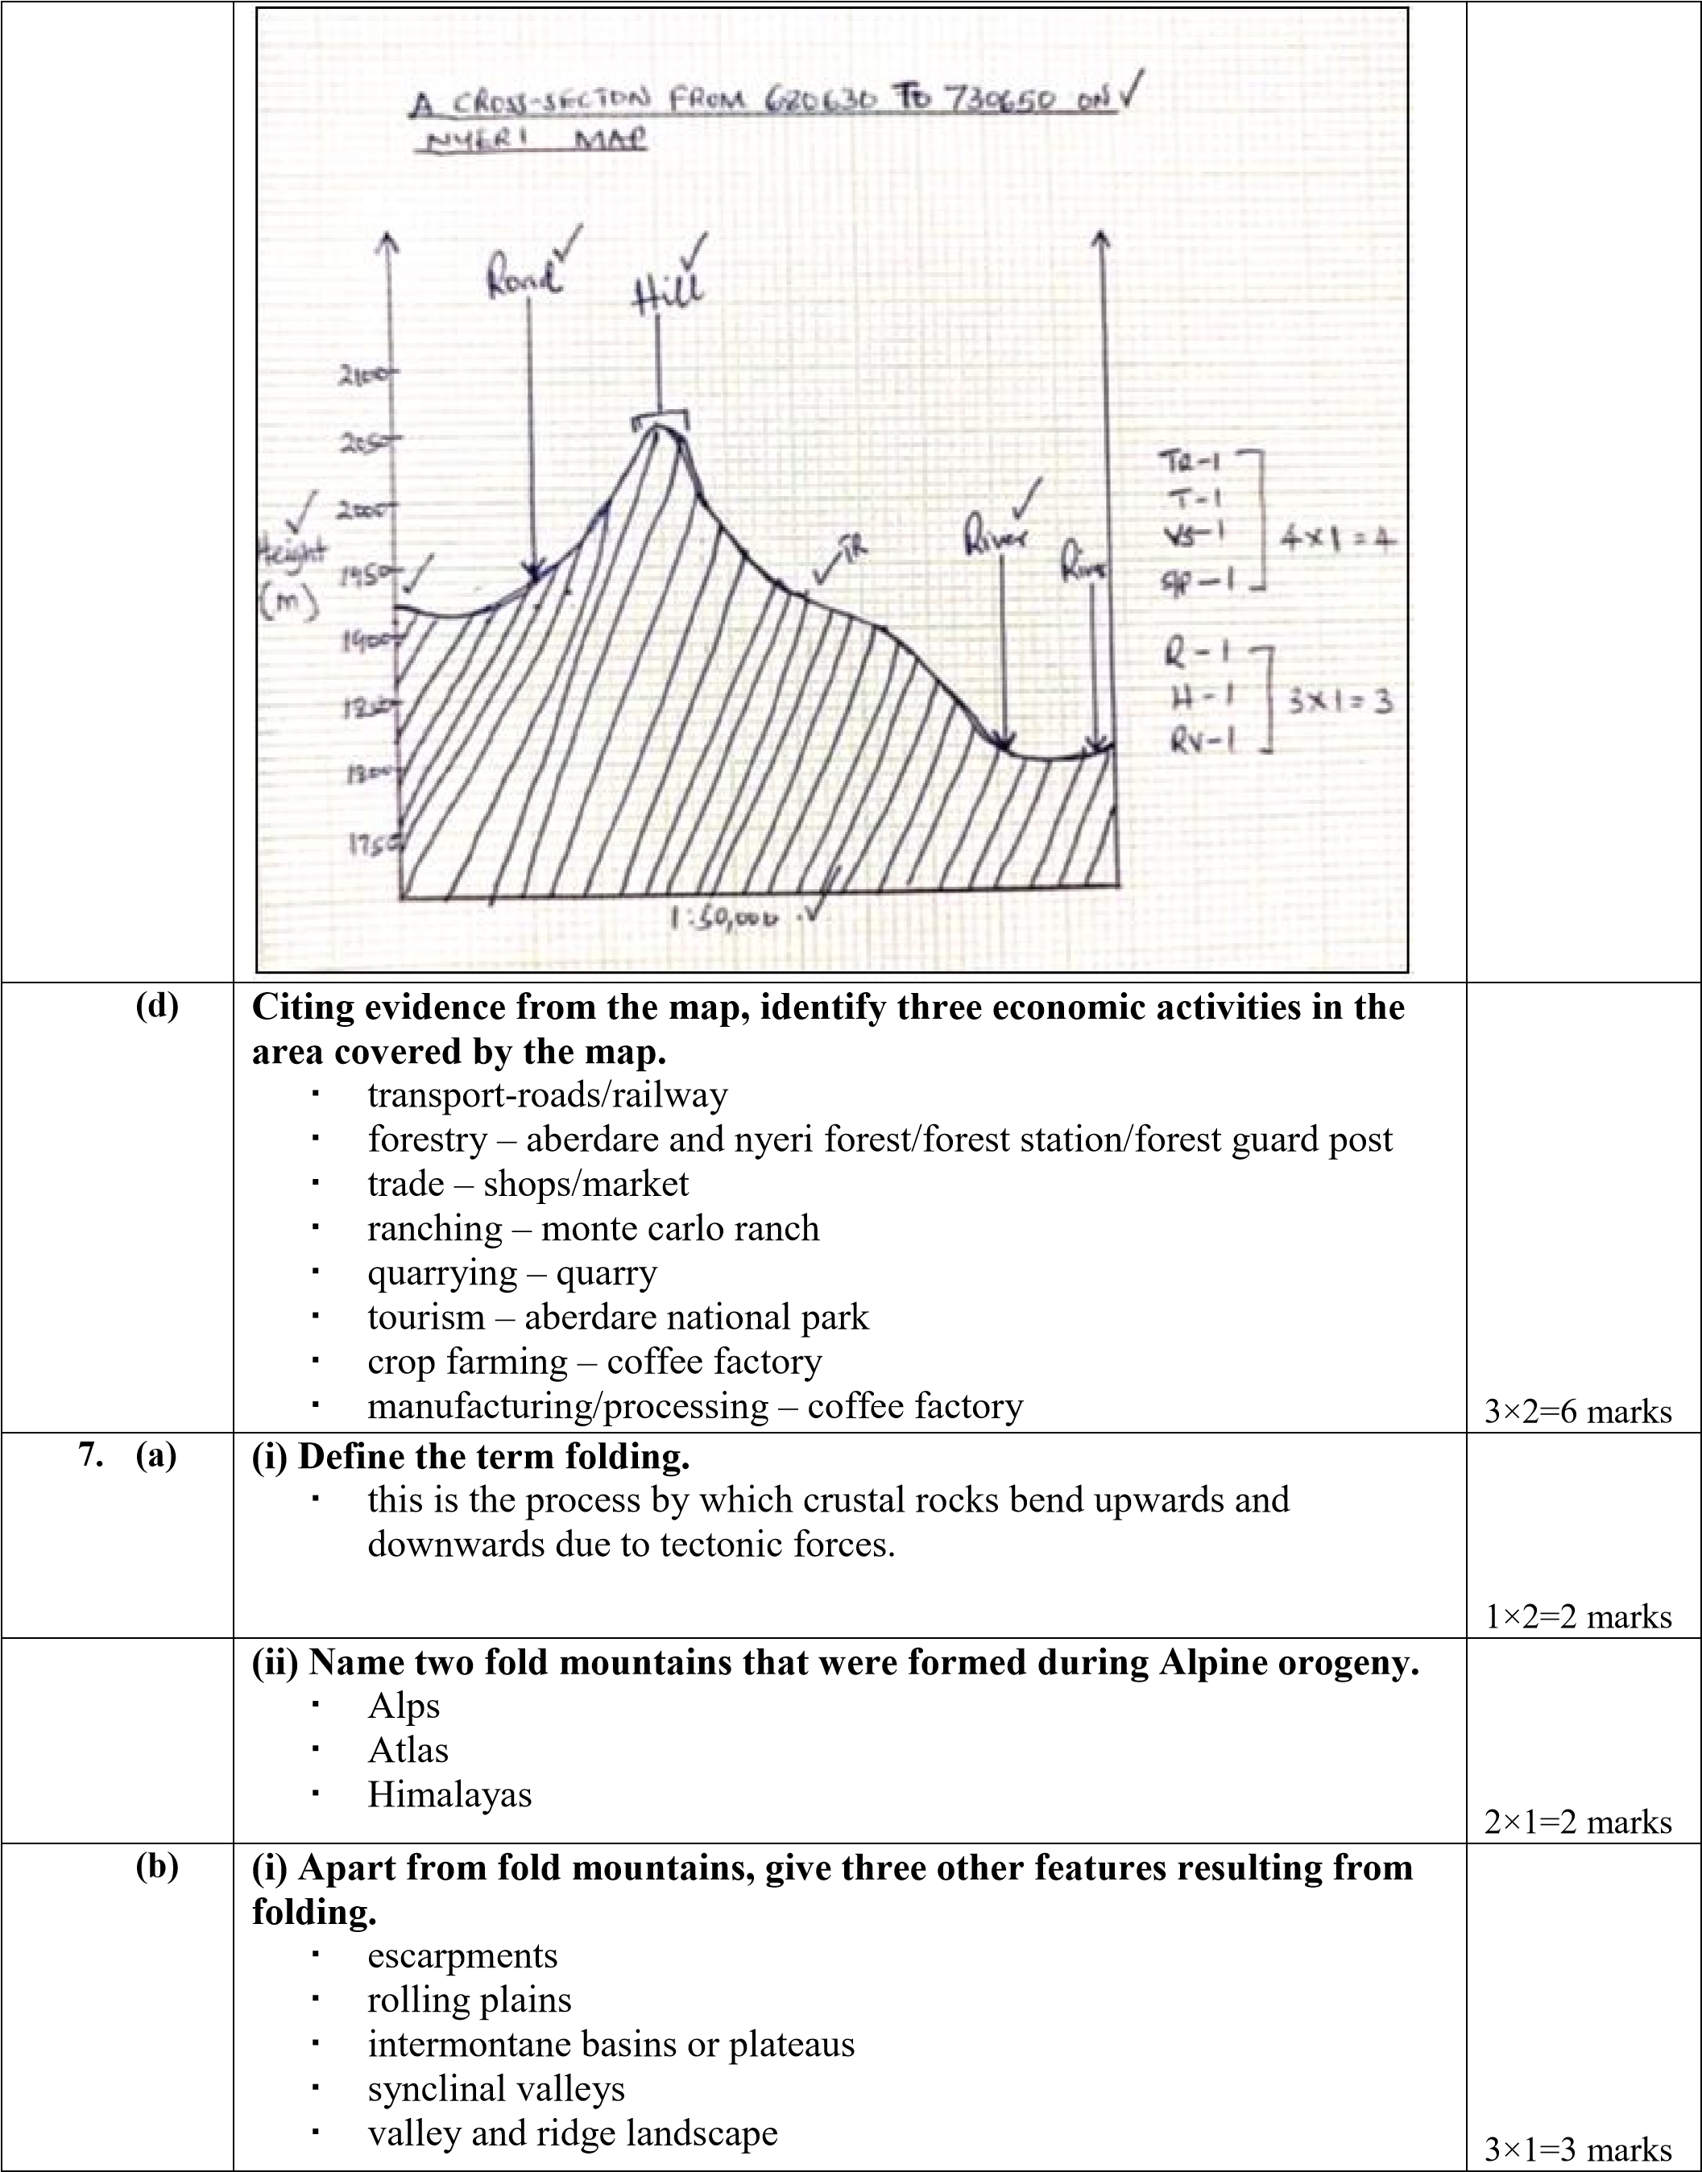

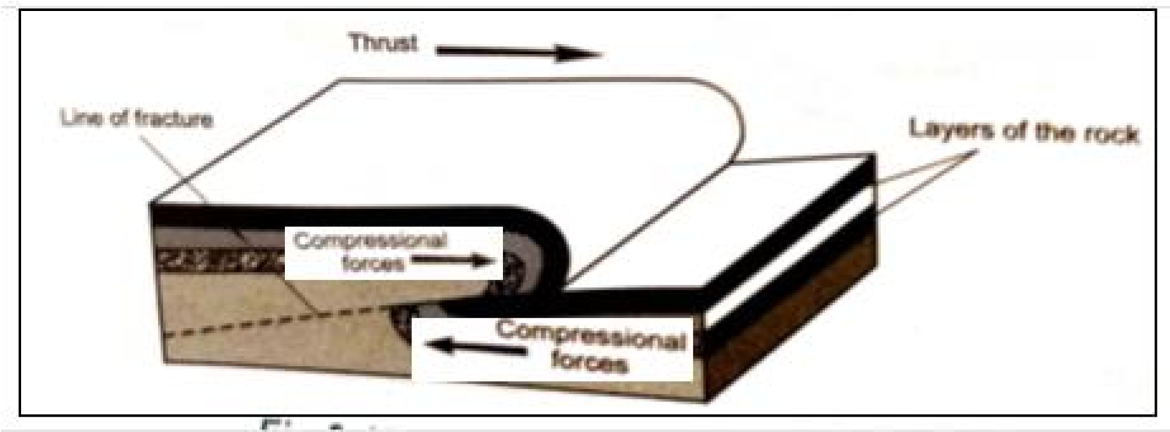
(ii) With the aid of a diagram, describe the formation of an overthrust fold.
- layers of crustal rocks are subjected to compressional forces
- intense folding lead to formation of overfold, increased pressure result in formation of recumbent fold.
- due to increased pressure, a fracture develops along the axis of the recumbent fold producing a thrust plane.
- the upper part of the recumbent fold slides forward over the lower part along the plane resulting in the formation of an overthrust fold
Text – 4 marks
Diagram – 2 marks

(c) Explain three positive effects of fold mountains on human activities.
- fold mountains are water catchment areas which provide water for rivers used for domestic/industrial/irrigation/production of hydroelectric power
- windward slopes of fold mountains receive heavy rainfall which support crop production/attract settlement
- some fold mountains have exposed valuable minerals making mining easy.
- fold mountains/snow covered slopes form beautiful sceneries which
attract tourists who bring foreign exchange. 3×2=6 marks
(d) Members of your class are planning to carry out a field study on an area that has undergone folding process

(i) Give three ways you would prepare for the study.
- formulate the objectives and hypothesis for the study
- identify methods of data collection
- seek permission from school administration
- conduct a pre-visit to the study area
- prepare a working schedule
- assemble relevant tools
- divide themselves into groups 3×1=3 marks

(ii) State three advantages of studying landforms through field work.  learners are able to acquire first-hand information
- students are able to apply knowledge gained to real life situations
- allow learners to acquire/apply skills
- breaks the classroom monotony
- enhances visual memory of the features observed _{3×1=3 marks}

(a) (i) What is weathering?
 |  | ▪ this is the physical breakdown or chemical decomposition of rocks at
 |  | or near earth’s surface in situ/without movement | 1×2=2 marks
(ii) Apart from plants, give three other factors that influence the rate of weathering.
- nature of rocks
- slope
- climate
 |  | ▪ human activities | 3×1=3 marks
(iii) Explain two ways in which plants cause weathering.
- plant roots penetrate into rock joints/cracks causing them to widen and eventually disintegrate
- plants absorb minerals from rocks and this weakens the rocks causing them to disintegrate
 |  |    rotting plant remains release organic acids which react with minerals in the rocks causing chemical disintegration. | 2×2=4 marks
 | (b) | Describe the following processes of weathering:  (i) Block disintegration  - occur in areas with large diurnal temperature ranges  - high temperatures during the day intensely heat rocks causing them to expand  - at night rapid cooling occurs causing the rocks to contract  - the process of expansion and contraction is repeated over time
 |  | causing stress in the rocks     the rocks break along cracks and joints hence separate | 4×1=4 marks
(ii) Carbonation
- common in limestone/chalk areas
- rainwater dissolves carbon (IV) oxide in the atmosphere to form weak carbonic acid
- weak carbonic acid reacts with limestone rocks to form calcium bicarbonate which is soluble in water
 |  | ▪ the rock readily disintegrates | 4×1=4 marks
 | (c) | Explain four effects of mass wasting on the environment.  - mass wasting lead to land dereliction as scars are left on the surface spoiling the beauty of the land  - as the materials move over the land they facilitate the loosening of top soil leading to erosion  - materials from a landslide may cause a barrier across a river leading to formation of a lake.  - landslides may cause a river to change its cause reducing the amount of water downstream  - landslides may cause damage to property when roads/settlements are buried
 |  | ▪ landslides may cause loss of life when settlements are buried | 4×2=8 marks
9. | (a) | (i) Apart from surface run off, give two other processes in the hydrological cycle.  - precipitation  - evaporation
- transpiration
- interception
- infiltration
 |  | ▪ percolation | 2×1=2 marks
(ii) State three factors that determine the amount of surface run off.
- amount of rainfall
- rate of evaporation
- gradient/slope of the land
- nature of the rocks/pervious/impervious
 |  | ▪ amount of vegetation cover | 3×1=3 marks
(b) |  | Explain three factors that influence the transportation of materials by a river.  - volume of water-large water volume carry large amount of load  - gradient of the channel-steep slopes generate greater kinetic energy enabling faster flow  - nature of the load-light load is transported faster/over long distance  - amount of load-small quantity transported for a long distance/large
 |  | load reduces the efficiency of a river to transport | 3×2=6 marks
(c) |  | (i) What is river rejuvenation?
 |  | ▪ this is the renewal of the erosive activity of a river | 1×2=2 marks
(ii) Explain three conditions that lead to rejuvenation of a river.
- increase in river discharge due to increased rainfall/river capture resulting in increased erosive power
- change in rock resistance which make the river to start eroding vigorously
- change in base level due to local uplift or drop in sea level causing a
 |  | steep gradient | 3×2=6 marks
(d) |  | Explain three negative effects of rivers to the human environment.  - flooding of rivers may destroy property/crops/displace people  - flooding of rivers can lead to loss of human lives  - some rivers are habitat to dangerous animals which may attack human beings or destroy crops  - wide or deep rivers are a barrier to transport especially where bridges have not been constructed  - river water may be a medium of spreading water borne diseases
 |  | especially when flooding occurs | 3×2=6 marks
10. (a) |  | (i) What is an ice sheet?
 |  | ▪ a continuous mass of ice covering a lowland area. | 1×2=2 marks
(ii) Explain three factors that influence the movement of ice from the point of accumulation.
- slope of the land-movement is faster on steep slopes
- temperature/seasonal changes-high temperatures result in thawing leading to faster movement
- friction lower the movement of ice
- size or thickness of glacier-large masses of ice exert pressure causing
 |  | melting which result in faster movement | 3×2=6 marks
(b) |  | Describe how an arête is formed.
- two adjacent cracks or hollows exists on a mountain side
- the hollows are filled with ice
- ice erodes the sides through plucking and deepens the hollow through abrasion
- the back walls of the hollows slowly recede and eventually the
 |  | hollows (cirques) are separated by a knife-edged ridge called an arête | 6×1=6 marks
(c) |  | The diagram below shows features resulting from glacial deposition on a lowland area.  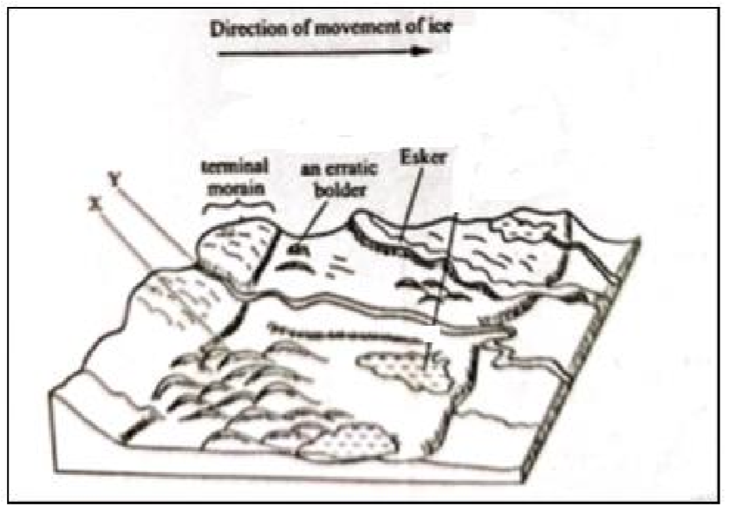  (i) Name the features marked X and Y.  X – drumlins
 |  | ▪ Y – river/melt water | 2×1=2 marks
(ii) Describe how terminal moraine is formed.
- moving ice stagnates and the ice at the snout melts
- melting ice releases its load and gradually the load piles into a ridge
 |  |    over time the ridge form a block of solid materials called terminal moraine | 3×1=3 marks
(d) |  | Explain three positive effects of glaciation in lowland areas.  - glacial till provides fertile soils suitable for arable farming  - outwash plains comprise of sand and gravel which are used as building materials  - glacial lakes in lowland areas can be exploited for various economic uses such fishing and transportation  - features such as eskers/drumlins attract tourists hence earning foreign exchange  - glaciated lowlands have gentle slopes ideal for establishment of
 |  | settlements. | 3×2=6 marks

