CEKENAS END OF TERM ONE EXAM-2022
Kenya Certificate of Secondary Education. (K.C.S.E)
312/2
GEOGRAPHY
PAPER 2

MARKING SCHEME
1.a) Define the term human geography (1x2)
Branch of Geography that studies human activities on the earth surface
b.) Give three subdivision of human Geography (3 x 1)
Population geography
Economic geography
Historical geography
Agricultural geography
2a.) Name two counties in Kenya in eastern highlands where tea is grown (2 x 1)
Meru
Embu
Kirinyaga
Nyeri
Murang’a
Nakuru
Kiambu
b.) State three economic problems experienced by small scale tea famers in Kenya (3 mrks)
Delayed payments or low payment which lowers farmer’s morale
Mismanagements / embezzlement of funds by the officials which discourages farmers
Fluctuation of tea prices in the world markets making it difficult for farmers to plan ahead and discourages them.
High costs of farm input leading to low yields
Poor marketing strategies leading to low earning by farmers
Shortage and expensive labor for picking tea leading to low income/low profits margins to the farmers.
3.a) What is mixed farming (2mks)
This is the growing of crops and rearing of livestock on the same farm
b.) Give three physical condition that favors wheat cultivation in Kenya (3mks)
Moderate rainfall/500mm-1270mm/to enhance growth of wheat
Temperature raging from 15⁰ C – 20⁰ C /warm condition to facilitate growth / maturity of wheat
A warm/dry/ sunny spell for ripening and harvesting
Deep volcanic soils to sustain high production
Gently sloping/undulating landscape to allow proper drainage / mechanized cultivation
4.a) Name the river along which Bunyala swamp is found in Kenya (1mk)
River Nzoia
b.) State four physical problem facing irrigation farming in Kenya (4mks)
Stagnant water in the plots and canal which encourages breeding of snails and mosquitos that spread diseases(bilharzia & Malaria) that weakens the farmers hence causing low output
Some irrigation schemes are located in sparsely populated area far from urban centreswhere there ready markets e.g. (Pekerra, Hola)
Some irrigation schemes e.g. Hola and Bunyala are affected by floods during rainy season that destroys crops grown and road networks.
Crops planted in the schemes are often attacked by pests and diseases e.g. quelea birds, destroying the crops in the field thus lowering the quality and quantity of production
5.a) What is energy crisis (2mks)
A situation when the demand for oil is higher than the supply leading to high prices of oil
b.) Give three limitations of using solar energy (3mks)
Solar energy is unable to run heavy machinery
Batteries used for storing solar energy are cumbersome and are to be replaced offenly
Quality solar panels are expensive to manufacture
Restallation of solar panels requires technical skills whish are underdeveloped for most people
Solar energy depends on whether patterns which make it user unreliable
6.a)i) Identify the county that had the highest beef production within the period (1mk)
Tana River
ii.) Name type of cattle breed reared by pastoralists in Kenya (2mks)
Zebu
Boran
b.i) Using the scale of 1 cm representing 100,000 metric. Draw a comparative bar graph to represent the above data (7mks)
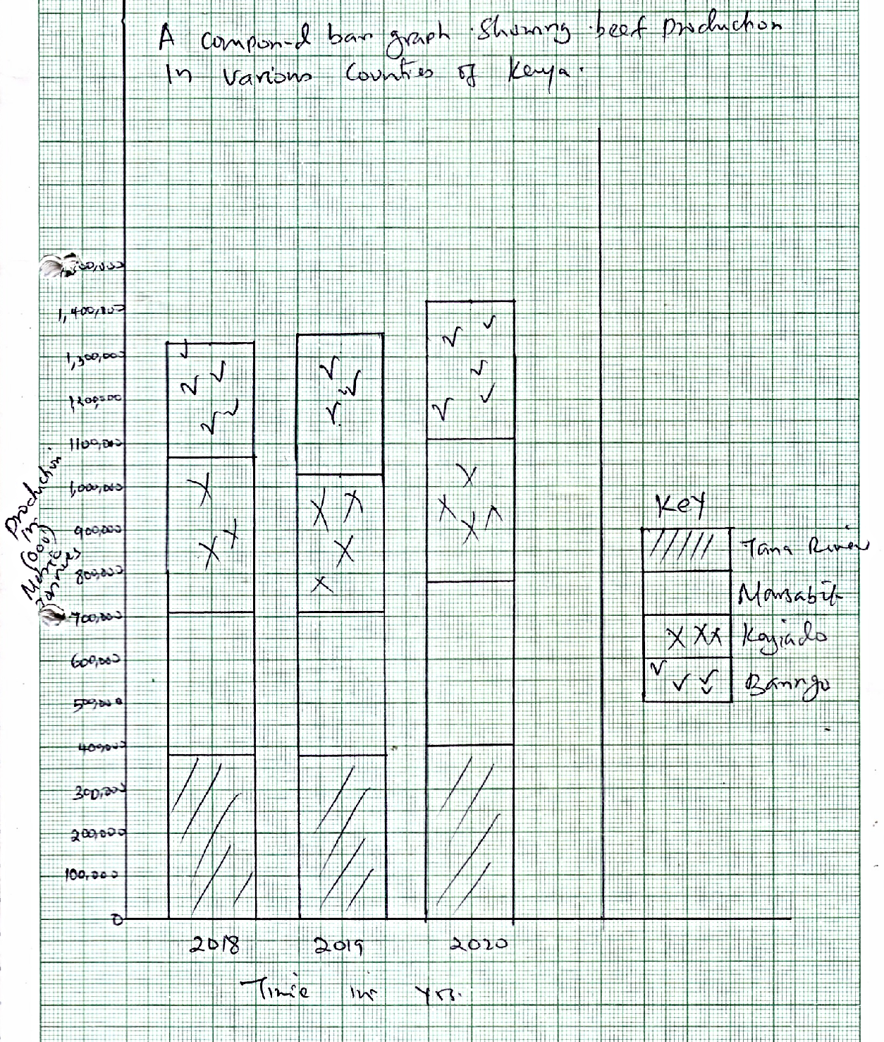

ii.) Explain three measures that have been taken by the government of Kenya to improve beef farming (6mks)
The government encourage research/cross breeding of traditional cattle breeds with exotic ones to improve the quality of animals/cross breed are resistant to diseases
Strengthen community education to teach beef cattle farmers on management practices
It has constructed roads to make it accessible to farmers/ make transportation of animals to the market easier
It encourages the replacement of coarse grass with nutrient pastures to increase quality of animals.
It has some boreholes/ dig wells/constructed dams to provide water for animals
It has survived Kmc a government parastal that brings animals from farmer for slaughter
iii.) Outline three ways in which the market of animals is done by the nomadic pastoralists in Kenya (3mks)
Some animals are sold to slaughter houses / individuals
Some sell their animals through community groups/ ranches
Some animals are sold to livestock and marketing departments
Some sell their animals to KMC
c.) Explain three environmental conditions that favor commercial beef farming in Argentina (6mks)
High quality natural pastures/ grass used to feed beef animals
Coarse grasses are replaced with alfafa& corn to improve the quality of pastures for feeding the animals
Extensive flat /gentle/ undulating pampas grass land which are suitable for grassing of cattle/beef ranching.
Maritime climate with warm condition and high well distributed rainfall for growth of pasture making grassing of cattle possible throughout the year
7.)a) Name two types of placer mining (2mks)
Panning
Hydraulic mining
Dredging

ii.) Describe the processing of gold in South Africa (6mks)
it ids mined using shaft method then lifted to surface for processing
The gold ore is crushed into powder
The powder is dissolved in a solution of sodium cyanide
Gold particles dissolves to form gold cyanide solution with Uranium impurities
Solution is mixed with zinc dust which makes a precipitate
Uranium is separated and fed into sulphur acid tank where it dissolved and then purified
Gold is then melted and made into gold bars in the gemstones
Gold is sold locally and some is exported

iii.) Give three uses of gold in South Africa (3mks)
Making jewelries / ornaments
Making gold paints
Gold bars are used as financial securities
Making medals and coins
In dentistry/ tooth filling
Making photographic materials in chemical industries
b.) Explain how the following factors influence exploitation of minerals
i.) Value of the mineral
Valuable minerals e.g. gold diamond silver and uranium are mined more compared to the other minerals since the fetch high prices of the market hence profitable
ii.)Quality of the ore
It is economical to mine mineral, whose of of high quality since that yield high amount of minerals
Low quality ore are rarely mined unless their value is high. Minerals with low contents of miner are uneconomic to mine.
Mineral are with high content of metals are economical to mine as they are high economic value
iii.) Mining method (2mks)
Some method of mining are cheaper hence mostly used e:g Open cast mining.
Underground methods are expensive to use unless the mineral is of value
c.)Explain four effects of open cast mining on the environment (8mks)
The land is left with gaping quarries which are ugly which interferes with beauty of the land scape
Cleaning of land before extraction of minerals encourages soil erosion
The dust, smoke and gases produced pollute the environment and are health hazard
Large scale blasting of rocks leads to instability of the basement rocks
It destroys the natural vegetation which is cleared before extraction of the minerals
Water collects in the hallows left by open cast which becomes a habitat for diseases vectors
Causes destruction of lowering of water table causing water shortage on the surface
Causes land dereliction/ waste agricultural, industrial and land for settlement
8.a.i) Distinguish between domestic and international tourism (2mks)

Domestic touring of a country for leisure and adventure by the residents of the country while international tourism is the visiting of person from one country to places of interest in another country;
ii.) State three effects of human encroachment in to wildlife habitats (3mks)
Leads to dying of some animals / killing of some wild animals
Some animals and plants may get extinct
It may lead to wildlife predation/ competition may increase/set in
It may lead to fragmentation of wildlife conflict
It may lead to increased human wildlife conflict
It may lead to migration of some wild life
b.) Study the map of East Africa provided and use to answer the questions that follows
Name
(i) The national parks labeled J,K and N (3mks)
J – Kidepo valley
K – Amboseli
N – Sibiloi
ii) The game reserve named L (1mk)
L – Mpunguti marinr reserve
c.) Explain the measures that Kenyans should take in order to attract more tourism (2mks)
Improving road / air/ railway/ airport/communication to all tourist sites in order to make it accessible.
Improving security to ensure safety of the tourists is guaranteed
Marketing the county more aggressively in order to make it more known/ improve the image of the country
Establishing a diversity of tourists attractions to avoid depending entirely on traditional attractions and reduce competition with other destinations
d.) Explain four factors why Switzerland receives more tourists than Kenya (8mks)
Switzerland is located in central Europe making it easily accessible to tourists Of European origin while Kenya is far from Europe.
Some of the attraction in the two countries are similar, hence tourists prefer to visit those are nearer hole.
The peaceful atmosphere /political neutrality in Switzerland encourages tourists in appesed to Kenya where there are reports of insecurity which scare away tourists.
Switzerland mounts to more effective marketing promotion while Kenya making less.
The well-developed transport network in Switzerland provides easy access to tourists site while in Kenya many roads are poorly maintained.
In Switzerland tourists are charged fairly for service while in Kenya charges relatively high.
In Switzerland there are more encouragement on package tourists which lower the rate charged for tourists facilities which in Kenya this is rarely common.
e. (i.) Students of Narok high school intend to visit Maasai Mara game reserve
(i) Outline two objectives for their study (2mks)
To find out the problems experienced in the game reserve
To find out the types of animal species in the game reserve
To identify the food chain system amongst the animals in the game reserve
ii) Give any two unique human activities they are likely to come across which is not in national park(2mks)
Grazing of livestock/cattle
Temporary settlements
Some people moving around the game reserve selling ornaments / artifacts
9.) a) i) Define the term fisheries (2mks)
These are water bodies where exploitation of aquatic organisms/life are carried out
ii.) Give two factors that favors the growth of planktons (2mks)
Shallow water for sunlight penetration / 180M deep
Cool temperatures / waters / temperatures of about 20⁰ C
Presences of mineral salts
(b) Name ocean current named X and Y (2mks)
X – Cold Labrador current
Y – Warm Gruf stream current
ii) Explain the way in which convergence of ocean current marked X and Y favors fishing in the North – West Atlantic (4mks)
The convergence of the two currents at grand banks modifies the temperatures of the water making the area ideal for fishing throughout the year.
The convergence of cold and warm currents causes upwelling of the ocean water which brings mineral of the surface for planktons attracting large numbers of fish species to the area.
The cool waters favours survival of wide variety of fish species which make the area an important fishing ground
(iii) Name the country marked Z (1mks)
Z – Canada
(iv) Name two examples of fish caught in the North-West atlantic fishing (2mks)
Cod
Halibut
Flounder
Hake
Shell fish
c.) Explain four reason that discouraged East Africa from being a major producer of fish and fish products in the world (8mks)
Narrow continental shelf with deep waters unsuitable Planktons and fish breeding hence few fish species.
Poor develop networks connecting fisheries discourages fishermen
Regular coastal line with few indentations which is unsuitable for fish breeding affect fishing due to few landing point
Too warm water for fish breeding and little/no upwelling to modify temperature discourages breeding of fishing.
Inadequate purchase of modern fishing and preservation facilitates limiting fishes activities
Low demand for salt water fish which discourages marine fishing
The stiff competition of the open sea from the industrial countries whose fisherman use modern fishery equipment discourages local fisherman.
Limited te8chnology makes it difficult to develop marine fishing
(d) State four measures that Kenyan Government has undertaken to conserve fisheries (4mks)
Standardizing the mesh/hole size [of fish nets used in fishing to ensure only the mature fish is caught
By ensuring the fish number/restock overfished areas by breeding fingerings in fish farms and the release them into sea
Restricting disposal of untreated into the sea to ensure that the water remain cleanfor survival of fish
Enforcing the international conviction in order to protect endangered fish species
Licensing of fishermen to control their number and to ensure that there is no over fishing
Restricting fishing to specific seasons to allow the breeding and maturing fish to regenerate
Monitoring the entry of foreign fishermen off the Indian ocean water
10. (a) Differentiate between forestry and forest (2mks)
Forestry is the science of developing and managing forests including cultivation and utilizing them while a forest is a large mass of tree occupying a large area/land
b.) (i) Give two softwood trees which grow in the forest in Kenya (2mks)
Cedar
Douglas fir
Pin
Balsa fir
Henberk
Cypress
spruce
(ii) Give characteristics of planted forest in Kenya (3mks)
Trees appear in rows
The tree species occurs in pure stands/ they have same species
Trees planted are mainly softwood and they mature faster or take short time to mature
Both exotic and indigenous forest are grown
There’s little / No under sprout
The trees appears in blocks / same, height
They are mainly located in high land areas
c.) Compare fishery in Kenya and in Canada under the following subheading
(i) Harvesting of trees (2mks)
In Canada harvesting is done through clear cutting while in Kenya it is done by selective cutting
(ii) Marketing (2mks)
Most of the Canada wood products are exported to USA/Britain/Europe while in Kenya wood products are sold local with few being exported to USA & Britain.
d.) Explain the measures taken by Kenyan government to control human encroachment on forested areas (2mk)
The government is gazetting forested areas to delimit the areas and reduces encroachment by the public
The government is evicting the people who have encroached into forest areas in order to rehabilitate the forest,.
By educating the public / creating awareness on the importance of conserving forest/ to gain their support on conserving measures, the government aims to control human encroachment
Government is enabling/ enforcing law to prohibit cutting of trees within the gazette areas and is also employs forest guards to patrol/ forest guard to patrol reserves to ensure that illegal activities are reported .
The government is encouraging people to use other alternative sources of energy in order to reduce the demand for wood.
The government also encourages people to practice agro-forestry to avoid dependance on the products from forest.

d.) a) The students of Mogoiri girls are planning too carry out a field study in forestry on the slope of Mt. Kenya
(i) Give three reasons why it would be necessary to sample part of the forest for the study (3mks)
To save time
To save energy since small area will be studied
Help reduce expenses/reduce on the cost of study
Help in reducing biasness
Suitable method since vegetative grows randomly
Conduct detailed study
Some part of the forest may not be accessible since roads are not possible
(ii) State two ways in which their findings would be useful to the community living near the forest (2mks)
They will be able to identify the tree species that are suitable for the area
They will be able to work out on solution to the problems affecting the forest
The community will use the report to identify importance of conserving forests
People will be able to adapt appropriate methods of utilizing the forest

