BSJE
Kenya Certificate of Secondary Education (KCSE)

312/1
GEOGRAPHY
Paper 1
Oct 2022
Marking Scheme

- (a) Name two major latitudes on the earth
- Equator (0⁰)
- Tropic of Cancer (23½⁰ North)
- Tropic of Capricorn (23½⁰ South)
- Arctic Circle (66½⁰ South)
- Antarctic Circle (66½⁰ North) (2×1mk=2mks)
- The figures below show two effects of revolution of the earth and the moon. Use them to answer the questions that follow.
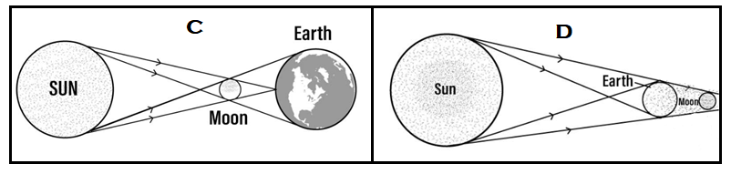
- Name the effects labeled C and D.
- C – Solar eclipse/eclipse of the
- D – Lunar eclipse/eclipse of the moon (2×1mk=2mks)

(ii) Describe the occurrence of effect labeled C.
- It occurs due to revolution of the moon around the earth.
- The moon lies between the earth and the sun, casting a shadow of the moon onto the earth

- The table below shows the temperature and rainfall characteristics of a station around the Lake Victoria basin. Use it to answer the questions that follow.
Month | J | F | M | A | M | J | J | A | S | O | N | D
Temp (⁰C) | 23.6 | 24.5 | 23.9 | 22.8 | 22.5 | 22.4 | 22.5 | 22.7 | 23.2 | 23.2 | 22.7 | 22.9
Rainfall (mm) | 115 | 94 | 190 | 288 | 273 | 109 | 98 | 107 | 113 | 202 | 248 | 189

- Name two instruments that could have been used to collect the data above.
- Six’s thermometer
- Maximum thermometer
- Minimum thermometer
- Rain gauge (2×1mk=2mks)

- State three characteristics of the weather experienced in the station.
- Rain falls throughout the year/no real dry months
- The rainfall is high
- rainfall regime is a double maxima
- Moderate temperatures
- Small annual range of temperature (3×1mk=3mks)

- Name four major earthquake zones of the world.
- Circum – pacific belt/ring of fire – around Japan, Philippines, East Indies and the Americas.
- The Mediterranean belt across southern Europe, southern Asia and the Himalayas.
- Along all the tectonic plate boundaries.
- Rift valley regions and other faulted areas.
- Areas of volcanic activity and volcanic islands.
- Mid ocean ridges and ocean deeps (4×1mk=4mks)

- (a) Name two major areas in East Africa that experience glaciation.
- Mount Kenya
- Mt. Elgon
- Mount Kilimanjaro (2×1mk=2mks)

(b) The diagram below shows some features of glacial erosion in highland areas. Use it to answer the questions that follow.
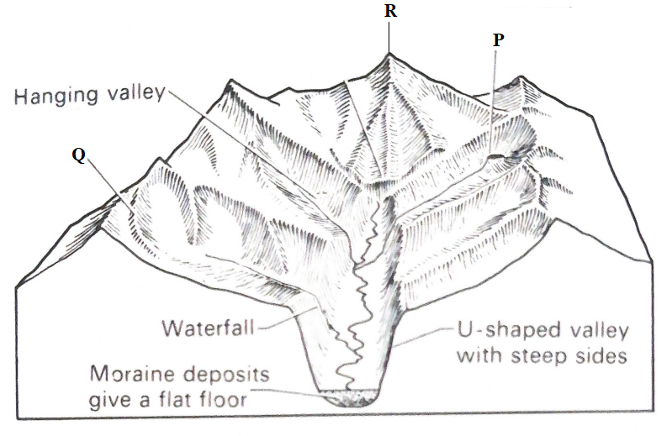
- Name the parts marked P and Q.
- P – Arete
- Q – Cirque (2×1mk=2mks)

- Give one example of the feature labeled R in East Africa.
- Corynder
- Delamere
- Albert
- Margherita
- Alexandria (1×1mk=1mk)

- (a) Differentiate between a constructive wave and a destructive wave.
- A constructive wave has a stronger swash and a weaker backwash whereas a destructive wave has a weaker swash and a stronger backwash.
- A constructive wave is found in nearly flat or gently sloping coastlines while a destructive wave is found in areas where the coastlines slopes steeply into the ocean
- A constructive wave causes more deposition while a destructive wave causes more erosion (1×2mks=2mks)

(b) State three factors that influence wave deposition.
- The breaking waves must be constructive
- Waves must break at low frequencies to allow the deposited materials to settle.
- Shores with gentle gradient reduces the velocity of the backwash hence causes waves to begin depositing their loads.
- Coastlines that change abruptly halts/stops the longshore drift, leading to deposition.
- Reduced depth of water halts wave transportation leading to deposition (3×1mk=3mks)

- Study the map of Nyeri 1: 50,000 (sheet 120/4) provided and answer the following questions.
- (i) Convert the ratio scale in the map into statement scale.
- $100,000 cm=1 km$
$$50,000 cm=\frac{50,000}{100,000}=0.5 km$$
- 1 cm represents 0.5 km (1×2mks=2mks)

(ii) Give the magnetic variation of the area covered by the map.
- $1^{0}{31}^{'}$ (1×1mk=1mk)

- (i) In which hemisphere of the map is the map extract located?
- Southern hemisphere (1×1mk=1mk)

(ii) What is the general direction of flow of the rivers in the map extract?
- East/Eastern (1×1mk=1mk)

- (i) Give the six figure grid reference of the Forest Guard Post within Nyeri Forest.
- 715581 (1×2mks=2mks)

(ii) Name three physical features in grid square 5165.
- Steep slope
- River
- River valley
- Woodland
- Scrub vegetation (3×1mk=3mks)

(iii) Measure the length of the Dry Weather Road from the junction in grid square 6262 to
Bondeni. Give your answer in kilometres.
- 3.6 km ± 0.1 km (1×2mks=2mks)

- (i) Draw a frame of dimensions 10cm by 6 cm to represent the area bounded by eastings 70 to 80 and by northings 54 to 60.

(ii) On the frame, mark and label:
- Aberdare Forest
- National Park Boundary (2×1mk=2mks)

(iii) Calculate the new scale of the map drawn.
- $\frac{1}{50,000}×\frac{1}{2}=\frac{1}{100,000} or 1:100,000$ (1×2mks=2mks)
- Describe the relief of the area covered by the map.
- The area is generally is a highland.
- The highest area is 2633 metres, lowest area 1720 metres
- Southern parts has steep slopes
- North eastern and western parts have gentle slopes
- The area slopes from the western to the eastern parts of them. (4×1mk=4mks)

- Citing evidence from the map, state three functions of Nyeri Town.
- Administration – PC, DC offices
- Sports Centre – golf course
- Trading - market
- Health care – hospital
- Rehabilitation – prison
- Security – Police station
- Industrial centre – coffee factory
- Religion - church
- Education – schools (3×1mk=3mks)

- (a) (i) Name two output processes of the hydrological cycle.
- Condensation
- Precipitation/Rainfall (2×1mk=2mks)

(ii) State three importance of the hydrological cycle.
- The amount of water vapour in the atmosphere determines the amount of energy stored in the atmosphere for the development of storms.
- The moisture in the atmosphere regulates the heat being lost from the ground by reflecting most of it back to the earth thereby absorbing terrestrial radiation
- It leads to formation of rainfall which assists in agricultural production and vegetation growth.
- It assists in the oxygen and carbon cycles in the atmosphere
- Hydrological cycle leads to the distribution of water on the earth’s crust. (2×1mk=2mks)

(b) Citing an example in each case, name three sources of rivers in Kenya.
- Mt. Elgon –R. Nzoia
- Mt. Kenya – R. Tana, R. Ewaso Ngiro
- Nandi Escarpment – R. Yala
- Mau Escarpment – R. Sondu, R. Njoro
- Kiabonyoru Highlands – River Kuja (2×1mk=2mks)

- Explain how the following factors influence river erosion;
(i) Stream gradient,
- Steep slopes experience higher velocity of river water due to greater influence of gravitational force. (1×2mk2=2mks)

(ii) Nature and amount of load.
- River beds with less resistant rocks are easily eroded especially if the rocks are well jointed or soluble in water. (1×2mks=2mks)

- The diagrams below show formation of an ox-bow lake. Use them to answer the questions that follow.
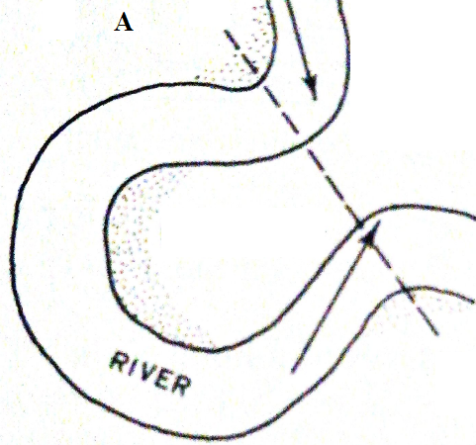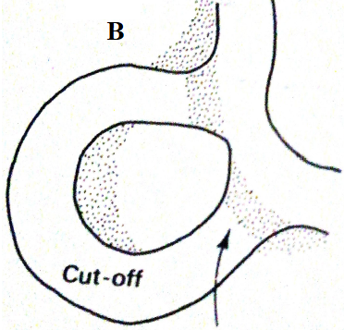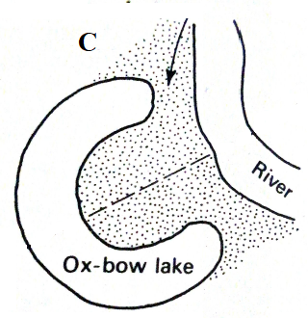
(i) Describe the processes in the diagrams labeled:
- A
- Neck of land separates two concave banks where erosion is more active. (1×1mk1=1mk)

- B
- Continued erosion on outer bank and deposition on the inner bank makes the neck to be cut through
- Deposition seals up the ends of the cut off meander (2×1mk=2mks)
- C
  - Continued deposition seals the cut off meander to form an ox-bow lake. (3×1mk=3mks)

(ii) Name three examples of ox-bow lakes in Kenya.
- Kanyaboli
- Shalu
- Shakababo
- Bilisa
- Gambi (3×1mk=3mks)

- Members of your class plan to conduct a field study on the lower course of River Nzoia.
- Name one county they may visit for the study.
- Busia
- Siaya (2×1mk=2mks)

(ii) State three characteristics of the river they are likely to observe during the study.
- The river flows slowly/sluggishly
- The river gradient is gentle
- The river channel is wide/wider
- Deposition is the most dominant river process
- The river is shallow
- Flooding is common in this course (3×1mk=3mks)

- (a) (i) Define the term volcanicity.
- Volcanicity is a process through which molten volcanic material (magma) invade the crustal rocks and escape to the earth’s surface where it cools and solidifies to form extrusive volcanic features. (1×2mks=2mks)

(ii) Give the three life cycles of a volcano.
- Dormant
- Active
- Extinct (3×1mk=3mks)

(b) The diagram below shows a feature of extrusive vulcanicity. Use it answer the questions that follow.
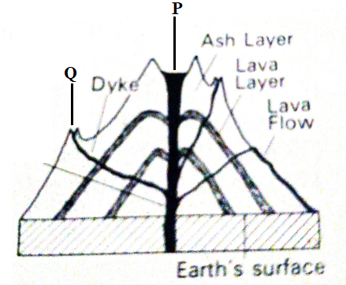
(i) Name the parts labeled P and Q.
- P – Crater/Caldera (1×1mk1=1mk)
- Q – Parasitic cone/Conelet (1×1mk1=1mk)

(ii) State three characteristics of the feature.
  - It has a vertical vent
  - It has a side vents
  - It is composed of alternating layers of pyroclasts and lava.
  - It’s conical in shape
  - It’s steep sided
  - It has conelets/parasitic cones on the sides.
  - At the peak it may have a crater, caldera/volcanic plug. (3×1mk=3mks)

(iii) Give two examples of the feature in East Africa.
- Mt. Kenya
- Mt. Longonot
- Mt. Suswa
- Mt. Elgon
- Mt. Kilimanjaro,
- Mare
- Ol Donyo Lengai (2×1mk=2mks)

(c) With the aid of a clearly labeled diagram, describe the formation of the following features of vulcanicity.
(i) Lava plateau.
- Earth movements/faulting may create fissures/cracks through which basic or ultra-basic magma erupts to the surface of the earth.
- The magma has low viscosity; hence on reaching the surface it flows over long distances before cooling and solidifying.
- As the basic lava flows over the earth’s surface, it fills the depressions and valleys, leveling the entire surface.
- On cooling and solidifying the lava forms a fairly level upland area called a lava plateau/plain depending on the elevation.

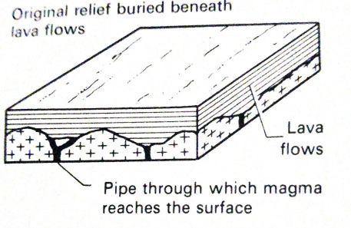 (5×1mk=5mks)
(ii) Dykes.
- When a mass of magma cuts across the bedding planes during intrusion, it cools and solidifies either vertically or in an inclined position to form a dyke
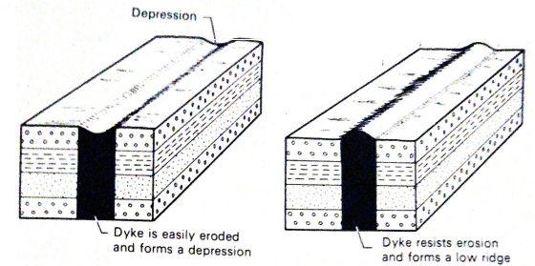 (2×2mks=4mks)
(d) State three negative effects of volcanic summits.
- Leeward sides of volcanic summits experience rain shadow effect leading to aridity and desertification
- Volcanic summits may be barriers to establishment and maintenance of transport and communication infrastructure e.g. roads, railway lines, pipelines, etc.
- Weathering of volcanic rocks from the summit may results in to soils of low quality to support growth of crops
- Toxic/poisonous emitted during formation of volcanic summits may be harmful to human health
- Formation of volcanic summits may cause death of human and loss of property (3×1mk=3mks)

- (a) (i) Define the term denudation.
- Denudation refers to all the processes of destruction, wastage and removal of parts of the earth’s surface by various land forming processes (1×2mks=2mks)

(ii) Explain two ways in which living organisms influences weathering.
- Human activities such as building and construction, mining, digging, quarrying and rock blasting lead to break up of rocks.
- Hooved animals (cattle) crash on rocks in search of water and pasture leading to break up.
- Burrowing (digging) animals such as rodents and termites provide passages through which moisture and air may reach the rock surfaces below, leading to chemical reactions that may cause decay and disintegration.
- Plants’ roots may cause cracks in rocks as they penetrate them, leading to physical break up and chemical when water and air passes through them.
- Plants that grow on rock surfaces such as mosses and lichens keep the rock surfaces moist thus facilitating chemical decay.
- Bacteria within the soils may lead to decay of other organisms which produce organic acids. These acids may react with certain minerals in the rocks and cause them to disintegrate or decay. (2×2mk=4mks)

(b) (i) Name two major areas that are likely to experience physical weathering.
- High altitude areas
- High latitude areas
- Equatorial/low latitude areas (2×1mk=2mks)

(ii) Give three processes of physical weathering.
- Block disintegration
- Granular disintegration
- Exfoliation
- Frost action
- Crystal growth
- Pressure release
- Slaking (2×1mk=2mks)

(c) (i) Differentiate between mass wasting and mass movement.
- Mass wasting is the movement of weathered materials down a slope under the influence of gravity while mass movement is the movement of weathered materials after lubrication from rainwater or water from melting snow (1×2mks=2mks)

(ii) Give three human activities may trigger mass wasting.
- Mining
- Quarrying
- Road/railway construction
- Clearing vegetation
- Grazing (2×1mk=2mks)

- The diagram below shows a process of mass wasting. Use it to answer the questions that follow.
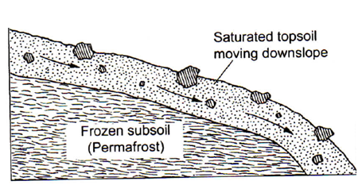
- Name the process shown above.
- Solifluction (1×1mk=1mk)

- What type of mass wasting is shown in the process?
- Slow mass wasting (1×1mk=1mk)

(iii) Describe how the process occurs.
- It occurs on cold mountain slopes where the soils are frozen in winter and during spring, thawing saturates them to slide down the slopes (3×1mk=3mks)

(e) Members of your class have planned to conduct a field study on mass wasting within the school’s environment.
(i) State two reasons why they would need to conduct a reconnaissance.
- To familiarize themselves with the study area
- To enable preparation of working schedule
- To identify suitability of the study area
- To identify possible problems and mitigate their solutions
- To identify data collection and recording techniques (2×1mk=2mks)

(ii) Give three evidences of soil creep that they are likely to observe during the study.
- Bent tree trunks
- Titled electricity poles and fencing posts
- Bare and exposed upper slopes
- Accumulation of soils at the foot of walls/slopes
- Cracked roads especially dry weather roads (3×1mk=3mks)

- (a) (i) Give three conditions that must be satisfied by a mineral.
- Crystalline or in solid state
- Occur naturally
- Inorganic
- Definite chemical composition (3×1mk=3mks)

(ii) Describe the following characteristics of minerals:
- Lustre
- Surface appearance of a mineral as it reflects light (1×2mks=2mks)

- Cleavage
  - Minerals aggregate or break into distinct shapes (1×2mks=2mks)

(b) State two ways in which volcanic rocks may be formed.
- These are formed from the magma that has reached the surface and flown for a considerable distance before cooling and solidifying, depending on its degree of fluidity.
- During volcanic eruption, solid or nearly solid materials of different sizes and shapes may be thrown out of the earth’s crust on to the earth’s surface. On cooling and solidification, these materials may form various rocks
(2×1mk=2mks)

(c) (i) State four characteristics of sedimentary rocks.
- They occur in layers/well jointed
- They are non-crystalline/lack crystals
- They may contain fossils (4×1mk=4mks)

(ii) Why is the coastal parts of Kenya distributed with majorly sedimentary rocks?
- It is a lowland area
- Presence of the Indian ocean facilitates deposition
- Presence of sediments due to high temperatures as a result of weathering (3×1mk=3mks)

(iii) Give three examples of metamorphic rocks.
- Gneiss
- Marble
- Slate
- Schist
- Graphite
- Quartzite
- Hornblende

(d) Explain three significance of rocks to the human environment.
- In some areas, the rocks form spectacular/fascinating features that are of tourist attractions thus earning foreign exchange e.g. the granitic tors
- Some rock types act as water reservoirs storing underground water that can be harnessed for domestic and industrial
- Rocks provide parent materials for formation of rich soils (through weathering) that are used for crop farming.
- Some rocks are used in building and construction e.g. phonolites
- Some rocks are sold in quarries hence sources of income to and improve their living standards.
- Minerals and other valuable substances may be extracted from rocks and used to earn income as well as sources of raw materials for industries. (3×2mks=6mks)

