NAME………………………………………………...……………………………………….……………
SCHOOL………………………………….……………………………………………….………….……
ADM NO.………………………………. DATE……………………..……………………………
STUDENT’S SIGN……………………....

GEOGRAPHY
Time: 2 ¹/₂ Hours

MOMALICHE MOCK EXAMS – JUNE 2022

INSTRUCTIONS
- Answer all questions in section A
- In section B answer question six and any other two questions

SECTION A
1. a)Differentiate between relative humidity and absolute humidity (2mks)
b)State three significance of water vapour in the atmosphere (3mks)
2. a)What do you understand by the term vertical Earth movement. (2mks)
b) Identify three causes of earth movements (3mks)
3. a) Give two process of slow mass movement. (3mks)
b)State two physical conditions that may influence landslides (2mks)
4 (a)State two factors that may determine the amount of surface run-off (2mks)
b)Use the diagram below to answer questions (i) and (ii)

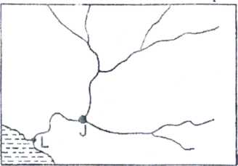
Name part labelled J and L (2mks)
5. a)Define the term oceans (2mks)
b)State three reasons why ocean water are salty (3mks)

SECTION B

Answer question 6 and two other questions in this section

6.Use the map of Oyugis (1:50,000) sheet 130/1 provided, to answer the questions that follow

a. (i)Give two adjoining index to the south and East of oyugis map (2mks)

ii)Convert the scale of the map extract given 1:50000 into a statement scale ( b)What is the bearing, distance and direction of the trigonometrical station Ingrid square 7030 from brickworks in grid square 7832 (3mks)

(c)Enlarge by two area bounded by easting 85 and 88,northing 39 and 41 (2mks)

On it label and name the following

i)River Awach kasipul (1mk)

ii)Forest boundary (1mk)

iii)woodland

(d)Explain three factors that have favoured trade in the map extract. (6mks)

(i)Citing evidence from the map state two social services offered in the area covered by Oyugis map (2mks)

(ii)Describe the relief of the area covered by the map (5mks)

7. (a)What is rotation of the Earth (2mks)

(b)The diagram below represents one effect resulting from rotation of the Earth. Use it to answer part (b( i) and (b( ii) below;

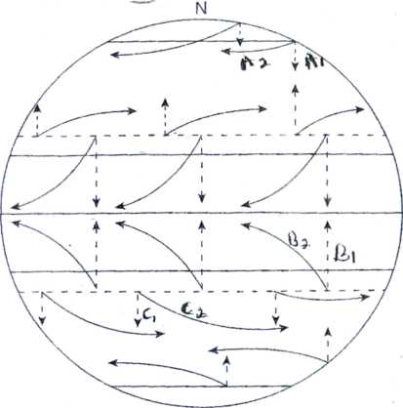
i) Name the effect of rotation represented by the diagram (1mk) (ii) Citing specific pressure zones and winds shown, describe the process represented in;
(i) A1 and A2 (3mks) (ii)B1 and B2 (3mks) (iii)C1 and C2 (3mks) (c)Explain how the following factors affects temperature

(i) Altitude (3mks)

(ii)Latitude (4mks)

d)Explain three reasons why a weather station must be sited away from tall building and trees (6mks)

8. (i)Name two types of vegetation .

(2mks)
II)Give two physiographic factors influencing vegetation distribution (2mks)
b)the diagram below shows vegetation zones of an East African mountain. Use it to answer questions below(bi) and b(ii)
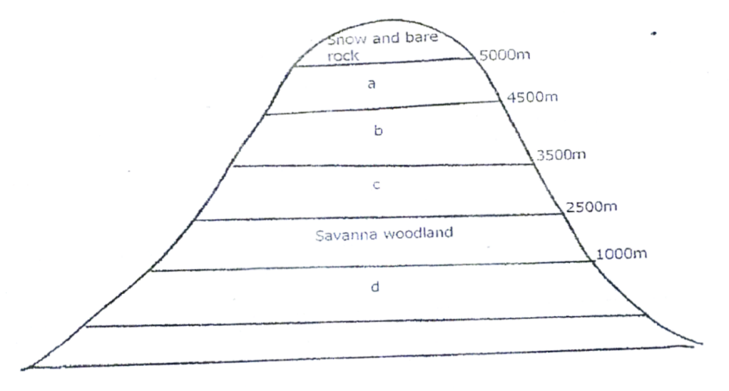
Name the zones a,b,c and d (4mks)
ii)Give one reason why there is no vegetation cover on the top of the mountain (1mk)
c (i)State the names given to temperate grassland vegetation in:
- North America
- Argentina
ii)Explain three uses of savannah vegetation (6mks)
d)Explain four characteristics of tropical desert vegetation (8mks)

9. (a)With the aid of well labelled diagram describe how a crag and tail is formed (6mks)
(b)Name and describe four types of glacial moraines (8mks)
C (i)Identify two features formed by glacial erosion in the highlands (2mks)
(ii) State three factors which encourage glacial deposition (3mks)
(iii)Explain three positive effects of glaciations to human activities (6mks)

10. (a)state
i)Three factors which contribute to the development of deserts (3mks)
ii)Three processes through which winds erodes a desert land scape (3mks)
b)Using well labelled diagrams explain how a rock pedestal is formed (6mks)
c)Explain three significance of wind depositional features (6mks)

d)Suppose you carry out a field sturdy on the action of water in a desert
i)List four features you are likely to study (4mks
ii)State three problems you are likely to experience during the field study (3mks)

