.NAME;……………………………………………………………… INDEX NO;…………………….
SCHOOL………………………………………………… DATE;…………………. SIGN;…….…….

312/1
GEOGRAPHY
PAPER 1
TIME: 2 ¾ HOURS
FORM 4 TERM II
SEPTEMBER 2022

KIJISET JOINT EXAMINATION 2022
312/1
GEOGRAPHY
PAPER 1

INSTRUCTIONS TO CANDIDATES
- This paper has two sections A and B
- Answer all questions in section A.
- Answer question 6 and any other two questions from section B.
- Candidates should check the questions paper to ascertain that all the pages are printed as indicated and that no question is missing.

 | QUESTION | TOTAL | SCORE
SECTION A | 1-5 | 25
SECTION B | 6 | 25
 | 7 | 25
 | 8 | 25
 | 9 | 25
 | 10 | 25

SECTION A
ANSWER ALL QUESTION IN THIS SECTION
- a) List down two isothermal layers of the atmosphere. (2mks)
b) State any three characteristics of the lowest layer of the atmosphere. (3mks)
2. a) Differentiate between faulting and folding. (2mks)
b) Apart from Fold Mountains, name three other land forms resulting from folding. (3mks)
3. a) What is mass wasting. (2mks)
b) Statethree economic benefits of the weathering process. (3mks)
4. a) What is soil degeneration?(2mks)
b) Identify three types of soil degeneration. (3mks)
5. a) Name the type of delta found at the mouth of: [2mks]
- RiverNile
- River Omo
b) State one effect for each of the following types of river erosion. (3mks)
- Head ward erosion
- Lateral erosion
- Vertical erosion

SECTION B
Answer Question 6 And Any Two Questions From This Section.
6. Study the map of Nyeri 1:50 000(sheet 120/4) provided and answer the following questions.
a) i) Identify two types of scale used in the map. (2mks)
ii) Give six figure grid reference of trigonometric station 120TT27 in the North Western part of the area covered by the map. (2mks)
b) i. Give the longitudinal and latitudinal extend of the area covered by the map. (2mks)
ii. Measure the length of all-weather road loose surface from Easting 57 to Easting 66. Give your
answers in kilometres. (2mks)
iii) Draw a rectangle 12cm by 16cm to represent the area enclosed by easting 64 and 67 and Northing 51 and 55. in the rectangle, mark the following: (5mks)
- Nyeri Hill Forest
- River Chanya
- Trigometrical Station 120T19
- Kagundu School
iv. Citing evidence from the map, identify three economic activities carried in the area. (6mks)
c) Explain three factors that have influenced settlement in the area covered by the map. (6mks)
7. a) Define the term Vulcanicity. (2mks)
b) Distinguish between Extrusive and Intrusive Vulcanicity. (4mks)
c) Give any three resultant features due to intrusive Vulcanicity. (3mks)
d) Describe the continental Drift theory. (3mks)
e) i. State two artificial causes of earth movement. (2mks)
ii. Explainany three significance of Vulcanicity to human activities. (8mks)
8. a) What is climate? (2mks)
b) Explain how the following factors influences climate [9mks]
- Latitude
- Altitude
- Ocean currents
- State four conditions that are necessary for the formation of fog [4mks]
c) i. Distinguish between aridity and desertification[2mks]
ii. State any four causes of aridity and desertification together with their possible solutions. (8mks)
9. a) Name two ways ofwater movement in oceans. (2mks)
b) List any four types of tides. (4mks)
c) State four factors that influence wave transportation. (4mks)
d) Form 4 geography class carried out afield study at a wave deposition site at the Coast of Mombasa.
- List any four wave depositional features that might have been observed. (4mks)
- Explain any two factors influencing the type of Coast that they might have studied. (4mks)
- Give any three benefits they might have enjoyed due to conducting reconnaissance to their placeof study. (3mks)
- List two ways the learners might have used in collecting data. (2mks)
- Mention any two types of coral reef they might have studied during the period of their study. (2mks)
10. a) Name three major desert found in Africa. [3mks]
- Give two processes in which wind erodes the earth’s surface. (2mks)
- Explain three ways in which wind transports its load. (6mks)
b) Using well labeled diagrams, explain how the following desert features are formed.
- Yardangs (5mks)
- Mushroom block. (6mks)

c) The diagram below represents features resulting from wind deposition in adesert.Use it to answer questions below;

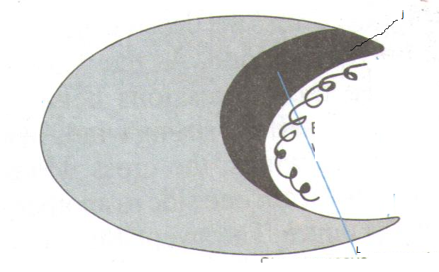

- Name the above feature. (1mk)
- Name the parts marked J and L (2mks)

