Term 1 – 2023 OPENER EXAM
GEOGRAPHY (312/1)
PAPER 1
FORM FOUR (4)
Time: 2 ¾ Hours
Name: …………………………………………………………. Adm No: ……………….
School: ……………………………………………………….. Class: …………………..
Signature: …………………………………………………….. Date: ……………………

Instructions to candidates
- Write your name, admission number and class in the spaces provided above.
- This paper has two sections: A and B
- Answer all the questions in section A
- Answer question 6 and any other two questions from section B
- All answers must be written in the answer booklet provided.
- This paper consists of 12 printed pages.
- Candidates should check the question paper to ascertain that all the pages are printed as indicated and that no questions are missing.
For Examiner’s Use Only
Section | Questions | Candidate’s  Score | Maximum  Score
A | 1 – 5 |  | 25
B | 6 |  | 25
 |  |  | 25
 |  |  | 25
 | Total Score |  | 100
SECTION A
Answer ALL questions in this section.
- (a) What is a natural satellite? (2 marks)
(b) The diagram below shows different positions of the earth during the revolution. Use it to answer the questions that follow.
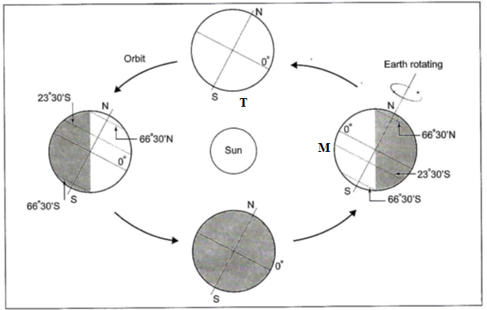

- Give the date when earth is at position marked T at midday. (1 mark)
- Identify the seasons experienced when earth is at position marked M. (2 marks)

- (a) Differentiate between sial and sima. (2 marks)
(b) Give three characteristics of the upper mantle. (3 marks)

- (a) Give two types of folds. (2 marks)
(b) State three effects of folding on physical environment. (3 marks)

- (a) What is Karst scenery? (2 marks)
(b) Give three ways in which a spring may be formed. (3 marks)

- (a) Give two agents of weathering. (2 marks)
(b) State three factors that cause soil creep. (3 marks)

SECTION B
Answer question 6 and any other two questions

- Study the map of Nyeri 1:50,000 (Sheet 120/4) provided and answer the following questions.
- (i) What type of map is Nyeri map extract? (1 mark)
(ii) Give the two scales that have been used in the map extract. (2 marks)
(iii) Measure the length of the road D435 from the chiefs centre to grid square 7154. Give your answer in km. (2 marks)
(iv) Calculate the area of Aberdare forest to the south of northing 50. Give your answer in Km² (2 marks)
- (i) Identify the methods that have been used to represent relief in the area covered by the map. (2 marks)
(ii) Give the physical features found in the grid square 7564. (2 marks)
(iii) Apart from forest, give two other types of vegetation in Nyeri map. (2 marks)
- Describe the drainage of the area covered by the map. (6 marks)
- Citing evidence from the map, name three economic activities in the area covered by the map. (6 marks)

- (a) (i) What is derived vegetation? (2 marks)
(ii) State three ways in which relief influences vegetation. (3 marks)
(b) (i) A part from forests, name two other vegetation zones in Kenya. (2 marks)
(ii) Give three categories of forests in Kenya. (3 marks)
(c) The diagram below shows major vegetation zones of the world.
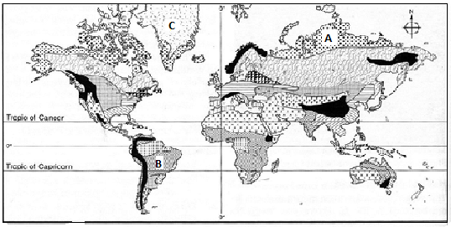

- Identify the vegetation zones marked A, B and C. (3 marks)
- State four characteristics of the vegetation in the zone marked B. (4 marks)
(d) Explain four significance of vegetation to human activities. (8 marks)

- (a) Differentiate between a river discharge and river regime. (2 marks)
(b) Describe three ways through which a river transports its load. (6 marks)
(c) The diagram below shows a section of a river. Use it to answer the questions that follow
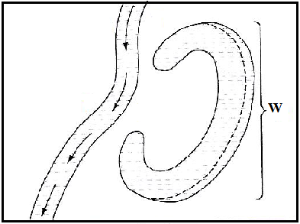
(i) At what stage of development is this section of the river? (1 mark)
(ii) Name two rivers in Kenya along which the feature marked W is found. (2 marks)
(iii) Describe how the feature marked W is formed. (6 marks)

(d) Members of your class plan to carry out a field study on a river within the county.
- Give two reasons why you would prepare a working schedule. (2 marks)
- State four significance of depositional features of a river your likely to identify during the study. (4 marks)
- Give two follow up activities you would be involved in. (2 marks)

- (a) (i) Identify two types of desert surfaces. (2 marks)
(ii) State three factors that have contributed to development of deserts. (3 marks)
(b) Describe two ways in which wind transports its load in arid areas. (4 marks)
(c) Using well labeled diagrams, describe how the following features are formed.
(i) Zeugen (5 marks)
(ii) Rock pedestal (5 marks)
(d) Explain three economic benefits of desert landforms. (6 marks)

- (a) (i) What is a glacier? (2 marks)
(ii) Apart from a valley glacier, name two types of ice masses found on mountains in East Africa.
(2 marks)
(b) Explain how the following factors influence the movement of glacier.
- Gradient of the land. (2 marks)
- Nature of the surface. (2 marks)
(c) Describe how a hanging valley is formed. (4 marks)
(d) Explain four positive effects of glaciation in lowland areas. (8 marks)
(e) Your class is to carry out a field study on land use on glaciated lowlands.
(i) Give three preparations you would make for your field study. (3 marks)
(ii) List two erosional features you are likely to identify during the study. (2 marks)

