Term 1 - 2023
GEOGRAPHY
QUESTION PAPER
FORM THREE
PAPER 1
TIME: 2 3/4 HOURS
Name: …………………………………………………………. Adm No: ……………….
School: ……………………………………………………….. Class: …………………..
Signature: …………………………………………………….. Date: …………………...

INSTRUCTIONS TO CANDIDATES:

- This paper has two sections A and B.
- Answer ALL questions in Section A. In section B answer question 6 and any other two questions.
- All answers to be written on the answer booklet provided.

SECTION A (25 MARKS)

Answer ALL the questions in this section
1. a) Name two forces that give the Earth its Geoid shape. 2mks
b) Apart from clouds, which two other solid particles are found in the Earth’s Atmosphere.
2mks
2. a) Outline two ways in which Earthquakes are measured. 2mks
b) State three factors that influence folding of crustal rocks. 3mks

3. a) Give three characteristics of nimbostratus clouds. 3mks
b) State three factors that influence atmospheric pressure. 2mks

4. a) State two natural causes of earth movement. 2mks
b) Name three boundaries due to earth movement. 3mks

5. a) List three causes of river rejuvenation. 3mks
b) State three characteristics of a river in its torrential stage. 3mks

SECTION B
Answer question 6 and any other two questions in this section
6. Study the map of Nyeri (1:50,000) sheet 120/4 provided and answer the questions that follow.
a) (i) Give the magnetic declination of the map. 1mk
(ii) Identify two physical features found in grid square 5649. 2mks
- Find the bearing of murram pit in grid square 6762 from the dam in grid square 6161. 2mks
- (i) Describe the drainage of the area covered by the map. 4mks
(ii)Citing evidence from the map name two economic activities carried out in the area. 4mks
c) (i) Draw a rectangle measuring 10cm x 7cm to represent the area between eastings 60 and 70 and northings 50 and 57. 1mk
(ii) On the rectangle, mark and name
- Nyeri Hill Forest 1mk
- Municipality boundary 1mk
- Forest Guard Post 1mk
(iii) Determine the new scale of the rectangle. 2mks

d) Students from Kagumo College grid 7648 conducted a field study of Aberdare Forest.
(i) Calculate area in km² of part of the forest between National Park Road and the National Park boundary that they studied. 2mks
(ii) State three follow-up activities they undertook after the field study 3mks

7. a) (i) Outline two differences between plutonic and volcanic rocks. 2mks
(ii) Give two examples of hypabyssal rocks 2mks
b) Describe the three ways by which sedimentary rocks are formed. 6mks
c) Students from your class conducted a field study on rocks around the school.
(i) State three characteristics they would look for while identifying different types of rocks. 3mks
(ii) List three methods they would use to record data while in the field. 3mks

d) Suppose from the field, they identified the following rock samples, augite, flint, gabbro, graphite, haematite and horn blende.
(i) Attempt to classify the above rocks by mode of formation. 3mks
(ii) State how they would use the following tools during the field study.
- Geological hammer 1mk
- Magnifying lens 1mk
- Polythene bag 1mk
- Dilute hydrochloric acid 1mk
e) Give two uses of rocks 2mks
8. a) Distinguish between weathering and mass wasting 2mks
b) Explain how the following factors contribute to the process of weathering
(i) Climate 2mks
(ii) Animals and plants 2mks

- Describe the following processes of weathering
(i) Exfoliation 3mks
(ii) Freezing and thawing 3mks
(iii) Carbonation 3mks

d) State and explain the significance of mass wasting in areas they have occurred. 6mks
e) You intend to carry out a field study on mass wasting around your school.
(i) State how you would prepare for the study. 2mks
(ii) What problems are you likely to encounter while out for the field study. 2mks

9. Study the map of the world provided and answer the following questions, a and b.
THE WORLD VEGETATION ZONES.
TROPIC OF CAPRICON
TROPIC OF CANCER
A
(a) Name the types of forests found in the regions marked X and Y, the grasslands in region K and the vegetation in region M. 4mks
(b) Describe the forest vegetation characteristics of the zone marked A identified. 4mks
(c) Give the names of
- The types of grassland vegetation found in:
- South Africa
- Australia 2mks
(ii) Explain four adaptations of the trees in the coniferous forests to climatic conditions. 8mks
(d) Students went to carry out a field study on vegetation zonation on the Mount Kenya slope.
(i) State two activities they would be involved in during the field study. 2mks
(ii) List three features they were likely to study. 3mks
(iii) State two problems they may have encountered. 2mks

10. (a) (i) Define River regime. 1mk
(ii) Describe how river erosion takes place through abrasion. 2mks
- The diagram below represents some features formed at the old stage of a river. Use it to answer questions (i), (ii), (iii).
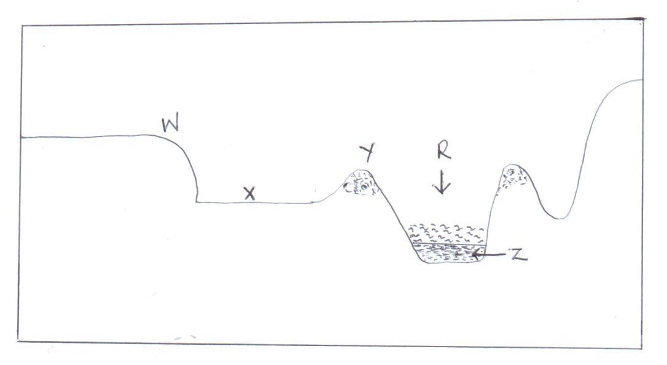
  - Identify the features marked W, X and Z. 3mks
  - Describe the formation of the feature marked Y. 3mks
  - Outline the significance of a river at the stage shown on the diagram. 5mks
- (i) Describe Trellis drainage pattern. 5mks
  - With the aid of well labeled diagrams, describe how an ox-bow lake is formed. 6mks

