Term 1 - 2023
GEOGRAPHY (312/2)
PAPER 2
FORM FOUR (4)
Time: 2 ¾ Hours

Name: …………………………………………………………. Adm No: ……………….
School: ……………………………………………………….. Class: …………………..
Signature: …………………………………………………….. Date: …………………… INSTRUCTIONS TO STUDENTS

- This paper has TWO sections A and B
- Answer ALL the questions in section A. In section B answer questions 6 and any other TWO questions.
- All answers MUST be written in the answer booklet provided.

SECTION A
Answer all the questions in this section.
1. (a) Define the term Geography (2 marks)
(b) Give three reasons why Geography is taught in Kenya. (3 marks)
2. (a) What is agroforestry? (2 marks)

(b) Mention three reasons why agroforestry is encouraged in Kenya (3 marks)
3. (a) Differentiate between horticulture and market gardening. (2 marks)
(b) State ways in which the government is using to control locust invasion in Kenya. (3 marks)
4. (a) Name two counties where maize is grown in Kenya (2 marks)
(b) State three conditions necessary for Maize farming. (3 marks)
5. (a) Explain the factors that have led to the increasing demand for fresh fruits and vegetables in Kenya. (5marks)

SECTION B
Answer question 6 and any other TWO questions from this section.

6. The table below shows Kenyan exports by destination in Ksh. Million between 2008 – 2010. Use it to answer question (a).
Region/year | 2008 | 2009 | 2010
Europe | 94,685 | 100,975 | 109,422
America | 22,055 | 18,961 | 24,380
Africa | 116,995 | 162,732 | 188,914
Asia | 57,241 | 59,236 | 81,600
Others | 206 | 3,044 | 5,225

(a) (i) In which year were Kenya’s exports highest? (1 mark)
(ii) Using a radius of 5cm, draw a pie chart to represent the data on Kenya’s exports in 2009. (8 marks)
(iii) State two advantages of using pie charts to represent data. (2 marks)
(b) Give reasons why horticultural farming is more developed in the Netherlands than in Kenya. (6marks)
(c) Mention major cash crops grown in Kenya (4marks)
d) Identify four characteristics of plantation farming in Kenya (4marks)

7. (a) Name two by-products obtained when crude oil is refined. (2 marks)
(b) State three ways in which mining derelicts can be reclaimed. (3 marks)
(c) (i) Give two uses of Gold. (2 marks)
(ii) Identify three problems facing gold mining in South Africa. (3 marks)
(iii) Describe the processing gold. (5 marks)
(d) (i) Name two alluvial mining methods. (2 marks)
(ii) Explain four ways in which soda ash mining contributes to the economy of Kenya. (8 marks)
8. Study the photograph shown and answer the questions that follow
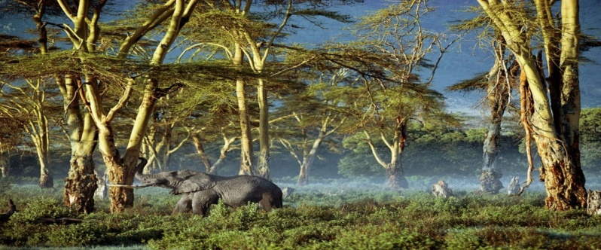
- (i) What type of a photograph is this ? Give justification for your answer. (3 marks)
(ii) Which type of a forest is this ? (1 mark)
(b)Draw a rectangle measuring 12 cm by 10cm to represent the photograph .On the rectangle mark and label three main features . (5marks
(c ) Explain six reasons why Kenya should conserve her forests. (12 marks)
(d) Give the differences between forestry in Kenya and Canada under the following sub-headings.
(i) Tree harvesting (2marks)
(ii) Transportation of logs. (2marks)
9. (a) Name two counties in Kenya where wheat is grown in large scale .(2 marks)
- State five physical conditions that favour wheat growing in the Kenya.
(5 marks)
(c) (i) Describe coffee growing in Kenya from planting to harvesting. (6 marks)
(ii) State four problems facing coffee farming in Kenya. (4 marks)
(d) Explain four measures taken by the government of Kenya to improve beef cattle farming. (8 marks)
10. (a)(i) What is nomadic pastoralism? (1marks)

(ii) Name two nomadic communities in Africa. (2marks)
(b) State five characteristics of nomadic herding. (5marks)
(c) Give four problems facing nomadic pastoralism. (4marks)
(d) Highlight three undertakings by the government of Kenya aimed at improving the livestock industry. (3marks)
(e) Discuss how cattle ranching contribute to the economy of Kenya. (5marks)

(f) State at least three features of ranching. (3marks)
(g) Give at least two problems facing pastoral communities in Kenya today. (2marks)

