**Term 1- 2023 OPENER EXAM**

**GEOGRAPHY (312/1)**

**PAPER 1**

**FORM FOUR (4)**

**Time: 2 ¾ Hours**

**MARKING SCHEME**

1. **(a) What is a natural satellite?**

* *a celestial body that orbits a larger celestial body *

**(b) The diagram below shows different positions of the earth during the revolution. Use it to answer the questions that follow.**

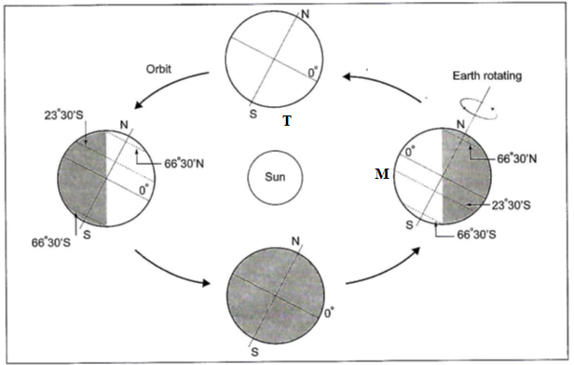

1. **Give the date when earth is at position marked T at midday.**

* *21st March 1 mark*

1. **Identify the seasons experienced when earth is at position marked M.**

* *Winter in the northern hemisphere*
* *Summer in the southern hemisphere *

1. **(a) Differentiate between sial and sima.**

* *Sial is part of crust which forms the continents while sima is the inner layer of the crust that forms the ocean floor.* 1*×*2*=2marks*

**(b) Give three characteristics of the upper mantle.**

* *Made up of hard rigid rocks*
* *Temperature is about 16000C*
* *Dominant minerals are olivine/ferro-magnesium silicate*  

1. **(a) Give other two types of folds.**

* *simple/symmetrical fold*
* *monoclinal fold*
* *asymmetrical fold*
* *over fold*
* *isoclinal fold*
* *recumbent fold*
* *overthrust/nappe fold* 

**(b) State three effects of folding on physical environment.**

* *Fold mountains receive heavy rainfall which give rise to rivers*
* *Fold mountains cause heavy rainfall in the windward slope/little rainfall on leeward side*
* *The heavy rainfall on the windward slopes leads to growth of thick forests*
* *The process of folding created crustal weakness which triggered off volcanic activities*
* *In the mountainous regions, the cold wind descend to the lowland and valleys causing frost/ temperature inversion*
* *Folding results in the formation of relief features/mountains/…*
* *In the northern hemisphere, the south facing slopes are warmer than the north facing slopes*

3×1=3 *marks*

1. **(a) What is Karst scenery?**

* *This refers to any area of limestone, chalk or dolomite rocks with unique features*

1×2=2 *marks*

**(b) Give three ways in which a spring may be formed.**

* *Where a permeable rock overlies an impermeable rock.*
* *Where there is a well jointed rock.*
* *At the foot of a steep scarp underlain by impermeable rock layers.*
* *Where an aquifer lies on the upper side of a dyke which out crop.*

3×1=3 *marks*

1. **(a) Give two agents of weathering.**

* *water*
* *air*
* *living organisms*
* *temperature* 2×1=2 *marks*

**(b) State three factors that cause soil creep.**

* *Temperature change causes soil particles to expand and contract.*
* *Rain water causes soils to become wet and compact.*
* *Freezing of soil water expands the spaces between soil particles.*
* *Human activities e.g. cultivation*
* *External forces e.g. vehicles and earth tremors.*

3×1=3 *marks*

1. **Study the map of Nyeri 1:50,000 (Sheet 120/4) provided and answer the following questions.**
2. **(i) What type of map is Nyeri map extract?**

* *Topographical map* 1×1=1 *mark*

**(ii) Give the two scales that have been used in the map extract.**

* *Representative fraction/ratio*
* *Linear scale* 

**(iii)** **Measure the length of the road D435 from the chiefs centre to grid square 7154. Give your answer in km.**

* *7.4±0.1 km* 1×2=2 *marks*

**(iv) Calculate the area of Aberdare forest to the south of northing 50. Give your answer in Km2**

* *37+=36km2* 1×2=2 *marks*

1. **(i) Identify the methods that have been used to represent relief in the area covered by the map.**

* *contours*
* *trigonometrical station* 

**(ii) Give the physical features found in the grid square 7564.**

* *river*
* *gentle slope*
* *river valley* 
* *scrub vegetation*

**(iii) Apart from forest, give two other types of vegetation in Nyeri map.**

* *scrub*
* *woodland*
* *bamboo*
* *thicket* 

1. **Describe the drainage of the area covered by the map.**

* *the main drainage features are rivers*
* *there are many permanent rivers e.g. R.Amboni(Honi)*
* *there are indefinite rivers*
* *most of the rivers originate from Aberdare forest*
* *most rivers form dendritic drainage pattern*
* *there are dams*
* *the main river is R. Amboni* 

1. **Citing evidence from the map, name three economic activities in the area covered by the map.**

* *crop farming – coffee factory*
* *trade - shops*
* *forestry – aberdare forest/forest guardpost*
* *manufacturing/processing – coffee factory*
* *transport – roads*
* *lumbering – sawmill* 

1. **(a) (i) What is derived vegetation?**

* *natural vegetation which is in the process of recovering from humans’ disturbance but yet to reach a new climax* 

**(ii) State three ways in which relief influences vegetation.**

* *high altitude areas support growth of forests due to low temperatures and high rainfall*
* *gentle slopes with well drained and mature soils have luxuriant growth of vegetation*
* *steep slopes which undergo heavy erosion mass wasting have thin soils hence poor plant growth*



**(b) (i) A part from forests, name two other vegetation zones in Kenya.**

* *savannah woodland*
* *savannah grassland*
* *scrub and desert vegetation*  

**(ii) Give three categories of forests in Kenya.**

* *highland/mountain forests*
* *lowland forests*
* *plateau forests* 

**(c) The diagram below shows major vegetation zones of the world.**

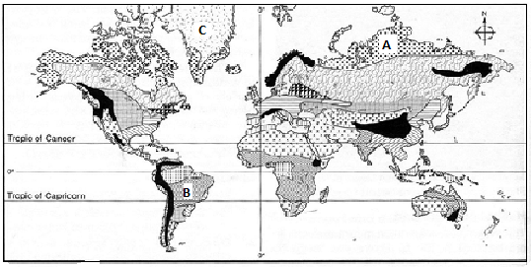

1. **Identify the vegetation zones marked A, B and C.**

* ***A*** *- Tundra vegetation (1 mark)*
* ***B –*** *Tropical (savanna) grassland (1 mark)*
* ***C –*** *Ice cap vegetation (1 mark)*

1. **State four characteristics of the vegetation in the zone marked B.**

* *Vegetation consists of mixture of scattered trees and dense growth of grass*
* *Acacia trees are the dominant species*
* *Trees are of medium height(13m) with umbrella shaped crowns*
* *Most trees are deciduous and shed their leaves in dry season*
* *The grasses are tall (3m)*
* *Trees have deep roots to tap water*
* *Trees have thin leaves reduced to thorns to limit water loss *

**(d) Explain four significance of vegetation to human activities.**

* *Forested areas act as water catchment areas providing for sources of rivers which provide water for domestic and industrial uses*
* *Vegetation promote tourism by providing home/habitat for wild animals*
* *Trees provide poles used in electricity, fencing, timber for furniture, building and construction*
* *Vegetation provides raw materials for paper, rubber and textile industries thus leading to industrialization*
* *Some vegetation have medicinal values* 

1. **(a) Differentiate between a river discharge and river regime.**

* *River**discharge is the amount of water that is passing through a particular point on the river’s course while river**regime is the seasonal variation or fluctuation in the volume of water in a river*. 1×2 = 2 *marks*

**(b) Describe three ways through which a river transports its load.**

* *Solution: this involves transportation of materials that are dissolved in water*
* *Suspension; lighter material float on the water surface or are partially submerged in the river water flowing downstream.*
* *Traction: larger particles (boulders) are pushed and rolled along the streambed by the force of water/hydraulic action and action of gravitational force.*
* *Saltation/hydraulic lift: medium sized load are moved in a series of short jumps/hops along the riverbed.*  3×2 = 6 *marks*

**(c) The diagram below shows a section of a river. Use it to answer the questions that follow**

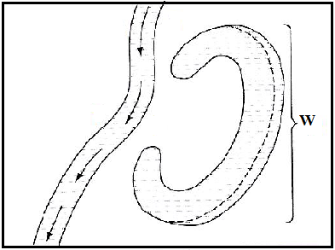

**(i) At what stage of development is this section of the river?**

* *old/lower/plain stage* 1×1 = 1 *mark*

**(ii) Name two rivers in Kenya along which the feature marked W is found.**

* *River Yala*
* *River Tana* 2×1 = 2 *marks*

**(iii) Describe how the feature marked W is formed.**

* *A river flows slowly and tends to flow round an obstacle instead of cutting through it.*
* *a bend develops around the obstacle, the water current pushes hard on the outer banks causing maximum lateral erosion*
* *The river water comes to a temporary stand still on the inner bank causing the river to deposit alluvium while at the same time eroding the outer bank*
* *The meander grows bigger and more pronounced due to alternate deposition and erosion on the inner and outer banks respectively*
* *Active lateral erosion takes on the outside of the bends narrowing the meander neck. The meander neck is eventually cut through*
* *The cut ends of the meander are sealed by deposition and the meander now becomes an ox-bow lake*

6×1 = 6 *marks*

**(d) Members of your class plan to carry out a field study on a river within the county.**

1. **Give two reasons why you would prepare a working schedule.**

* *so as to remain within the range of the study.*
* *to effectively estimate the time required for the study.*
* *to enable assessment of the field study whilst in progress.*
* *to ensure completion of the field study within the stipulated times*
* *to ensure no activity is forgotten during the field study by giving adequate time for each.*

2×1 = 2 *marks*

1. **State four significance of depositional features of a river your likely to identify during the study.**

* *deltas (other features) attract tourists who visit them*
* *flood plains contain fertile alluvial soils which support crop farming*
* *gentle nature of flood plains makes it suitable for settlement*
* *river beds have deposits of gravel and sand used in building and construction*
* *alluvial deposits may contain valuable minerals which support mining*

4×1 = 4 *marks*

1. **Give two follow up activities you would be involved in.**

* *displaying photographs*
* *drawing diagrams*
* *writing reports*
* *holding group discussions*

2×1 = 2 *marks*

1. **(a) (i) Identify two types of desert surfaces.**

* *Sandy/erg*
* *stony desert/reg*
* *rocky deserts/Hamada* 2×1 = 2 *marks*

**(ii) State three factors that have contributed to development of deserts.**

* *Increased temperatures and excessive evaporation/ prolonged drought/no rainfall/little rainfall*
* *Existence of cold ocean currents on path of rain-bearing wind*
* *Rain shadow effects of high mountains*
* *Continentality /remoteness/distance from the sea*
* *Human activities e.g deforestation/overstocking*
* *Anticyclones/ descending/diverging winds* 3×1 = 3 *marks*

**(b) Describe two ways in which wind transports its load in arid areas.**

* *Suspension-fine dust particles are lifted clear off the ground. Eventually they are blown away by wind currents and transported for long distances.*
* *Saltation-large fragments/sand particles are lifted from the ground by eddy currents. They are moved in a series of hop sand jumps within the wind current.*
* *Surface creep-heavy materials/small stones/pebbles are dragged along the ground by wind currents for short distance.*

2×2 = 4 *marks*

**(c) Using well labeled diagrams, describe how the following features are formed.**

**(i) Zeugen**

* *Physical weathering assists in widening the joints/cracks on the upper layers of rock and causing the rock to disintegrate along the cracks/joints*
* *Prevailing winds then remove and carry the loose unconsolidated materials through deflation*
* *Abrasion continues to act on the lines of weakness, enlarging and deepening the furrows.*
* *The less resistant rocks are eroded further leaving behind a resistant and standing tabular mass/ridge on either side of the furrow called a* ***zeugen.***

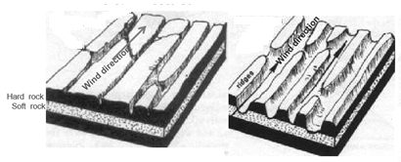

*Text – 3 marks Diagram – 2 marks*

**(ii) Rock pedestal**

* *A mass of rock with alternating layers of resistant and less resistant (heterogeneous) rocks lie horizontally in the path of wind ladened with weathered material*
* *The less resistant layers are heavily eroded by wind abrasion as the wind-borne materials knock on them compared to the resistant rock layers that undergo little erosion*
* *This result in the formation of an irregular rock mass with protruding layers of resistant rocks alternating with layers of less resistant rocks called a* ***rock pedestal***

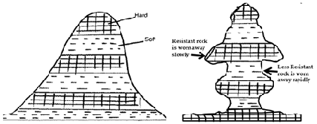

*Text – 3 marks Diagram – 2 marks*

**(d) Explain three economic benefits of desert landforms.**

* *Water from the oasis is used for irrigation, domestic use and industrial use.*
* *Loess form fertile soils in which support crop farming.*
* *Desert features form a major tourist attraction e.g. rock pedestals, yardangs and Zeugens earning foreign exchange*

3×2 = 6 *marks*

1. **(a) (i) What is a glacier?**

* *this is a mass of ice moving outward from an area of accumulation.* 1×2 = 2 *marks*

**(ii) Apart from a valley glacier, name two types of ice masses found on mountains in East Africa.**

* *Ice caps*
* *Cirque glaciers* 2×1 = 2 *marks*

**(b) Explain how the following factors influence the movement of glacier.**

* ***Gradient of the land-*** *Ice move faster when the slope is steep due to influence of gravity*

1×2 = 2 *marks*

* **Nature of the surface**
* *When ice is moving on a rough surface, friction occur which lower the speed of the ice movement.*
* *When ice moves on a smooth surface, it moves faster due to lack of friction.*1×2 = 2 *marks*

**(c) Describe how a hanging valley is formed.**

* *Initially there exist river valleys; the main and a tributary valley*
* *Both the main and tributary valley are occupied by the glacier.*
* *There is more erosion on the main valley compared with the tributary valley.*
* *The main valley is therefore deepened and widened faster than the tributary valley.*
* *When the glacier melts, it exposes a deep, - shaped glacial valley, with the smaller tributary valley suspended high up the valley side.*
* *the suspended tributary valley form a hanging valley*

4×1= 4 *marks*

**(d) Explain four positive effects of glaciation in lowland areas.**

* *Glacial till provide fertile soils which are good for arable farming.*
* *Outwash plans are made up of sand and gravel which are used as materials for building and construction*
* *Glaciated lowland features are tourist attractions hence earning the country foreign exchange.*
* *Ice melts in to rivers which can be exploited for domestic use.*
* *Ice sheets in their scouring effect reduce the land surface thus exposing minerals making it easy to exploit.*

4×2= 8 *marks*

**(e) Your class is to carry out a field study on land use on glaciated lowlands.**

**(i) Give three preparations you would make for your field study.**

* *Preparation of questionnaire.*
* *Read through relevant books.*
* *Seek permission.*
* *Prepare a working schedule* 3×1 = 3 *marks*

**(ii) List two erosional features you are likely to identify during the study.**

* *crag and tail*
* *roche mountonee*
* *depressions*
* *ice eroded plains* 2×1= 2 *marks*