GEOGRAPHY 312/1
PAPER 1
SUKELLEMO JOINT EXAMINATION
MARKING SCHEME
JUNE 2022
- Explain two relationships between geography and physics
- Physics deals with aspects of matter, energy, light, heat, sound, gravity and magnetism. Similarly geography while studying the atmosphere focuses on the heat from the sun which is responsible for the movement of air, evaporation of water and distribution of moisture in the atmosphere.
- Information obtained by geophysics about the earth’s magnetic field, gravity and vibrations of the earth helps geographers in understanding the cause’s effects of earthquakes.
(2pts well explained x 2 = 4 marks
- a) What is the difference between a meteor and a meteorite?
- A meteor is a visible streak of light given off when a meteoroid is passing through the sky whereas a meteorite is a solid piece of debris that origins from outer space as a remnant of a meteoroid
(2 marks.)
b) State four effects of ration of the earth on its own axis.
- Rising and falling of tides
- It causes day and night
- Results in a difference of one hour between two longitudes 15⁰ a part
- Deflection of winds and ocean currents.
Give geographically clear statements to be awarded (1 mark x 4 = 4 marks)

- a) What is atmospheric pressure?
- Is the weight / force exerted at a point on the earth’s surface due to the weight of a column of air above that point.
(1 x 2 marks)
b) Identify three factors that influence atmospheric pressure on the surface of the earth.
- Temperature
- Altitude
- Earth’s rotation
(3 x 1 = 3 marks)
- a) Desert basin
- marks)
b) L- Playas
M- Bajada
N- Pediment
(3 x 1mark each = 3marks)
- a) Name two types of ice masses found on mountains in East Africa.
- Ice caps
- Cirque /corrie glaciers
- Valet glaciers.
(Any 2 x 1 = 2marks)

b) Describe three district characteristics of a pyramidal peak.
- Has steep slopes
- Is surrounded by cirques / corries
- Is a sharp rock pinnacle / horn
- Has radiating pattern of aretes
(Any 3 x 1 = 3 marks)

SECTION B (75 MARKS)
Answer question six and any other two questions from this section
- Study the map of Nyeri 1: 50,000 (sheet 120/4 provided and answer the following questions:

- i) What is the map title?
- East Africa 1: 50,000 (Kenya)
(1mark))
ii) Longitudinal extent of the area covered by the map
- 36⁰45` East to 37⁰00` East
(2 marks)

iii) Index to the adjoining sheet to the North West of the area covered by the map
- 120/1 - Ndaragwa
(1 mark)
iv) Identify two provinces that are covered by the area shown on the map
- Rift valley province
- Central province
(2 x 1mk each = 2marks)
- i) Complete squares – 35
Incomplete squares – ¹³_{/2} = 6.5

Area is (35 + 6.5) square kms
= 41.5km²

(2marks)

ii) Name 3 human features in grid square 6660

- Water hole
- Building
- Pipe line
- Dry weather road
- Natural park boundary
(Any 3 x 1 = 3 marks)

ci)
Using a vertical scale of 1cm represents 40cm, draw a cross-section along northing 60 from easting 64 to 70
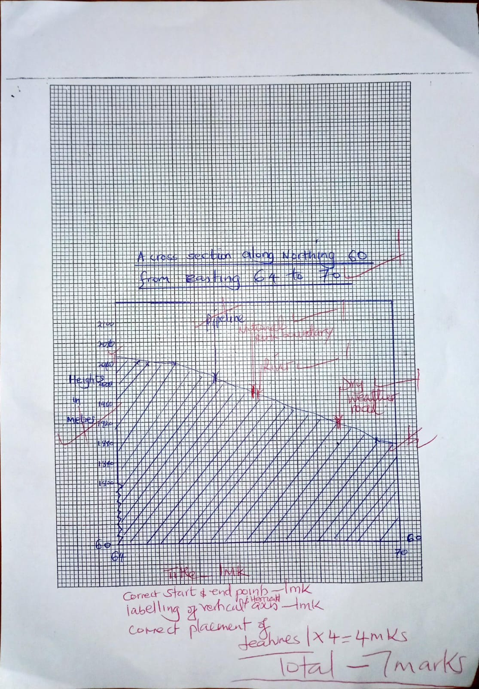
(3mks)
ii) Icm reps 40 m
1m = 100cms
40ms = (40 x 100)
= 4000cm
HS = 1, 5,000
VE = ^{VS}/_{HS} = ¹.₄₀₀₀ ÷¹/₅₀₀₀₀
⁵⁰⁰⁰⁰/₄₀₀₀ = 12.5
(2 marks)

- Describe the relief of the area covered by the map
- The area is generally rising towards the west
- There are many river valleys drained by rivers such as River Muringaro
- There are many ridges on the western part of the area covered by the map
- There are spurs on river valleys.
- The Eastern part of the area covered by the map is generally low-lying shown by widely spaced contours.
- The Western part of the area covered by the map is steep shown by closely spaced contours. There are several peaks on the western part of the area covered by the map.
(Any 5 x 1 = 5 mark
7a)
- What is a rock? (2mks)
A rock is an aggregate of mineral particles which form the solid part of the earth`s crust
( 1 x 2 = 2mark)

- State any three characteristics of minerals (3mks)
- Minerals have different degrees of hardness
- Some minerals aggregate into distinct shapes e.g. quartz is a six sided prism
- Some minerals have one element while others have more than one element
- Minerals can be opaque, translucent or transparent i.e. have different ability to allow light to pass through
- Different minerals have different texture
- Different minerals have different colors e.g gold is yellow
- Minerals have luster i.e the surface appearance of minerals
- Minerals differ in steak. This is the Colour that a mineral leave when it is rubbed against a hard surface
- Minerals have different degree of tenacity i.e. the ability to withstand tearing, crushing, crushing or breaking
(3x 1mk each = 2marks)

b) Explain three classification of mechanically formed sedimentary rocks and to each give an example. (6mks)
- Areneceous-formed mainly from sand particles eg sand stones
- Argillaceous-formed from very small particles such as those of mad and clay e.g. shale, claystone, siltstone, loess &mudstone
- Rudaceous-rocks which have particles larger in size than sand particles e.g. congremerate,breccia and boulder clay
(3 x 2mk each = 6marks)

Ci) State three changes that occur in the sedimentary rocks when they are subjected to intense heat and pressure. (3mks)
- Change in physical appearance
- Change in shape
- Change in chemical competition
- Change in hardness
(2 x 1mk each = 2marks)

ii) Outline any three differences between plutonic and volcanic rocks (3mks)
- Plutonic rocks form from magma while volcanic rocks form from lava
- Plutonic cool slowly while volcanic rocks cool rapidly
- Plutonic rocks are coarse textured whereas volcanic rocks are fine textured
- Plutonic rocks consists large crystals whereas volcanic rocks have small crystals
- Plutonic rocks are formed below the earth’s surface whereas volcanic form on the earth’s surface.
d) Name the type of rocks which results from metamorphism of;
- Granite - Gneiss (1mk)
- Clay - Slate (1mk)

- Name the substances in the areas labelled L, M and N (3mks)
- L-Gas
- M-Oil/petroleum
- N-Water
- Give three by products obtained when crude oil is refined (3mks)
- wax
- bitumen/Tar
- lubricant/grease

8)

- What are faults? (2mks)
- Faults are fractures or cracks that develop in the crust as a result of earth movement
( 1 x 2= 2 mark)

- Identify any three major faulted areas of the world (3mks)
- The Great Rift Valley region
- The western cordillera of North America
- Northern England and the Great Glen fault in Scotland
- The Guadalquivir valley of Spain
- The central massif of southern France
- The middle Rhine rift valley at the borders of north east France

i)Other than the reverse fault, name two other types of faults (2mks)
- Normal fault
- Shear/tear fault
- Thrust fault
- Anticlinal fault

- With the aid of a well labelled diagram, describe how a reverse fault is
formed . (5mks)
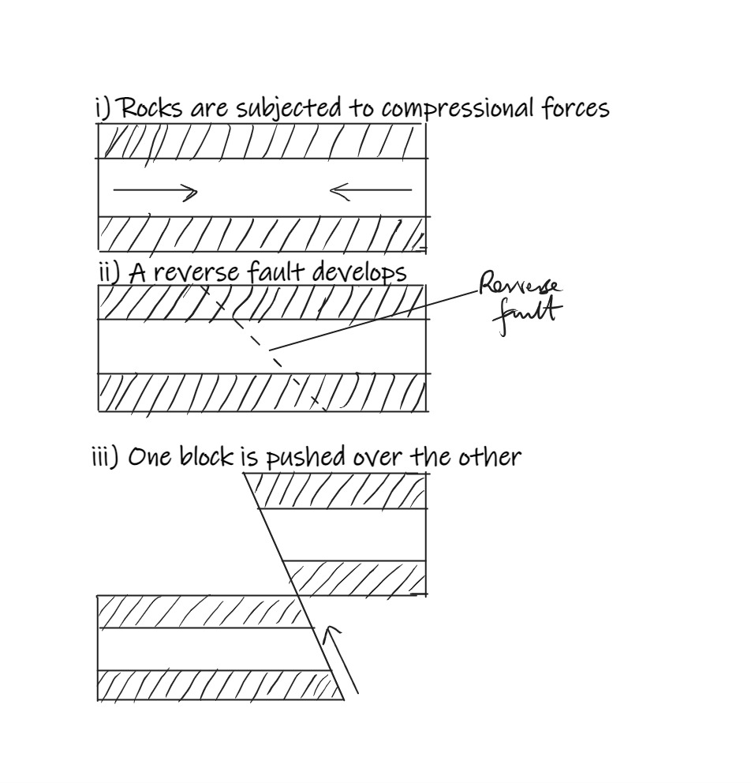

Diagrams 3, text 2 = 5 marks

Name the escarpments labelled A to D (4mks)
A-Kikuyu
B-Nguruman
C-Mau
D-Tugen
- Apart from the rift valley, identify any other 3 features resulting from faulting(3mks)
- Fault scarps
- Fault steps
- Fault blocks
- Tilt block
(Any 3 x 1 = 3mark
- Explain three ways in which faulting can influence drainage (6mks)
- Uplifting of landscape which leads to faulting may cause rivers to reverse their direction of flow
- Vertical faulting across a river may cause a change in the local base level resulting in the formation of a waterfall
- Basins /depressions resulting from faulting may be filled with water to form lakes.
- Some rivers flow a long fault lines forming a fault guided drainage pattern.
- Some rivers may disappear into the ground through a fault forming underground streams.
(Any3 x 2= 6 mark)
9)
i)
Distinguish between an ocean and a sea (2mks)
- An ocean a large and extensive body of saline water occupying a basin between continents while a sea is large body of saline water on the margins of continents
- State four sources of ocean salinity (4mks)
- Most of the salinity is thought to have existed since the formation of the water bodies
- A lot of salinity is salt from rivers which carry dissolved salt form the land.
- Sea water also dissolves salt directly from the rock it is in contact with.
- Salts may be added from volcanic materials on the floor of the ocean.
4 x 1 = 4 marks

- with well labelled diagrams, explain how the following wave erosional features are formed (10mks)
- Cliff
- A cliff is a steep rock bordering the sea
- Forms where the coast is sloping smoothly but steeply into the sea
- Breaking wave cut a notch on the rock surface at the position where they break at high tide
- The base of the rock face continues to be undercut by the breaking waves, while the upper part of the rock is attacked by weathering.
- If the upper part resist weathering and undercutting continues, the rock may eventually collapse forming a cliff.
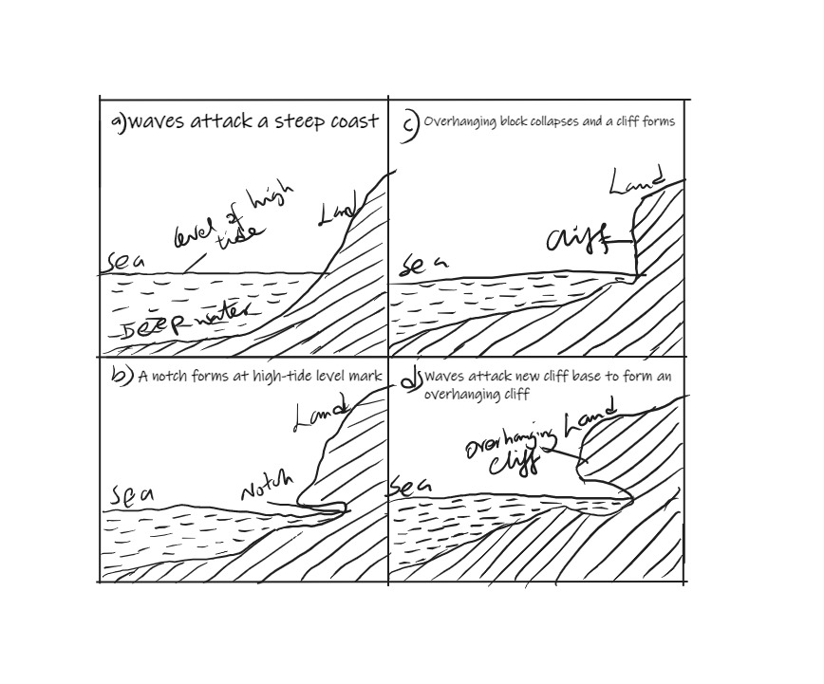
Diagram 2mks, text 3mks=5mks
- Geo
- A geo is along; narrow and steep-sided sea inlet that runs inland from the edge of a cliff.
- Marine erosion wears away the base of a cliff along lines of weaknesses such as a major joint; a cave forms and is extended inland.
- Waves surging into the cave keep cutting away at its roof.
- Compressional air action also widens and acts on the roof of the cave.
- The roof of the cave between the blowhole and the edge of the cliff collapse
- A narrow sea inlet forms called a geo.
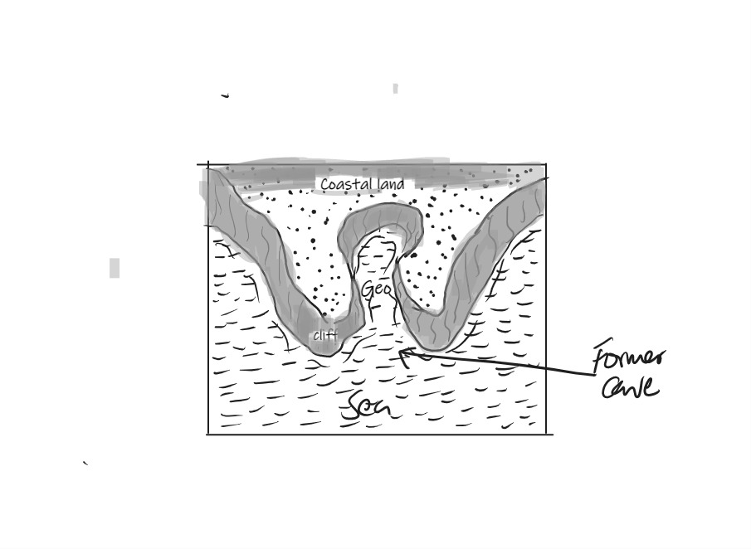
Diagram 2mks, text 3mks=5mks
- You are planning to carry out a field study on the depositional features along the coast of Kenya
- Give three types of submerged highland coasts you identified (3mks)
- A ria coast
- Fiord coast
- Longitudinal coast
(3 x 1 = 3 mark

- State three objectives you would formulate for the study (3mks)
To find out the various types of depositional features
To find out the economic importance of depositional features
To establish how depositional features have affected human activities along the Kenyan coast

Any other relevant point (3 x 1 = 3 mark

- Give three methods you would use to record the information collected (3mks)
- Taking notes
- Tallying
- Field sketching
- Photographing

- Name the ranges marked P, Q, R, S (4mks)

P-Andes
Q- Appalachians
R-Atlas mts
S-Himalayas

- Apart from fold mountains, name two other features resulting from folding (2mks)
- Rolling plains
- Ridge and valley landscape
- Intermontane plateau
- Intermontane basins
(Any2 x 1= 2 mark
- Explain how the following theories led to the formation of fold mountains
- Contraction theory (3mks)
- The surface rocks cooled and contracted faster than those of the interior
- Since the interior was cooling at a slower rate, the surface rocks started wrinkling in order to fit on the cooling and contracting rocks of the interior
- These wrinkles became Fold Mountains.
(Any3 x 1= 3 mark
- The convectional current theory (3mks)
- When the convectional currents in the mantle move horizontally, they cause a frictional pull on the crustal rocks, making them move along.
- When continental coasts are pulled towards each other due to the effect of these currents.
- The sediments in the sea are squeezed into folds
(Any3 x 1= 3 mark
- Explain four negative effects of fold mountains on human activities (8mks
- Fold Mountains act as transport and communication barriers, crossing through such mountains could only be through passes which sometimes are covered by snow. Use of aircrafts may be problematic due to poor visibility.
- When cold winds descends through some mountains, they may cause a lot of harm to crops such as graphs.
- Relief of some mountainous areas discourages settlement due to their ruggedness and steepness.
- Folding sometimes causes the crustal rocks to become weak because faults develop in such rocks. The weak lines act as passes for magma to escape, thus triggering off volcanic activity.
(4 x 2 = 8 marks

- State three ways in which the students would prepare themselves for the study. (3mks)
- Seek permission from relevant authorities
- Conducting a reconnaissance
- Holding class discussions
- Preparing a questionnaire
- Dividing themselves into groups
- Assembling of relevant documents
- Reading through relevant documents
- Preparing of a working schedule
(Any 3 x 1 = 3 marks)
- Name two follow up activities they would conduct after the study (2mks)
- Report writing
- Displaying of the samples on the notice board
- Holding of class discussions
- Analyzing data
(Any 2 x 1 = 2marks)

