NAME: ………………………………… ADM NO: ………… CLASS: …………
312/1
GEOGRAPHY
PAPER 1
FORM THREE
MARKING SCHEME

INSTRUCTIONS TO CANDIDATES:
- This paper consists of three sections; A, B and C.
- Answer all questions from section A and B.
- In section C, answer any three questions. All answers must be written on the answer sheets provided.
SECTION A:
Answer all the questions in this section.

1. (a) Name two types of earth movements. (2 mks)
- Horizontal/Lateral/Orogenic earth movement
- Vertical/Epeirogenic earth movement.

(b) The diagram below represents tectonic plate boundary.

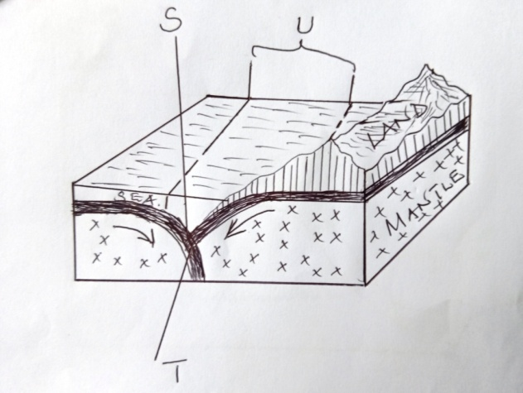

Name the areas marked S, T and U. (3 mks)
- S – Oceanic trench
- T – Destructive/convergent/compressional boundary
- U-Subduction zone

2. (a) Differentiate between seismic focus and epicenter. (2 mks)
- Seismic focus is the origin of the shock waves inside the earth’s crust whereas epicenter is the point on the earth’s surface vertically above the focus.

(b) Name two types of surface longitudinal waves. (2 mks)
- Rayleigh waves
- Love waves

3. (a) Apart from exfoliation, name two other physical weathering processes influenced by
temperature changes. (2 mks)
- Block disintegration/Block separation
- Granular disintegration
- crystal growth
- frost action

(b) Describe exfoliation process. (4 mks)
- Occurs within rocks of uniform structure mainly in arid and semi-arid areas.
- During the day, temperatures are high and the rocks are heated on the surface and the inner part is coloer making the rock surface to expand.
- During the night, temperatures are lower and the rocks cool and contract on the surface.
- Continued expansion and contraction makes the rock surface to develop cracks which will break and peel off in cured sheets, this is exfoliation.

4. (a) State two ways through which a river transports its load. (2 mks)
- By solution
- By suspension
- By saltation/Hydraulic lift
- By traction/rolling

(b) State three conditions necessary for the formation of a delta. (3 mks)
- There must be large quantities of silt/sediments to be deposited at the river mouth
- There should be a shallow continental shelf/shore around the river mouth
- Higher rate of deposition than rate of removal of silt at the river mouth/presence of calm sea/weak sea waves/weak tidal currents at the coast.
- Absence of obstacles/filters in the river course such as swampy vegetation/marsh.
5. (a) The diagram below shows a process of slow mass wasting.

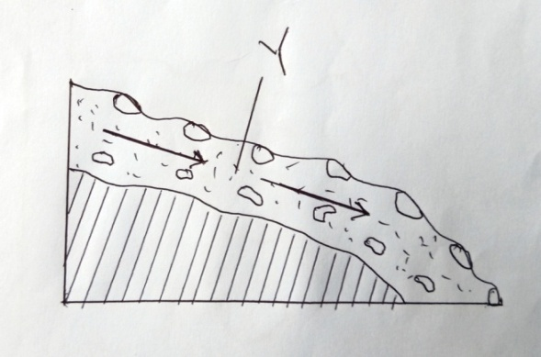
(i) Identify the process. (1 mk)
- Solifluction/Solifluxion

(ii) Name the feature marked Y. (1 mk)
- Saturated soil/rock debris

(b) State three conditions which may influence occurrence of landslides. (3 mks)
- Nature of materials on a slope
- Extent of saturation/Amount of precipitation
- Angle of the slope/Gradient of the land
- Human activities such as mining and building
- Occurrence of earthquakes/volcanic eruptions/isostatic adjustment.

STUDY THE MAP OF YIMBO (1:50,000 SHEET 115/1) provided and answer the following questions
6. (a) (i) Name two natural features found in grid square 3696. (2 mks)
- River
- Scrub
- Scattered trees/woodland
(ii) Give two types of scales used on Yimbo map. (2 mks)
- Ratio scale
- Linear scale
(iii) Give the six figure grid reference of the trigonometrical station point
1207 (115 T 27) (2 mks)
- 329857
(b) (i) Give the adjoining sheet found to the North-east of Yimbo map . (1 mk)
- Ugenya (101/4)

(ii) Give the latitudinal and longitudinal extent of the area covered by the map extract.
(2 mks)
- OºOO’ – Oº15’S, 34ºOO’ – 34º15’E
(c) Identify three types of natural vegetation in the area covered by the map. (3 mks)
- Scrub
- Scatteredd trees
- Thickets
- Papyrus swamp

(d) (i) Give three methods used to show relief in the area covered by the map. (3 mks)
- Contours
- Trigonometrical stations
- Names of the relief features

(ii) Give the height of the highest and the lowest points on the map. (2 mks)
- Highest point 1318m a.s.l
- Lowest point 1140m a.s.l

(e) You are required to carry out a field study on economic activities carried out in the area
covered by the map.
(i) Outline the ways in which you will pre pare before the study. (5 mks)
- Seeking permission from the relevant authorities
- Conducting a pre-visit to the area
- Holding class discussion on the topic
- Preparing a questionnaire
- Dividing the class into convenient groups
- Preparing methods of data collection/recording
- Formulating the objectives/Hypothesis of the study
- Preparing a working schedule
- Selecting relevant tools e.g. camera, a route map etc.

(ii) List the activities you will be involved in during the study. (3 mks)
- Observation
- Taking photographs
- Interviewing people
- Administering a questionnaire

7. (a) (i) What is fog? (2 mks)
- Mass of water droplets which are suspended in the lower atmosphere and reduces visibility to less than a kilometre.

(ii) State two conditions necessary for the formation of fog. (2 mks)
- Abundant moisture in the air
- Air must be cooled below dew point
- The wind must be light/calm
- Clear sky to permit free terrestrial radiation.

(b) With the aid of a labeled diagram, describe how relief rainfall is formed. (7 mks)
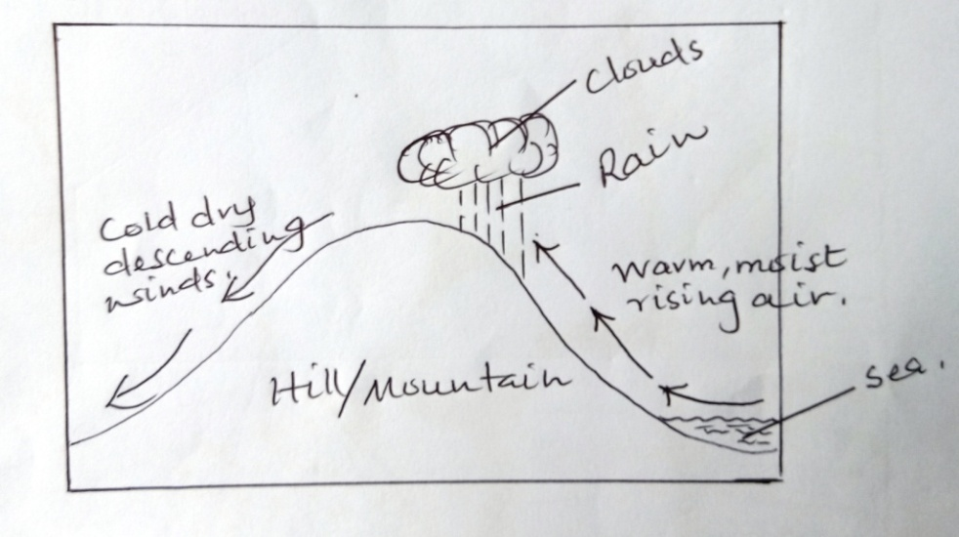
- A water body is heated causing evaporation of water
- Warm, moist air from the water body is forced to ascend a hill/mountain side
- Forced ascend leads to expansion and cooling of air
- The moisture in the air condenses forming clouds
- Rain falls mainly on the windward side of the hill/mountain.

(c) Use the map of Africa below to answer the questions that follow.
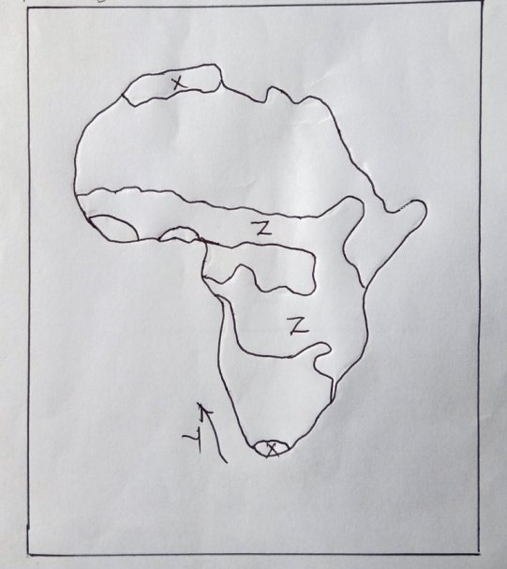
(i) Name, the type of climate experienced in the region marked X. (1 mk)
- Mediterranean

The ocean current marked Y. (1 mk)
- The cold Bengula current

(ii) Describe the characteristics of the type of climate found in the area marked Z.
(6 mks)
- Moderate rainfall/750 – 1000mm
- Rainfall is mainly convectional
- Rainfalls during the hot season
- Rainfall amounts decreases in places away from the equator.
- High temperatures throughout the year/ 22ºC – 32ºC
- High annual range of temperature (11ºC)
- The prevailing winds are mainly the trade winds
- There are two distinct seasons/wet and dry seasons

(d) Suppose your class carried out a field study on weather around the school environment;
(i) Explain two effects of wind on climate that they are likely to have identified.
(2 mks)
- Winds from a warm region raise temperatures of the areas they blow to
- Winds from cold regions lower temperature of the areas they blow to
- Winds passing over moist regions pick moisture causing rainfall in areas they blow to
- Winds passing over dry areas remain dry causing dry conditions over the areas they blow to.
(ii) Give two methods the class used to collect data in the field. (2 mks)
- Observation
- Photographing
- Counting
- Administering questionnaires

(iii) Give two follow-up activities the class was involved in after the field study. (2 mks)
- Displaying photographs/items collected
- Discussing with the rest of the class
- Writing reports
- Analyzing the information collected
- Drawing diagram/charts
- Reading further on the topic

8. (a) Distinguish between magma and Lava. (2 mks)
- Magma is the hot molten rock in the interior of the earth while lava is the hot molten rock which reaches the surface of the earth.
(b) The diagram below shows intrusive volcanic landforms. Use it to answer the questions that
follow.
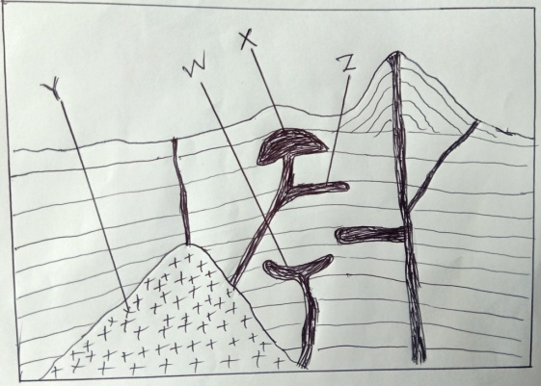
(i) Name the features marked W, X and Y. (3 mks)
- W – Lopolith
- X – Laccolith (Laccolite)
- Y - Batholith

(ii) Describe how feature Z is formed (4 mks)
- Formed when magma is forced along the horizontal lines/bedding planes of the crustal rocks.
- The intruding magma will then cool and harden/solidify horizontally along the bedding plane of the crustal rocks forming an intrusive volcanic landform.
- This is how a sill is formed.

(c) (i) Name two features that result from fissure eruption. (2 mks)
- Lava plateau
- Lava plains
- Tuff plateau
(ii) List two types of lava. (2 mks)
- Acidic lava
- Basic lava
- Intermediate lava
- Ultra-basic lava

(d) (i) Describe how a composite volcano is formed. (6 mks)
- High temperature and pressure inside the earth’s crust leads to the formation of magma.
- Earth’s movements leads to the formation of cracks in the crustal blocks
- Volcanic eruption occurs and pyroclasts are violently thrown out through the vent and settles around it.
- Another volcanic eruption of acidic lava occurs through the vent which cools and solidifies on top of the pyroclasts
- Successive eruption occurs and results in the accumulation of layers of pyroclasts and lava
- Magma cools, solidifies in the vent forming a plug that seals the vent
- High pressure builds up in the interior of the earth
- Magma escapes through a side vent, cools and solidify to form a parasitic cone.
- The cone-shaped feature formed of alternating layers of pyroclasts and lava is called a composite volcano.

(ii) Explain the significance of volcanic features to human activities. (6 mks)
- Volcanic mountains receive high rainfall on their windward slopes which promotes agriculture
- Volcanic mountains, Hot springs and geysers provide beautiful scenery which promotes tourism
- Regions of volcanic activities yield valuable minerals which promotes mining
- Hotsprings and Geysers are sources of geothermal power.
- Some volcanic rocks such as phonolites and trachytes are used in building and construction industry.
- Volcanic mountains form water catchment areas and are sources of rivers.
- Volcanic rocks especially basalt weather down to form fertile soils which support crop farming
- Steep volcanic mountain slopes discourage settlement and development of transport/communication network.
- Volcanic mountains create a rain shadow effect on their Leeward sides causing aridity.

9. (a) (i) Define Secondary Vegetation. (2 mks)
- Plant cover that grows naturally in a place but has been interfered with by man/livestock/wild animals.

(ii) State three climatic factors which influence the distribution and type of vegetation. (3 mks)
- Variation in temperature
- Amount of sunshine
- Duration of sunshine
- Nature and strength of the winds
- Variation in the amount of rainfall

(iii) Give three uses of mangrove trees. (3 mks)
- wood is used as firewood
- Poles are used for Construction
- The bark is used for the extraction of tannin

(b) The diagram below represents zones of natural vegetation on a mountain slope. Use it
to answer the questions that follow.
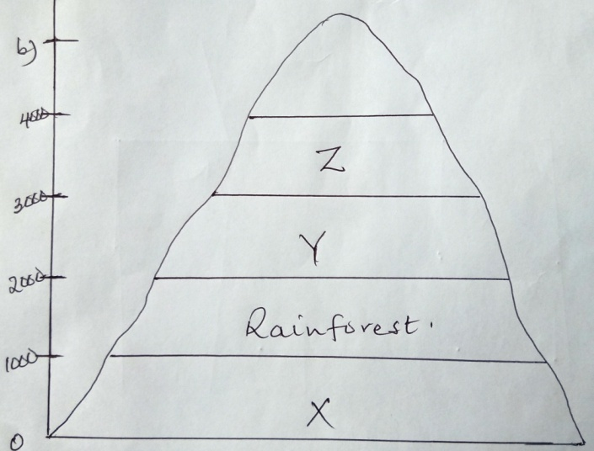

(i) Name the vegetation zones marked X, Y and Z. (3 mks)
X - Savannah vegetation
Y- Bamboo forest
Z- Heath and moor land

(ii) Describe the characteristics of the rainforest vegetation. (6 mks)
- The forest consists of mixed variety of tree species.
- Forests are evergreen/trees shed their leaves at different times of the year.
- The trees are tall/straight with large trunks.
- The trees have broad leaves
- The trees take long to mature
- The trees are mainly hard woods
- The trees are mainly close to each other
- Some trees have buttress roots
- Forest crowns form three distinct layers/canopies.

(c) You are required to carry out a field study on natural vegetation within your local
environment.
(i) Give three types of information for your study. (3 mks)
- Type of trees
- Age of the trees
- Height of the trees
- Uses of the vegetation
- Characteristics of the vegetation

(ii) State three ways you would use to identify the different types of plants. (3 mks)
- By observing the colour of the leaves.
- By observing the leaf size/pattern
- By observing the root system
- By estimating the age of the plants
- By observing the height of the plants
- By feeling the texture of the leaves
- By observing the size of the stems/ trunks

(iii) State two ways in which the information collected during the study would be useful to the local community. (2 mks)
- Can be used to plan agricultural activities.
- Can be used in the conservation of the environment.
- Can be used in the rationalization of land use.
- Can be used for future reference
- Can be used to determine the economic uses of plants.
10. (a) (i) Define the term Ocean. (2 mks)
- A large and extensive mass/body of saline water occupying a basin between continents.

(ii) State three sources of salt in ocean water. (3 mks)
- bedrocks of some oceans may contain salts which are dissolved by ocean water, thus increasing salinity
- volcanic eruptions may take place in the ocean beds thus bringing a lot of salt through the lava ejected.
- some rivers may dissolve salts along their valleys and transport them in solution form into oceans raising the salinity of the water.

(iii) State three factors which determine the temperature of the ocean water. (3 mks)
- nature of the ocean currents
- Latitudinal position of Oceans
- The depth of an ocean

(b) (i) Describe three processes of wave erosion. (6 mks)
- Abrasion/corrosion
Rocks fragments carried by waves are used as tools to grind the floor and the cliff face as the waves break / rock fragments carried by the backwash erodes the sea floor
- solution/corrosion
The solvent and chemical action of the sea water dissolves and removes the soluble minerals that are found in the cliff/sea floor especially where there are limestone rocks.
- Hydraulic Action
The breaking waves hit against the cliffs shattering the rocks/the force of breaking waves compress air into the joints/cracks in the cliff face. This enlarges the cracks and parts of the rocks may break off
- Attrition
Particles that are carried by waves are constantly colliding. This wears them into smaller sizes.

(ii) Name five features resulting from wave erosion. (5 mks)
- Bays
- Headlands
- Caves
- Blowholes
- Geos
- Arches
- Stumps
- Stacks
- Cliffs
- Wave cut platforms

(c) Your class is required to carry out a field study on wave erosion along the Kenyan
coastline.
(i) Why would you need to carry the following?
A mosquito net. (1 mk)
- The Kenyan Coast is humid with mosquitoes thriving here.
- To protect ourselves from mosquito bites
Light clothes (1 mk)
- The cost is hot and humid and therefore light clothes are the most suitable to wear.
A bag (1mk)
To carry back rock samples for analysis after the study.

(ii) Explain reasons why you think your study will be important to the government of
Kenya (3 mks)
- To advise the government on the economic potential of the Kenyan Coast.
- To reveal to the government the areas that requires conservation.
- To sensitize the Coastal people on the aesthetic importance of such a heritage encouraging them to take advantage of tourist activities to earn a living.

