NAME……………………….……………………………………CLASS……….ADM:..................
DATE…………………………….………………………………. SIGNATURE…………………...

312/1
GEOGRAPHY Paper 1
Time: 2¾ hours

Kenya Certificate of Secondary Education
312/1
GEOGRAPHY Paper 1

INSTRUCTIONS TO CANDIDATES
- This paper has two sections: A and B
- Answer ALL the questions in section A.
- In section B, answer questions 6 and any other TWO questions.
- All the answers must be written on the foolscaps provided after page 4.
- Candidates must answer the questions in English.

FOR EXAMINER’S USE ONLY

Section | Questions | Maximum  Score | Candidate’s  Score
A | 1 - 5 | 25
B | 6 | 25
 |  | 25
 |  | 25
Total Score

This paper consists of 4 printed pages. Candidates should check the question paper to ascertain that all pages are printed as indicated and that no questions/pages are missing.

SECTION A
1. The diagram below shows a type of an eclipse.
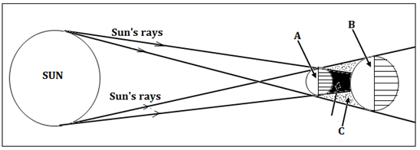
(a) Name the parts marked A, B, and C. (3 marks)
(b) Apart from the occurrence of eclipses, state three other effects of the movement of the earth round the sun. (3 marks)
2. (a) What are metamorphic rocks? (2 marks)
(b) Give two examples of organically formed sedimentary rocks. (2 marks)
3. (a) List three landmasses that formed from Gondwanaland according to continental drift theory. (3 marks)
(b) Give two types of tectonic plate boundaries. (2 marks)
4. (a) What is an earthquake? (2 marks)
(b) State three natural causes of earthquakes. (3 marks)
5. The diagram below shows some features that form ocean relief.
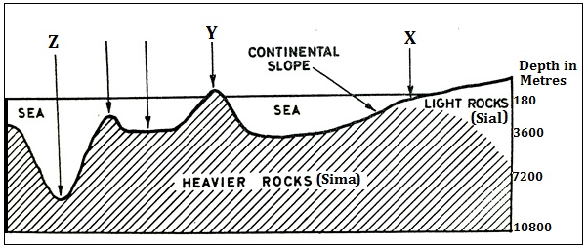
(a) Identify the features marked X, Y and Z. (3 marks)
(b) List two main forms of horizontal movements of ocean water. (2 marks)

SECTION B
6. Study the map of Kijabe (1:50,000 sheet 134/3) provided and use it to answer the following questions.
(a) (i) Determine the six figure grid reference of an air photo principal point near the South Western corner of the map. (2 marks)
(ii) Give two types of scale on the map extract (2 marks)
(iii) Give the position of the South Eastern corner of the area covered by the map by latitude and longitude. (2 marks)
(b) (i) Citing evidence from the map, give three settlement patterns in the area covered by the map. (3 marks)
(ii) Identify two relief features at grid square 3099. (2 marks)
(iii) Explain how relief has influenced the distribution of settlements in the area covered by the map. (4 marks)
(c) Citing evidence from the map, give five economic activities carried out in the area covered by the map. (5 marks)
(d) Describe the distribution of natural vegetation in the area covered by the map. (5 marks)

7. (a) (i) Differentiate between weather and weather climate. (2 marks)
(ii) Give three types of rainfall. (3 marks)
(b) Explain how the following factors affect the climate of a place:
(i) Cold ocean currents. (4 marks)
(ii) Inter Tropical Convergence Zone. (2 marks)
(c) With the aid of a well labelled diagram, describe how sea breeze occurs. (8 marks)
(d) Suppose you were to carry out a field study at a weather station:
(i) Give three methods that they would use to collect data (3 marks)
(ii) State three follow up activities for the field study. (3 marks)

8. (a) (i) Define the term folding. (2 marks)
(ii) Name three types of folds. (3 marks)
(b) The world map below shows the distribution of some fold mountains. Use it to answer question (i)
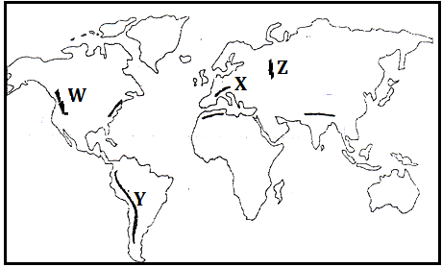
(i) Identify the fold mountains marked W, X, Y and Z (4 marks)
- With the aid of well labelled diagrams, how Fold Mountains were formed. (10 marks)
(c) Explain three negative effects of Fold Mountains (6 marks)

9. (a) (i) What is a karst scenery? (2 marks)
(ii) State five characteristics of karst landscapes. (5 marks)
(b) Give four sources of ground water. (4 marks)
(c) Explain how the following factors influence the occurrence of ground water:
(i) Nature of rocks. (2 marks)
(ii) Slope of land. (2 marks)
(iii) Vegetation cover. (2 marks)
(d) Explain four conditions that favour the development of an artesian well. (8 marks)

10. (a) (i) What is glaciation? (2 marks)
(ii) Outline four factors which determine the rate at which ice moves. (4 marks)
(b) Apart from a cirque, name four other glacial erosional features. (4 marks)
(c) Using well-labelled diagrams, describe how a cirque is formed. (8 marks)
(d) Students of Nanyuki High School carried out a field study on glaciation on Mt. Kenya
(i) Give three reasons why they conducted a reconnaissance. (3 marks)
(ii) State two factors they must have considered when selecting the data collection methods. (2 marks)
- Give two activities they may have been involved in during the study. (2 marks)

