NAME…………………………………………ADM. NO…..………….CLASS…………….
SCHOOL………………………………………………SIGNATURE………………………
312/2
GEOGRAPHY
Paper 2
Time 2¾ hours.
EAGLE EXAMINATIONS SEPTEMBER .2021
(Kenya certificate of secondary education)
312/2
Paper 2
GEOGRAPHY.
INSTRUCTIONS TO CANDIDATES.
(a) This paper has two sections A and B
(b) Answer ALL the questions in section A.
(c) Answer question 6 and any other TWO questions from section B.
(d) All answers must be written in the answer booklet provided.
(e) Candidates should check the question paper to ascertain that all the pages are printed as indicated and no questions are missing.

For Examiner’s Use Only.

 | SECTION A |  |  |  |  | SECTION B
QUESTION | 1 | 2 | 3 | 4 | 5 | 6 | 7 | 8 | 9 | 10

SECTION A
Answer ALL the questions in this section
- a) Give three major areas studied in Human and Economic geography (3mks)
b) State how geography is related to agriculture (2mks)
- a) Give three reasons why it is necessary to study geography through fieldwork (3mks)
b) State two disadvantages of direct observation as a method of data collection (2mks)
- a) State three uses of Soda Ash (3mks)
b) Name two areas where diamond is mined in South Africa (2mks)
4. a) identify two protective role of forest in Kenya (2mks)
b) State three factors that lead to depletion of forests in Kenya. (3marks
- a) State three physical condition favouring the growing of cocoa in Ghana (3mks)
b) List two problems facing cocoa farming in Ghana (2mks
SECTION B
Answer Question 6 and any other two questions from this section.
- The table below shows domestic consumption of dairy products in Kenya in millions kilograms between 2008 and 2011. Use it to answer questions that follows;

years  Dairy  products | 2008 | 2009 | 2010 | 2011
Butter | 20,000 | 25,000 | 30,000 | 35,000
Canned Milk | 15,000 | 30,000 | 25,000 | 20,000
Cheese | 10,000 | 9,500 | 5,000 | 4,000
Yoghurt junket | 2,000 | 4,000 | 5,000 | 9,000

- i) Using a vertical scale of 1cm to represent 5000 million kilograms , draw Cumulative bar graphs to represent the data (8mks)
ii) Give three disadvantages of using cumulative bar graph to represent the data (3mks)
- i) Name four dairy breeds kept in Kenya (4mks)
ii) State two differences between dairy farming in Kenya and Denmark (4mks)
- Explain three ways taken by the government of Kenya to improve dairy farming
(6mks)
7. a. i) Name two types of alluvial mining method (2mks)
ii) Identify four factors that influence the exploitation of minerals in Kenya (4mks)
iii) Describe the shaft method of mining (6mks)
b. Explain three adverse effect of gold mining to the environment of South Africa (6mks)
c. Your class intends to carry out a field study on gold mining site in Migori County in Nyanza region;
i) Outline four ways in which the students would prepare for this field study (4mks)
ii) State three reasons why they would be required to conduct a reconnaissance (3mks)

- a. i) State three benefits of out grower schemes in growing of sugar cane in Kenya (3mks)
ii) State three reasons why Kenya imports sugar sometimes (3mks)
b. i) State four physical conditions which favour large scale sugarcane growing in Kenya (4mks)
ii) Describe the stages involved in the processing of sugarcane at the factory (8mks)
iii) Give three by – products obtained from sugar cane (3mks)
c. State four problems facing sugar cane farmers in Kenya (4mks)

9. a. i) Give three methods used to drained swamps in Kenya (3mks)
ii) State four benefits that resulted from the reclamation of the Yala swamp (4mks)
b. i) What is a polder (2mks)
ii) Name three areas which make up the wider zuder zee reclamation project in the Netherland (3mks)
c. i) Name two methods of irrigation used in Kenya (2mks)
ii) State three importance of irrigation farming in Kenya (3mks)
- State four differences between land reclamation in Kenya and the Netherland (8mks)

10. a. i) What is fish farming (2mks)
ii) State three reasons why marine fisheries are underdeveloped in Kenya (3mks)
b. i) describe the purse seining as a method of fishing (6mks)
ii) State four ways in which the Kenyan government is promoting the fishing industry in the country (4mks)
c. The world map below shows major fishing grounds of the world. Use it to answer the following questions;
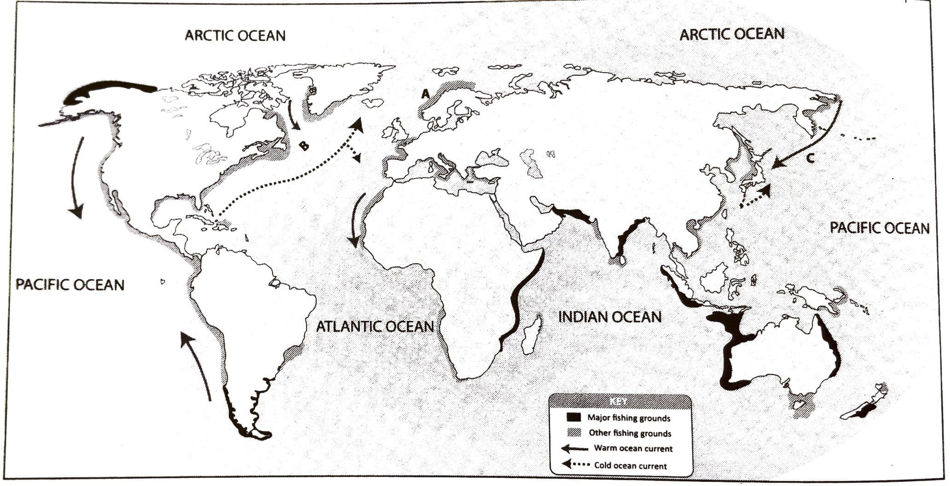

- Name the fishing ground marked A and B (2mks)

- Explain four factors that make the area marked C an important fishing ground (8mks)

