Name: …………………………………….. Index No: ……Adm No ………..

Candidate’s Signature: ……....Date: ………Class…….

School: …………………………………………..

312/1
GEOGRAPHY
Paper 1
November 2021
Time 2 hours 45 min.

EAGLE PRE-MOCK JOINT EXAM 2021
Kenya Certificate of Secondary Education
Instructions
1. Attempt all the questions in section A
2. Attempt question 6 and any other two questions from section B.
3. Use separate foolscaps to answer each question in section B.
4. Each question to be started of a new foolscap
FOR EXAMINERS USE ONLY:
SCORE SHEET
QUESTION | SCORE
SECTION A (1-5)

6

7

8

9

10
TOTAL
SECTION A 25MARKS
Answer all the questions in this section.
1. a ) Name two branches of geography. (2marks)
b) Give three reasons why it is importance to study geography. (3marks)

2. a ) What is the solar system? (2 marks)
b ) State three characteristics of sima crust (3 marks)

3. The diagram below shows a weather measuring instrument. Use it to answer the following questions.
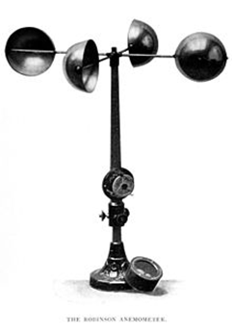
(a) Identify the instrument (1 mark)
(b) Describe how the instrument functions (4 marks)

4. a) Distinguish between volcanicity and vulcanicity (2marks)
b) Give three intrusive volcanic features. (3marks)
5 a) Define term rock (2marks)
b) State three characteristics of minerals (3marks)

Section B (75 marks)
Answer Question 6 and any other two.
6. (a) Study the map of Kijabe 1: 50,000 provided and answer the following questions:
(i) What is the approximate height of the top of Kijabe hill? (1 mark)

(ii) Measure the length of Nairobi – Naivasha railway line from Landhies (grid Reference 257978) to the level crossing near Kijabe station (grid reference 308984). Give your answer in kilometers. (2 marks)

(iii) Give the longitudinal extend of the map extract. (1 mark)

(b) i) Find the bearing of the cattle dip at Kenton from the pump house near the hot springs (2 marks)

ii) Name two types of the scales on the map extract. (2 marks)

iii) Give two functions of Kijabe Township. (2marks)

(c) Identify the vegetation of the area covered by the map (4 marks)

(d) Explain how relief has influenced the distribution of settlement in the area covered by the map. (6 marks)
(e) i) Draw a rectangle measuring 14cm by 10cm, to represent the region enclosed by Easting’s 24 and 31 and northings 96 and 01. (2marks)
ii) On the rectangle identify and mark the following features.
- Railway line. ( 1mark)
- Regional boundary. ( 1mark)
- School (1 mark)

7. i) Define the term faulting. (2marks)

ii) Name two types of faults. (2marks)

iii) Use the diagram below to answer the question that follows:-

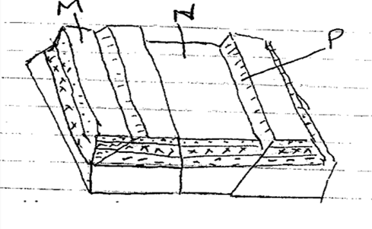
a) Name the features marked M, N and P (3marks)

b) With well labelled diagrams explain the formation of the Rift valley through tensional forces. (8marks)
c) Explain five positive effects of faulting. (10marks)
8. (a) State four physical factors that contribute to development of deserts.
(4 marks)
(b) Give four characteristics of hot desert landscape. (4 marks)
(c) Explain three factors that influence wind transport in the desert. (6 marks)
(d) Describe how a deflation hollow is formed. (4 marks)
(e) You carried out a field study in a desert landscape.
(i) State four preparations for your study. (4 marks)
(ii) List three water depositional features you identified. (3 marks)
9. (a) (i) Define the term glaciation. (2 marks)
(ii) Name three types of moraines. (3 marks)
(b) Describe how the following features found in upland glaciated landscapes are formed.
(i) Glacial through (4 marks)
(ii) Pyramid peak. (6 marks)
c) Explain three significance of upland glaciated features to human activities. (6 marks)
(d) Suppose you were to carry out a field study of glaciated lowland.
(i) State two advantages of using oral inter views to collect information during the field study. (2 marks)
(ii) Name two features found in glaciated lowlands that you are likely to study. (2 marks)
10. (a) Differentiate between soil texture and soil structure. (2 marks)
(b) (i) Apart from organic matter, name four other components of soil. (4 marks)
(ii) State four ways in which humus contributes to the quality of soil. (4 marks)
(iii) Explain how the following farming practices may result to loss of soil fertility.
• Continuous irrigation (2 marks)
• Overgrazing (2 marks)
• Over cultivation (2 marks)
(c) Give three soil forming processes (3 marks)
(d) Explain three ways in which natural vegetation may prevent soil from erosion. (6 marks)

