EAGLE JOINT EXAMINATION AUGUST/ SEPTEMBER
GEOGRAPHY PAPER 1 MARKING SCHEME
Section A 25 Marks
1. a) Name two branches of geography (2mks)
Physical geography
Human geography
Practical geography (2*1=2mks)
b) Give three reasons why it is important to study geography. (3mks)
-Geography is a career subject it provides a firm foundation for advanced studies in specialized fields like engineering, remote sensing, urban planning etc.
-Study of geography enables one to acquire basic skills and knowledge which contribute to local, regional and national development.
-Through the study of fieldwork, geography teaches one on how to manage time properly by drawing a time schedule and adhering to it.
-Geography focuses on physical study of the earth. We are therefore able to learn and explain the origin of the earth and the solar system.
-Geography enables the learners to understand and appreciate different environmental influences at work on different societies.
-Geography creates awareness in the people on the significance of management and conservation of the environment.
Any 3 correct ones.

2(a) what is the solar system? (2marks)
- The composition of the sun, the planets and other heavenly bodies orbiting around the sun.
(b) State three characteristics of the oceanic crust. (3marks)
- Made up of solid or brittle rocks
-The oceanic crust support oceans / inner crust.
-The oceanic crust has plastic like / flexible rocks
-The oceanic crust has silica and magnesium.
-The oceanic crust has mainly basaltic rocks
- The ocean crust is denser / 2.8 gmice-3.0gm/cc (any 3 x 1 = 3marks)
3. The diagram below shows a weather measuring instrument. Use it to answer the questions that follow:

- Identify the instrument (1mark)
A cup anemometer/ anemometer

- Describe how the instrument is used to measure the weather element.
(4marks)
- It is used to measure the speed of the wind
- As the wind blows, the metal cups will rotate freely and the numbers of rotations are recorded on a meter to give the speed of the wind in knots.
4 .a) Distinguish between volcanicity and vulcanicity. 2 marks
- Vulcanicity is the process operating in the interior of earth surface through which solid, liquid or gaseous materials are forced out of the interior of the earth while Volcanicity is the process through which volcanic features are formed from lava/magma .
b) Intrusive volcanic features
- Dyke
- Sill
Batholiths
- Lacolith
- Lopolith 3x1=3mks
5. a) Define rock – Rock is naturally occurring agglomeration of mineral particles in the crust or Hard compact solid mass on the crust 2x1=2mks
b) Characteristics of minerals
- Have different degrees of hardness
- Have specific colour
- Have one element
- Can be transparent, opaque, translucent

Answer Question 6 and any other two.
6. a) Study the map of Kijabe 1: 50,000 provided and answer the following questions:
(i) What is the approximate height of the top of Kijabe hill? (1 mark)
-Between 2660m and 2679m above sea level
(ii) Measure the length of Nairobi – Naivasha railway line from Landhies (grid Reference 257978) to the level crossing near Kijabe station (grid reference 308984). Give your answer in kilometers. (2 marks)
-5.6 km ±0.1 (5.5 – 5.7 Km)
(iii) Give the longitudinal extend of the map extract. (1 mark)
- from 36⁰ 30’E to 36 ⁰45’E
b) i) Find the bearing of the cattle dip at Kenton from the pump house near the hot springs (2 marks)
- 310⁰ or N50 ⁰ W
ii) Two scales used in the map. (2 marks)
-ratio scale
-linear scale
iii) Fuctions of kijabe Township
- Transport centre
-Educational centre
-Security centre
c) Describe the vegetation of the area covered by the map (4 marks) –presence of scrub vegetation
- Forest vegetation
-Thickets vegetation
-woodlands vegetation
(d) Explain how relief has influenced the distribution of settlement in the area covered by the map. (6 marks)
-Most of the settlement are found at the foot of the escarpment because the land is gently sloping
- The escarpment has no settlement because the land is steep
- Kijabe hill has a few settlement on the eastern side because the land is gently sloping/ the Western side of the hill has no settlement as the land is steep
- The land immediate to the east of the escarpment has many settlement because it is plateau/ gently sloping (any 3x2=6marks)
e) i) Draw a rectangle measuring 14cm by 10cm, to represent the region enclosed by Eastings 24 and 31 and northings 96 and 01. (2marks)
ii) On the rectangle identify and mark the following features.
Check the following
- Title 1 mark
- Rectangle with dimensions 1 mark
- Each feature 1*3= 3marks

7. a) i) Faulting is the process whereby crustal rocks fracture/crack due to Tectonic forces. (2marks)
ii) - Normal fault
- Reverse fault
- A tear/sheer / slip
- A thrust fault
- An anticlines fault (2marks)

iii) M - Horst Mountain
N - Rift valley
P - Scarp (3marks)

b) With well labelled diagrams explain the formation of the Rift valley through tensional forces. (8marks)
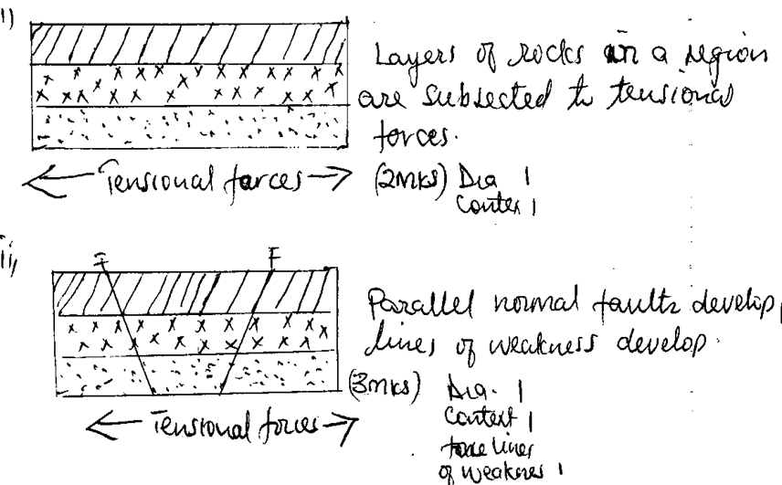

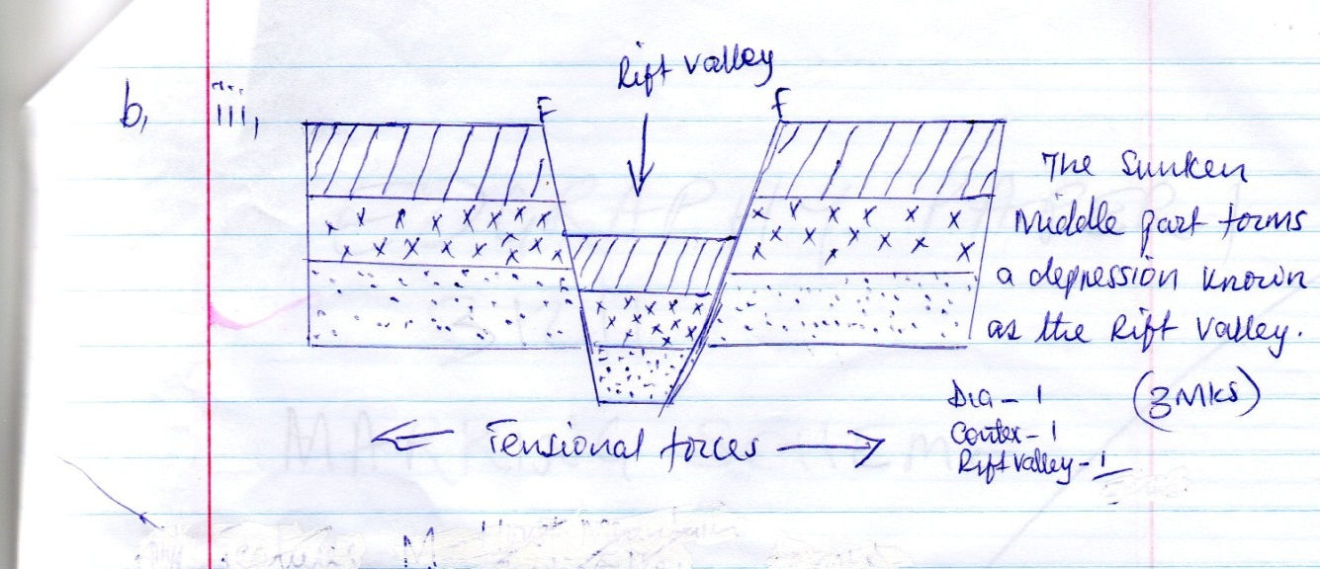
b) iii)

N/B Arrows indicating tension force should indicated sidewards touching crustal layers
Texts 3 marks
Diagram 3 marks

c) Explain 5 positive effects of faulting (10mks)
- Faulted features e.g rift valley and highest mountains provide unique scenery which promotes tourisms hence a source of foreign exchange.
- Some rift valley lakes are important fishing grounds/mining sites/provide water for irrigation.
- Block/host/mountains relieve high rainfall on the wind ward side which favours agriculture which encourage settlements and growth of forest that provide timber.
- Formation of rift valley led to the exposure of valuable minerals such as diatomite mined at the floor of the rift valley.
- Block/host mountains are a source of rivers which provide water for industrial/agriculture/domestic/hydro – electric power produce.
- Hot springs and geysers can be harnessed for geo – thermal power production for industrial and domestic use.
- Vertical faulting across a river may cause a water fall which may be used to generate hydro – electric power project that used in industries /domestic

Any 5 x 2 = 10mk
8. (a) Four physical factors that contribute to development of deserts. (4 marks)
- Continentality / distance from large water bodies
- A place being located in an area with descending winds / anticyclones ✓ Rain shadow effect
- Prolonged droughts
- Cold ocean currents
- Prolonged / persisted high temperatures
-Climate change / global warming
- Persistent offshore / dry winds / cold winds
(b) Four characteristics of desert hot landscape. (4 marks)
- Most of the ground is bare / scanty vegetation/ Little organic matter.
- Absence surface water
-Wind is dorminant leading to desert sand storms
- Land surface is covered by fine sand / stones / rock outcrops
-Galleys / badlands are common
- Thin soils
(c) Three factors that influence wind transport in the desert. (6 marks)
-Speed and the force / strength of the wind
-Nature of the load / either light / heavy
- Intervening obstacles e.g. dead animals , twig or rock
- Water mass / rain / moisture. Any well explained 3 x 2 = 6mks
(c) How a deflation hollow is formed. (4 marks)
- A pre-existing depression /localized fault is exposed to wind erosion.
- Wind eddies remove the unconsolidated materials by deflation
- Weathering aids in breaking down the exposed rock
- Wind abrasion excavates the depression by eroding the rock along weak lines
- The depression is deepened and widened as a deflation continues to remove the loose materials leading to formation of a large depression known as deflation hollow.

(d) (i) Four preparations for your study. (4 marks)
- Seeking permission
-Conduct a reconnaissance
- Formulate / adjust hypothesis and objectives
- Choose methods of data collection
- Assemble necessary tools / materials
- Prepare a working schedule
- Divide the students into groups
- Discuss the topic in class
-Literature review/ further reading
(ii) List three water depositional features you identified. (3 marks)
- Salina
- playa
- Alluvial fans / cones
- Bajadas
9. a) i) Define the term glaciation. (2 marks)
- Glaciation refers to the action of moving ice/process by which glaciers change the landscape on large scale/ process through moving ice erodes, transport and deposit materials on the earth surface.
ii) Name three types of moraine. (3 marks)
-Ground moraine
- Lateral moraine
- Medial moraine
- Terminal moraine
- Niche glaciers
b) Describe how the following features found in upland glaciated landscape are formed: (4marks)
i) Glacial trough
- A pre-existing glacier is filled with ice /glacier.
-The glacier erodes the v-shaped valley by abrasion and plucking process vertically
- The valley is deepened and widened by vertical erosion and lateral erosion.
- The end spurs are truncated/trimmed/cut.
- The ice melts away leaving a u-shaped valley
i) Pyramidal peak (6 marks)
- Initially the ice collects in several hollows on the mountain side.
- The ice exerts pressure on the hollows/cracks.
- The plucking action of the ice enlarges the hallows so that more ice collects in them.
- Freeze and thaw action of the ice leads to the expansion of cracks/ hollows making them large basins which are called cirques.
- Nivation into back walls of the hollows make them recede into the mountain side/ the cirque recedes outwards.
- Steep sided knife edged ridges called arêtes are formed and they separate the cirques.
-Eventually three or more of these ridges/ arêtes converge at the top of the mountain forming jugged peak /horn (surrounded by corries/ cirques). this is called pyramidal peak
c) Explain three significance of upland glaciated features to human activities. (6 marks)
- The warm glaciated valleys are suitable for farming / glaciated uplands provide suitable grazing lands as they form fine benches on which summer pastures grows e. g Switzerland.
- Glaciated landforms form magnificent features that encourage recreation /sporting activities.
- Glaciated mountain discourage human settlement hence growth of forests (lumbering).
- Waterfalls formed by the rivers in glaciated highlands provide suitable sites for hydroelectric production.
-Corrie lakes /tarn lakes are suitable areas for sport fishing.
- The U - shaped valleys / glacier though form natural route ways.
- Fiords coastline form deep and well sheltered natural harbours as well as good fishing ground.
d) Suppose you were to carry out a field study of a glaciated lowland.
i) State two advantages of using oral interview to collect information during field study. (2 marks)
- Give firsthand information.
- Interviewers can seek clarification on any ambiguities.
- Interviewer creates a good rapport with an interviewee.
- Interviewers can get more information by initiating further discussion.
-The method is useful in collecting information from people who cannot read and write.

ii) Name two features found in glaciated lowlands that you are likely to study. (2 marks)
- Depression / glacial lakes
- Roche mountonnée.
- Craq and tail.
-Drumlins
- Erratic.
- Boulder train.
-Till plain.
- Outwash plain
10a) Soil texture is the size distribution of minerals particles composed in the soil while soil structure is the way individual soil particles are arranged and joined to form lumps or clusters.
OR
Soil texture is the coarseness and finess of soil grains while soil structure is the arrangement of soil particles to form destructive shapes

b)i) Apart from organic matter, name four other components of soil. (4 marks)
-Soil water
-Soil air
-Mineral particles/weathered materials/inorganic matter
-Living organisms

ii) State four ways in which humus contributes to the quality of soil. (4 marks)
- Improves the textures of soil/binds soil particles together
- Improves/adds soil fertility
- Enables soil to retain moisture
- Facilitates aeration of soil
- Source of food for soil micro-organisms which regulate soil temperature

iii) - Continuous irrigation: Causes leaching of soil nutrients making the top soil deficient of soluble minerals causing soil salinity.
-Overgrazing: lead to removal of vegetation cover thus exposing soil to agents of erosion which will remove the top fertile soil.
-Over cultivation: weakens soil structure making it easy for agents of soil erosion carrying away the top fertile soil./May also increase oxidation resulting to loss of organic matter.
c) Give three soil forming processes (3 marks)
-Weathering.
-Decomposition of organic matter.
-Leaching.
d) Explain three ways in which natural vegetation may prevent soil from erosion. (6 marks)
-The plant leaves covers and reduces the force of the raindrops controlling splash erosion
-The vegetation cover increases the rate of rain water infiltration into the soil reducing surface run-off controlling sheet erosion.
- The roots of plants increase the rate of rain water percolating into the soil controlling erosion.
- The plant roots binds the soil particles together thus controlling erosion
- Plant cover reduces the rate of soil water evaporation making the soil moist/wet and compact.
- Dealt and decaying vegetation matter adds more humus to the soil making the soil particles bound together reducing erosion.

