MARKING SCHEME: 312/2
1. (a) Define forestry (2 marks)
- This is the science of developing/cultivating and managing of forests
(b) State three problems facing forestry in Kenya (3 marks)
- Forest fires destroy large tracts of forests
- Encroachment into forest land to create room for agriculture & settlement
- Over exploitation due to higher rate of exploitation than being replaced
- Poor harvesting methods & management of forests like indiscriminate cutting & illegal logging
- De-gazettment of forest reserves has led to reduction of forest cover
- Prolonged droughts have led to shrinking of forests
- Attack by pests and diseases like aphids has destroyed the forests with exotic trees
- Destruction of forests by huge animals like elephants which trample and damage the trees
- Illegal logging that has reduced the number of trees in the forests.
- Drug growing that has reduced the size of forests ( any 3x1=3 mks)
2a) A part from ground general view photograph, name one type of ground horizontal photograph. (1mk)
Ground close-up
b) What evidences can be used in any photograph to show that it is a ground general view type of photograph. (3mks)
- When the camera is focused on many features.
- When the object become progressively smaller towards the background.
- The photograph captures the general appearance of the area.
3(a) Give two reasons why pastoralists keep large herds of animals. (2 marks)
- Is a sign of wealth
- Payment of dowry
- An insurance against death
- The animals are a source of food-meat and milk
- The animals when sold is a source of money
- The hides/skins are used for clothing
(Any 2 x 1 = 2mks)
b) State three physical factors that favour dairy farming in the Kenya highlands (2 marks)
- Gently sloping landscape for easy movement
- Cool climatic conditions ideal for exotic dairy cattle
- Availability of continuous growth quality pasture throughout the year
- High rainfall received throughout the year supports the growth of pasture
- Availability of water from rivers/streams and reservoirs for watering the animals
- Deep, fertile volcanic soils which ensure growth of quality pasture.
- Availability of large tracts of land for establishment of dairy farms
(Any 3 x 1 = 3 marks)
4a) Differentiate between continuous and discrete data. (2mks)
Continuous data is information expressed in any form such as decimals,fractions and ratios while discrete data is information expressed in whole numbers.
b) Name three sources of secondary data (3mks)
- Geological reports
- journals,
- magazines,
- Newspapers
- films
- Maps
- Census reports
- Textbooks
- Statistical abstracts (Any 3x1=3mks)
5) Study the map of the Ruhr industrial region and use it to answer the questions that follow.
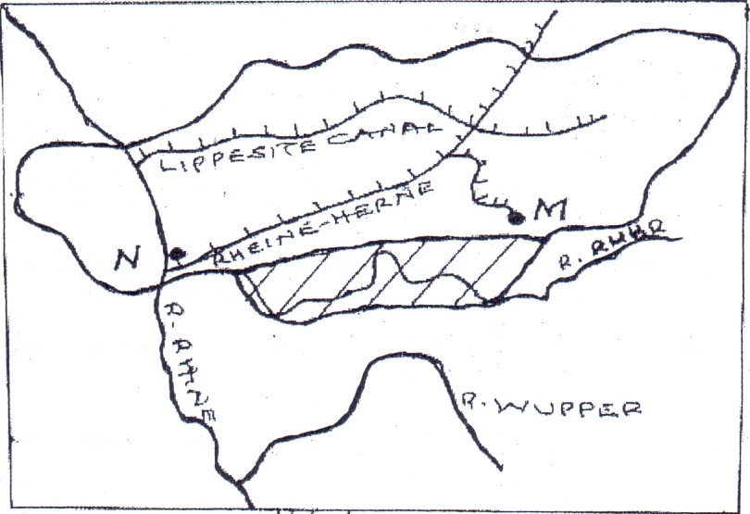
Y
X
Dortmund - Ems Canal

R. Rhine
R. Wupper

(i) Name the River marked X. (1 mark)
- Ruhr river
(ii) Name the Canal marked Y. (1 mark)
- Lippe canal
(iii) Apart from iron and steel industries, name one other industries in the Ruhr region. (1 marks)
- Petro-chemical industries
- Textile industries
- Oil refining
- Electronics industries
- Food processing
- Cutlery and surgical industries
- Engineering industries
(b) State two characteristics of Jua Kali industries in Kenya (2 marks)
- Mostly operated in the open/sheds,
- They use simple equipment,
- Use locally available / recycled raw materials,
- Use simple / basic skills in craft,
- Operated by individuals / small groups,
- Pursued as part time or full-time occupation,
- Require low capital investment,
- They are widespread.
SECTION B
ANSWER QUESTION 6 AND ANY OTHER TWO QUESTIONS
6.. The table below shows four proportional crops produced in Kenya in the year 2000-2001. Use it to answer questions (a) and (b)
CROP  YEAR | AMOUNT IN METRIC TONNES
 | 2000 | 2001
WHEAT  MAIZE  COFEE | 70,000  200.000  98,000 | 130,000  370,000  295,000

- I) Using a vertical scale 1cm represent 50,000 metric tonnes, draw a comparative bar graph representing each crop in the two years (8mks)
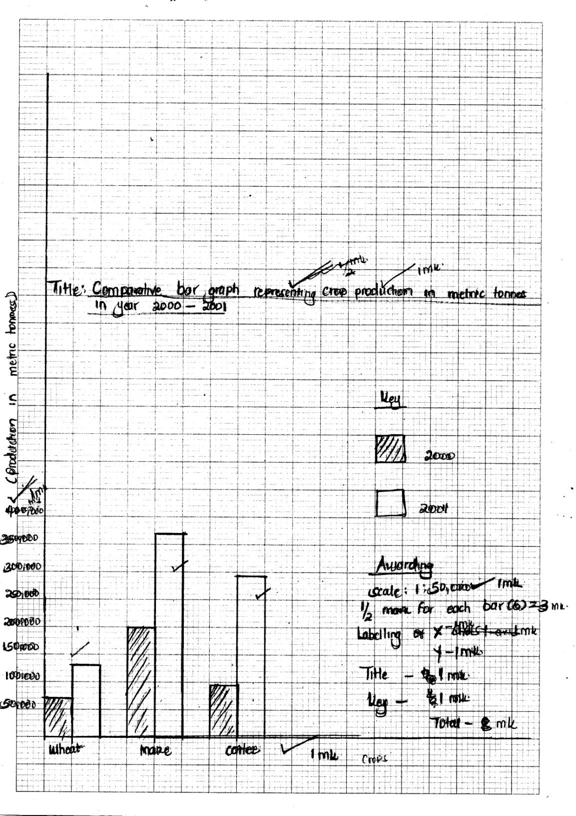
- State two advantages of using comparative bar graphs (2mks)
- It is easy to draw
- It is easy to read and interprete
- It gives clear visual impression
- It clearly compares the items represented ( Any 2x1=2mks)

- Calculate the percentage increase in wheat production between the years 2000-2001
- 130,000 – 70,000=60,000
60,000 x 100 = 85.71%
70,000 (1x2 = 2mks)

(i) State four physical conditions that favour wheat growing
- Moderate temperature through the year
- Moderate rainfall which is well distributed throughout the growing season
- A warm/dry/sunny spell of ripening
- Deep well drained volcanic soil
- Gently sloping/undulating landscape to allow proper drainage/mechanization ( any 4x1=4mks)

(ii) Outline three uses of wheat (3mks)
- Wheat flour is used as food
- Wheat bran is used as animal feed
- Wheat flour is used for distilling alcohols
- Wheat flour is used for making adhesives
(Any 3 x 1= 3mks)
- Explain three economic significance of wheat farming in Canada
- Wheat is exported to earn the country foreign exchange which is used in development of other sectors of economy eg transport
- Wheat farms and mill have offered employment opportunities to many Canadians thus raising their living standard.
- It has led to development of transport lines eg railway lines to access wheat farms
- Wheat had provided raw material to wheat related industries thus promoting industrialization
- It has provided wheat for local consumption thus saving foreign exchange which could have been used in importation.
(Any 3 x2 =6mks)
- (i) Name two types of rural settlement patterns
- Nucleated
- Scattered/dispersed
- Linear (Any 2x1=2mks)

ii) Apart from urban rural migration name two types of migration (2mks)
- Urban- Urban
- Rural-rural
- Rural-urban
- International/external migration (any 2 x1 = 2mks)
iii) Give three factors that may lead to urban-rural migration (3mks)
- Retirement /retrenchment/loss of job
- Lack of jobs in urban centre
- Insecurity in urban centre/high crime rate
- Provision of infrastructural facilities in rural areas/social amenities
- Setting up industries in rural areas/discovery of minerals
(any 3x1 = 3mks)
b) Apart from pollution, explain four problems experienced in urban centre. (8mks)
- Insecurity leads to fear
- Unemployment /idleness leading to emergence of slums/poor housing/high rent
- Inadequate housing leading to emergence of slums/poor housing/ high rent
- Limited land for expansion cause delaying movement
- Traffic congestion cause delaying movement
- Inadequate transport facilities leading to delays/long ques
- Inadequate social amenities leading to overcrowding in hospitals/schools/shortage of water/poor sanitation
- High rate of crime leading to insecurity/fear/loss of lives/loss of property (any 4x2 = 8mks)

c(i) Explain three factors that led to the growth of Kisumu town (6mks)
- Its location of the shores of Lake Victoria led to its growth as a lake port handling trade among the three east African countries
- In 1901, Kisumu became a terminus for the Ugandan railway leading to the influx and settlement of early Asian traders. This led to commercial development of the town.
- Kisumu was a regional administrative centre during the colonial period. This led to setting up of administrative offices and other infrastructural facilities e.g roads, airports
- The rich highland with mineral/agricultural resources provided raw materials for the development of industries/food supply for the town residents
- The high population in the surrounding areas provided labour force required for the development of industries.
- The nearby rivers and Lake Victoria provided fresh water for industrial/domestic use

- The well-developed means of transport/road/railway/airport makes the town easily accessible from other parts of the country (any 3x2 = 6)
ii) Citing evidence, state four functions of Kisumu town (4mks)
- It is an industrial centre- has industries eg. Textile industry, motor vehicles assembly etc.
- It is a commercial centre- has shops, banks, port etc
- It is a residential centre-has residential houses for all classes
- It is a transport and communication centre- it has a railway, a port roads
- It is an education centre- has schools and universities eg Maside Murilo university.
- It has a health centre- has hospitals eg Kisumu Hospital (Any 4x1=4mks)

8. i) identify two characteristics of pelagic fish.
- Lives near the water surface or in shallow waters of the sea
- Small in size
- Live and move in shoals or large groups
- Migrate from place to place within the sea
- Caught using pelagic fishing methods like Drifting, seining etc. ( any 2x1=2mks)
Ii) Name two main countries involved in fishing in the North West Pacific fishing grounds.
- Japan
- China
- North-Korea
- South-Korea
- Russia (2mks)
iii) Explain three factors which favor fishing in the North West Pacific fishing grounds.
- Advanced technology has resulted in highly developed ship building / fishing vessels are equipped with modern preservation facilities , thus making it possible for fishermen to carry out large scale fishing
- The hinterland is densely populated thus provide ready/large market for fish
- Availability of capital for purchasing equipment required for deep sea fishing /for the development of the industry
- The long history of sea farming e.g. in Japan thus people are highly experienced in fishing
- Most settlements are found along the coast and the main occupation of the people there is fishing.
- The convergence of the warm kuro siwo and cold oya shio current that provide cool waters for the breeding of fish and growth of planktons
- Broad continental shelf with shallow waters that provide ideal/favourable conditions for the growth of planktons
- The indented coastline with sheltered bays provide ideal site for breeding of fish /develpoments of ports
- The rugged terrain/mountainous landscape that discourage agricultural activities leaving fishing as the major economic activity. (any 3 well explained factors 6mks)
b) The diagram below shows a fishing method.
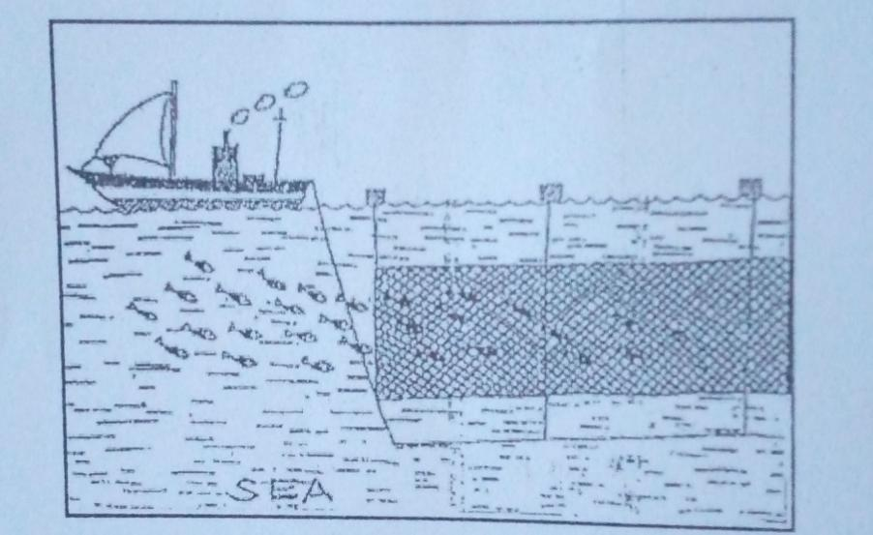
- Describe how the method is used in catching fish.
- A net resembling a gill is cast into the a water by the drifter
- The net hangs vertically in the water
- The upper part of the net is kept afloat by corks /floats
- Weights are fitted at the bottom of the net. This helps to stretch it like a tennis net
- The net is held close to the surface of the water where fish swim in large shoals
- As the fish try to swim past the net , they are trapped by their grills
- Once sufficient fish has been caught , the net is hauled onto the drifter to empty the fish
- The net is attached to a drifter. (5mks)

i) Explain three measures being taken by the government of Kenya to conserve marine fisheries.
- International conventions are being enforced in order to protect endangered fish species from extinction
- Standardizing the size of the nets used in fishing to ensure that mature fish are caught
- Restricting the disposal of untreated waste into the sea to ensure that the water remains clean for the survival of the fish
- Patrolling the Kenyan sea waters to ensure that only licensed fishermen operate
- Developing transport routes to enable the exploitation of fishing grounds in remote areas (inland lakes) so as to reduce the exploitation of the accessible marine fisheries
- Encouraging fish farming so as to compliment/diversify the variety of fish being caught in natural fisheries
- Establishing research station to study various fish species and their breeding habits with a view of protecting them
- Licensing of fishermen so as to control their numbers and ensure there is no overfishing .
- Restricting fishing for specific seasons so as to allow breeding and maturing of fish (any 3 well explained x2=6mks)
- State four problems experienced in the marketing of fish in Kenya.
- Some fishing areas are far from the markets making fish to go bad en-route
- Roads from some fisheries are in poor condition thus fish go bad before reaching markets
- Fishermen lack appropriate storage or preservation facilities leading to deteriorating of the fish
- There are limited local markets due to poor fish eating culture among most Kenyans
- Exports markets are limited due to tight restrictions and competition for market by other producers or fish importers.
- Limited number of fish species limiting the market for fish
- Competition from other established producers leading to few market for fish and other fish products. ( any 4x1=4mks)
- (a). (i) W – Flouspar
X – Gold
Y – Diamond
Z – Copper

(ii) Problems facing gold mining in South Africa.
- Costs involved in mining gold have increased greatly.
- Due to increasing demand to provide higher wages, married quarters and other social amenities thus has led to additional cost in acquiring labor.
- A lot of water is needed for processing gold but ever increasing population in the Rand also needs, yet this area receives seasonal rainfall.
- Rand mines are becoming deeper. This has led to pressure bursts underground and ground shatters as the ore is removed. This is due to the great pressure from the heavy weight of overlying rocks.
- The gold grade being worked on now has a poorer quality than that of some years back.
- Exhaustion of minerals because gold is a non-renewable resource.
( any 4x1=4mks)
(b). (i) Factors influencing exploitation of minerals
- Minerals have different values. Minerals of high value are often mined at a very high cost because of their high demand.
- Size of mineral deposit, where mineral deposit is small labor and cheap methods are employed.
- High grade and quality are more economical to exploit than lower grade ores because they yield large amount of metal.
- Minerals occurring near the surface are easily mined by open cast method, while those occurring deep below especially those mined by deep shaft are expensive.
- Mining involves large outlay of capital.
- When minerals occur, and there are transport systems then its cheap to exploit them.
- World fluctuation of prices affect expected incomes by exporting countries.
( any 5x1=5 mks)

ii. Name four by-products extracted from crude oil.
(ii) -Tar
-Wax
-Bitumen/Pitch/Asphalt
-Grease/Lubricants
-Resin/Petrol chemicals ( any 4x1= 4mks)
(c) Negative effects of mining on the environment.
- Mining causes land destruction making it ugly or badlands.hence wastage of agricultural lands
- May lower water-table of a given place hence making water availability to be scarce.
- Leads to land dereliction that causes wastage of agricultural land
- Causes pollution e.g water pollution that causes death of aquatic/marine life/air pollution when harmful gases are released in the atmosphere may lead to acid rains that corrode the iron sheets/cause global warming
- The dumping of rock waste has led to loss of bio diversity/ destruction of natural vegetation
- The clearing of vegetation has made the land bare hence it becomes prone to soil erosion.
- The open pits left behind become breeding grounds for mosquitoes and other waterborne diseases ( any 4 well explainedx2=8 mks)
10.a) (i) What is a polder (2mks)
Is land in the Netherlands that has been reclaimed from the sea .

(ii) Name two crops grown in the polders (2mks)

-Rye
- Tomatoes - Flowers
- Barley -Oat - Fodder crops
- Sugar beet - Potatoes - Wheat ( any 2x1=2 mks)

b) Describe the stages of reclamation of land from the sea in the Netherlands
- Protective dykes/sea walls are constructed enclosing the part of the sea to be reclaimed.
- Rings canals are constructed.
- Pumping stations are installed to pump out sea water from the area enclosed by the dyke.
- Reeds are sown to help dry out excess water form the soil/reduce salinity
-chemicals are applied to the soil to reduce salinity
- Oats, rye and sugar beets are planted to improve the soil ph
- Drainage ditches and more pumping stations are made on the land being reclaimed.
- Drainage pipes are laid below the soil.
- The area is divided into rectangular portions using. Inner dykes and ring canal.
- The drained land is flushed with fresh water to remove salt from the soil.
- Pumping water from the polders is a continuous process to prevent water from accumulating in the reclaimed land. ( any 7x1=7mks)

c) (i) State three physical factors that influence the establishment of Pekerra irrigation scheme
-Gentle slope of the area which allows mechanization and flow of water to the field by gravity.
-Presence of fertile loamy soils on which a variety of crops can be grown.
-Semi-arid conditions of the area which necessitated the use of irrigation as the only way to make food production possible.
-Extensive area of land that enable large scale cultivation of crops
-Constant supply of water for irrigation from river perkerra.
( any 3x1=3 mks)

(ii) State three human problems experienced in irrigation farming in Kenya.
-Disease incidences such as bilharzia and malaria transmitted by vectors in stagnant waters.
-Payment of low prices to the farmers which kills morale of the farmers.
-High cost of production making the farmers to sell their produce at high costs
-Mismanagement of irrigation bodies leading to losses, lack of credit and low prices.
-Shortage of labour during planting, weeding and harvesting giving the farmers the burden of hiring labour at high cost. ( any 3x1=3mks)

d) Explain four significance of irrigation farming in Kenya (8mks)
-Irrigation farming enables farmers to earn an income when they sell farm produce hence raising their living standards.
-Provision of employment opportunities which has alleviated poverty.
-Promoted industrial development through providing raw materials e.g rice mills.
-Has enhanced food security in the country by encouraging growing of food crops such as maize.
-Development of transport network e.g construction of new roads leading to the irrigation farm. In-order to facilitate the movement of inputs and crops to the markets
- when some horticultural crops are exported it earns the government foreign exchange that is used to improve other sectors of economy.
-irrigation reclaims some unproductive lands increasing agricultural productions and food production
-has led to growth of towns due to the presence of irrigation schemes
( any 4 well explained x2=8 mks)

