MINCKS SCHOOLS. TERM 2 2022

FRENCH PAPER 3 MARKING SCHEMER TESSECTION I
Reading Aloud Passage A CARD A
1.
• Section I of this examination will test Reading aloud skills. Candidates should study the passage for 5 minutes before entering the examination room.
• Section II will be an Exposé based on the situation outlined oń the examination card. Candidates should study the situation for 10 minutes and then be prepared to talk on topic assigned to them. Exposé should last 2 minutes.
• Section III will test the candidate’s conversational skills of a general nature. It should last 5-7 minutes. All three sections of the examination should be marked according to the marking scheme provided.
sx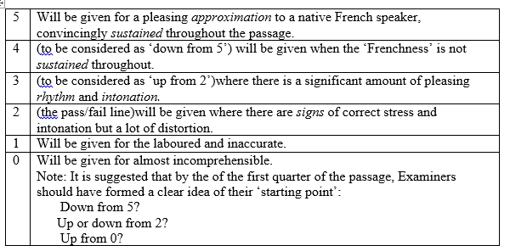
SECTION II
Exposé
1. The cards provided contain one situation each. The candidates will pick a card by drawing lots from the set cards provided. The candidates should not be made aware of the content of cards prior to making their choice.
2. Each candidate should be given a maximum of ten minutes to prepare for the topic on the card that he/she has picked.
3. Each candidate should be given a maximum of 2 minutes to present the exposé.
4. The examiner may not interrupt the candidate before the expiry of the two minutes.
5. Only verbal communication will be assessed: marks will not be awarded for gestures, facial expressions of any other non-verbal forms of communication.
Marks will be awarded using the following scale.
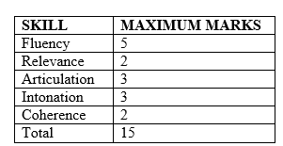
The exposé will be marked out of 15 marks based on the scale above. The total marks for the exposé being 5 marks, the examiner should scale down the candidate’s total marks by dividing it by 3 to get the right score out of 5 marks.
SECTION III
Conversation Total 15 marks. About 5 minutes. It should be a conversation of a general nature related to the candidate’s experience and the content on pages 448-450 of the KCSE Regulations and Syllabuses, 2012-2013, of KNEC.The examiner is expected to ask specific questions on related topics and just concentrate on one topic:
—You should allow the stipulated length of time each candidate.
—You should start out from any point of interest noted earlier or ask a few general questions relating to everyday life such as school, family, and etc.Not more than four (4) topics from the list on pages 448-450(KCSE Regulations and Syllabuses, 2012-2013) should be examined.
—Precise factual knowledge or information is not necessary.
—Candidates should be expected to respond naturally to questions; their answers need not therefore be in the form of complete sentences. You should take care to avoid questions inviting simply ‘Yes’ or ‘No’ by using a variety of interrogatives (see list next page).The examiners should use ‘vous’when addressing the candidates during the examination.
—Questions should be adjusted to the candidate’s ability. Candidates should be prompted and encouraged where necessary.
—Long periods of silence should be avoided.
—Do not interrupt the candidate unless you are sure he/she cannot complete the answer. —Incorrect answers should neither be corrected, nor answers supplied when none is given.
—Questions should either be rephrased or allowed to go unanswered rather than be repeated.
—The use of English vocabulary should be avoided. List of Questions. (Guidelines)
—Quels sont les avantages/inconvenient/problems.........................?
—Qu’est-ceq’u vous aimez/préférez? Pourquoi?
—Qu’est-ce qui vous intéresse?
—Comment trouvez-vous..........................?
—Comment trouvez-vous..........................?
—Que pensez-vous de...............................?
—Quelle est ľimportance de......................?
—Qu’aimerez-vous faire/devenir?
—Quelle sorte de.................................?
—Pouvez-vous donner des exemples?
—Qu’est-cequi se passé.......................?
—Que peut-on faire.............................?
—Comment est-ce qu’on......................?
—Que feriez-vous si............................?
—Parlez-moi un peu de.........................?
—Comparez...........................................

SECTION IV
Conversation Marking Scheme. Total=15MARKS
NOTE: No half marks should be awarded. The objective here is to induce a spontaneous fluent conversation in which the candidate speaks more than the examiner.

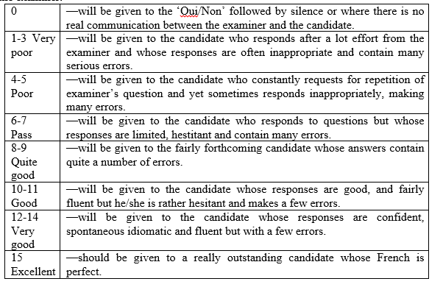
5 marks

