NAME……………………………………………………………..ADM/NO……………………

DATE…………………………. ………………… ………….CLASS……………………………

FORM 3
PHYSICS 232
TIME: 2HRS

INSTRUCTIONS TO STUDENTS
- Write your name and admission number in the spaces provided above.
- The paper contains two sections, section A and B
- Answer all the questions in the spaces provided
- All working must be clearly shown
- Candidates should check the question paper to ascertain that all the 12 pages are printed as indicted and that no questions are missing.
- Candidates should answer the questions in English

SECTION | QUESTION | MAXIMUM SCORE | CANDIDATE’S  SCORE
A | 1-12 | 25
B | 13-18 | 55
TOTAL

SECTION A (25 MARKS)
Answer all questions in the spaces provided

- The micrometer screw gauge below has a zero error of - 0.19mm.
Determine the actual thickness of the object. (2mks)

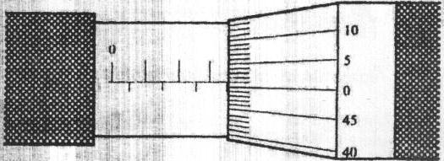

- Two mirrored walls stand at an angle to each other. A student standing in the room counts nine images of himself in the mirrors. Determine the angle between the walls.
(3mks)

- a) What is meant by the term anomalous expansion of water? (1mks)
………………………………………………………………………………………………………
………………………………………………………………………………………………………
………………………………………………………………………………………………………
………………………………………………………………………………………………………

b) Explain any two applications of contraction and expansion in solids. (2mks)
………………………………………………………………………………………………………
………………………………………………………………………………………………………
………………………………………………………………………………………………………
………………………………………………………………………………………………………
………………………………………………………………………………………………………
………………………………………………………………………………………………………
………………………………………………………………………………………………………
………………………………………………………………………………………………………
- A body weighs 600N on the surface of the earth and 450N on the surface of another planet. Calculate the value of g in that planet (g on the earth = 10N/Kg) (3mks)

- State two applications of electrostatic charges (2mks)

………………………………………………………………………………………………………
………………………………………………………………………………………………………
………………………………………………………………………………………………………

- 200 coulombs of charge passes through a point in a circuit for 0.6 minutes. What is the magnitude of the current flowing? (3mks)

- While heating water in a beaker, a wire gauze is placed below the beaker explain.(2mks)

………………………………………………………………………………………………………
………………………………………………………………………………………………………
………………………………………………………………………………………………………
………………………………………………………………………………………………………
………………………………………………………………………………………………………

- What is the relationship between physics and technology (2mks)

………………………………………………………………………………………………………
………………………………………………………………………………………………………
………………………………………………………………………………………………………
………………………………………………………………………………………………………
………………………………………………………………………………………………………
………………………………………………………………………………………………………

- Using the domain theory distinguish between magnetic material and a magnet (2mks)

………………………………………………………………………………………………………
………………………………………………………………………………………………………
………………………………………………………………………………………………………
………………………………………………………………………………………………………
………………………………………………………………………………………………………
………………………………………………………………………………………………………
………………………………………………………………………………………………………
………………………………………………………………………………………………………
………………………………………………………………………………………………………
- State two application of convection in fluids (2mks)

………………………………………………………………………………………………………
………………………………………………………………………………………………………
………………………………………………………………………………………………………

- Convert a temperature of 234K to degree celsious (1mk)

SECTION B (55 MARKS)
- (a) State Hooke’s law (1mk)
………………………………………………………………………………………………………
………………………………………………………………………………………………………
………………………………………………………………………………………………………
(b) In an experiment to verify Hooke’s law, a piece of rubber was fixed to a rigid support and the other end pulled with a force of ranging magnitude. The values of force and the extension were recorded as in the table below:-
Force (N) | 0 | 0.20 | 0.55 | 0.75 | 1.00 | 1.30 | 1.40
Extension(cm) | 0 | 1.5 | 2.5 | 3.5 | 4.5 | 6.0 | 7.0

- Plot a graph of force ( Y axis) against extension (X-axis) on the gird provided
(5mks)
- From the graph, determine the spring constant of the rubber within elastic limit (3mks)

\

- What is the size of force at the elastic limit (1mks)

- (a) State three characteristics of a brake fluid. (1mk)

………………………………………………………………………………………………………
………………………………………………………………………………………………………
………………………………………………………………………………………………………
………………………………………………………………………………………………………
………………………………………………………………………………………………………
………………………………………………………………………………………………………
………………………………………………………………………………………………………
………………………………………………………………………………………………………
……………………………………………………………………………………………………
(b) The height of a mercury barometer at a particular place is 70cm. given that the density of mercury is 13600kgm³, determine;
(i) The atmospheric pressure at the place. (3mks)

(ii) The height of a water barometer at the same place. (Density of water=1g/cm³) (2mks)

(iii) Give a reason why mercury is preferred as a barometric liquid. (1mks)

(c) Calculate the minimum pressure a block of dimensions 3cm by 10cm by 15cm and mass 12kg could exert on a horizontal surface. (3mks)

- a) Differentiate between transverse waves and longitudinal waves.(2mks)

………………………………………………………………………………………………………
………………………………………………………………………………………………………
………………………………………………………………………………………………………
………………………………………………………………………………………………………
- The figure below shows a wave form in a string.
5
-5
5
10
20
30
40
50
602
70
(m)
(m)

Given that the speed of the wave is 10m/s. With reference to this wave motion, determine;
- Wavelength. (1mk)

- Amplitude. (1mk)

- Frequency. (2mks)

- Period (2mks)

- A person standing 49.5m from the foot of a cliff claps his hands and hears an echo 0.3 seconds later. Calculate the velocity of the sound in air. (3mks)

- (a) What property of light is suggested by the formation of shadows? (1mk)
…………………………………………………………………………………………………
(b) A building standing 200m from a pinhole camera produces on the screen of the camera an image 2.5cm and high 5.0cm behind the pinhole.
Determine the actual height of the building (3mks)

(c) An object of height 2.0cm is placed 5.0cm in front of a convex mirror of focal length 10.0cm

(i) On the grid provided, draw to scale a ray diagram to locate the position of the image.(4mks)

(ii) State two applications of concave mirrors (2mks)
………………………………………………………………………………………………………
………………………………………………………………………………………………………
………………………………………………………………………………………………………
- (a) When is an object said to be in stable equilibrium? (1mk)

………………………………………………………………………………………………………
………………………………………………………………………………………………………

(b) A uniform metal rod of length 80cm and mass 3.2kg is supported horizontally by two vertical spring’s balances C and D. Balance C is a 20cm from one end while balance D is 30cm from the other end. Find the reading on each balance. (4mks)

- (a) The figure below shows an electric bell. Briefly explain how it works. (4mks)
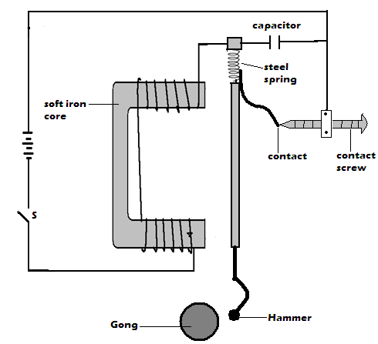

………………………………………………………………………………………………………
………………………………………………………………………………………………………
………………………………………………………………………………………………………
………………………………………………………………………………………………………
………………………………………………………………………………………………………
………………………………………………………………………………………………………
………………………………………………………………………………………………………
………………………………………………………………………………………………………
………………………………………………………………………………………………………
………………………………………………………………………………………………………
………………………………………………………………………………………………………
………………………………………………………………………………………………………
………………………………………………………………………………………………………
- State the right hand grip rule for straight conductor carrying current (1mks)
………………………………………………………………………………………………………
………………………………………………………………………………………………………
………………………………………………………………………………………………………
………………………………………………………………………………………………………
………………………………………………………………………………………………………
………………………………………………………………………………………………………
- a) State the equation of continuity (1mk)
…………………………………………………………………………………………………….

b) The velocity of glycerin in a 5cm internal diameter pipe is 1.00m/s. Find the velocity in a 3cm internal diameter pipe that connects with it, both pipes flowing full. (3mks)

