MARKING SCHEME
GEOGRAPHY
SECTION A
1.a
Environment refers to all the external conditions surrounding an organism (plant and animals) and which have influence over its behaviour or activities.
b
I) Physical geography
ii) Human geography

2. a
A map is a representation of a part of the earth or the whole earth on a flat surface like a sheet of paper drawn to scale.

b.
- Formlines
- Hachures
- Spot heights and trigonometrically stations
- Hill shading
-Colouring or layer tinting
- Cliff and rock drawing

c.
- By use of direction, bearing and distance
- By use of place names
- By use of latitudes and longitudes
- By use of grid reference system
3. a.
A star with a greater gravitational pull passed near the sun. It attracted large quantities of gaseous materials from the sun. The materials split, cooled and condensed to form planets. The planets were set in orbit by the passing star.

b.
- Does not explain the origin of the sun and Star
- Minimal Chance of a star approaching another
- Materials would disperse than condense

c.
- Causes four seasons
- Varying lengths of day and night
- Changes in the position of the midday sun
-lunar eclipse

4. a.
Mineral is inorganic substance which occur naturally at or beneath the surface of the earth with definite chemical and physical properties.

b.
- Veins and lodes
- Seams and beds
- Alluvial deposits
- Weathering products

c.
- Formation of soil for agriculture
- Some rocks act as tourist attraction site
- Source of fossils fuel
- Building materials
- Storing underground water
- Mineral deposits

5. a.
Faulting is the cracking or fracturing of the rocks of the earth's crust caused by tectonic forces.
Folding is the bending of the rocks of the earth's crust due to earth movements.

b.
- Normal fault
- Reverse fault
- A tear, shear or slip fault
- A thrust fault
- An anticlinal fault

c.
- Mountainous areas often receive high rainfall which give rise to important rivers
- The process of folding creates areas of crustal weakness which may trigger volcanic activity
- Mountain environments offer unique scenery, which is an important tourist attraction
- Folding mountains act as barriers to transport and communication
- Folding may bring minerals to the surface

6. a.
Weather is the daily atmospheric conditions of a place at a particular time

b.
- Altitude
- Nearness to the water bodies
- Aspects
- Latitude
- Cloud cover and humidity

c.
- Hygrometer
- Maximum thermometer
- Minimum thermometer
- Six's thermometer

7. a.
This is the type of vegetation which grows without interference and modification by human activity

b.
- Trees forms a canopy
- The trees are tall, smooth barked and with no branches at the lower sections
- Equatorial vegetation have a varied number of plants species within a small portion
- Trees found in these forests have broad leaves to protect them from collapsing during the intense midday insolation and high temperature
- Trees are evergreen.

SECTION B
8.(a).
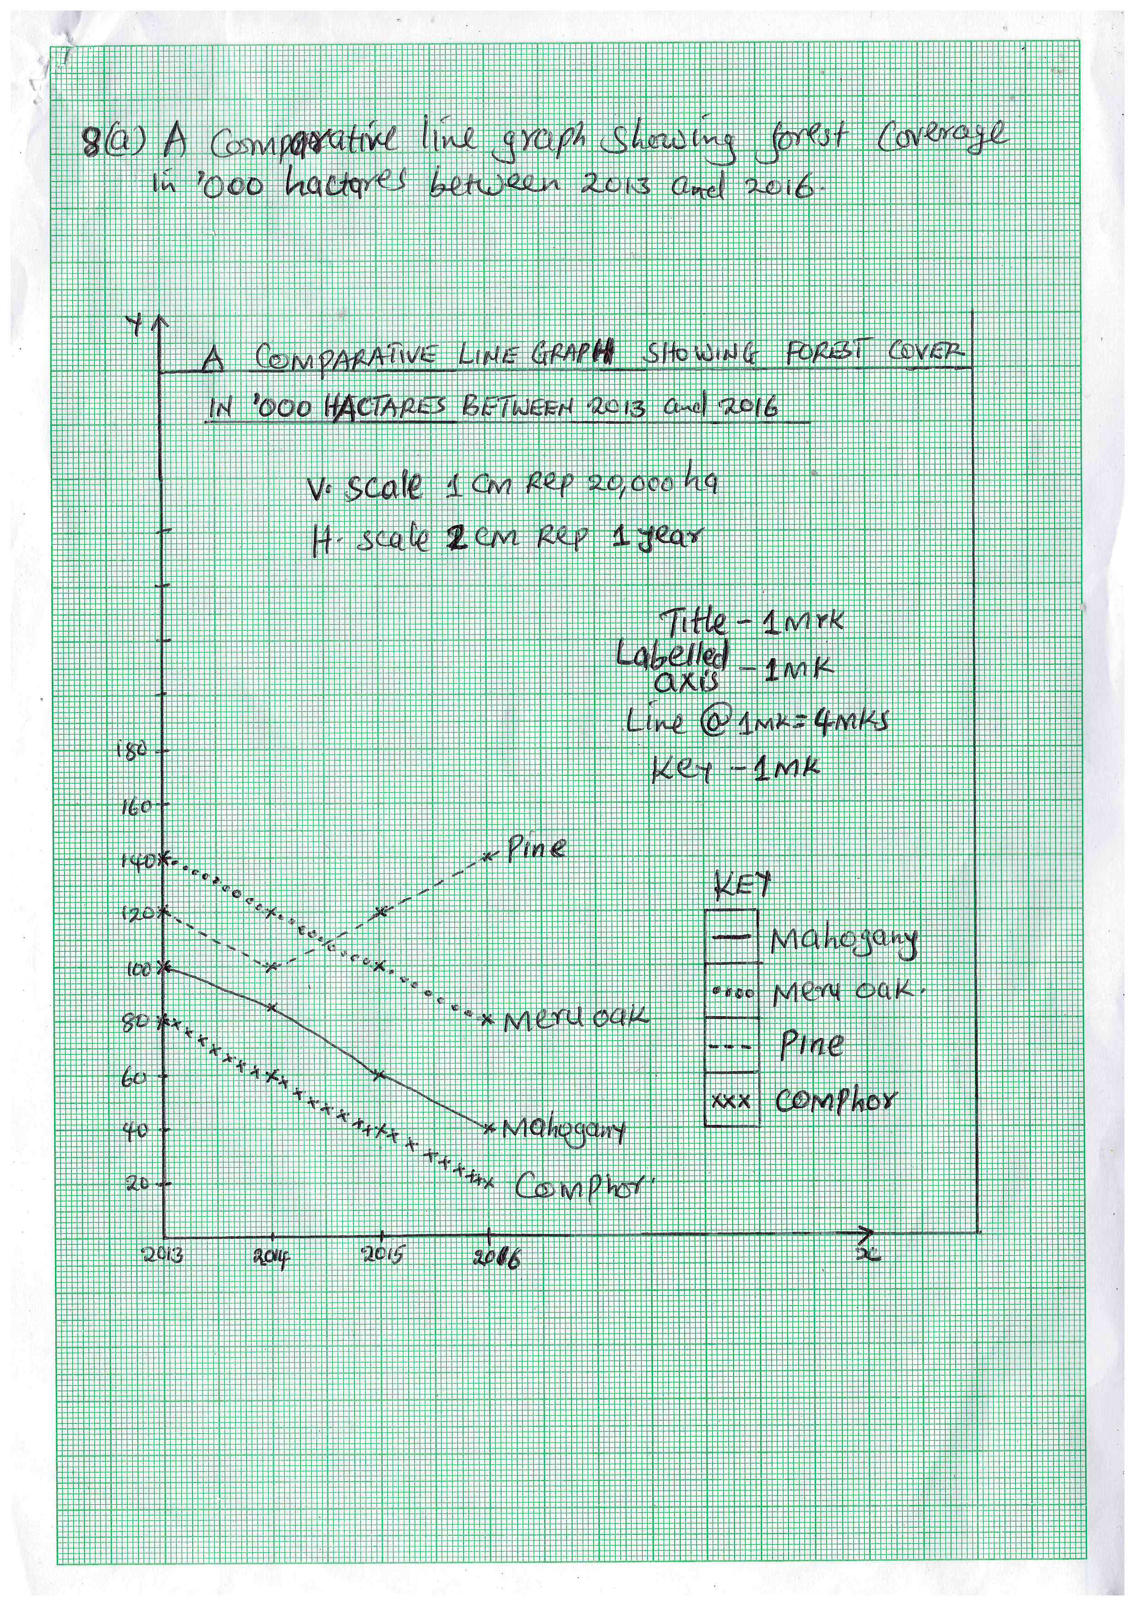
b.
- Does not give a clear visual impression on the quantity of the data
- Only a limited number of variables can be shown in the same graph because too many variables would crowd the graph
- It shows no comparisons between two or more sets of data
- The causes of the illustrated relationship cannot be established from the graph

9. a.
A forest is a continuous growth of trees and other plants covering Large tract of land for commercial value.
Forestry is the science of cultivating trees for commercial value.

b.
i) Temperature: High temperatures causes faster growth of trees while low temperature causes slow growth.
ii) Aspect: Dense forests are found on windward slopes of mountains because they are wetter than leeward slopes.
ii) Human activities: Deforestation and shifting cultivation; man has cleared forests to create room for agriculture and settlement.

10. a.
- Field excursion
- Field research
- Field study

b.
- Language barrier
- Bad weather
- Attacks by wild animals
- Illiterate respondents
- Dishonest respondents
- Accidents in the field
- Researcher may fall sick

c.
- It gives firsthand information
- The interviewer can seek clarification from the respondent
- The interviewer can also gauge the accuracy of the responses
- Information can be obtained from people who cannot read or write
- It saves time

11. a.
- Mid- ocean ridges
- Within the rift valley
- In areas of volcanic activity
- Ocean deeps and volcanic islands
- Regions of crustal compressions
b.
- Tectonic movement
- Vulcanicity
- Isostatic adjustment
- Human activities

12. a.
- Drilling method
- Adit/drift method
- Solution method

b.
- Value of the mineral
- The size of deposit
- Quality of the ore
- Transport cost
- Skilled and qualified workers
- Demand for mineral
- Availability of capital

13. a.
Extrusive Vulcanicity is the process where materials actually breaks through the surface of the earth in a vulcanic eruption.
Intrusive Vulcanicity happens when the materials does not have enough strength to break through the surface

b.
- Volcanic activity has contributed greatly to the scenic beauty of the landscape which act as tourist attraction
- Volcanic rocks are valuable building stones and road materials
- Sometimes a volcanic eruption can be so violent that it can cause great loss of life and damage of property
- Volcanic eruption results in the pollution of the environment

14.(a).
- There is no real dry season
- It has a double maxima rainfall regime
- The temperature are high throughout the year
- The hottest month are December and January
- Humidity is high throughout the year
(b).
- Hills /mountains
- Valley
-Drainage features
- Vegetation
-escarpments

