NAME…………………………………………………. DATE……………
ADM…………………………………………………… SIGN…................

CHEMISTRY FORM 3
TIME: 2 HOURS
Instructions to candidates
- Write your name and admission number in the spaces provided above.
- Sign and write the date of examination in the spaces provided above.
- Answer all the questions in the spaces provided (ALL questions are compulsory)
- Check the question paper to ascertain that all the pages are printed as indicated and no questions are missing.

FOR EXAMINER’S USE ONLY

QUESTIONS | MAXIMUM SCORE | STUDENT’S SCORE
1-22 | 80

- Distinguish between a dropping funnel and a thistle funnel (2mks)
………………………………………………………………………………………………………………………………………………………………………………………………
- What is a fume chamber/cupboard and give its use
(2mks)
………………………………………………………………………………………………………………………………………………………………………………………………
- The setup below was used to prepare and collect hydrogen gas
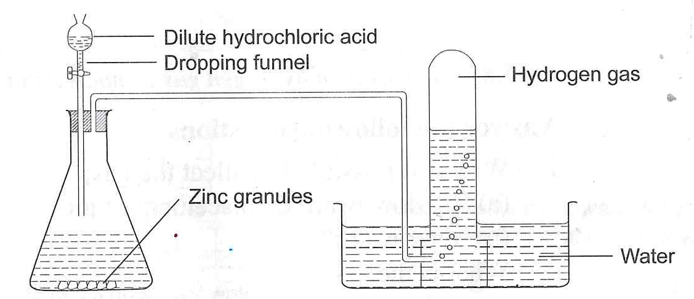

- write an equation for the reaction that produces hydrogen gas (2mks)
…………………………………………………………………………………………………………………………………………………………………………………..
- Why is hydrogen gas collected over water (1mk)
…………………………………………………………………………………………
- State what is observed when a few drops of phenolphthalein indicator were added to a solution of wood ash. (1mk)
…………………………………………………………………………..................................................................................................................................................................
- Fractional distillation of liquid air is a method used to separate various gaseous mixture in air. Explain how to (3mks)
i)remove carbon(IV) oxide
………………………………………………………………………………………………………………………………………………………………………………………………
ii) remove water
………………………………………………………………………………………………………………………………………………………………………………………………
iii) obtain nitrogen
……………………………………………………………………………………………………………………………………………………………………………………………...
- The following apparatus and chemicals are used to investigate the percentage of air used when iron rusts: iron fillings100ml measuring cylinder, trough and water.
a)Draw a setup of the experiment (2mks)

- What is the method used to obtain sunflower oil from sunflower seeds (1mk)
………………………………………………………………………………………………

- After use, non luminous flame should be put off or adjusted to a luminous flame. Explain (2mks)
…………………………………………………………………………………………………………………………………………………………………………………………….
- Draw and show the electron arrangement of phosphorus (atomic number 15) (2mks)

- Atoms are made up of subatomic particles.name them (3mks)
………………………………………………………………………………………………………………………………………………………………………………………………………………………………………………………………………………………………
- In an experiment hydrogen gas was passed over heated copper(II)Oxide as shown.
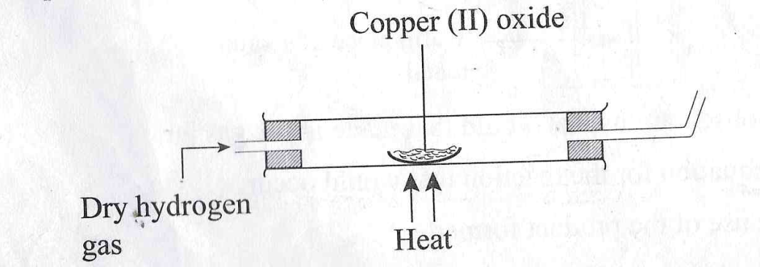

- State the observations made in the combustion tube after the experiment (2mks)
…………………………………………………………………………………………
- Write the equation for the reaction between copper(II)oxide and hydrogen gas (1mk)
………………………………………………………………………………………...
- Explain why heat is necessary in this experiment. (1mk)
…………………………………………………………………………………………
- The curves below represent the variation in temperature with time when pure and impure samples of a solid were heated separately.
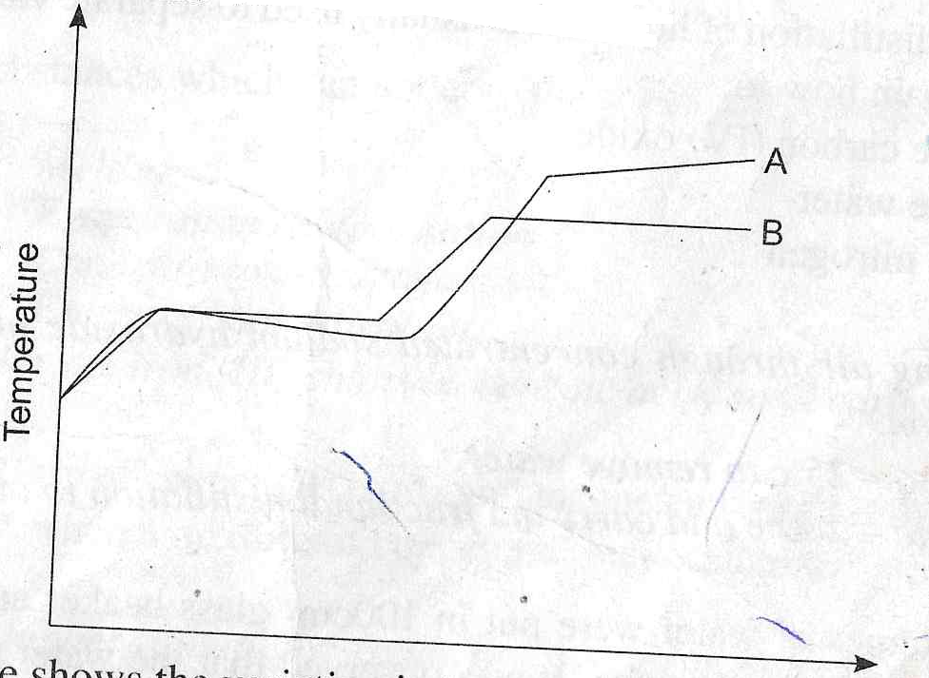

- Which curve shows variation in temperature of a pure solid. Explain (2mks)
…………………………………………………………………………………………………………………………………………………………………………
- state the effect of an impurity on the melting and boiling points of a pure substance (2mks)
…………………………………………………………………………………………………………………………………………………………………………
- The table below gives the atomic number of elements M,N,P,Q,R,S and T.The letters are not the actual symbols of the elements.
Element | M | N | P | Q | R | S | T
Atomic no. | 12 | 13 | 14 | 15 | 16 | 17 | 18

- Write the electron arrangement of element P (1mk)
………………………………………………………………………………………………………………………………………………………………
- The stable ion of N (2mk)
……………………………………………………………………………….
- Write the formula of the compound formed between N and S (2mks)
………………………………………………………………………………………
- Using dot (.) and cross (x) diagram show how bonding occurs between P and S (2mks)

- Using dot (.) and cross (x) diagram show how bonding occurs in water molecule.H2O (2mks)

- Explain the following observations
- Noble gases are generally unreactive (1mks)
…………………………………………………………………………………
- Atomic radius of alkali metals increase down the group (1mk)
…………………………………………………………………………………
- Aluminium is a better conductor of electricity than sodium (1mk)
…………………………………………………………………………………

- An element Q consists of three isotopes with mass number of 22,24 and 25 with percentage abundance of 89.6%,6.4% and 4% respectively.Find the relative atomic mass of element Q. (2mks)

- Write the formula of the compounds below. (3mks)
NAME | FORMULAR OF COMPOUND
COPPER(I) OXIDE
IRON(II)SULPHATE
SULPHUR(IV)OXIDE
- List any 3 elements that belong to group (VIII)of the periodic table (3mks)
………………………………………………………………………………………………………………………………………………………………………………………………………………………………………………………………………………………………
- The following diagrams show the structures of two allotropes of carbon.Study them and answer the questions that follow.
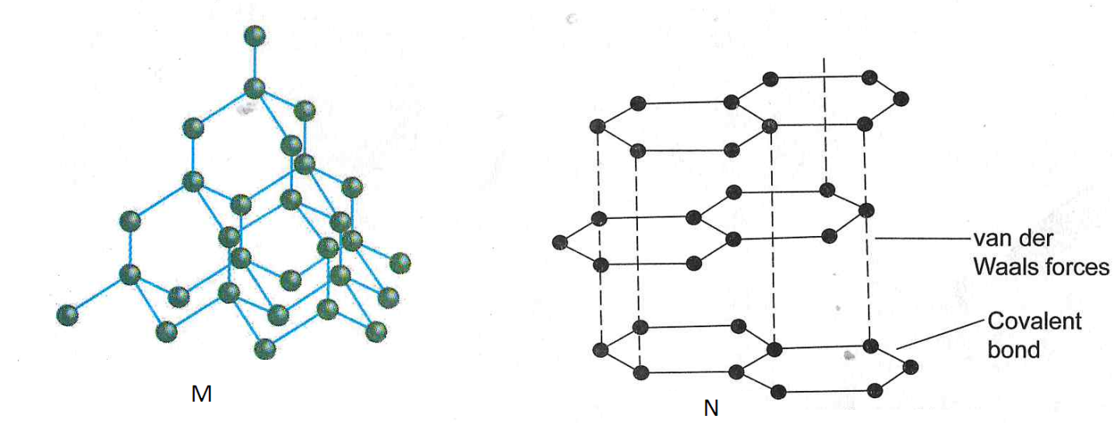

- Name allotrope (2mks)
M-

N-

- Give one use of N (1mk)
…………………………………………………………………………………………
- Which allotrope conducts electricity? Explain (2mks)
…………………………………………………………………………………………

- Below is a structure of Aluminium chloride.
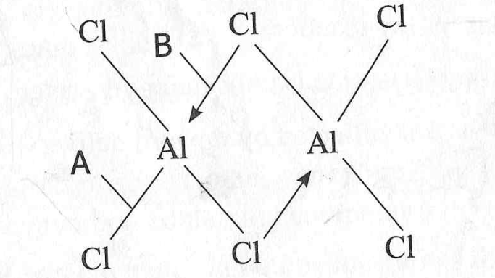

- Identify the bonds labelled A and B (2mks)
………………………………………………………………………………………………………………………………………………………………………………...
- Aluminium oxide is said to be an amphoteric oxide,what is an amphoteric oxide (2mks)
……………………………………………………………………………………………………………………………………………………………………………

- study the diagram below and use it to answer the questions that follow.
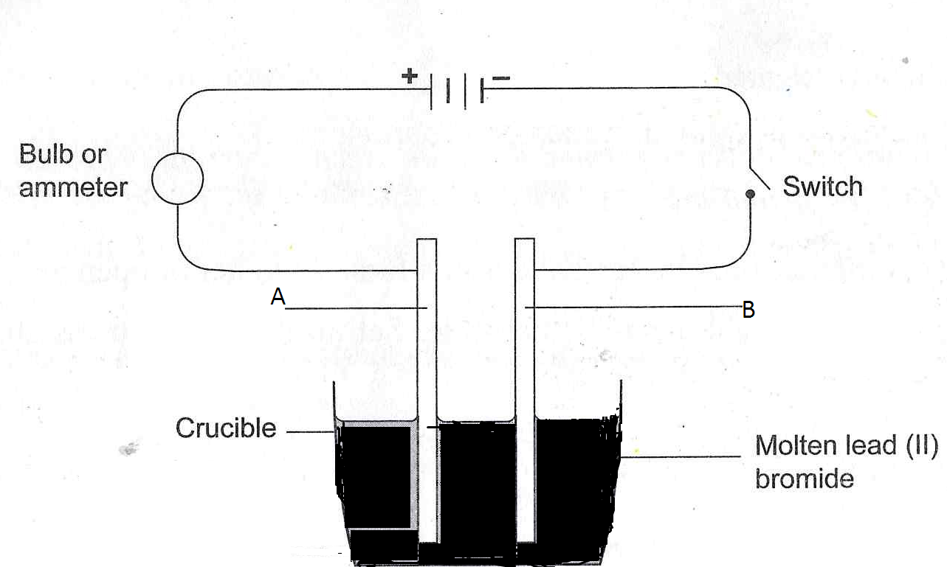
- Differentiate between electrolyte and non-electrolyte (2mks)
………………………………………………………………………………………………………………………………………………………………………….
- Identify electrode A and B (2mks)
…………………………………………………………………………………………………………………………………………………………………………
- Write the electrode half equation at electrode A (1mk)
……………………………………………………………………………………
- State any two applications of electrolysis (2mks)
…………………………………………………………………………………………………………………………………………………………………………
- Write the chemical equation for the effect of heat on
(2mks)
- Lead carbonate- heat
…………………………………………………………………………………………
- State two uses of carbon(IV)oxide (2mks)
……………………………………………………………………………………………………………………………………………………………………………………..
- The grid below represents part of the periodic table. The letters do not represent the actual symbols of the elements. Study it and answer the questions that follow:
L |  |  |  |  |  |  | L
M | P |  |  | T |  | J | U | X
N | Q |  | R | S |  |  | V | Y
 |  |  |  |  |  |  | W

- Explain why element L appears in two different groups in the grid above (2mk)
……………………………………………………………………………………………………………………………………………………………………………………………………………………………………………………………………………………………………………………….
- State the name of the chemical family to which P and Q belong (1mk)
………………………………………………………………………………………………………………………………………………………………………………………………………………
- Write the formula of the compound formed between P and V (1mk)
……………………………………………………………………………………………………………………………………………………………………………………………………………….
- Compare the melting points of Q and V. Explain (2mks)
………………………………………………………………………………………………………………………………………………………………………………………………………………
- Write the equation for the burning of T in excess air (1mk)
………………………………………………………………………………………………………
- State two use of element X (2mk)
………………………………………………………………………………………………………
- Define the term efflorescence (2mks)
……………………………………………………………………………………………………………………………………………………………………………………………

