BIOLOGY FORM 3 MARKING SCHEME
- State the use of each of the following. (3mks)
- Ribosomes - site for protein synthesis
- Mitochondria - site for respiration in a cell
- Lysosome – contains lytic enzymes that destroys worn out cells/cell organels
- A ‘dolf’ is an offspring between a wolf and a dog. This animal is infertile. Give a reason for this. (1mk)
Because the wolf and the dog do not belong to the same species hence they give rise to infertile offsprings.
- a) What is a hypotonic solution? (1mk)
solution having less solutes than solvent molecules compared to cell sap.
b) Explain the changes that will be observed if a drop of human blood is added to this solution. (3mks)
The RBC will be hypertonic to the solution. Water molecules from solution will move into RBC by osmosis. The cell swell, enlarge and burst since they lack cell wall.
c) State four importance of osmosis to plants. (3mks)
- Helps in the opening and closing of the stomata.
- Aid in uptake of water by root hairs from the soil .
- Facilitates feeding in insectivorous plants.
- Enhances turgidity of cells in herbaceous plants giving them support.
- Assist in movement of water from cell to cell
- Give two main branches of Biology. (2mks)
- Botany
- zoology
- A certain animal has no incisors and no canine but has six premolars and 6 molars in the upper jaw. In the lower jaw there are 6 incisors, 2 canines, 6 premolars and 6 molars.
- What is the dental formula of the animal? (1mk)
i${ 0}/3$ c $0/1$ pm $3/3$ m $3/3$
- Calculate the total number of teeth. (1mk)
32
- Giving reasons, state the mode of feeding. (2mks)
Herbivorous/herbivory, they lack upper incisors and canines
- State and explain three environmental factors that affect transpiration. (6mks)
- Humidity – at high humidity, the rate of transpiration is low while at low humidity the transpiration rate is high
- Wind – transpiration rate is higher during a windy day because of increased evaporation on leaf surface.
- Temperature – at high temperature, transpiration rate is high while at low temperature the transpiration rate is low
- A man is of group A+.
- What type of antigen does his blood have? (1mk)
- Antigen A, rhesuss factor
- What types of antibodies are present in his blood? (1mk)
- Antibody b
- Which blood groups can he receive blood from? (2mks)
- A⁺ and O⁺
- (a) How is the mitochondrion adapted to its function? (2mks)
- Has cristae which provide large surface area for attachment of respiratory enzymes.
- Has matrix which contains numerous respiratory enzymes
(b) In which part of the mitochondrion does aerobic respiration take place? (1mk)
- Matrix
- State four structural differences between arteries and veins. (4mks)
Arteries | Veins
- Have narrow lumen | - Have a wide lumen
- Lack valves except at the base of the aorta and pulmonary artery | - Have valves at intervals
- Have thick elastic walls | - Have thin and less elastic walls

- State three characteristics of a respiratory surface. (3mks)
- Thin epithelium for rapid diffusion of respiratory gases
- Large surface area for rapid diffusion of respiratory gases
- Moist surface for respiratory gases to dissolve
- Well vascularised to transport respiratory gases

- The diagram below illustrates the structure of a gill from a bonny fish.
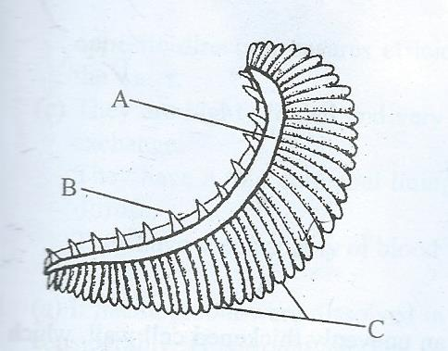

- Name the structures labelled A, B and C and give their functions. (6mks)
A: Gill bar – hold gill filament and rakers in position
B: Gill rakes – protect delicate gill filament from damage
C: Gill filament site for gaseous exchange
- How is structure labeled C adapted to its function? (1mk)
- Numerous providing large surface area for gaseous exchange.
- Have thin epithelium lining thus reducing distance over which gases diffuse
- Have rich supply of blood vessels to transport respiratory gases/ create a steep diffusion gradient

- State the functions of the following parts of a microscope. (3mks)
- Diaphragmit regulates the amount of light passing through the condenser to the specimen
- Condenser concentrates light rays into state to illuminate the specimen on stage
- Fine adjustment knob
Raises and lowers body tube over short distance to bring image into shaper focus.

- The diagram below represents a transverse section of a part of a young plant and seen under light microscope.
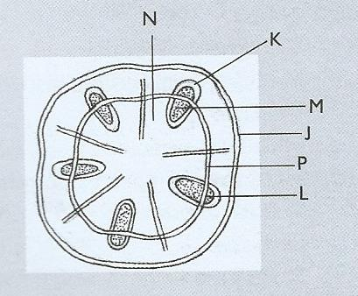
- From which part of the plant was the specimen obtained? (1mk)
- (Dicotyledonous )stem
- Name the parts labelled J,P and M. (3mks)
J: Epidermis
P: cambium
M: xylem

- Name the functions of the part labelled M. (1mk)
- Transports water and mineral salts.
- State three factors that determine the amount of energy a human requires in a day. (3mks)
- Basal metabolic rate
- Sex
- Age
- Occupation
- Body size
- State two defects of circulatory system. (2mks)
- Varicose veins
- Hypertension
- Thrombosis
- Arteriosclerosis
b) State three adaptations of erythrocytes to their functions. (3mks)
- Have biconcave shape that crates a large surface area for diffusion of gases
- Contains haemoglobin which readily combines with oxygen
- Lack nucleus which creates more space for packaging of haemoglobin
- Numerous to offer a large surface area for diffusion of gases.
- Thin for the respiratory gases to take short distance in movement by difussion
- A jet aeroplane is able to move and oxidise fuel to carbon (IV) oxide and water yet it is not classified as a living thing. List other characteristics of living things not shown by a jet aeroplane. (3mks)
- Growth
- Reproduction
- Irritability
- Feeding
- Outline three applications of anaerobic respiration. (3mks)
- Manufacturing of organic acids
- Sewage treatment
- Making of silage
- Production of biogas
- Baking industry
- Brewing industry
- Define the following terms. (3mks)
- Excretion:removal of metabolic waste products from the body of an organism
- Secretion:production of substances from cells which are useful to the body
- Homeostasis:it is maintenance of constant internal conditions despite fluctuations in the external environment
- The diagram below illustrates a nephron from a mammalian kidney.
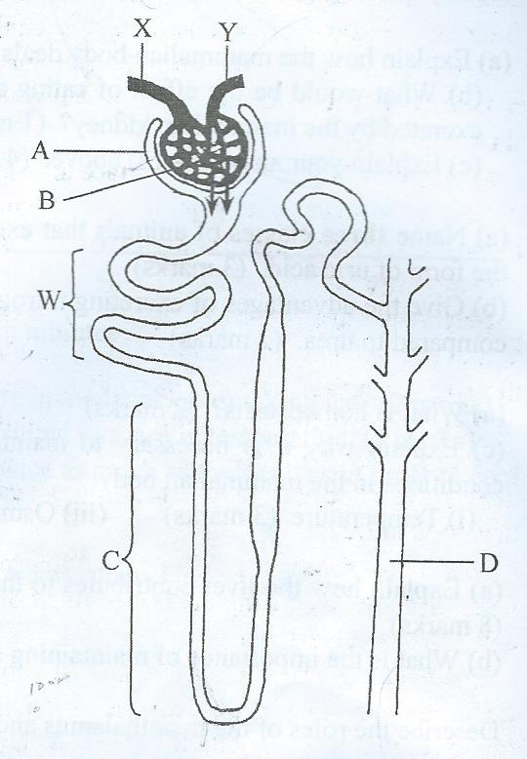

- Name the parts labelled A, B,C and D. (4mks)
A: bowman’s capsule
B: glomerulus filtrate
C: loop of henle
D: collecting duct
- Name the process represented by arrows. (1mk)
Ultrafiltration
- Name three substances that are completely reabsorbed in the part labelled W in a normal human being. (3mks)
- Amino acids
- Vitamins
- glucose
- Name the components of blood that do not enter the renal tubule in mammals. (1mk)
- Blood cells
- Plasma proteins
- How does the part labelled C of a camel compare with that of a hippo? (2mks)
- it is long and penetrates deep in medulla while in a hippo it is short and confined to the cortex

