NAME………………………………………………………………..ADM…………….
Class……………………………………………

AGRICULTURE FORM 2

TIME: 2 HOURS

Instructions:
- This paper consists of 11 printed pages.
-This paper has three sections A,B and C.
- Answer ALL questions in sections A and B.
-Answer any TWO questions in section C.

For Examiners use:
SECTION | QUESTIONS | MAXIMUM SCORE | STUDENTS SCORE
A | 1-17 | 30
B | 18-21 | 20
C | 22 | 20
 | 23 | 20
 | 24 | 20
TOTAL |  | 90

SECTION A (ANSWER ALL THE QUESTIONS IN THIS SECTION)
- Define the following terms. (2mks)
- Arable farming
………………………………………………………………………………………………………………………………………………………………………………………………………………
- Organic farming
………………………………………………………………………………………………………………………………………………………………………………………………………………
- Name four branches of livestock farming. (2mks)
……………………………………………………………………………………………………………………………………………………………………………………………………………………………………………………………………………………………………………………………………………………………………………………………………………………………………………………………………………………………………………………………………………………..
- State four characteristics of extensive farming system. (2mks)
……………………………………………………………………………………………………………………………………………………………………………………………………………………………………………………………………………………………………………………………………………………………………………………………………………………………………………………………………………………………………………………………………………………
- List four aspects of rainfall that affect Agriculture. (2mks)
……………………………………………………………………………………………………………………………………………………………………………………………………………………………………………………………………………………………………………………………………………………………………………………………………………………………………………………………………………………………………………………………………………………
- Give four constituents of soil. (2mks)
……………………………………………………………………………………………………………………………………………………………………………………………………………………………………………………………………………………………………………………………………………………………………………………………………………………………………………………………………………………………………………………………………………………..

- Name any four types of soil structures. (2mks)
……………………………………………………………………………………………………………………………………………………………………………………………………………………………………………………………………………………………………………………………………………………………………………………………………………………………………………………………………………………………………………………………………………………………………………………………………………………………………………………………...
- State four ways of modifying soil P.H (2mks)
……………………………………………………………………………………………………………………………………………………………………………………………………………………………………………………………………………………………………………………………………………………………………………………………………………………………………………………………………………………………………………………………………………………..
- State the use of the following tools and equipments. (2mks)
- Strip cup: ……………………………………………………………………………………….
- Burdizzo: ………………………………………………………………………………………
- Bolus gun: …………………………………………………………………………………….
- Plumb bob: ……………………………………………………………………………………..
- Give four ways of clearing land during preparations. (2mks)
……………………………………………………………………………………………………………………………………………………………………………………………………………………………………………………………………………………………………………………………………………………………………………………………………………………………………………………………………………………………………………………………………………………
- Name two types of underground water sources. (1mk)
………………………………………………………………………………………………………………………………………………………………………………………………………………………………………………………………………………………………………………………………..

- State two types of pipes used to convey water to the farm. (1mk)
………………………………………………………………………………………………………………………………………………………………………………………………………………………………………………………………………………………………………………………………..

- List four types of irrigation systems. (2mks)
……………………………………………………………………………………………………………………………………………………………………………………………………………………………………………………………………………………………………………………………………………………………………………………………………………………………………………………………………………………………………………………………………………………
- Give any four methods of drainage. (2mks)
……………………………………………………………………………………………………………………………………………………………………………………………………………………………………………………………………………………………………………………………………………………………………………………………………………………………………………………………………………………………………………………………………………………..
- Name any two types of organic manure. (1mk)
………………………………………………………………………………………………………………………………………………………………………………………………………………………………………………………………………………………………………………………………
- State four ways by which soil looses fertility. (2mks)
……………………………………………………………………………………………………………………………………………………………………………………………………………………………………………………………………………………………………………………………………………………………………………………………………………………………………………………………………………………………………………………………………………………..

- List four types of products a farmer can obtain from domesticated livestock. (2mks)
……………………………………………………………………………………………………………………………………………………………………………………………………………………………………………………………………………………………………………………………………………………………………………………………………………………………………………………………………………………………………………………………………………………..
- Name two types of camel species reared in the farm. (1mk)
………………………………………………………………………………………………………………………………………………………………………………………………………………………………………………………………………………………………………………………………

SECTION B (Answer ALL the questions in this section)
- Study the diagram below and answer the questions that follow.
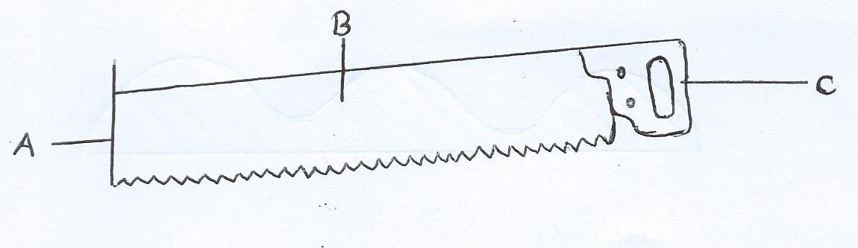

- Identify the tool illustrated above. (1mk)
…………………………………………………………………………………………………………..
- On the diagram label parts A,B and C. (3mks)
A…………………………………………………………………………………………………….
B…………………………………………………………………………………………………….
C…………………………………………………………………………………………………
- State two maintenance practices that can be done on the tool. (1mk)
……………………………………………………………………………………………………………………………………………………………………………………………………………………..

- The diagram below illustrates a farming operation done during crop production
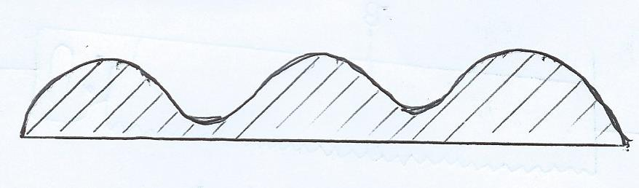
- Identify the practice. (1mk)
…………………………………………………………………………………………………………
- Describe how the above practice is done. (2mks)
………………………………………………………………………………………………………………………………………………………………………………………………………………………………………………………………………………………………………………………………
- State the importance of the practice. (2mks)
………………………………………………………………………………………………………………………………………………………………………………………………………………………………………………………………………………………………………………………………..

- The diagram below illustrates a method of water harvesting

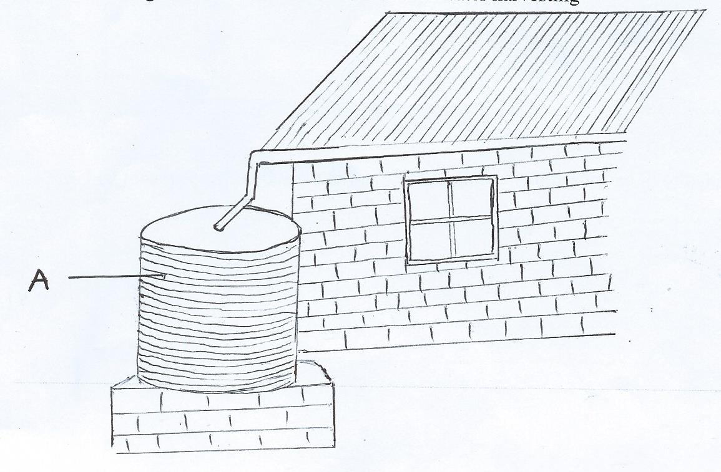

- Identify the method of water harvesting. (1mk)
…………………………………………………………………………………………………………....................................................................................................................................................................
- State factors that determine the amount of water harvested by the method above. (2mks)
………………………………………………………………………………………………………………………………………………………………………………………………………………………………………………………………………………………………………………………………..
- State the maintenance practices that should be done on part A. (2mks)
………………………………………………………………………………………………………………………………………………………………………………………………………………………………………………………………………………………………………………………………

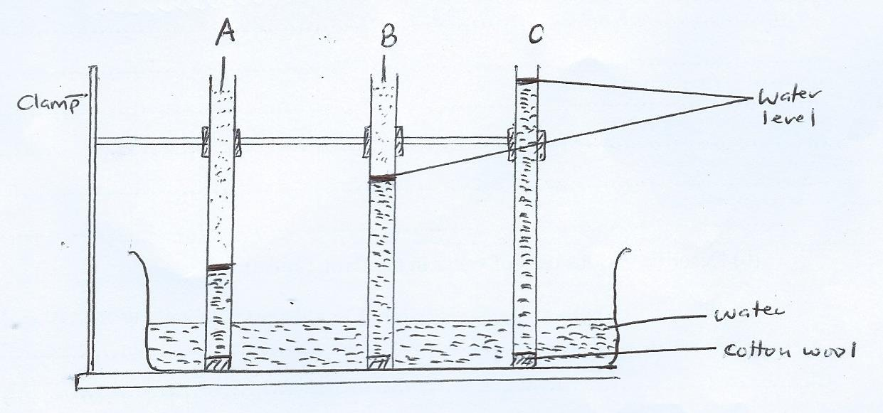

- State the aim of the experiment. (1mk)
…………………………………………………………………………………………………………………………………………………………………………………………………………………….

- Identify soil types A,B,C. (3mks)
A………………………………………………………………………………………………………..
B………………………………………………………………………………………………………
C……………………………………………………………………………………………………..

- Which of the above soil types is suitable for growing of paddy rice. (1mk)
……………………………………………………………………………………………………………………………………………………………………………………………………………………..

SECTION C (Answer any TWO questions in this section)

- (a) Discuss the process of water treatment. (12mks)
…………………………………………………………………………………………………………………………………………………………………………………………………………………………………………………………………………………………………………………………………………………………………………………………………………………………………………………………………………………………………………………………………………………………………………………………………………………………………………………………………………………………………………………………………………………………………………………………………………………………………………………………………………………………………………………………………………………………………………………………………………………………………………………………………………………………………………………………………………………………………………………………………………………………………………………………………………………………………………………………………………………………………………………………………………………………………………………………………………………………………………………………………………........………………………………………………………………………………
(b) Describe various uses of water in the farm. (5mks)
………………………………………………………………………………………………………………………………………………………………………………………………………………………………………………………………………………………………………………………………………………………………………………………………………………………………………………………………………………………………………………………………………………………………………………………………………………………………………………………………………………………………………………………………………………………………………………………………………………
(c) State three reasons of treating water in the farm. (3mks)
………………………………………………………………………………………………………………………………………………………………………………………………………………………………………………………………………………………………………………………………………………………………………………………………………………………………………………………………

- (a) Highlight five characteristics of fertile soils. (5mks)
………………………………………………………………………………………………………………………………………………………………………………………………………………………………………………………………………………………………………………………………………………………………………………………………………………………………………………………………………………………………………………………………………………………………………………………………………………………………………………………………..
(b) Describe various ways by which soil fertility can be maintained. (10mks)
………………………………………………………………………………………………………………………………………………………………………………………………………………………………………………………………………………………………………………………………………………………………………………………………………………………………………………………………………………………………………………………………………………………………………………………………………………………………………………………………………………………………………………………………………………………………………………………………………………………………………………………………………………………………………………………………………………………………………………………………………………………………………………………………………………………………………………………………………………………………………………………………………………………………………………………………………………………………………………………………………………………………………….…………………………………………………………….........................................................................................................................................................................................................................................................................................................................................
(c) List five factors that affect quality of farmyard manure. (5mks)
………………………………………………………………………………………………………………………………………………………………………………………………………………………………………………………………………………………………………………………………………………………………………………………………………………………………………………………………………………………………………………………………………………………………………………………………………………………………………………………………………………………………

- (a) State the importance of livestock in the farm. (5mks)
……………………………………………………………………………………………………………………………………………………………………………………………………………………………………………………………………………………………………………………………………………………………………………………………………………………………………………………………………………………………………………………………………………………………………………………………………………………………………………………………….
(b) Describe the general characteristics of Dairy cattle breeds. (7mks)
………………………………………………………………………………………………………………………………………………………………………………………………………………………………………………………………………………………………………………………………………………………………………………………………………………………………………………………………………………………………………………………………………………………………………………………………………………………………………………………………………………………………………………………………………………………………………………………………………………………………………………………………………………………………………………………………………………………………………………………………………………………………………………………………………………………………………………………………………………………………………………………………………………………………………………………………………………………………………………………………
(c) Explain the uses of farm records. (8mks)
………………………………………………………………………………………………………………………………………………………………………………………………………………………………………………………………………………………………………………………………………………………………………………………………………………………………………………………………………………………………………………………………………………………………………………………………………………………………………………………………………………………………………………………………………………………………………………………………………………………………………………………………………………………………………………………………………………………………………………………………

