Environmental & Religious Activities - Grade 4 of Term 1 2023

QUESTIONS
KALI AREA
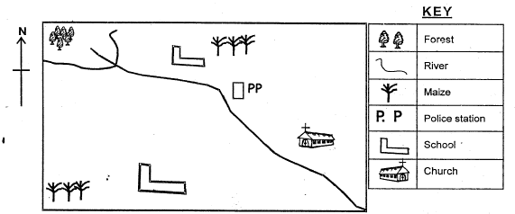
Use the map below to answer questions 1 - 5.
- The source of the river is_______
- How many tributries does the river have?
- Which food crop is grown in Kali area?
- The people of Kali area are_______
- There are schools in Kali area.
- What are resources?
- Maasai live in a special house known as_______
- _____is buying and selling of goods and services.
- Give two examples of resources.
- Name the main compass directions.
- ______is people's way of life.
- Write your school motto.
- Name two economic activities.
- Give examples of community leaders.
- How do you conserve the resources in your county?
- Name two materials used in pottery.
C.R.E
- _______created us in His image and likeness.
- _______was thrown in the den of lions.
- I am a child of_______
- I show God_______ when I bow when praying. (face, respect)
- The prayer that Jesus taught His disciples is called the_______(Jesus' prayer, Lord's player)
- The following groups show members of a family.
  - Group A
Father
Mother
Grandfather
  - Group B
Grandfather
Uncle
Mother
  - Group C
Grandfather
Cousin
Nephew
The group that shows member3 of an extended family is group
- When someone does good to you you say_______
- The story of Ananias and Sapphira teaches us that we should be_______ (clean, honest)
- _______walked on water and did not sink. (Peter, John)
- An activity that children do in the church to show respect for church as the house of God is (reciting verses of the Bible, playing games)
- Name one of the twelve disciples of Jesus
- The three Hebrew men were saved from fire by the_______ (angel, king)
- In Philippians 4:4 we learn that we should_______ in the Lord always.
- We should make_______ choices at all times.
- Which one of the following is not a good feeling? (happiness, love, anger)
ISLAMIC RELIGIOUS EDUCATION
Match the pillars of Islam
- Zakat Prayers
- Saum Kalima
- Hajj Fastings
- Shahada Pilgrimage
- Salah Alms
- Muslims pray_______ times a day.
- Muslims face _______while praying.
Write THREE manners to be observed before eating

MARKING SCHEME
ENVIRONMENTAL
- forest
- 2
- maize
- Christians
- 2
- Things we use to get money
- manyatta
- Trade
- land
- mineral

  - North
  - South
  - East
  - West
- Culture

  - Farming
  - Trading
- M.C.A
- M.P
- a/b any correct
C.R.E
- God
- Daniel
- God
- respect
- Lord's prayer
- A
- Thank you
- honest
- Peter
- reading verses of the Bible
- any correct answer
- angel
- rejoice
- God
- anger

