English Activities - Grade 4 Term 1 Exams 2023

QUESTIONS
TASK 1: Read aloud (10mks)
There are small animals which live on or within the bodics of other animals for food. Such animals are called parasites. The animals on or in which they live in are called host. Some parasites are not good because they make host sick, lice, bedbugs, ticks and mites are called external parasites. tapeworms and thread worms are internal parasites.
2. Listening and speaking (5mks)
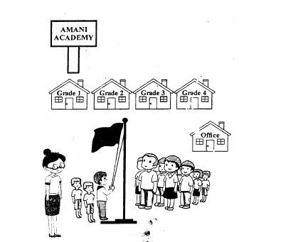
- The school is called .................................................................
- The three boys are ................................................................. the flag
- The children are standing at .................................................................
- Name the two colours on the flag
  - .................................................................
  - .................................................................
3. Read the story and answer the questions (10mks)
Mr. Cheki has a big farm in Perusi county. His farm has any animals like cows, donkeys, camel, is and cogs. He also keeps poultry like duck, hen Frigeon and geese.
Mr. Cheki is known in the nearby market because of his milk and eggs. Mr. Checki also grows many different crops that give him a good harvest. Everybody in the village is happy for his hard work.
- In which county is Cheki .................................................................
- Name four poultry that Mr. Cheki keeps
  - .................................................................
  - .................................................................
  - .................................................................
  - .................................................................
- Why is Mr. Cheki known in the nearby market
- Name two animals kept by Mr. Cheki
  - .................................................................
  - .................................................................
- Mr. Cheki is a .................................................................
- Which animal do you think Mr. Cheki uses for transport .................................................................
4. Write the opposite of the words
- wife .................................................................
- good .................................................................
- nephew .................................................................
- deep .................................................................
- brother .................................................................
5. Write the plural
- This is a baby
.................................................................
- This is a sheep
.................................................................
- The girl is wonderful
.................................................................
- The book is new
.................................................................
6. Use 'an'or'a'
- .................................................................orphan
- .................................................................good teacher
TASK 4 10mks
Write a composition about
MY FRIEND
HINT
- What is the name of a friend
- He learn in which school
- How old is your friend
- Where do they live
- Why do you love your friend

MARKING SCHEME

  - Amani Academy
  - Marching
  - Attention

    - red (any other)
    - black

  - Perusi county

    - duck
    - pigeon
    - geese
  - hen because of his milk and meat

    - dog
    - cow
  - farmer
  - donkey/camel

  - husband
  - bad
  - niece
  - shallow
  - sister

  - These are babies
  - These are sheep
  - The girls is wonderful
  - These books are new

  - an
  - a

