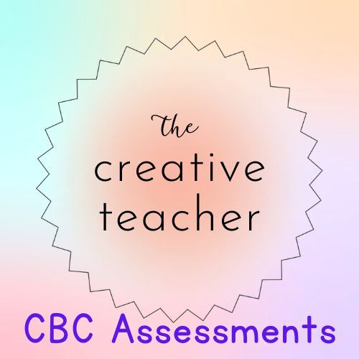
JJJ

Name:………………………………………………………….…Admission no.:………………..…

Class: ……………………….. Date: ………………………..

INSTRUCTIONS TO CANDIDATES
- Write your name and admission number in the spaces provided at the top of the page.
- Write the date of the examination in the spaces provided above.
- Answer all the questions in the spaces provided using a biro pen.
- Ensure your work is neat.

FOR EXAMINER’S USE ONLY
MARKS
Total score
Out of | 30
Percentage

- Apart from your name, what other three details do you need to give when introducing yourself? (3mks)

- What is independent reading? (2mks)

- Name three good reading habits. (3mks)

- a. what are nouns? (2mks)

b. Define the following terms and give two examples in each;
Proper nouns. (3mks)

Common nouns. (3mks)

Concrete nouns. (3mks)

Abstract nouns. (3mks)

- a. What is a trickster narrative? (2mks)

b. What is the difference between a trickster and a dupe in a trickster narrative? (4mks)

c. List ways in which we describe character traits of characters in narratives. (2mks)

