English - Grade 5 Term 1 Exams 2023
TASK 1
- Read aloud (15mks)
They sat at a dining table ready to eat. Even before they could thank God for the food, Hyena had started eating. Hyena served himself a mountain of good. There was not enough for everybody else.
As they ate he kept talking with his mouth open food particle flew from his mouth to the food of hare's father-in-law. The Hyena did not seem to notice
- Read the story and answer the questions (10mks)
Adija and Kagendo were going to visit their grandmother. They boarded a matatu. The conductor was a shabby dressed young man. He called other passengers loudly when the matatu was full, the driver came.
He too was shabbily dressed. He smelled of alcohol. Other drivers told him it was not safe to driver. When the conductor got where Adaji was he asked for here fare. She gave him thier fare. By now the matatu was driven dangerously.
Kangendo told Adija they were taking a risk. They decided to get off at the next stage. It dropped them and sped off later, as they were still on the way, they found the matatu had crashed causing many injuries, they were lucky to get off.
Questions
  - Name the two girls mentioned
  - The two girls were going to visit their____
  - The two girls boarded a____
  - Name two people who are shabby
  - Who smelled alcohol
  - Who said they were taking risk
  - A person who drives a car is called?
- Name the pictures
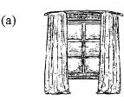
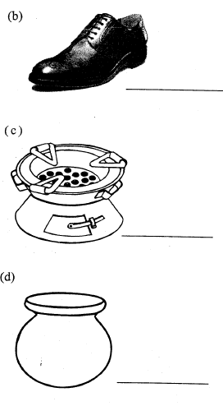
- Use the appropriate pronouns to complete these sentences
  - This book is mine.It belongs to____
  - That bag is____. It belongs to her.
  - Ken owns that car. It belongs to____
  - I bought you a present. This car belongs to____
- Fill in the missing words using comparatives
  - big___biggest
  - Hot, Hotter,____
  - Tall____tallest
  - ____cooler coolest
- Use "an, “a”
  - ____elephant
  - ____house
TASK 4(10mks)
Write a letter to your mother explaining her on your progress at a new school and ask her to buy you some items.
HINT
- Address
- greetings
- reason for writing the letter
- what are your new friends

MARKING SCHEME

  - Adija
Kagendo
  - grandmother
  - matatu
  - conductor
driver
  - driver
  - Kagendo
  - driver
  - A persons who are boarding vehicle

  - window
  - shoe
  - jiko
  - pot

  - me
  - her's
  - him
  - you

  - bigger
  - hottest
  - taller
  - cool

  - an
  - a

