ELECTRICITY (Theory)
Paper 1
BUNAMFAN CLUSTERS EXAM 2022 (TERM 1 2022)
MARKING SCHEME
SECTION A (48 marks)

- (a) List four insulating materials used in electrical installations.
- PVC
- Glass fibre
- Mica
- Cotton paper and any other correct @ ½ =2 marks
(b) State two advantages of mineral insulated copper sheathed cables over PVC sheathed.
- Requires no further protection.
- Impervious to water and oil.
- Long lasting.
- Good heat resistance. @ ½ =2 marks
- (a) State Lenz’s law of electromagnetic induction.
- states that the direction of the current induced in a conductor by a changing magnetic field is such that the magnetic field created by the induced current opposes the initial changing magnetic field which produced it. Correctly stated @ 2 marks
(b) Name four applications of electromagnets.
- Door bells, buzzers and chimes.
- Relays.
- Circuit breakers.
- Telephone receivers.
- Loud speakers.
- Measuring instruments.
- Sorting magnetic materials from scrap metals.
- Record and play heads of cassette recorders.
- Lifting magnetic materials.
- Field poles for motors and generators. Any 4 correct @ ½ =2 marks
- (a) Name four National Polytechnics in Kenya.
- Kisumu polytechnic
- Eldoret polytechnic
- Kabete National Polytechnic
- Meru National Polytechnic
- Mombasa National Polytechnic
- Nyeri National Polytechnic
- Kisii National Polytechnic
- Sigalagala National Polytechnic
- North Eastern Province National Polytechnic
- Kitale National Polytechnic Any 4 correct @ ½ =2 marks
(b) List two business opportunities in the field of electricity.
- Electrical/electronics shop
- Repair workshop
- Electrical contractor Any 2 correct @ ½ =2 marks
- (a) State how each of the following electrical material waste should be disposed safely:
- Burnt fluorescent tubes;
- Recycle @ ½ =½ mark
- Damaged computers.
- Recycle @ ½ =½ mark
(b) State the application of each of the following types of extinguishers:
- Carbon dioxide;
- To put out burning gases or vapour @ ½ =½ mark
- Water.
- Burning solid materials @ ½ =½ mark
- (a) Figure 1 shows a carbon resistor with color codes. Determine the value of the resistor given, (2 marks)
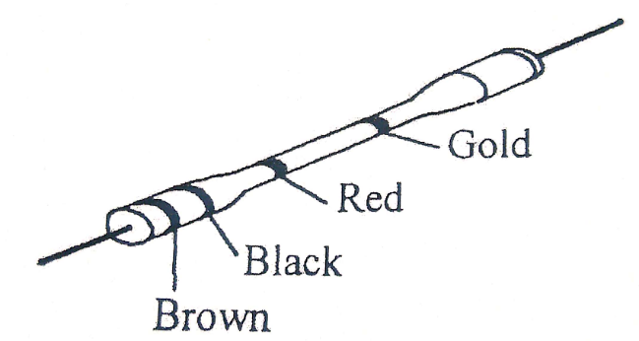

- Figure 2 shows a resistive circuit.
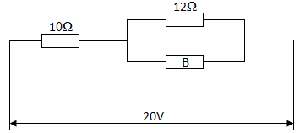
Determine the:
- Value of the resistor B if the total circuit resistance is 20Ω; (4 marks)

- Total circuit current. (2 marks)

- (a) Name four parts of a fluorescent fitting. (2 marks)
………………………………………………………………………………………………………………………………………………………………………………………………………………………………………………………………………………………………………………………………………………………………………………………………………………………………………………………………
- List four marking out tools used in fabricating sheet metal casing. (2 marks)
………………………………………………………………………………………………………………………………………………………………………………………………………………………………………………………………………………………………………………………………………………………………………………………………………………………………………………………………
- (a) Figure 3 shows two views of an object drawn in third angle projection.
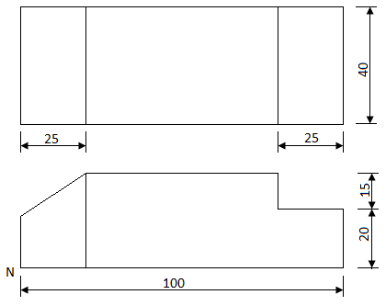

On the grid provided, make a free hand isometric sketch with corner N as the lowest point. (3 marks)

(b) Outline two ways that can be used to troubleshoot a faulty television. (2 marks)
………………………………………………………………………………………………………………………………………………………………………………………………………………………………
- (a) With the aid of sketches, distinguish between P-N-P and an N-P-N transistor. (3 marks)

(b) Name four applications of a P-N junction diode. (2 marks)
………………………………………………………………………………………………………………………………………………………………………………………………………………………………………………………………………………………………………………………………………………………........………………………………………………………………………………………………
- (a) State three advantages of digital instruments over analogue instruments. (3 marks)
………………………………………………………………………………………………………………………………………………………………………………………………………………………………………………………………………………………………………………………………………………………………………………………………………………………………………………………………
(b) An ideal transformer connected to a 240V mains supplies a 12V, 120W lamp. Calculate the:
- Transformer’s turns ratio; (3 marks)

- Current taken from the supply. (3 marks)

SECTION B (52 marks)
Answer any four questions in the spaces provided.
- (a) (i) Convert 23₁₀ to binary. (2 marks)

(ii) Convert 11011₂ to decimal. (2 marks)

(b) Draw a truth table for each of the following logic gate;
(i) NOR; (4 marks)

(ii) NAND. (4 marks)

(c) Name two applications of logic gates. (1 mark)
………………………………………………………………………………………………………………………………………………………………………………………………………………………………………………………………………………………………………………………………………………

- (a) Draw a sine wave and indicate the following:
- Peak value; (5 marks)
- Instantaneous value;
- Cycle.

(b) Figure 4 shows an RLC circuit.
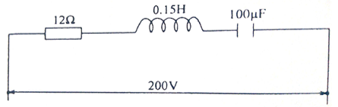

Calculate the:
- Inductive reactance; (2 marks)

- Capacitive reactance; (2 marks)

- Circuit impedance; (2 marks)

- Circuit current. (2 marks)

- (a) State;
- Two advantages of a moving coil instrument. (2 marks)
………………………………………………………………………………………………………………………………………………………………………………………………………………………………………………………………………………………………………………………………………………
- Two essential features of an analogue instrument. (2 marks)
………………………………………………………………………………………………………………………………………………………………………………………………………………………………………………………………………………………………………………………………………………
(b) With the aid of a labelled diagram, explain the Flemmings right hand rule to demonstrate the direction of induced EMF. (6 marks)

(c) show that for two capacitors C₁ and C₂ connected in series, the total capacitance is given by:
$$C_{T}=\frac{C_{1}×C_{2}}{C_{1}+C_{2}}$$
(3 marks)

- (a) State:
- Two advantages of trunking over steel conduit wiring systems. (2 marks)
………………………………………………………………………………………………………………………………………………………………………………………………………………………………………………………………………………………………………………………………………………
- Two advantages of MCBs over rewirable fuses. (2 marks)
………………………………………………………………………………………………………………………………………………………………………………………………………………………………………………………………………………………………………………………………………………
(b) (i) Draw and label a diagram of a switch start fluorescent fitting. (6 marks)

(ii) Outline three tests carried out in a completed electrical installation. (3 marks)

………………………………………………………………………………………………………………………………………………………………………………………………………………………………………………………………………………………………………………………………………………
………………………………………………………………………………………………………………………………………………………………………………………………………………………………………………………………………………………………………………………………………………

- Figure 5 shows a machine block drawing of an isometric projection.
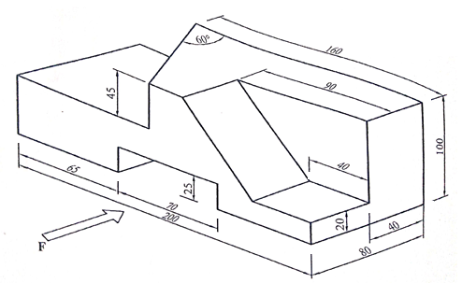
Draw the following views in full size in first angle projection:
- Front elevation in the direction of arrow F:
- Plan;
- Indicate six dimensions. (13 marks)

THIS IS THE LAST PRINTED PAGE

