BUNAMFAN CLUSTER EXAMINATION - 2022

Kenya Certificate of Secondary Education
448/1 – ELECTRICITY (Theory)– Paper 1

June 2022 - 2 ½ hours

Name…………………………………Adm No……

Class…………… Date……………………………

INSTRUCTIONS TO CANDIDATES

Candidates should have the following for this examination
- Mathematical tables or non-programmable calculators maybe used
- This paper has TWO sections: A and B
- Answer ALL the questions in section A and ANY FOUR questions from section B.
- All dimensions are in millimeters unless stated otherwise.
- This paper consists of 11 Printed pages.
- Candidates should check the question paper to ensure that all the Papers are printed as indicated and no questions are missing

This paper consists of 9 Printed pages.
Candidates should check the question paper to ensure that all the
Papers are printed as indicated and no questions are missing

SECTION A (48 marks)
Answer all the questions in this section in the spaces provided

- (a) List four insulating materials used in electrical installations. (2 marks)
………………………………………………………………………………………………………………………………………………………………………………………………………………………………………………………………………………………………………………………………………………………………………………………………………………………………………………………………………………………………………………………………………………………………………………
(b) State two advantages of mineral insulated copper sheathed cables over PVC sheathed. (2 marks)
………………………………………………………………………………………………………………………………………………………………………………………………………………………………
- (a) State Lenz’s law of electromagnetic induction. (2 marks)
………………………………………………………………………………………………………………………………………………………………………………………………………………………………
(b) Name four applications of electromagnets. (2 marks)
………………………………………………………………………………………………………………………………………………………………………………………………………………………………………………………………………………………………………………………………………………………………………………………………………………………………………………………………
- (a) Name four National Polytechnics in Kenya. (2 marks)
………………………………………………………………………………………………………………………………………………………………………………………………………………………………………………………………………………………………………………………………………………………………………………………………………………………………………………………………
(b) List two business opportunities in the field of electricity. (1 mark)
………………………………………………………………………………………………………………………………………………………………………………………………………………………………………………………………………………………………………………………………………………………………………………………………………………………………………………………………………………………………………………………………………………………………………………

- (a) State how each of the following electrical material waste should be disposed safely:
- Burnt fluorescent tubes; (½ mark)
………………………………………………………………………………………………………………………………………………………………………………………………………………………………
- Damaged computers. (½ mark)
………………………………………………………………………………………………………………………………………………………………………………………………………………………………
(b) State the application of each of the following types of extinguishers:
- Carbon dioxide; (1 mark)
………………………………………………………………………………………………………………………………………………………………………………………………………………………………
- Water. (1 mark)
………………………………………………………………………………………………………………………………………………………………………………………………………………………………
- (a) Figure 1 shows a carbon resistor with color codes. Determine the value of the resistor given, (2 marks)
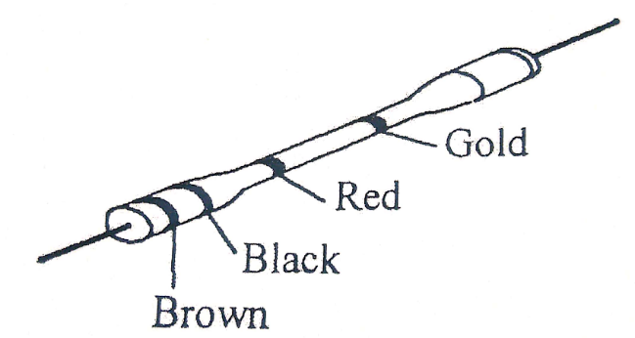

- Figure 2 shows a resistive circuit.
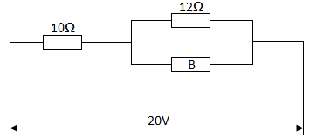
Determine the:
- Value of the resistor B if the total circuit resistance is 20Ω; (4 marks)

- Total circuit current. (2 marks)

- (a) Name four parts of a fluorescent fitting. (2 marks)
………………………………………………………………………………………………………………………………………………………………………………………………………………………………………………………………………………………………………………………………………………………………………………………………………………………………………………………………
- List four marking out tools used in fabricating sheet metal casing. (2 marks)
………………………………………………………………………………………………………………………………………………………………………………………………………………………………………………………………………………………………………………………………………………………………………………………………………………………………………………………………
- (a) Figure 3 shows two views of an object drawn in third angle projection.
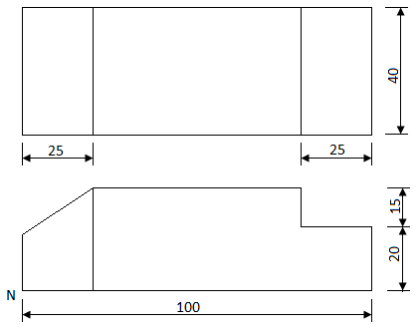

On the grid provided, make a free hand isometric sketch with corner N as the lowest point. (3 marks)

(b) Outline two ways that can be used to troubleshoot a faulty television. (2 marks)
………………………………………………………………………………………………………………………………………………………………………………………………………………………………
- (a) With the aid of sketches, distinguish between P-N-P and an N-P-N transistor. (3 marks)

(b) Name four applications of a P-N junction diode. (2 marks)
………………………………………………………………………………………………………………………………………………………………………………………………………………………………………………………………………………………………………………………………………………………........………………………………………………………………………………………………

- (a) State three advantages of digital instruments over analogue instruments. (3 marks)
………………………………………………………………………………………………………………………………………………………………………………………………………………………………………………………………………………………………………………………………………………………………………………………………………………………………………………………………
(b) An ideal transformer connected to a 240V mains supplies a 12V, 120W lamp. Calculate the:
- Transformer’s turns ratio; (3 marks)

- Current taken from the supply. (3 marks)

SECTION B (52 marks)
Answer any four questions in the spaces provided.
- (a) (i) Convert 23₁₀ to binary. (2 marks)

(ii) Convert 11011₂ to decimal. (2 marks)

(b) Draw a truth table for each of the following logic gate;
(i) NOR; (4 marks)

(ii) NAND. (4 marks)

(c) Name two applications of logic gates. (1 mark)
………………………………………………………………………………………………………………………………………………………………………………………………………………………………………………………………………………………………………………………………………………

- (a) Draw a sine wave and indicate the following:
- Peak value; (5 marks)
- Instantaneous value;
- Cycle.

(b) Figure 4 shows an RLC circuit.
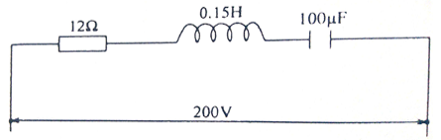

Calculate the:
- Inductive reactance; (2 marks)

- Capacitive reactance; (2 marks)

- Circuit impedance; (2 marks)

- Circuit current. (2 marks)

- (a) State;
- Two advantages of a moving coil instrument. (2 marks)
………………………………………………………………………………………………………………………………………………………………………………………………………………………………………………………………………………………………………………………………………………
- Two essential features of an analogue instrument. (2 marks)
………………………………………………………………………………………………………………………………………………………………………………………………………………………………………………………………………………………………………………………………………………
(b) With the aid of a labelled diagram, explain the Flemmings right hand rule to demonstrate the direction of induced EMF. (6 marks)

(c) show that for two capacitors C₁ and C₂ connected in series, the total capacitance is given by:
$$C_{T}=\frac{C_{1}×C_{2}}{C_{1}+C_{2}}$$
(3 marks)

- (a) State:
- Two advantages of trunking over steel conduit wiring systems. (2 marks)
………………………………………………………………………………………………………………………………………………………………………………………………………………………………………………………………………………………………………………………………………………
- Two advantages of MCBs over rewirable fuses. (2 marks)
………………………………………………………………………………………………………………………………………………………………………………………………………………………………………………………………………………………………………………………………………………
(b) (i) Draw and label a diagram of a switch start fluorescent fitting. (6 marks)

(ii) Outline three tests carried out in a completed electrical installation. (3 marks)

………………………………………………………………………………………………………………………………………………………………………………………………………………………………………………………………………………………………………………………………………………
………………………………………………………………………………………………………………………………………………………………………………………………………………………………………………………………………………………………………………………………………………

- Figure 5 shows a machine block drawing of an isometric projection.
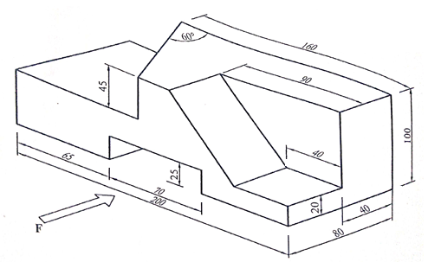
Draw the following views in full size in first angle projection:
- Front elevation in the direction of arrow F:
- Plan;
- Indicate six dimensions. (13 marks)

THIS IS THE LAST PRINTED PAGE

