COMPETENCY BASED CURRICULUM

1. keeps on changing from time to time (climate, weather) Name the following symbols drawn below
2.
3.
- Our national flag has how many colours
- Clean water should be stored in
( Ponds, drums )
- We wear cloths when it is hot (light, heavy, many )
- is the top colour in our flag ( white, red, black )
Name three types of soil
8.
9.
10.
Name three wild animals
11.
12.
13.

GRADE 3 - TERM 1 EXAM 2023 ENVIRONMENTAL ACTIVITIES
NAME: SCHOOL…………………………………………
  - Which soil is used for building houses
( clay, loam, sandy )
  - Animals kept at home are called
( many, wild, domestic )
  - Name the weather symbol
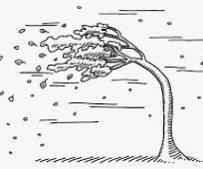

  - Name three things that can be used to model clouds in class
We can get attached by rainy weather in many ways like
18.
19.
20.
- List clothes that should be worn according to this table
Clothes to wear when weather is  hot | Clothes to wear when it is cold

Complete the sentences correctly
22. Harvest _____________during the rainy season
23. Always ensure that__________ are closed when it is windy
24. Give two reasons why we store water
______________________
_____________________

