ENGLISH ACTIVITIES - CBC GRADE 3 TERM 1 EXAMS 2023
QUESTIONS
- Read aloud (10mks)
A frog is a small animal. It lives partly in water and soil. A frog lay eggs. It crocks at night. It moves by hopping. A frog has two eyes, four legs and it is
covered by scales.
- LISTENING AND SPEAKING
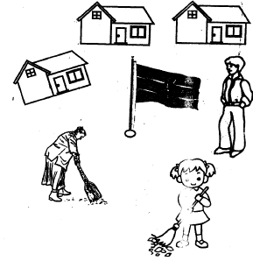
What are the girls doing?
How many girls can you see?
Name three things that you can see
- Read the following story and answer the questions
Once upon a time the cat and the rat were great friends. They lived in a big cave in the forest. The cat hunted the small insect to feed the kittens.
The rat built the nest for the kiiten. They had a big farm near the forest. They worked together. They planted, beans, maize ad bonanas.
One day there was no food the cat ate rats babies and ron. away to the nearby home. The cat and rat became enemies.
  - Name the two great friends
  - Where did the two animals live?
  - What was the work of a rat?
  - What was the work of a cat?
  - Name three crops that were grown in the farm
  - Who ate the rat babies?
  - Why did the cat and rat became enemies?

- Change the words to show more than one (plural)
Example
baby -babies
  - child
  - sheep
  - story
  - lorry
  - tomato
- Match the words which have the same sounds
sun - gun
dig peck
lice bell
ring wig
shell rice
neck sing
- use 'a' or 'an'
  - _____umbrella
  - _____bag
  - _____apple
  - _____box
  - _____axe
- Guided writing by the teacher
Write the words read by the teacher

MARKING SCHEME
- sweeping
1
  - House
  - flag
  - boy
  - girl
  - woman
  - broom
(any three)

  - cat
rat
  - cave
  - build a nest
  - hunted for insects

    - beans
    - maize
    - bananas
  - cat
  - the cat ate the rat babies

  - children
  - stories
  - lorries
  - tomatoes
- dig - wig
lice - rice
ring - sing
shell - bell
neck - peck

  - an
  - a
  - an
  - a
  - an

