ENGLISH ACTIVITIES - GRADE 3 TERM 1 2023
TASK 1: LISTENING AND SPEAKING (5 mks)
The teacher to ask the learner the following questions.
- Name one domestic animal you know.
(Learner responds)
- The animal has how many legs?
(Learner responds)
- What does the animal eat?
(Learner responds)
- What do you get from the animal?
(Learner responds)
- How can you take care of the animal?
(Learner responds)
TASK 2: READING ALOUD (5 mks)
Read this story aloud.
Jim and Rose went to the river to fetch water. They carried buckets. Jim had a blue bucket. Rose had a yellow bucket. At the river they found very many people. A certain boy helped them to fetch water. They picked their buckets and started their journey back home. Their mother was happy to see them back.
TASK 3: COMPREHENSION (5 mks)
Read this story and answer the questions.
Allan was sent to buy bread and milk. His mother gave him a one hundred shilling note. As he was going to the shop, he met his friend Joan. She was also going to the shop to buy sugar. At the shop, they bought what they had been sent and started the journey back home.
- What was Allan sent to buy?
- How much money was Allan given?
- Whom did Allan meet on the way?
- What is the opposite of the word bought?
- Where did Allan buy what he was sent?
TASK 4: GRAMMAR
Use 'this or 'these'
- Is ________ your book?
- I bought __________ chair today
- We have all __________ books
- They gave us _____ _____apples
- Can you carry __________ table?
Name these pictures.
11.
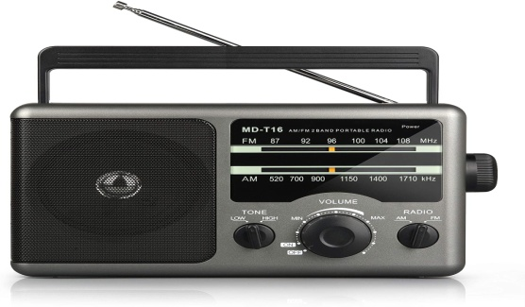
________________________
13.
____________________________
14.

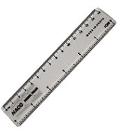
___________________________________

15.
_______________________

Write the opposite of these words.
- High
- Top
- Black
- Happy
- Tall

