NAME……………………………………………………….…… INDEX NO.:………………
STREAM: .…..…………………………………………………… ADM NO: …………………
DATE: …………………….
448/2
ELECTRICITY
PRACTICAL (448/2)
TERM 2- 2022
TIME: 2 ½ HRS

MINCKS GROUP OF SCHOOLS
FORM FOUR
KENYA CERTIFICATE OF SECONDARY SCHOOLS
FORM FOUR-TERM TWO
ELECTRICITY
PRACTICAL
Instructions to the candidates
(a) Write your name and index no on the spaces provided
(b) Sign and write the date of examination on the spaces provided
(c) There are five exercises in this paper
(d) Candidates are allowed 30 min for each exercise
(e) Attempt all the five exercises as directed by the examiner
(f)All dimensions are in mm unless otherwise
For examiner’s use only
exercise | 1 | 2 | 3 | 4 | 5 | total
Score

EXERCISE 1
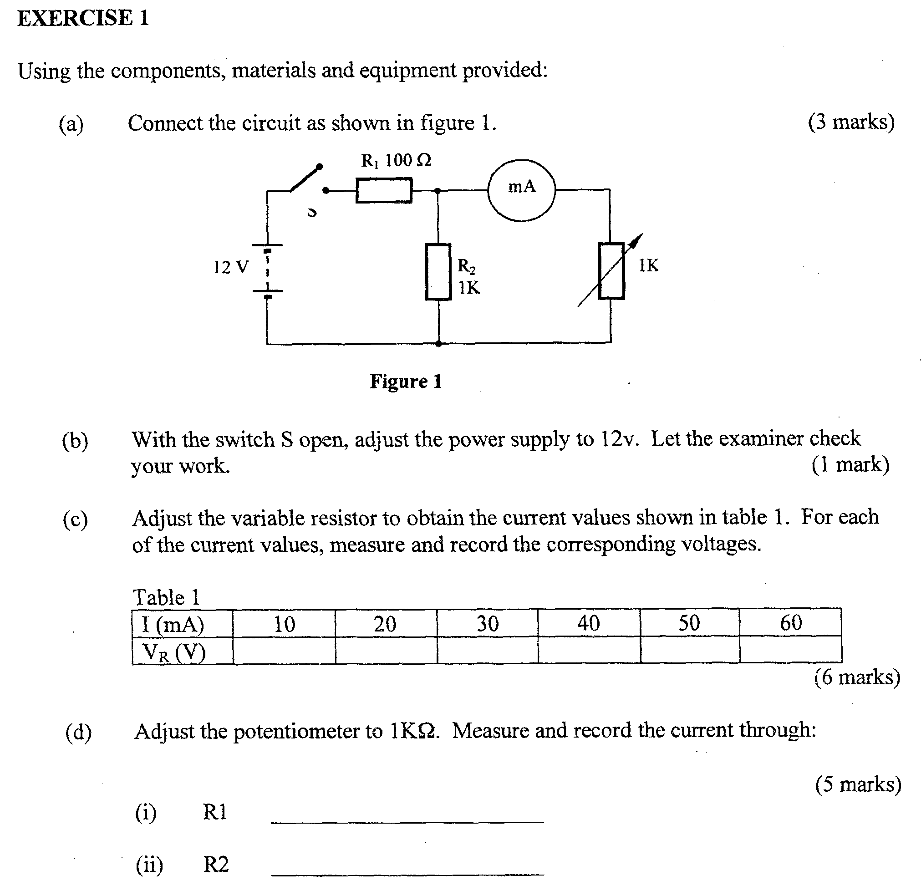

EXERCISE 2
Use the tools, equipment and materials provided to fabricate the object shown in FIGURE 2 below. (20mks)
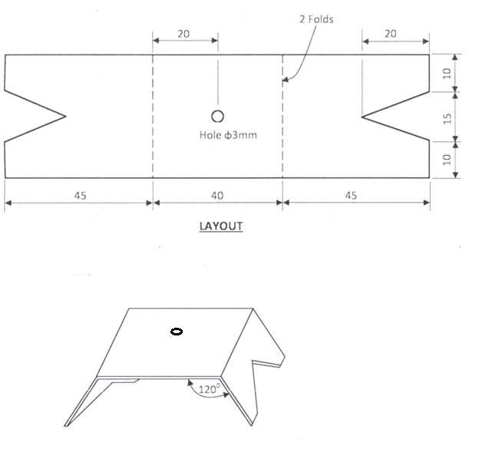FIGURE 2

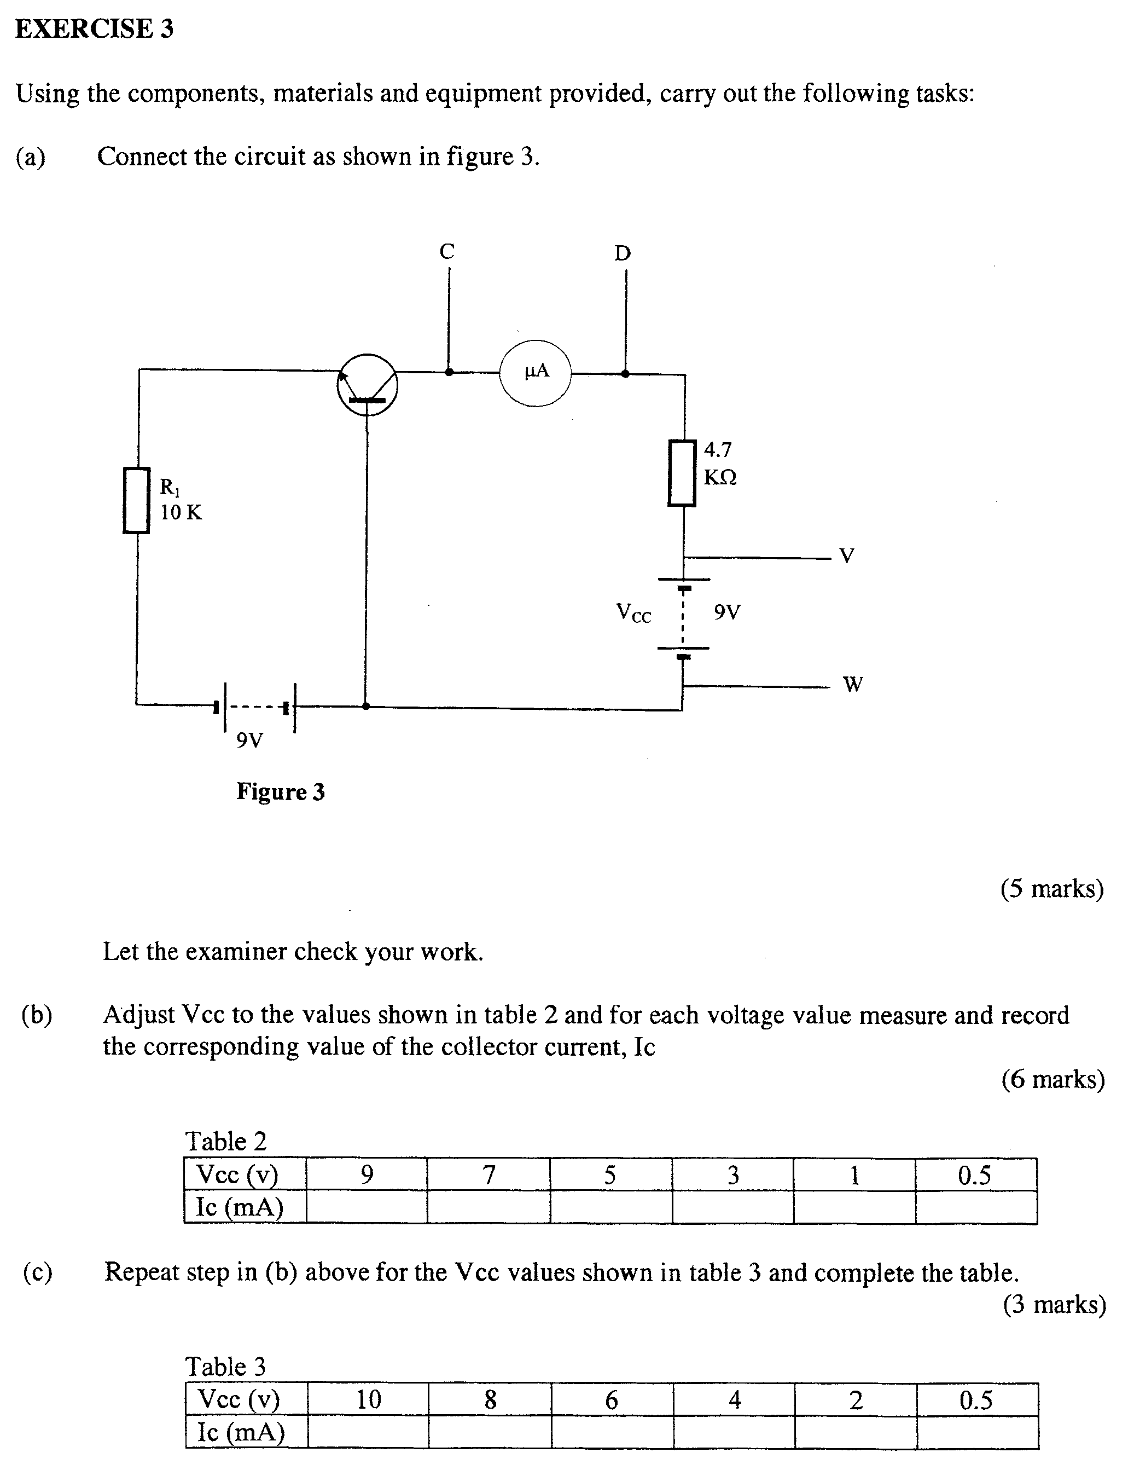
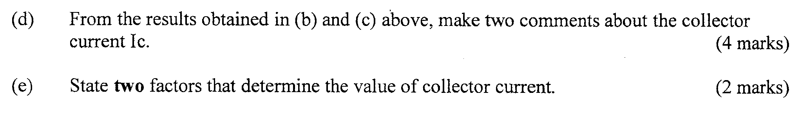
EXERCISE 4
Using the tools and materials provided, terminate the iron box to the plug and to the socket terminals (16mks)
Measure the following resistances and record below (4mks)
Live at socket and Live at plug……………………….
Live at socket and neutral at the plug…………………
Live at the socket and body of the socket …………..
Earth at the socket and erath at the plug………………

Exercise 5
Figure 5 below shows a layout of a lighting circuit. Using PVC conduit wiring system, install the circuit such that the lamp is independently controlled by S1 and S2.

