NAME…………………………………………….………..INDEX NO………….….....................………
SCHOOL………………………………………………..CANDIDATES SIGN…………....................….
DATE…………………......................………
449/1
DRAWING & DESIGN
PAPER 1
TIME: 2 ½ HOURS
AUGUST-2022
CEKENAS END OF TERM TWO EXAM-2022
FORM FOUR EXAM
Kenya Certificate of Secondary Education. (K.C.S.E)
DRAWING & DESIGN
PAPER 1
449/1

INSTRUCTIONS TO CANDIDATES
- Write your name and index number in the spaces provided above
- Sign and write date of examination in the space provided.
- Answer ALL questions in this paper.
- Candidates should check the question paper to ensure that all pages are printed as indicated and no questions are missing.
- Answer all questions in English.

Section A
1. a. State what an industrial training centre in Kenya is. (lmk)
…………………………………………………………………………………………………………….....
…………………………………………………………………………………………………………….....
b. State two factors to consider in order to produce quality drawing. (2mks)
…………………………………………………………………………………………………………….....
…………………………………………………………………………………………………………….....
…………………………………………………………………………………………………………….....
…………………………………………………………………………………………………………….....
c. State four ways through which design ideas are communicated (2mks)
…………………………………………………………………………………………………………….....
…………………………………………………………………………………………………………….....
…………………………………………………………………………………………………………….....
…………………………………………………………………………………………………………….....
2. State two classification of metals and to each case give an example. (2mks)
…………………………………………………………………………………………………………….....
…………………………………………………………………………………………………………….....
3. Give reasons for each of the following cases. (4mks)
a) Set squares are made of plastics
…………………………………………………………………………………………………………….....
…………………………………………………………………………………………………………….....
b) Drawing board are made of block board.
…………………………………………………………………………………………………………….....
…………………………………………………………………………………………………………….....
4. State the reasons why manufactured board were introduced into the wood industries. (3mks)
…………………………………………………………………………………………………………….....
…………………………………………………………………………………………………………….....
…………………………………………………………………………………………………………….....

5. With the aid of sketches explain two (2) methods of obtaining veneers from logs. (6mks)

6. Sketch the following types of wood joints. (4mks)
a) Dovetail joint

b) Dowelled joint

7. a. Sketch the conventions for each of the following: (4mks)
i. Circular tube

ii. Planed timber

iii. Switch

iv. Knurling

b. Give the composition of the each of the following alloys: (2mks)
i. Brass
…………………………………………………………………………………………………………….....
…………………………………………………………………………………………………………….....
ii. Stainless steel
…………………………………………………………………………………………………………….....
…………………………………………………………………………………………………………….....
8. Explain each of the following scales in relation to the size of the drawing and the actual object. Give a common example where each of the below scales would be used. (4mks)
i. 20:1
…………………………………………………………………………………………………………….....
…………………………………………………………………………………………………………….....
…………………………………………………………………………………………………………….....
…………………………………………………………………………………………………………….....
ii. 1:20
…………………………………………………………………………………………………………….....
…………………………………………………………………………………………………………….....
…………………………………………………………………………………………………………….....
…………………………………………………………………………………………………………….....
9. The figure below shows a pictorial view of a machined block. Draw FULL SIZE in first angle projection, the three orthographic views of the block. (9mks)
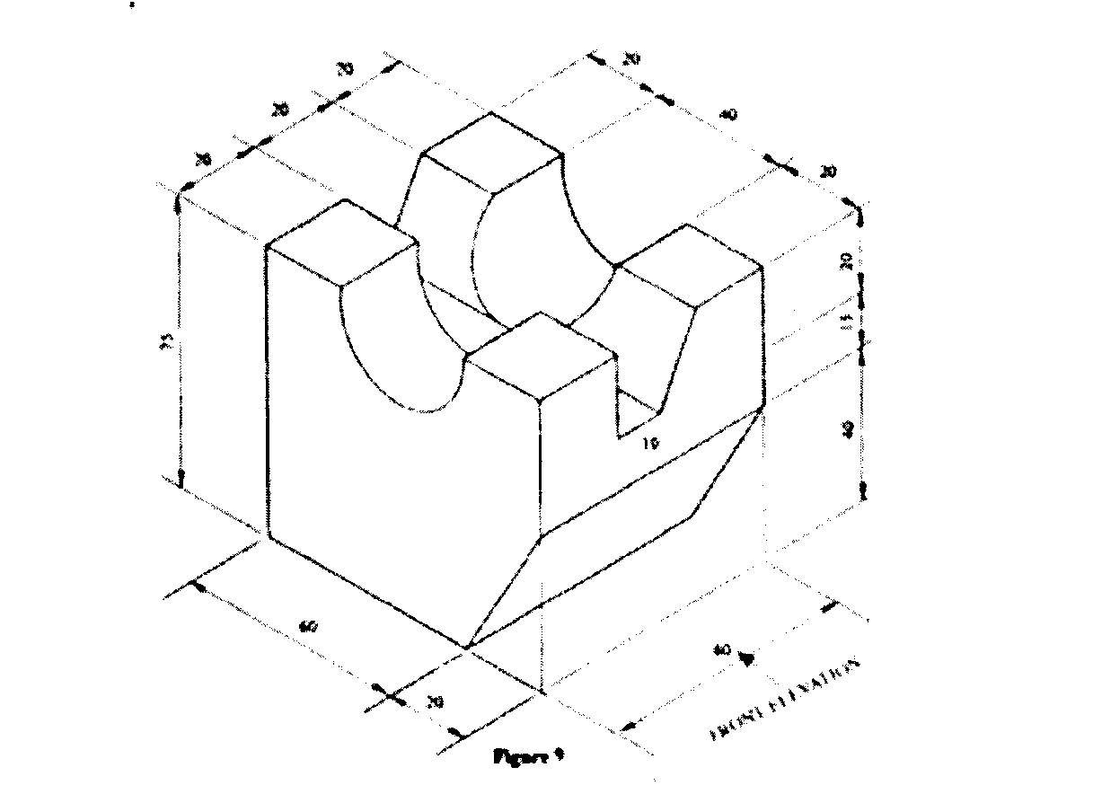

10. The figure below shows three views drawn in third angle projections. Make an isometric drawing from the three views. (7mks)
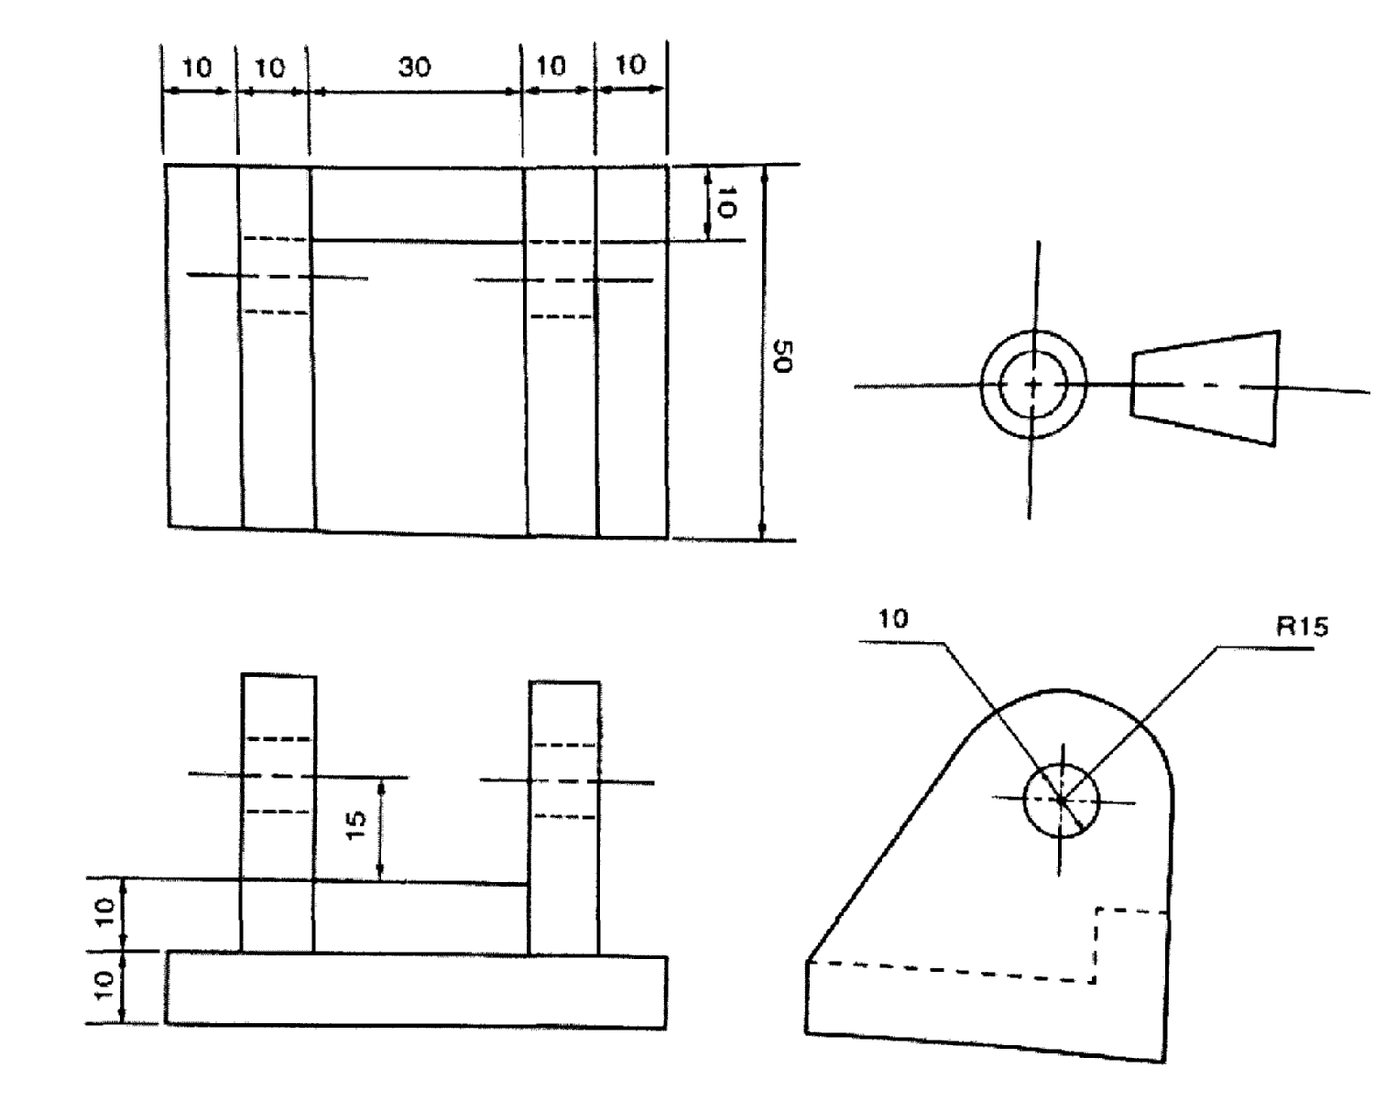

SECTION B (20MKS)
Question 11 compulsory
It should be answered on the A3 paper provided.
11 Figure 6 shows parts of a tool post drawn in first angle projection Assemb1c the parts and draw full size the following views in third angle projection:
(a) Sectional front elevation along the cutting plane X—X,
(b) Plan.
Insert four leading dimensions and do not show hidden details. (20 marks)
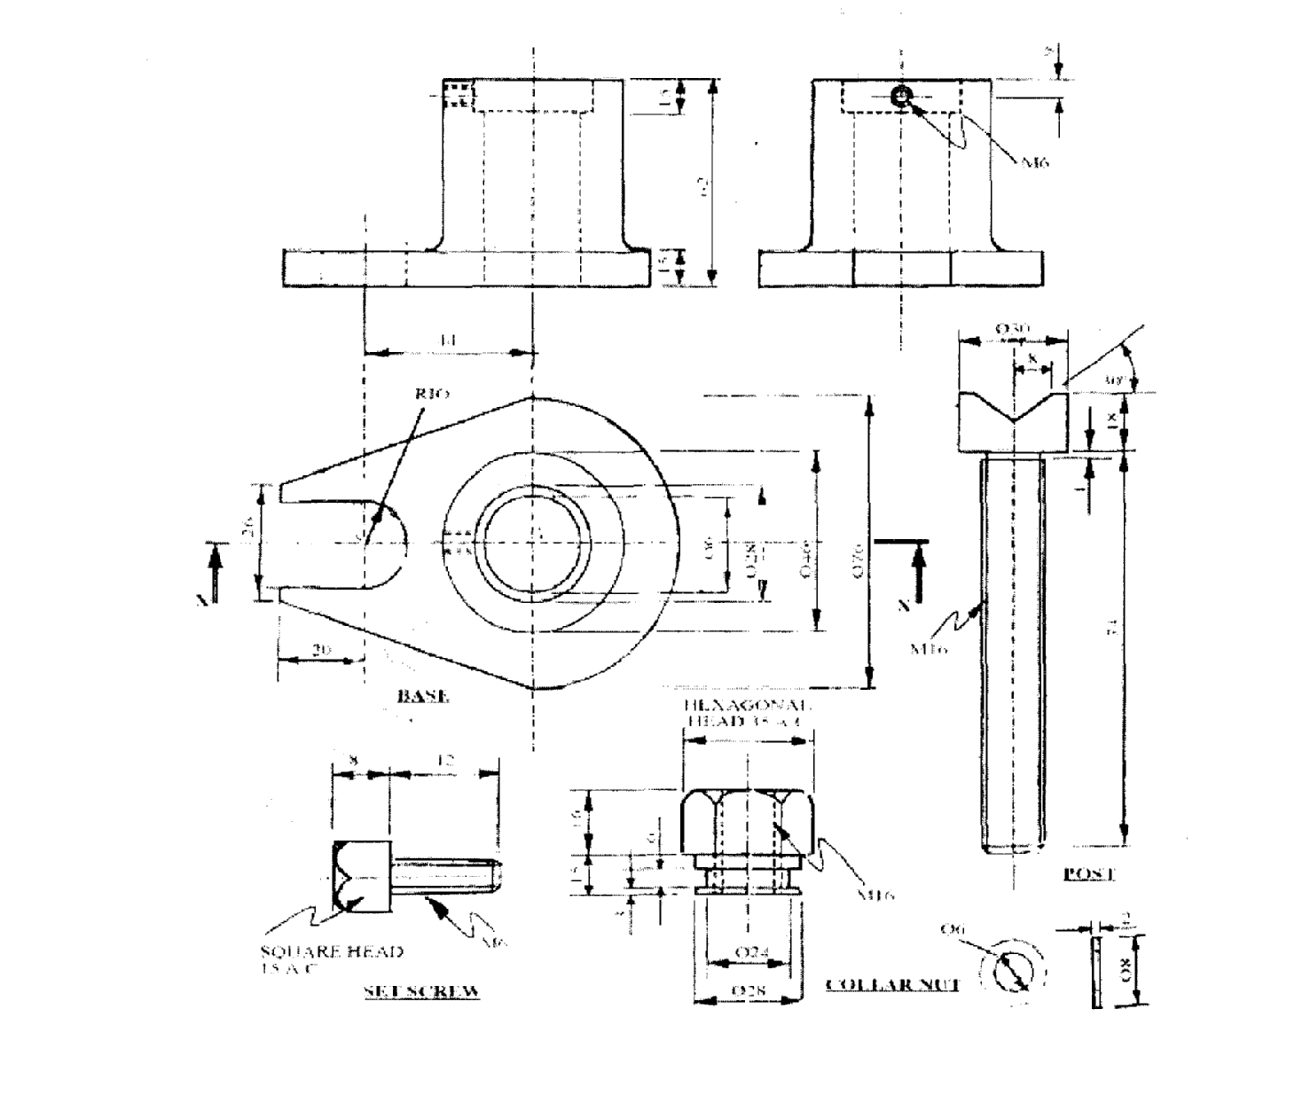
Section C
11. A wheel 72mm diameter is rolled on the outside of a large wheel 190mm diameter and after one revolution it is turned to roll on the inside of the same large wheel. Draw the locus of a point on the circumference of the small wheel as it rolls on both surface. (l5mks)
12. The figure below shows three views of a bracket in first angle projection. Draw the full size the oblique view of the bracket with X-X as the lowest edge. (l5mks)
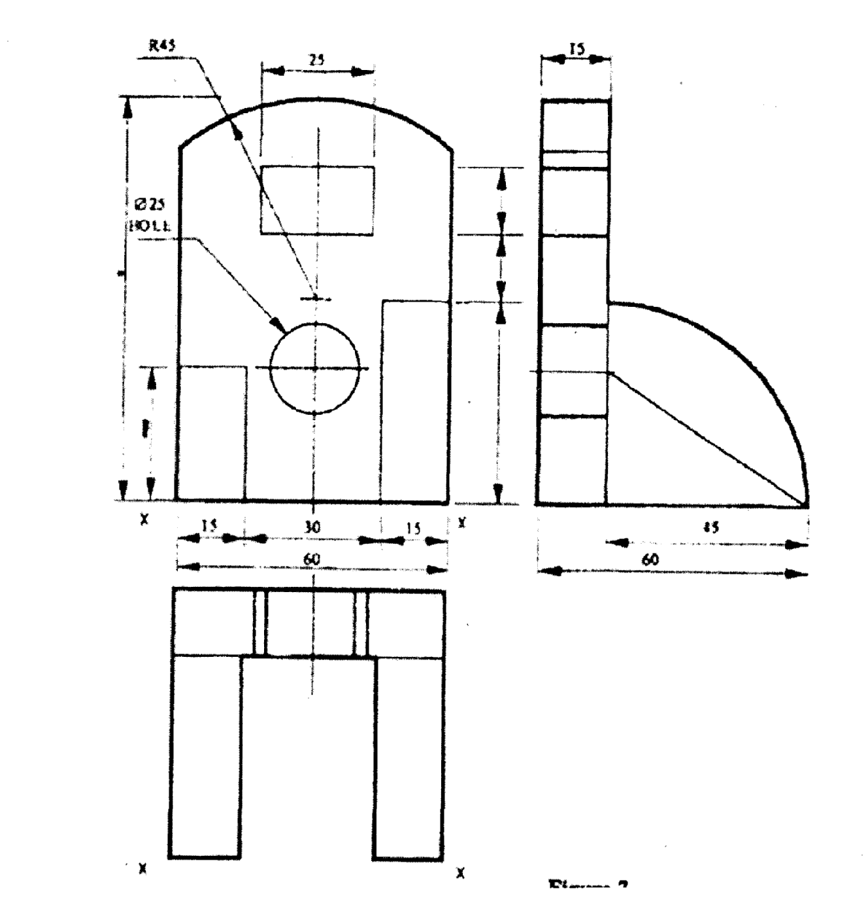
13. The figure below shows the intersection of two pieces of equal diameter at 45°. (l5mks)
Copy the given views
Complete the plan
Draw the surface development of the branch pipe labelled A
