Term 2 - 2022
DRAWING & DESIGN (449/2)
FORM FOUR (4)
PAPER 2
Time: 2½ Hours
Name: …………………………………………………………. Adm No: ……………….
School: ……………………………………………………….. Class: …………………..
Signature: …………………………………………………….. Date: …………………...
FOR EXAMINERS USE ONLY
A | b | C | d | E | TOTAL
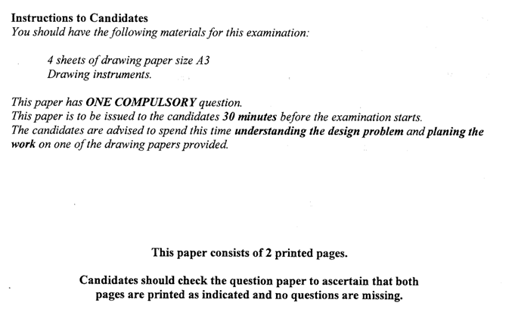

Due to increased enrolment in schools and colleges, use of desks and lockers has created congestions in classroom. Therefore there is need to use dining halls and lecture halls.
Design a portable lecture chair for students considering that;
- It should have a comfortable seat with backrest.
- It should have a suitable flap for taking notes when seated.
- It should have a shelve for placing books and other items.
- It should have means of adjusting the height to suit student with different heights
- It should be moved around with ease without making noise.
Requirements
- Make two rough sketches for the design. (4 marks)
- Produce a refined well-labelled sketch of the chair. (14 marks)
- Make exploded sketches of mechanisms to allow for considerations 2, 3, 4, and 5 above. (16 marks)
- List two materials used in the design and each case state the reason for the material choice. (4 marks)
- List two methods of joining used in your design. (2 marks)

