Term 2 - 2022
DRAWING & DESIGN (449/2)
FORM FOUR (4)
PAPER 2
Time: 2½ Hours
MARKING SCHEME

A.
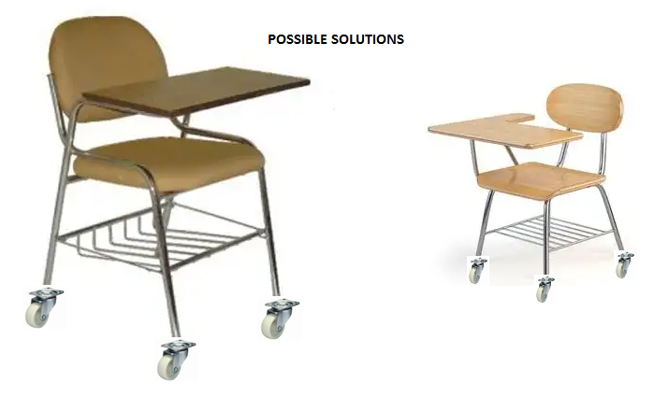

(B) REFINED PICTORIAL DRAWING OF THE BEST SOLUTION
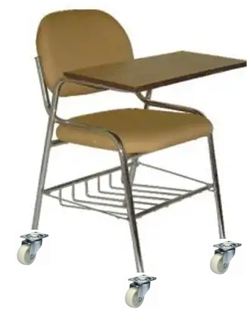

C.

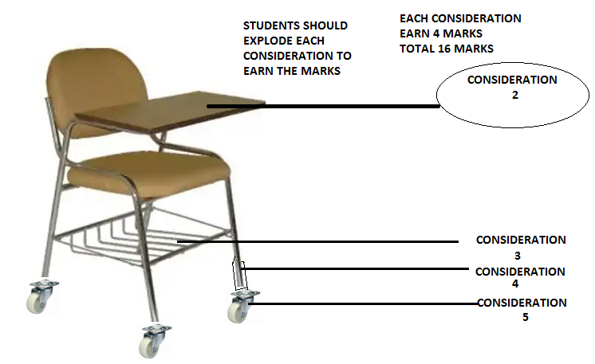
D). Alluminium------------light and strong
Mild steel---------------strong
Triply -------------------good surface finish
E.) rivets
Bolts and nuts
Screws
Arc welding

