Term 2 - 2022
DRAWING & DESIGN (449/1)
FORM FOUR (4)
PAPER 1
Time: 2½ Hours
Name: …………………………………………………………. Adm No: ……………….
School: ……………………………………………………….. Class: …………………..
Signature: …………………………………………………….. Date: …………………...

FOR EXAMINERS USE ONLY
1 | 2 | 3 | 4 | 5 | 6 | 7 | 8 | 9 | 10 | 11 | 12 | 13 | 14 | TOTAL

INSTRUCTIONS TO CANDIDATES.

You should have the following for this examination:
- Drawing instruments
- 3 sheet of drawing paper size A3
- Scale rule
This paper consists of THREE sections A, B and C.
Answer ALL the questions in section A and B and any TWO questions from section C.
Questions in section A must be answered on the answer sheets provided.
Questions in section B and C should be answered on the A3 drawing papers provided.
All dimensions are in millimeters unless otherwise stated.
Candidates may be penalized for not following the instructions given in this paper.

SECTION A (50 marks)
Answer ALL the questions in this section.
1.(a) Distinguish between the roles of an architect and a draughtsman. (2 marks)
…………………………………………………………………………………………………………………………………………………………………………………………………………………………………………………………………………………………………………………………………………………………………………………………………………………………………………………………………………..
(b) State two precautions to be observed when storing a T-square, (2 marks) ……………………………………………………………………………………………………………………………………………………………………………………………………………………………………
2 (a) Give two reasons why e dimensioning symbols used? (2 mark)
i. ……………………………………………………………………………………………………
ii. ………………………………………………………………………………………………….
(b) Define the following as used in engineering
(i) Orthographic projections.
(ii) Detailed drawings
c) Demonstrate using sketches how to dimension blind hole.

- (a) With reference to engineering design, define the following terms:((2 marks)
- restriction……………………………………………………………………………………………………………………………………………………………………………………………………
- prototype. ………………………………………………………………………………………………………………………………………………………………………………………………………………

(b) Figure 2 shows a longitudinal section of an ISO metric thread. Show the following:
(i) pitch
(ii) crest
(iii) root
(iv) major diameter. (2 marks)
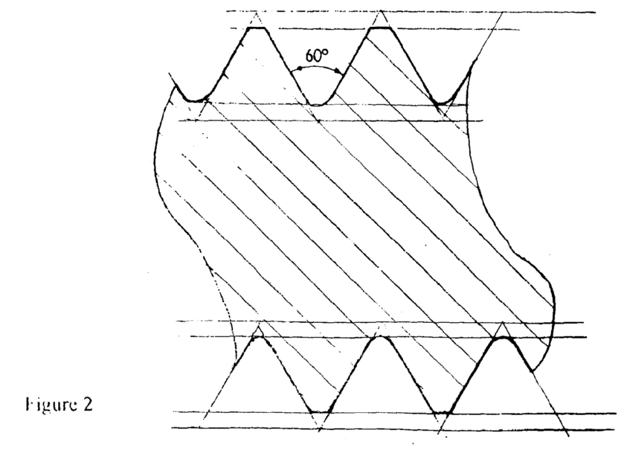
4. Figure 3 shows the elevation of a cam profile
Construct the profile (3marks)
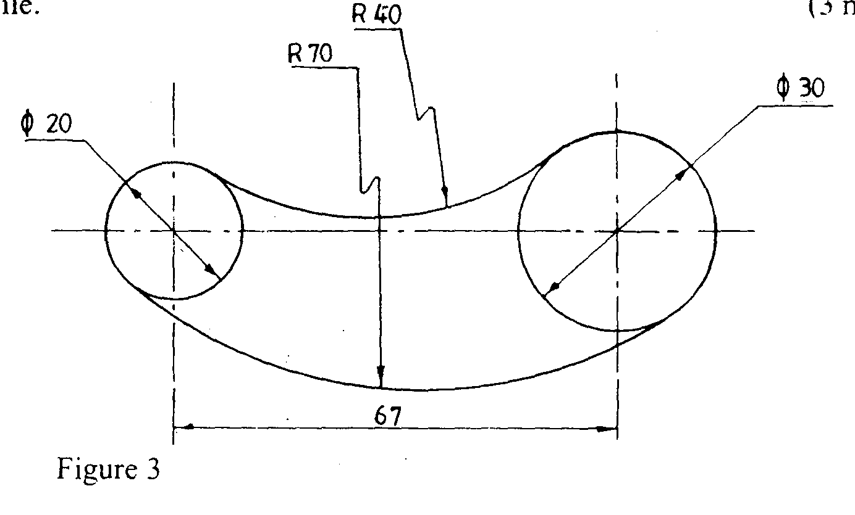
5 (a) Give two major elements in each of the following materials: ( 3 marks)
(i) bronze…………………………………………………………………………………...
(ii) soft solder……………………………………………………………………………….
(iii) brass………………………………………………………………………………………..
(b) Figure 4 shows two views of a block. Sketch the oblique views of the block with A-A being the lowest point. (3 marks)
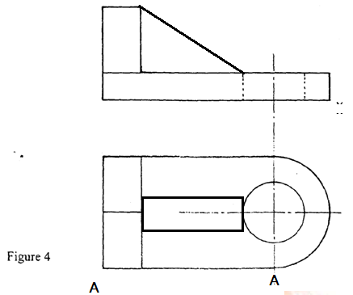

6. Sketch free hand exploded pictorial views for each of the following wood joints (4 marks)
a) double mortise and tenon joint

b) stopped housing joint.

7. Construct a plain scale of 1:5 to measure to an accuracy of 10mm and to a maximum length of 600mm. Show a reading oi’380rnm. (3 marks)

8 (a) Figure 5 shows a plan of a machine part drawn to a scale twice full size. Measure and dimension correctly the arc, tapped hole and bevel. (3 marks)

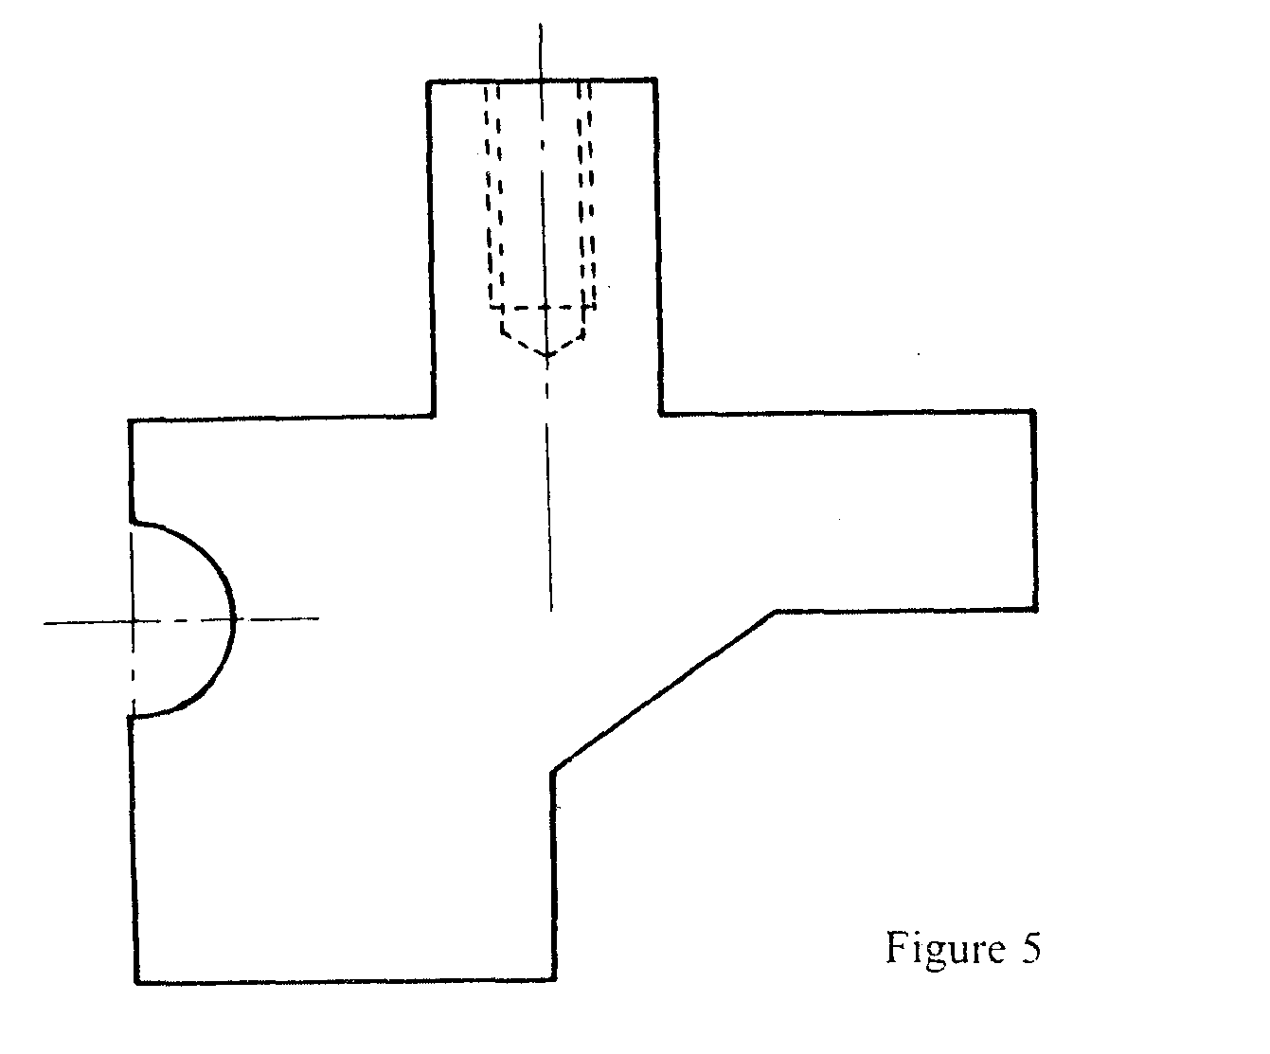

(b) Draw an oblique square based pyramid whose vertical height is equal to the base
Length 40mm . Retain the construction lines. (2 marks)

9. Figure 6 shows a cube drawn in perspective. Name the labelled areas A, B, C and D. (2 marks)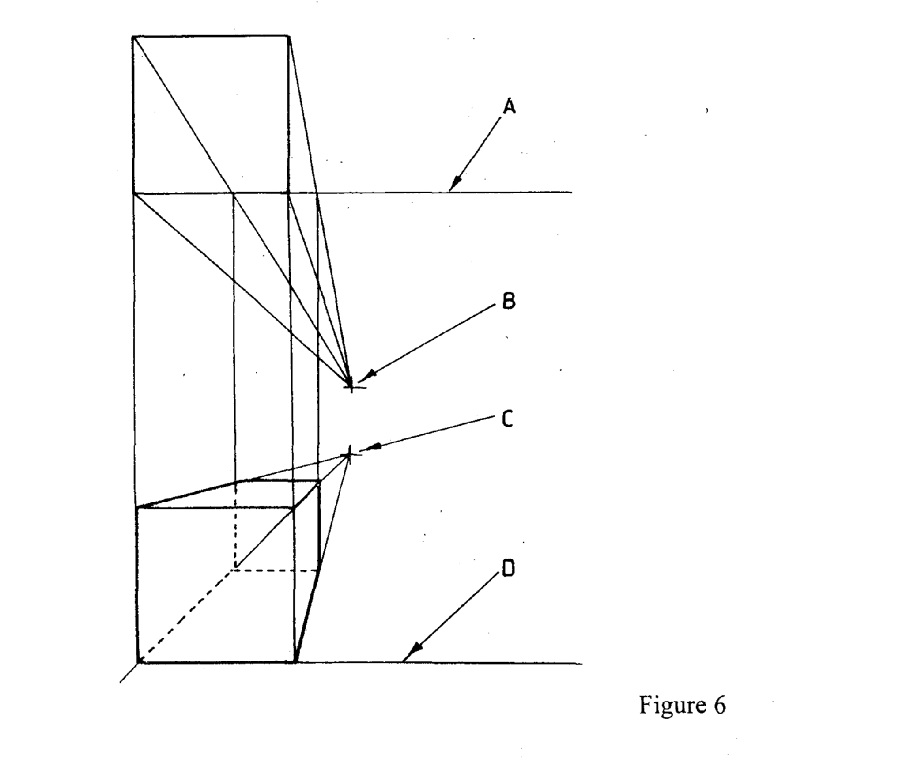

10. Figure 7 shows an isometric drawing of a block. Draw:

(a) Sectional front elevation along plane A — A.
b) End elevation.
c) Plan. (6marks)
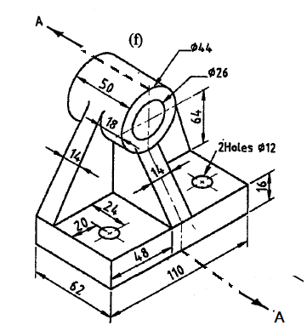

SECTION B (20 marks)
This question is compulsory. Candidates are advised to spend not more than one hour on this question.

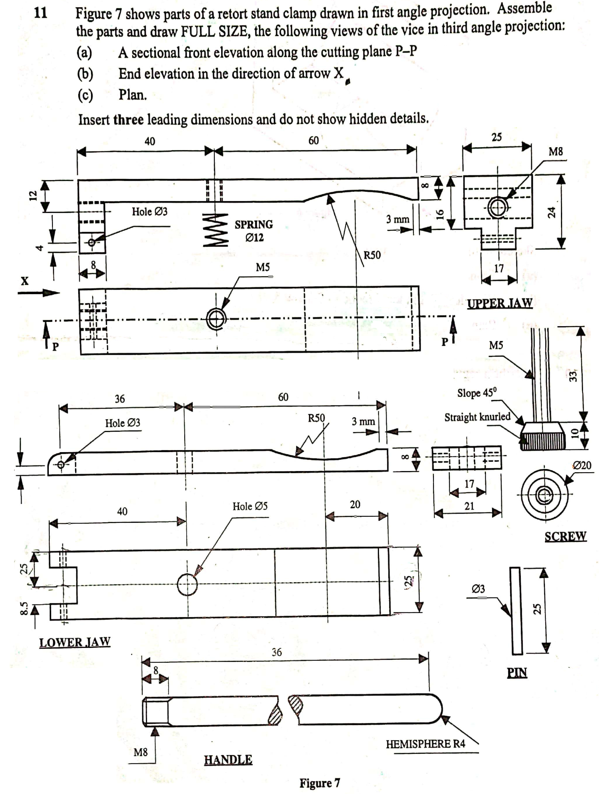

SECTION C (30 MARKS)

Answer any two questions in this section.
12. The figure below shows two-piece elbow pipes intersecting.
Draw the surface developments of pipes X and Y. (15 marks) 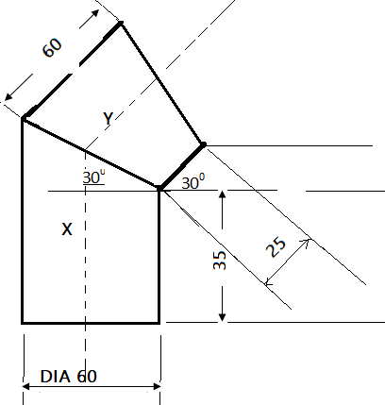

13. Figure below shows a pentagonal pyramid truncated by a cutting plane tilted at 30⁰
copy the view and draw the following:
a) Complete plan
b) True shape and auxiliary view at 45⁰
