Term 2 - 2022
DRAWING & DESIGN (449/1)
FORM FOUR (4)
PAPER 1
Time: 2½ Hours
MARKING SCHEME

1 (a) Architect He produces designs in form of sketches. He is a client representative on site

Draughtsman he produces accurate working drainage to be used. He works on sketches produced in a designer

(b) (i) BLADE: should not be in contacts with heavy objects suspend it and work with cloth.

(ii) STOCK –Take care not to have a loose stock tighten the screw or assemble it to form 90⁰

2. (a) LOCATING CENTRES OF (i) Dividing drawing into equal or symmetrical parts.
(ii) indicating Arcs.

Fig 1
(b) (i) Straight Knurting (ii) Hardcore (iii) Centerline (iv) Two way Switch
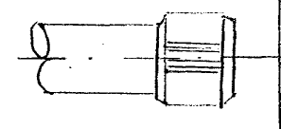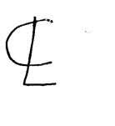

3 (a) Restriction is a factor which limits the freedom of choice e.g. of materials methods sizes e.t.v
Prototype a scaled model which reveals design problems not anticipated or forseen during the stages
(b)
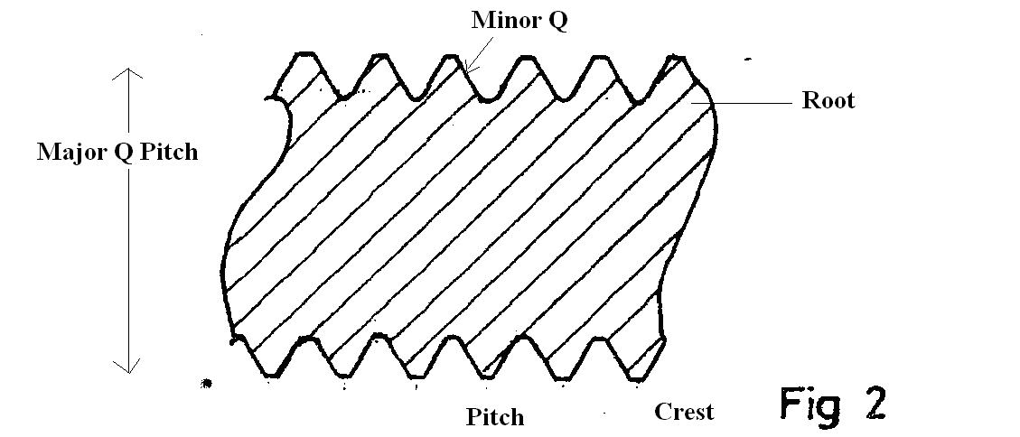

4.
Bronze 5 (a) (i) Soft solder 5 (a) ii Brass 5 (a) iii
In and copper and will Tin and lend copper and zinc
quantities of zinc
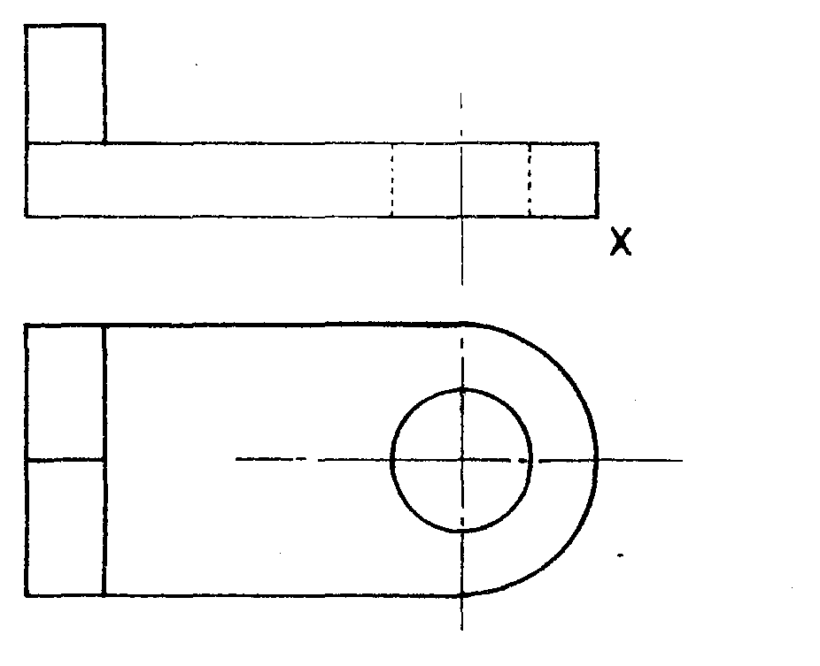
5 (b)
Figure 4

Double mortice and tenon joint stopped housing joint
6 (a) 6. (b)

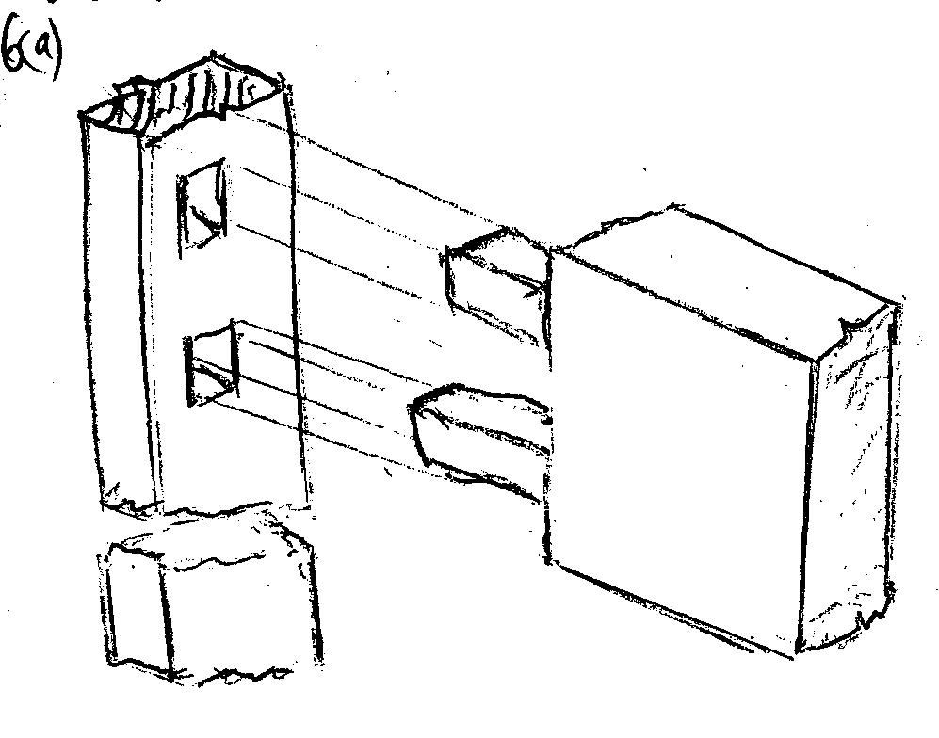
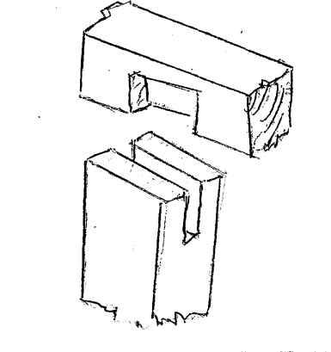

7, Plain scale
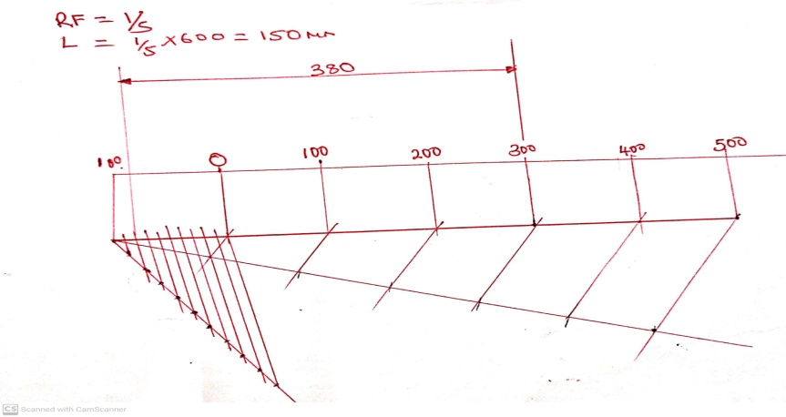

8 (a)
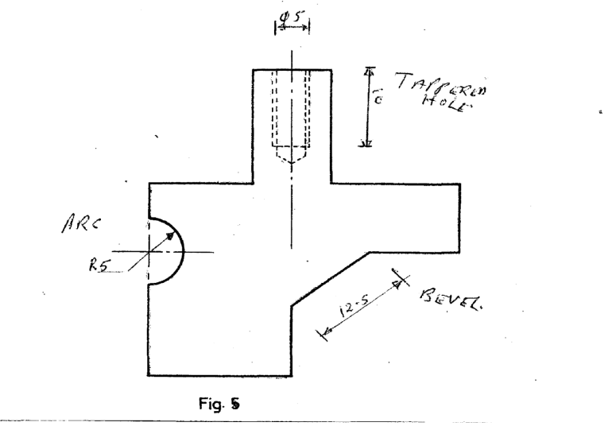

8 (b)
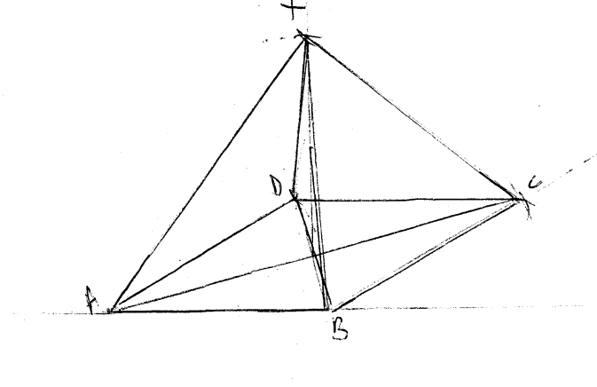

9. 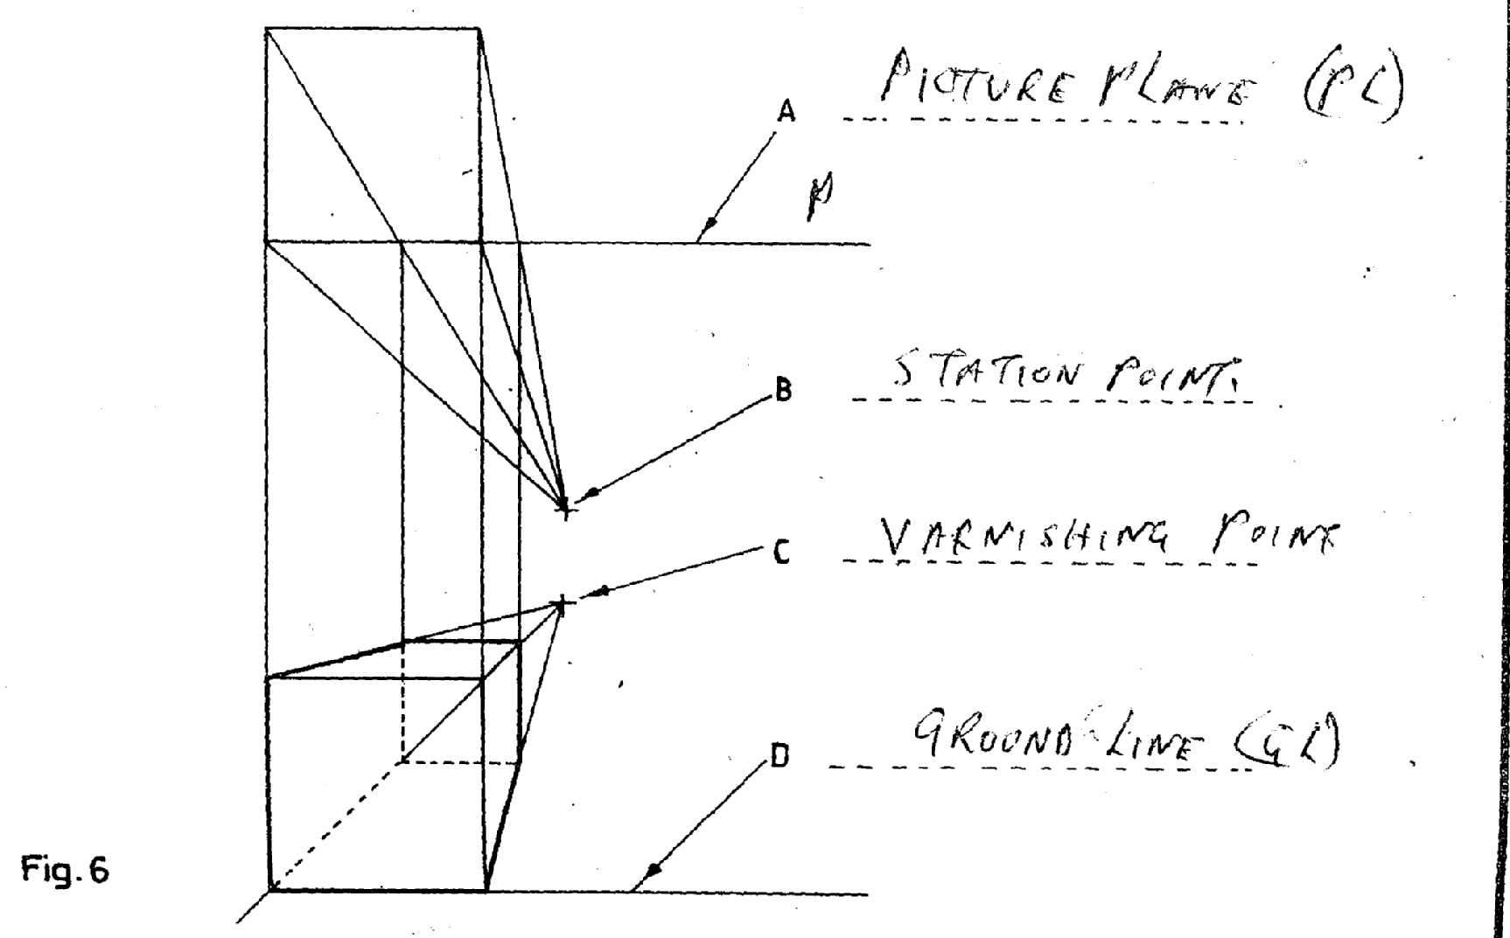

10.

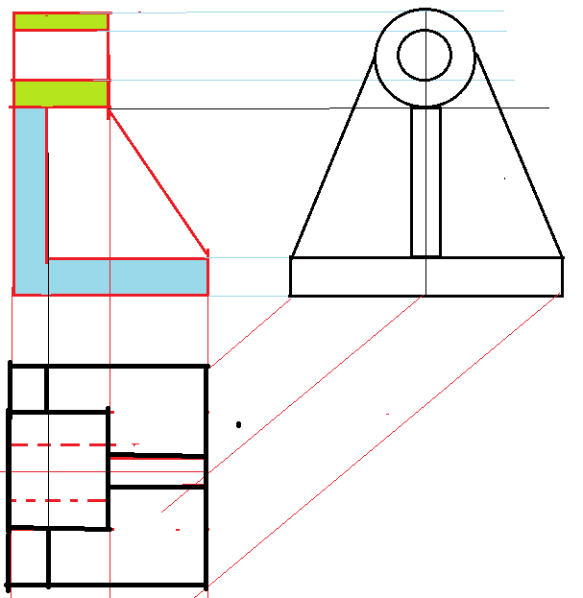

11. 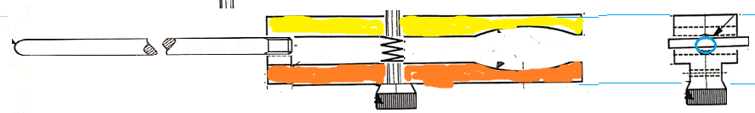
12
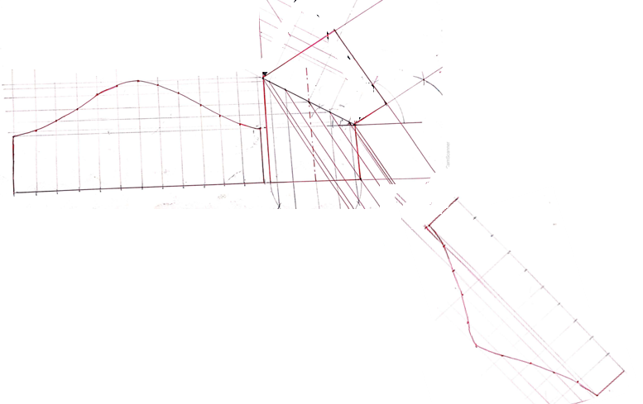
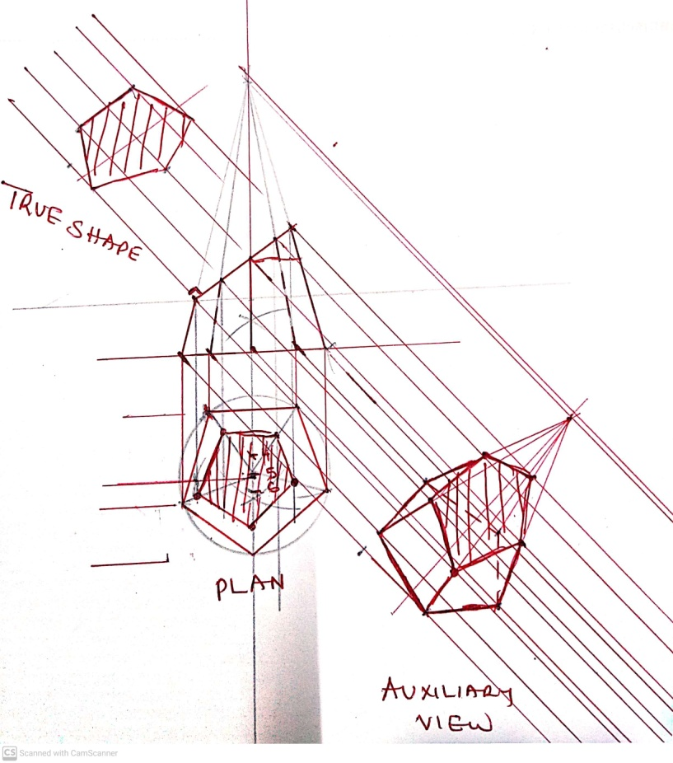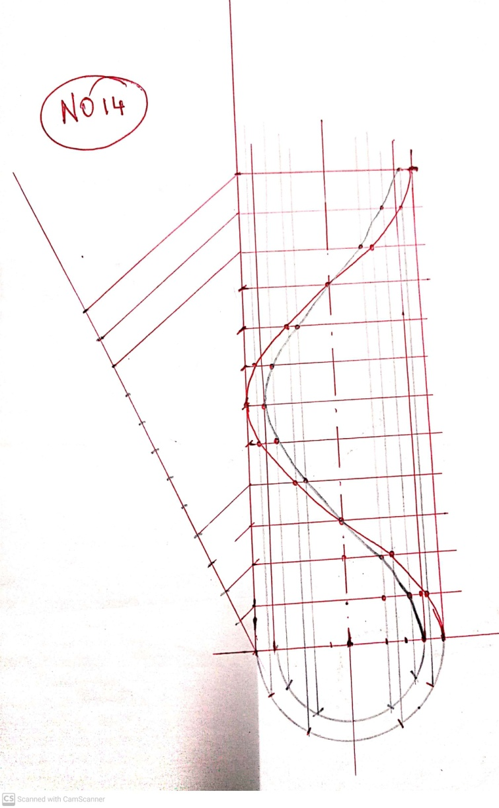
13

