NAME…………………………………………………………………………………………………..…………………..CLASS…………….……….ADM…………………………….......
DRAWING &DESIGN: [449/1]
FORM THREE
THEORY

2½hours

TERM I, 2023
Instructions to candidates
- You should have the following for this examinations:
- Answer sheet;
- Drawing instruments;
- 4 sheets of drawing paper size A3;
- Scale rule.
- This paper consists of three sections: A, B and C.
- Answer ALL the questions in sections A and B and C.
- Questions in section A must be answered on the spaces provided in the answer sheets
- Questions in section B and C should be answered on the A3 papers provided.
SECTION A |  |  |  |  |  |  |  |  |  | SEC B | SECTION C
1 | 2 | 3 | 4 | 5 | 6 | 7 | 8 | 9 | 10 | 11 | 12 | 13 | 14 | TOTAL

SECTION A (50 Marks)
Answer all the questions in this section in the spaces provided.
            - (a) List two uses of TEE Square (2mks)

(b) Why are different styles of lines used in drawing? (2 marks)

        - define a circle (2 marks)

- List any three differences between first angle and third angle projection. (3 marks)

- Describe the duties the following personnel in engineering production Industries:
(a) Designer. (2 marks)

(b) Draughts person. (2 marks)

- Illustrate using sketches the difference between chain and datum dimensioning. (2marks)

- Construct a regular octagon whose distance across the corners. ( 5 marks)

- Sketch the three views of the block shown below in third angle projection (5marks)
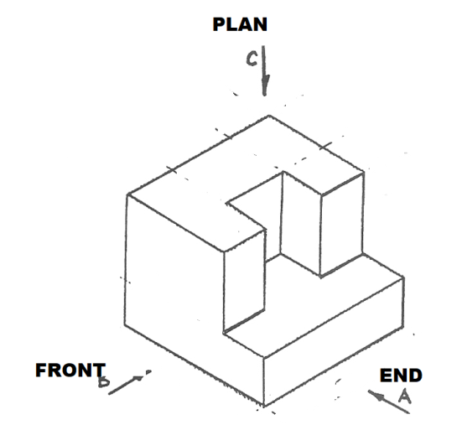

- Figure below shows two views of a truncated hexagonal pyramid. Complete the plan and draw an auxiliary view Q as projected through the elevation. (7 marks)
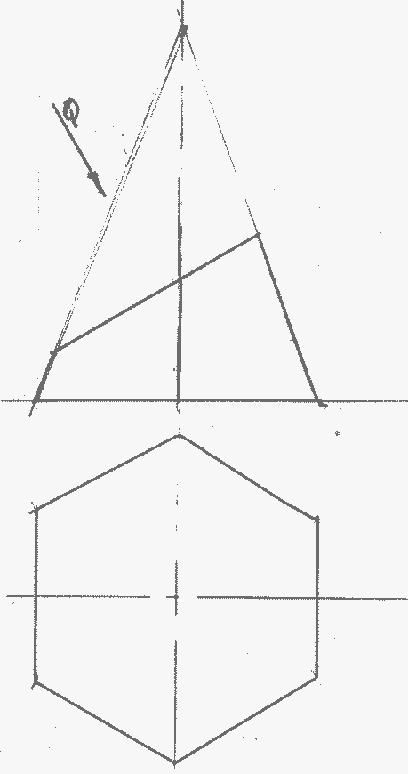

- Sketch the two views given below in isometric (8 marks)
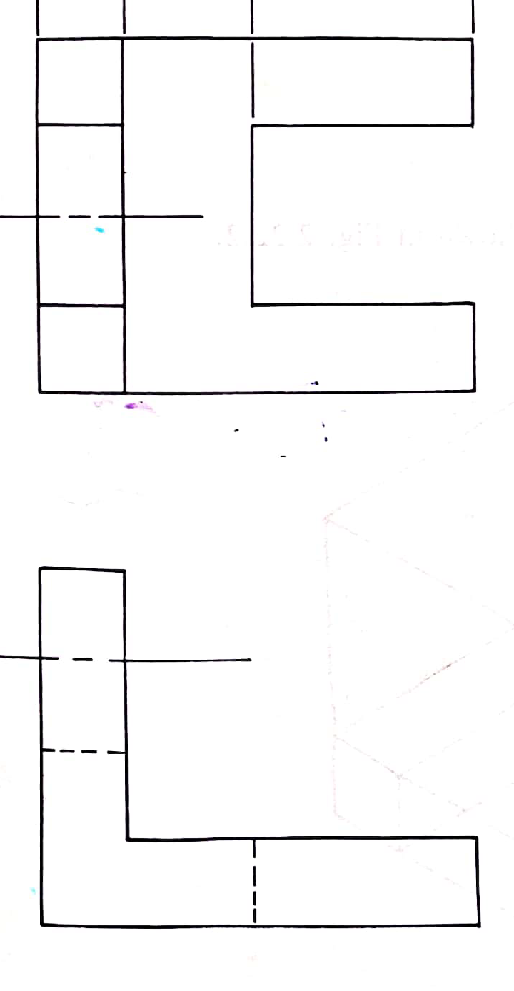

- Construct a diagonal scale 20:1, to read to 5 mm. and with an accuracy of 0.02 mm. Show a reading of 3.76 mm. on the scale. (5 marks)

- Sketch views given below in oblique (5marks)

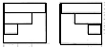

SECTION B (20 marks)
This question is compulsory
- Figure 6 shows parts of a cable spool and its support bracket. Draw FULL SIZE in third angle projection, the following views of the assembly:
- Sectional front elevation along the cutting plane P-P.
- Plan.
Insert four leading dimensions. Do not show any hidden details.

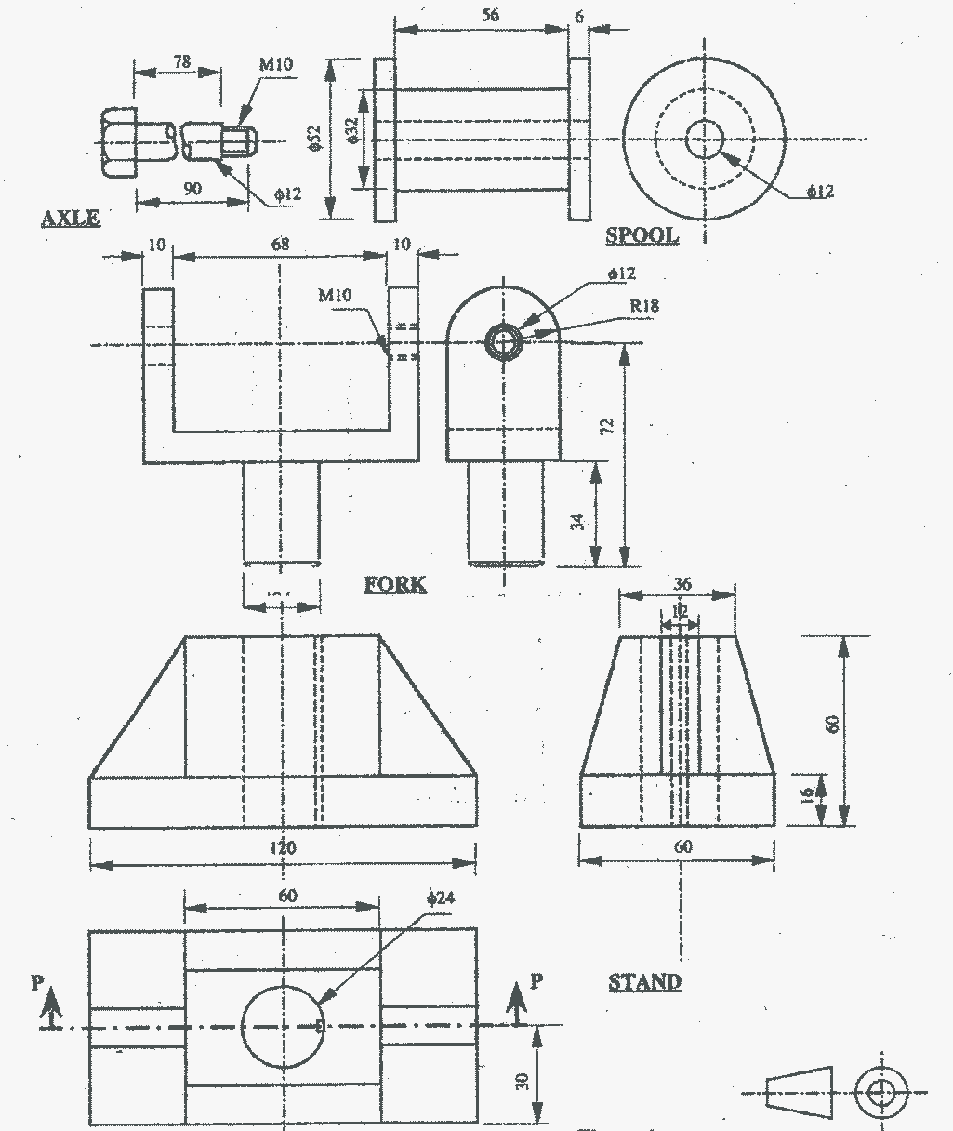
SECTION C (30Marks)
Answer Any Two Questions
- Draw full size an isometric view of a shaped block whose two views are shown in Figure 7 taking A as the lowest point. (15 marks)
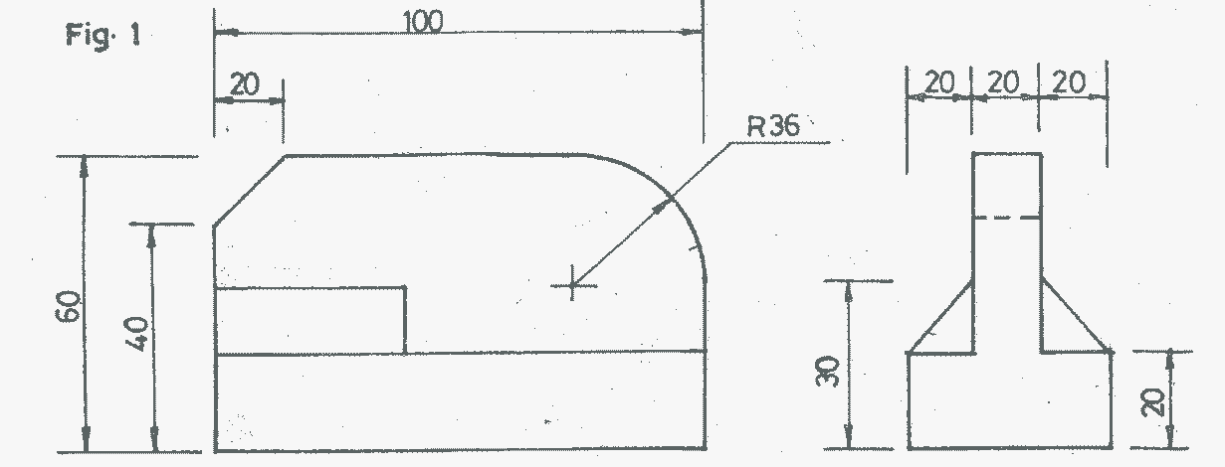

A
Figure 7

