NAME_____________________________________ADM__________________CLASS____________________________

SIGNATURE______________________________________________DATE____________________________________

DRAWING AND DESIGN

MID TERM ONE SERIES-TERM 1-2023

FORM 4

PAPER 1

TIME: 2½HOURS

**FOR EXAMINERS USE ONLY**

|  |  |  |  |  |  |  |  |  |  |  |  |  |  |  |
| --- | --- | --- | --- | --- | --- | --- | --- | --- | --- | --- | --- | --- | --- | --- |
| **1** | **2** | **3** | **4** | **5** | **6** | **7** | **8** | **9** | **10** | **11** | **12** | **13** | **14** | **TOTAL** |
|  |  |  |  |  |  |  |  |  |  |  |  |  |  |  |

**INSTRUCTIONS:**

* You should have the following for this examination:

–Drawing instructions.

–3 sheets of drawing paper A3.

* This paper consists of section A, B, and C.
* Answer all the questions in section A and B and any other two questions from section C.
* Questions in section A must be answered in the spaces provided.
* Questions in section **B** and **C** should be answered in the A**4** sheets of drawing papers provided.
* All dimensions are in ***mm***.

**Section A (50 marks)**

**Answer all questions in this section**

1. (a) Illustrate how dimension a circle and an arc. (2 Marks)

(b) Illustrate two ways in a leader line is terminated. (2marks)

1. Sketch the three view of the block shown below ( 6 marks)

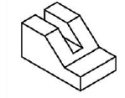

1. Construct a diagonal scale whose accuracy is **1**mm and long enough to measure up to 6 metres. (5 marks)
2. state three main factors that contribute to quality drawing (3 marks)
3. The adjacent sides of of a kite **ABCD** make angles of **300** and **450** with the longer diagonal **AC=60mm**. Construct the kite **ABCD.**  (6 marks)
4. Convert views given Fig 1 below into isometric block. (5 marks)

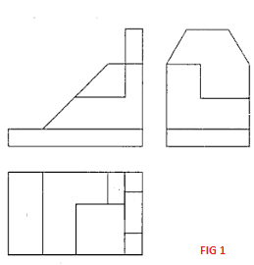

1. Sketch the auxiliary view of the triangular based pyramid shown in fig 2 below. (6 marks)

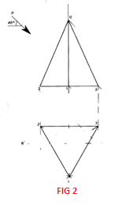

1. Construct a triangle of perimeter 185mm whose sides are in a ratio of 3:5:6 and convert to a square of the area. (6 marks)
2. Construct a triangle whose base is 60mm and two base angles are 1200 and 300 and inscribe a circle. ( 4 marks)
3. Sketch the missing view of the orthographic projections. (5marks)

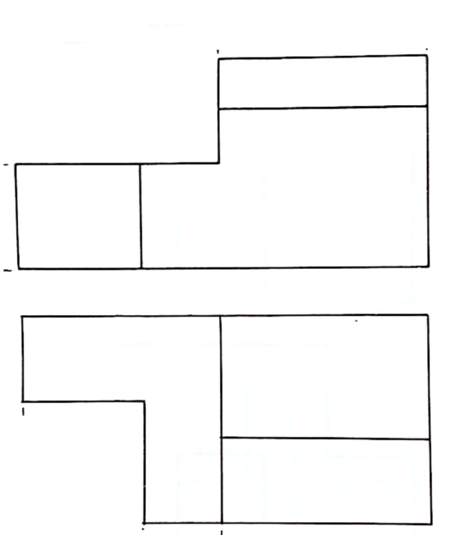

**Section B (20 Marks)**

***Compulsory question***

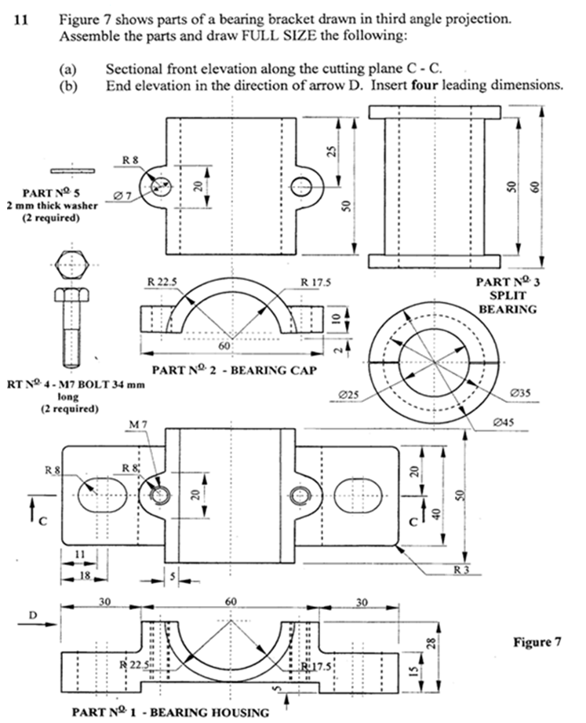

***Section C (30 marks)***

***Answer Any Two Questions***

1. In the mechanism shown in figure 4, the crank rotates about fixed point A. Connecting rod BC is free to slide within pivoted block D. The length of the links in mm is shown in the figure. Draw the locus of the point C for one complete revolution of crank AB. (15 marks)



1. Draw the views given below in isometric. (15 marks)



1. Pictorial view of a machine component is shown in the figure below.

Draw full size the following views. (15 marks)

1. Sectional front elevation X-X
2. End elevation
3. The plan.

