ZERAKI ACHIEVERS’ EXAMINATIONS (2022)
Term 1 – 2023 OPENER
DRAWING AND DESIGN (449/1)
PAPER 1
FORM FOUR (4)
Time: 2½ Hours
MARKING SCHEME
SECTION A (50 MARKS)
Answer All Questions in This Section
- (a) Outline four qualities of an entrepreneur. (4 marks)

Passion
Creativity
Self confidence
Vision
Risk taker
Curiosity
Visionary
Motivated

(b) List four advantages of using a computer draw over use of hands (4 marks)
Fast

Accurate
Clean
Cheap
Neat

- State what an industrial training Centre in Kenya is. ( 1mark)
These are government or non-governmental institutions that offer marketable skills at artisan or craft level

- State the composition of the following alloys (2 marks)
- Brass copper and zinc
- Stainless steel iron and chrome/vanadium
- State two advantages of plywood over solid timber (2 marks)
Uniform in strength, Cheap,
Versatile, Available in big sizes (8 x4)

- Sketch a conventional breaks of the following (4 marks)
- Wood
- Pipe
- Round section
- Short break
- State four reasons for sectioning parts in engineering drawings. (4 marks)
- To see the inside construction
- Dispense the need of using dotted lines
- Reduce the number of views
- Shows clearly how a mechanism works
- Two views of a machine part are shown below. Project the auxiliary view in the direction of arrow A (8 marks)
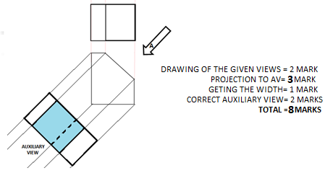
- Construct a regular octagon whose distance across the flats is 60mm. (6 marks)
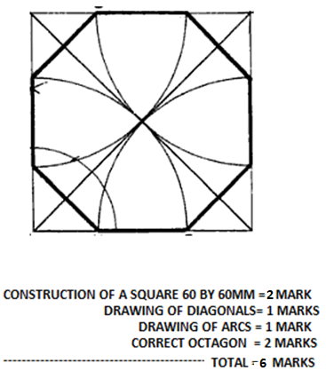
- (a) Use sketches to describe three types of dimensions in drawing. (3 marks)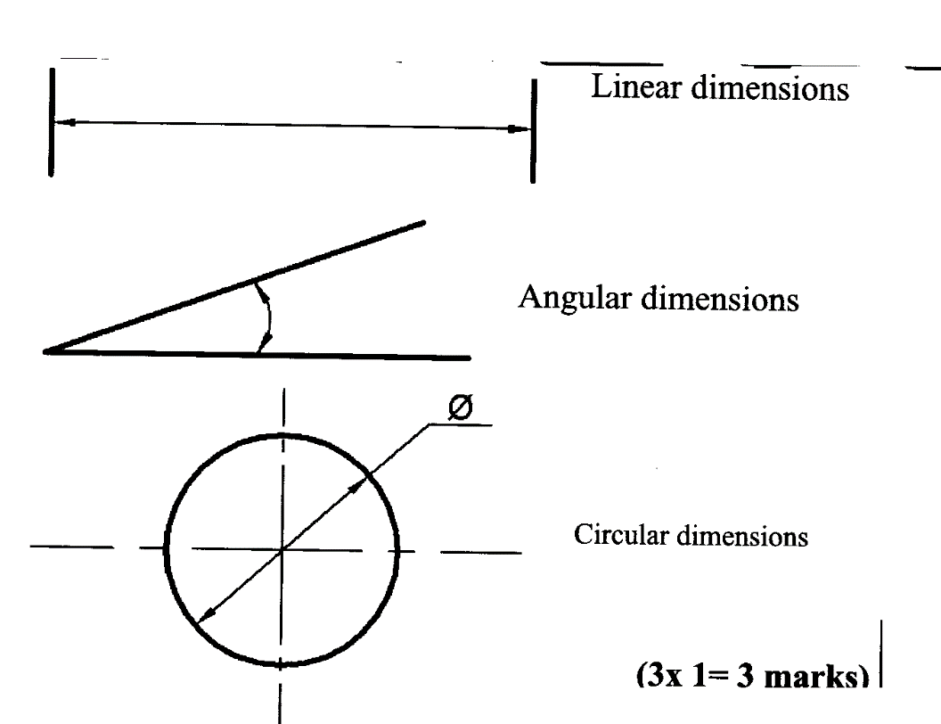
(b) Construct a diagonal scale in which 30mm represent 1 km to read up to 4km. Indicate a distance of 2.84km on the scale. (6 marks)

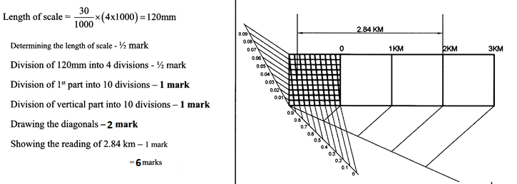

- Figure 3 shows the front elevation and incomplete plan of a truncated square pyramid complete the plan and draw the true shape of the cut face. (6 marks)

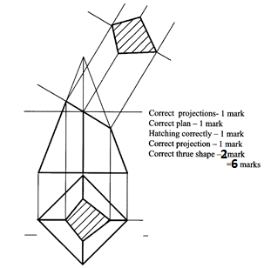

Section B (20 Marks) QSTN 11
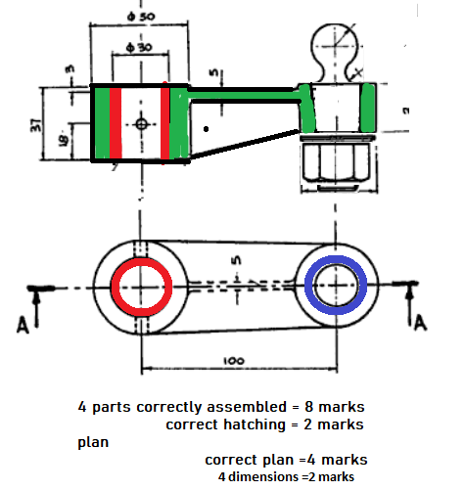

Section C (30 Marks)
Answer any two questions from this section
12. Figure 8 shows a cylinder truncated by two cutting planes A-A and B-B.

